9.2.4) https://www.w3schools.com/code/tryit.asp?filename=FLZHTL3DJMFG

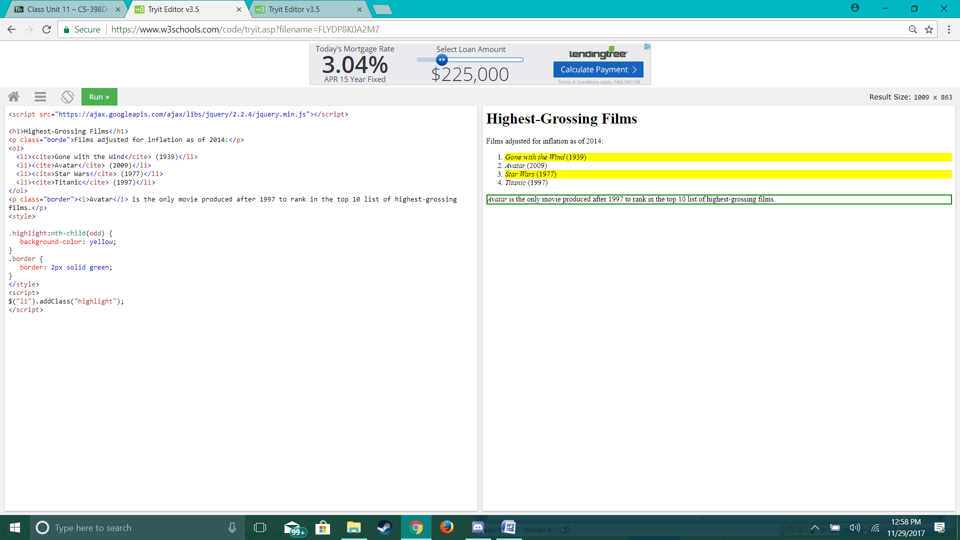

9.3.3) https://www.w3schools.com/code/tryit.asp?filename=FLYDP8K0A2M7