A) 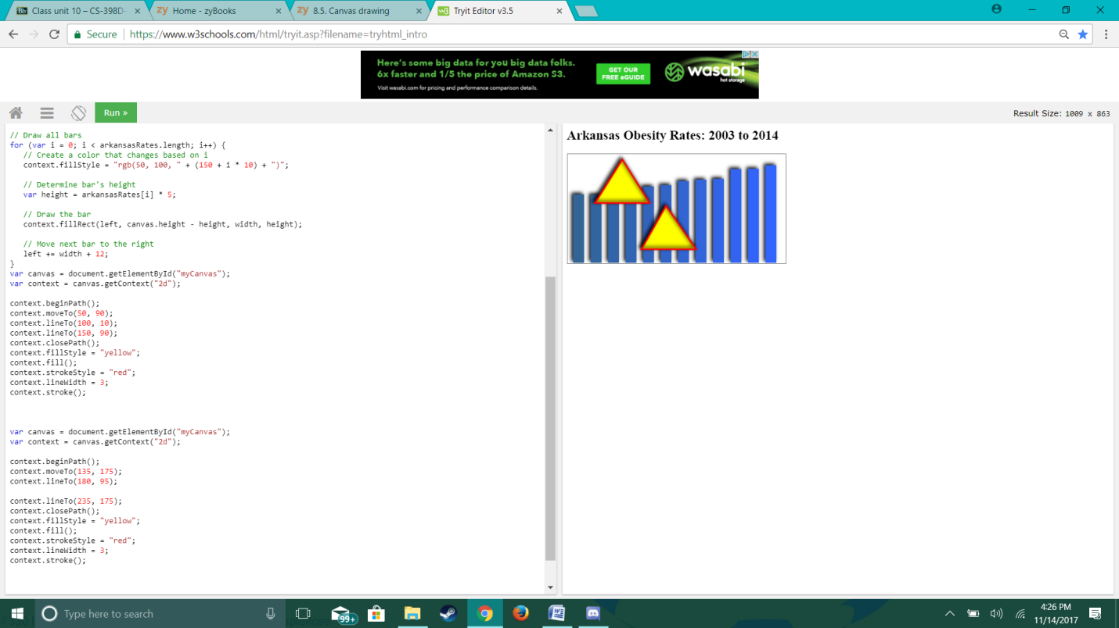

https://www.w3schools.com/code/tryit.asp?filename=FLIBK9DCX02B

B) 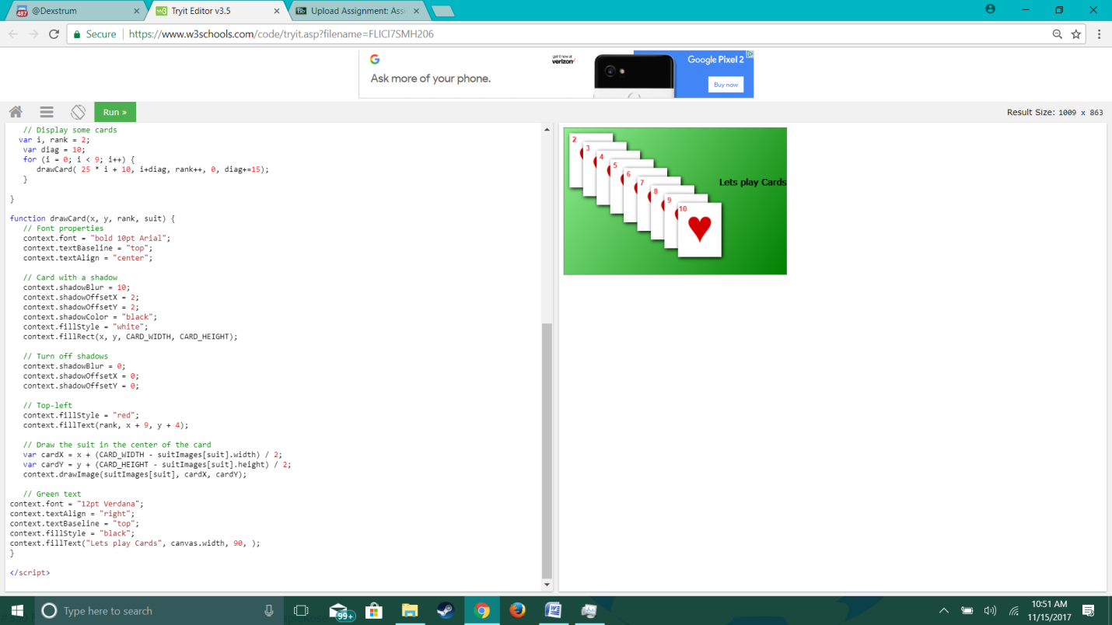

https://www.w3schools.com/code/tryit.asp?filename=FLJ8DD9RSQNG