# AUSTRIA

The [OECD Regional Outlook](https://www.oecd-ilibrary.org/urban-rural-and-regional-development/oecd-regional-outlook_2dafc8cf-en) reviews recent trends, policy developments, and prospects across OECD regions, including the underlying causes driving regional inequalities in performance and well-being. The report offers evidence, guidance and policy recommendations on how to improve competitiveness and productivity, promote inclusive growth, accelerate the net-zero transition and raise well-being standards through effective regional development policy and multi-level governance.

## Territorial definitions

The data in this note reflect different sub-national geographic levels in OECD countries. In particular, **regions** are classified on two territorial levels reflecting the administrative organisation of countries: large regions (TL2) and small regions (TL3). In Canada, TL2 corresponds to the provinces and territories.

Small regions are classified according to their access to metropolitan areas (Fadic et al. 2019). The typology classifies small (TL3) regions into metropolitan and non-metropolitan regions according to the following criteria:

* **Metropolitan regions**, if more than half of the population live in a FUA. Metropolitan regions are further classified into **metropolitan large**, if more than half of the population live in a (large) FUA of at least 1.5 million inhabitants; and **metropolitan midsize**, if more than half of the population live in a (midsize) FUA of at 250 000 to 1.5 million inhabitants.
* **Non-metropolitan regions**, if less than half of the population live in a midsize/large FUA. These regions are further classified according to their level of access to FUAs of different sizes: **near a midsize/large FUA** if more than half of the population live within a 60-minute drive from a midsize/large FUA (of more than 250 000 inhabitants) or if the TL3 region contains more than 80% of the area of a midsize/large FUA; **near a small FUA** if the region does not have access to a midsize/large FUA and at least half of its population have access to a small FUA (i.e. between 50 000 and 250 000 inhabitants) within a 60-minute drive, or contains 80% of the area of a small FUA; and **remote**, otherwise.

Disclaimer: <https://oecdcode.org/disclaimers/territories.html>

Overview

|  |  |
| --- | --- |
| Population and territory | 8,979,894 inhabitants (01/01/2022), 83,878 km² |
| Administrative structure *(unitary/federal)* | federal |
| Regional or state-level governments *(number)* | 9 Länder (federal states) |
| Intermediate-level governments *(number)* |  |
| Municipal-level governments *(number)* | 2,093 (2022) |
| Share of subnational government in total expenditure/revenues (2021) | 33.8% of total expenditure  36.6% of total revenues  [Source: [Subnational governments in OECD countries: key data, 2023 edition](https://stats.oecd.org/Index.aspx?DataSetCode=SNGF)] |
| Key regional development challenges | • Access to public services for small-scaled municipal structure;  • Adapt to climate change requirements, particularly in most affected mountain regions. |
| Objectives of regional policy | • Sparing use of resources at all scales, with a particular focus on spatial challenges;  • Strengthen social and spatial cohesion;  • Develop economic spaces and systems climate-friendly and sustainably;  • Support vertical and horizontal governance procedures. |
| Legal/institutional framework for regional policy | Diverse national sectoral strategies with spatial impact;  Treaty on the Functioning if the European Union, Art. 174;  Objectives of EU Cohesion policy and EU’s CAP; Climate Action Plan 2.0 of the Alpine Convention (2020). |
| Budget allocated to regional development (i.e., amount) and fiscal equalisation mechanisms between jurisdictions (if any) | * Cohesion Policy Partnership Agreement 2021-2027: 1.3 bio. € of EU Structural Funds and 1.8 bio € of national co-financing.  * 36.1 bio Euro (2020): Transfers from the federal government to states and municipalities are defined in the FAG, which distinguishes between general grants (quota allocation funds) and specific grants (to cover special needs or purposes). Based on Fiscal Constitutional Law providing for the Fiscal Equalization Law (*Finanzausgleichsgesetz*). |
| National regional development policy framework | The Partnership Agreement 2021-2027 for Austria covers the national ERDF programme and 14 INTERREG programmes (concerning territorial trans-national cooperation) |
| Urban policy framework | No specific policy regulation, but challenges highlighted in ÖREK 2030 (summary, p.19f.). |
| Rural policy framework | CAP Strategic Plan 2023-2027 (Federal Ministry of Agriculture, Forestry, Regions and Water Management) |
| Major regional policy tools (e.g., funds, plans, policy initiatives, institutional agreements, etc.) | • European Structural Funds and national co-funding.  • Rural Development Programme  • international agreement on Alpine Convention  • Institutional Agreements and Framework Programme Agreements.  • Local development programmes, including LEADER/CLLD, LA21, Climate and Energy Model Regions.  • Policies for employment and enterprise support by Länder (women and youth employment; specific support measures; SMEs)  • Tourism development support |
| Policy co-ordination tools at national level | • Department for Regional Policy and Spatial Planning, at Federal Ministry of Agriculture, Forestry, Regions and Water Management (BML)  • Austrian Conference on Spatial Planning (ÖROK; Coordination agency for vertical and horizontal governance of spatial planning issues) |
| Multi-level governance mechanisms between national and subnational levels (e.g., institutional agreements, Committees, etc.) | • National platform for spatial governance (ÖROK) for coordination, and monitoring of national regional policy activities and EU Structural Funds programmes; 10-year strategic document: Austrian Spatial Development Concept (ÖREK 2030)  • National Committee for the Co-ordination and Monitoring of the Regional Policy (Partnership Agreement Committee) |
| Policy co-ordination tools at regional level | • Policy guidelines (thematic and regional) at Länder level, as coordination tool for regions and local development activities;  • Inter-regional operational programmes. |
| Evaluation and monitoring tools | • Programming, Evaluation and Analysis Unit at BML for CAP, including national RDP monitoring and evaluation;  • Approach and systems for monitoring and evaluation of programmes in preparation  • System of territorial indicators and targets linked to the Partnership Agreement |
| Future orientations of regional policy | The continued application of Cohesion policy funds strengthens action to promote economic development, well-being, environmental sustainability and resilience in all regions through ERDF and ESF. Supporting European objectives, the national programmes to use these funds address structural challenges, aspects of circular economy, enhancing inclusive and just society, by strengthening multi-level governance arrangements and coordination. As the national priority is on the Rural Development Programme the measures for non-agricultural activities, diversification and value chain integration, and ecological performance are of particular relevance for regional development.  Future orientations include:  • Make use of complementarities between the different policy instruments and funds, exploiting specific characteristics to enhance innovation, well-being and adapted climate action;  • aim at sustainable growth to decouple economic development from natural resource use increase;  • enhance territorial cooperation at fine geographical level and for trans-national cooperation, to mitigate development obstacles due to fragmentation of small scales (municipality and regional levels). |

## Regional Inequality Trends

Austria experienced a decline in the Theil index of GDP per capita over 2000-2020. Inequality reached its maximum in 2006. The figures are normalized, with values in the year 2000 set to 1.

The Top 20%/Mean ratio was 0.114 lower in 2020 compared to 2000, indicating decreased polarisation. The Bottom 20%/Mean ratio was 0.069 higher in the same period, indicating bottom convergence.

**Figure 1. Trends in GDP per capita inequality indicators, TL3 OECD regions**

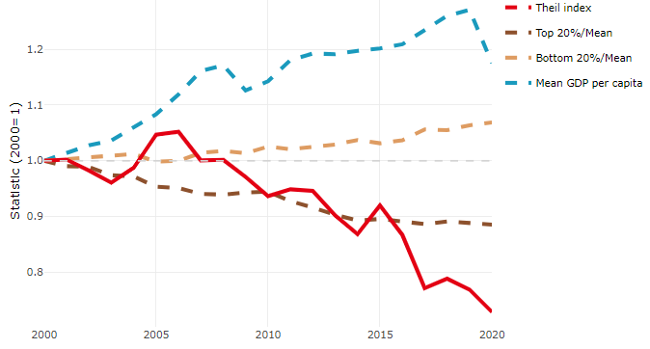

**Note**: Top/bottom calculated as population equivalent (top/bottom regions with at least 20% of the population). The interpretation of top/bottom 20% GDP per capita is that 20% of the population in the country holds 20% of the value. Top 20%/Mean calculated as mean GDP per capita in top 20% regions over mean TL3 GDP per capita in a given year. Bottom 20%/Mean calculated as mean TL3 GDP per capita in bottom 20% regions over mean TL3 GDP per capita in a given year. To improve data consistency, input series are aggregated when TL3 regions are part of the same FUA. To improve time series, TL3 missing values have been estimated based on the evolution at higher geographic level.

**Source**: OECD Regional Database (2022).

In 2020, the gap in GDP per capita between large metropolitan and non-large metropolitan regions was 1.177. For reference, the same value for OECD was 1.475. This gap decreased by 0.248 percentage points between 2000 and 2020.

Meanwhile, in 2020, the gap in GDP per capita between metropolitan and non-metropolitan regions was 1.245. For reference, the same value for OECD was 1.325. This gap decreased by 0.17 percentage points since 2000.

In turn, the gap in GDP per capita between regions near and far a Functional Urban Area (FUA) of more than 250 thousand inhabitants was 1.143 in 2020 and decreased by 0.045 percentage points since 2000.

**Figure 2. GDP per capita gap by type of region compared to the OECD average**

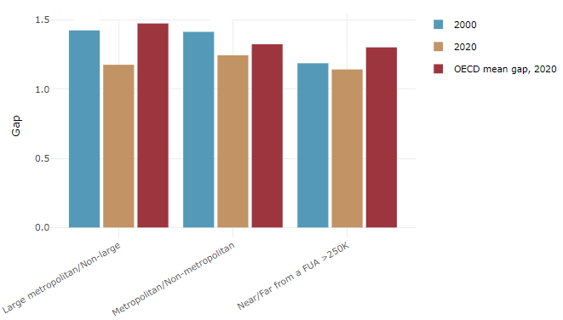

**Note**: Far from a FUA>250K includes regions near/with a small FUA and remote regions. OECD mean gap based on 1 586 TL3 regions in 27 countries with available data (no TL3 data for Australia, Canada, Chile, Colombia, Costa Rica, Iceland, Ireland, Israel, Mexico, Luxembourg and Switzerland).

**Source**: OECD Regional Database (2022).

In Austria, the gap between the upper and the lower half of regions in terms of labour productivity decreased between 2001 and 2019. Over this period labour productivity in the upper half of regions grew roughly by 9%, 9 percentage points less than in the lower half of regions. During 2020, the gap continued to narrow. Nevertheless, more years of data are necessary to determine the long-term impact of the COVID-19 pandemic on labour productivity gaps in regions.

**Figure 3. Evolution of labour productivity, TL3 OECD regions**

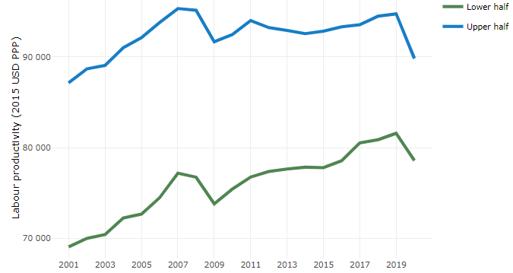

**Note**: A region is in the “upper half” if labour productivity was above the country median in the first year with available data and “lower half” if productivity was below the country median. Labour productivity in each group is equal to the sum of Gross Value Added, expressed in USD at constant prices and PPP (base year 2015) within the group, divided by the sum of total employment in regions within the group. Regions are small (TL3) regions, except for Australia, Canada, Chile, Colombia, Ireland, Mexico, Norway, Switzerland, Türkiye and the United States where they are large (TL2) regions due to data availability.

**Source**: OECD Regional Database (2022).

Regions where the economic activity shifts towards tradable activities, such as industry and tradable services, tend to grow faster in terms of labour productivity. In Austria, between 2001 and 2020, the share of workers in the industrial sector went down in regions that used to be located in the upper half of the labour productivity distribution while it remained stable in the rest. At the same time, the share of workers in the tradable services sector went up in all regions but more so in regions that used to be in the lower half of the labour productivity distribution. Hence, the evolution of employment shares both in the industrial and in the tradable services sectors reduced the labour productivity gap between regions.

**Figure 4. Share of workers in most productive (tradable) sectors, TL3 OECD regions**

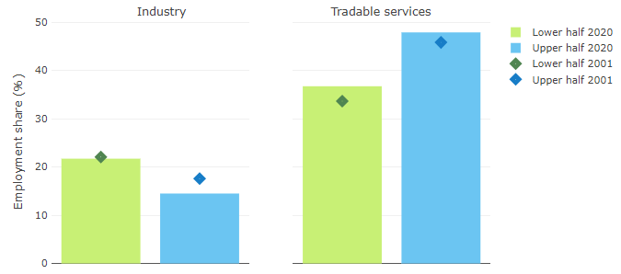

**Note**: A region is in the “upper half” if labour productivity was above the country median in the first year with available data and “lower half” if productivity was below the country median. The share of workers in a given sector for a group of regions is defined as the sum of employment in that sector within the group divided by the sum of total employment within the group. Regions are small (TL3) regions, except for Australia, Canada, Chile, Ireland, Mexico, Norway, Switzerland, Türkiye and the United States where they are large (TL2) regions due to data availability. Industry includes the following tradable goods sectors: Mining and quarrying (B), Manufacturing (C), Electricity, gas, steam and air conditioning supply (D) and Water supply; sewerage; waste management and remediation activities (E) NACE macro sectors. Tradable services include Information and communication (J), Financial and insurance activities (K), Real estate activities (L), Professional, scientific and technical activities (M), Administrative and support service activities (N).

**Source**: OECD Regional Database (2022).

## Recent policy developments

The Cohesion Policy Partnership Agreement between the EU Commission and Austria, adopted on 2 May 2022, sets out investment priorities for the period 2021-2027 to promote national cohesion and sustainable development. It foresees an amount of 1.3 bio € of Structural Funds support for Austrian programmes which will be co-financed by about 1.8 bio. € of national funds. Specific criteria to enhance an innovative and energy sufficient Austria are principles of circular economy, digitalisation and energy efficiency for selection of projects. Moreover, through the Just Transition Fund the country's transition to a climate-neutral economy through diversification of companies and start-ups to climate neutral and resource efficient activities that provide alternative jobs to replace those in energy intensive industries presently relying on fossil fuels as energy sources will be supported. The European Social Fund will support investments in infrastructures, jobs and education for persons with disabilities, people with migrant backgrounds and other disadvantaged groups. At the local scale, for support of life in cities and rural areas, projects on resource efficiency, climate adaptation, an innovation-oriented economy and local development will be supported. These activities continue on-going activities of several selected regions.

On the basis of the long-term strategy document, “ÖREK 2030”, a reorientation in priorities of regional development objectives has started recently and will be implemented over the next years. This includes in particular action on sparing use of land resources throughout the country, and climate action to achieve efficient and resilient resource use objectives. A series of national coordination and strategic planning activities will be implemented. So far, a land use development strategy to reduce the future land consumption and the high level of soil sealing by 2030 has been initiated. The second strategic working group (“Space for building culture”) aims at enhancing the societal role of architectural culture and heritage, in particular to strengthen town and city centres for shaping sustainable and resource efficient options of future spatial development.

Due to the specific relevance of landscapes for Austria’s regions, the renewed tourism strategy sets out a vision for this sector, particularly in relation to regional development options. The so-called “Plan T” sets the vision for sustainable tourism development.