# DENMARK

The [OECD Regional Outlook](https://www.oecd-ilibrary.org/urban-rural-and-regional-development/oecd-regional-outlook_2dafc8cf-en) reviews recent trends, policy developments, and prospects across OECD regions, including the underlying causes driving regional inequalities in performance and well-being. The report offers evidence, guidance and policy recommendations on how to improve competitiveness and productivity, promote inclusive growth, accelerate the net-zero transition and raise well-being standards through effective regional development policy and multi-level governance.

## Territorial definitions

The data in this note reflect different sub-national geographic levels in OECD countries. In particular, **regions** are classified on two territorial levels reflecting the administrative organisation of countries: large regions (TL2) and small regions (TL3). In Canada, TL2 corresponds to the provinces and territories.

Small regions are classified according to their access to metropolitan areas (Fadic et al. 2019). The typology classifies small (TL3) regions into metropolitan and non-metropolitan regions according to the following criteria:

* **Metropolitan regions**, if more than half of the population live in a FUA. Metropolitan regions are further classified into **metropolitan large**, if more than half of the population live in a (large) FUA of at least 1.5 million inhabitants; and **metropolitan midsize**, if more than half of the population live in a (midsize) FUA of at 250 000 to 1.5 million inhabitants.
* **Non-metropolitan regions**, if less than half of the population live in a midsize/large FUA. These regions are further classified according to their level of access to FUAs of different sizes: **near a midsize/large FUA** if more than half of the population live within a 60-minute drive from a midsize/large FUA (of more than 250 000 inhabitants) or if the TL3 region contains more than 80% of the area of a midsize/large FUA; **near a small FUA** if the region does not have access to a midsize/large FUA and at least half of its population have access to a small FUA (i.e. between 50 000 and 250 000 inhabitants) within a 60-minute drive, or contains 80% of the area of a small FUA; and **remote**, otherwise.

Disclaimer: <https://oecdcode.org/disclaimers/territories.html>

Overview

|  |  |
| --- | --- |
| Population *(specify date)* and territory | 5,932,654 (01/01/2023), 42,951 km2 |
| Administrative structure *(unitary/federal)* | Unitary |
| Regional or state-level governments *(number)* | 5 regioner (regions) |
| Intermediate-level governments *(number)* |  |
| Municipal-level governments *(number)* | 98 kommuner (municipalities) |
| Share of subnational government in total expenditure/revenues (2021) | Danish subnational governments generally enjoy high levels of fiscal decentralisation regarding expenditures, but their autonomy is much more limited when it comes to revenue. Municipalities are the only subnational level to raise tax revenues, as opposed to regions who have no taxation powers.  66.5% of total expenditure  62.4% of total revenues  [Source: [Subnational governments in OECD countries: key data, 2023 edition](https://stats.oecd.org/Index.aspx?DataSetCode=SNGF)] |
| Key regional development challenges | Regional urbanization: an increasing part of the population lives in or close to the major cities which results in local schools and stores closing in rural areas continuously and reducing the job supply. |
| Objectives of regional policy | Improving the cohesion between rural and urban areas by evening out economic, financial and demographic differences to address the depopulation of rural and remote areas.  In 2021, the Danish government set up seven regional teams with the objective of recommending ways to cultivate regional business strengths. The growth teams recommended establishing 8 local business “lighthouses” consisting of wide partnership with the objective of supporting the development of future sector strongholds and emerging industries. |
| Legal/institutional framework for regional policy | Structural reform of 2007 (Kommunalreformen), which significantly changed the institutional and territorial organisation of the country.  Treaty on the Functioning of the European Union, Article 174 |
| Budget allocated to regional development (i.e., amount) and fiscal equalisation mechanisms between jurisdictions (if any) | The Danish Regions have budgeted with 400 million € for regional development and close to 1 billion € in capital investment, while the municipalities have estimated expenditures of 2.5 billion € for capital investments.  Municipality equalisation reform of 2020, see recent policy developments. |
| National regional development policy framework | The Cohesion Policy Partnership Agreement 2021-2027: 656 million € of EU Structural Funds (ERDF, ESF+, JTF, EHFAF) and 40 million € (expected) annual national co-funding.  The Danish Business Authority, the Danish Authority of Social Services and Housing, the Danish regions and the Danish Fisheries Agency are the primary administrative authorities of the aforementioned funds.  Each of the five regions formulate a regional development strategy every 3-4 years. There is no national strategic document although it has been a clear political priority of the government to ensure balanced regional development in recent years.  As part of a wider reform of the public sector administration, nine municipalities (number extended later) took part in a policy experiment called the “Free Municipality” initiative. They were granted exemptions from government rules and bureaucracy requirements with the aim to review potential future legislation simplifying. |
| Urban policy framework | Revitalisation of town centers in small and medium sized towns has received increased national attention in the last ten years. National focus has, first of all, been directed towards improving the regional cohesion and balance through infrastructure developments, decentralization of public institutions and through business development.  Secondly, on town level, attention has been on the access to private and public services such as shops, schools and health facilities. Inspired by a place-based development framework the government has encouraged municipalities to strengthen private-public partnerships and to identify place-based qualities and strategies. Two examples of such policy tools are the urban renewal scheme and the “Partnership for thriving town centers” (2020-2022). |
| Rural policy framework | CAP Strategic Plan 2023-2027 (Ministry of Food, Agriculture and Fisheries, Ministry of Ecclesiastical Affairs and The Danish Agency for Planning and Rural Development). As part of the CAP Strategic Plan: 62 million € for local rural development projects which are implemented through local action groups.  In 2019, the Danish government issued the Business Promotion Act with the purpose of improving the conditions for business owners, enhancing productivity and export and avoid overlapping regional development and business promotion initiatives.  The responsibility of business promotion was transferred from the regions to national level (Danish Board of Business Development) in 2019. The responsibility for business promotion is now divided between municipalities (local business services) and the state (specialized business service). |
| Major regional policy tools (e.g., funds, plans, policy initiatives, institutional agreements, etc.) | Denmark's approach to regional development prioritises the competitiveness of all of its regions. A high share of EU Cohesion Policy funding is dedicated to this objective, along with other instruments such as business development centers and publicly funded clusters based on Sector Strongholds and Emerging Industries.  Policy tools:   * National technology and innovation clusters * Regional business development centres * A national online guide for business (Virksomhedsguiden). * Development of smaller cities and tourism infrastructure. * Projects of strategic importance (business “lighthouses”) |
| Policy co-ordination tools at national level | A National Board for Business Promotion was established in 2019 to allow for a clearer strategic focus to improve competitiveness across regions while taking local and regional specificities into account. |
| Multi-level governance mechanisms between national and subnational levels (e.g., institutional agreements, Committees, etc.) | The existence of the National Board of Business Promotion is determined by law but the members of the board are determined collaboratively by business organisations, municipalities, unions, etc. |
| Policy co-ordination tools at regional level | Both the national association of municipalites, the Danish regions, and the regional business development centres are important partners in determining the joint direction of regional development. The regional business development centers will also be responsible for the municipalities’ business service and activities for 13 locations across the country. |
| Evaluation and monitoring tools | As the administrative authority, the Danish Business Authority continously performs evaluations and measurements of the effects of regional development projects funded by European Structural Funds combined with national co-funding.  All projects funded by the European Structural Funds exceeding a monetary threshold is evaluated by an external evaluator. Furthermore, the Danish Business Authority estimates the socioeconomic effect on all participating businesses in collaboration with the Danish National Statistics Office (Statistics Denmark). |
| Future orientations of regional policy | The National Board of Business Promotion formulates a national strategy for Business Promotion for the period 2024-2027, which is expected to include:   * Improving the complementarities between the funds and the policy instruments to simplify being an enterprise in Denmark. * Improving and cultivating sector strongholds. * Improving the digital and green robustness and adaptation readiness of the Danish enterprises. * Improving the geographical availability of regional development initiatives. |

## Regional Inequality Trends

Denmark experienced an increase in the Theil index of GDP per capita over 2000-2020. Inequality reached its maximum in 2018. The figures are normalized, with values in the year 2000 set to 1.

The Top 20%/Mean ratio was 0.063 higher in 2020 compared to 2000, indicating increased polarisation. The Bottom 20%/Mean ratio was 0.033 lower in the same period, indicating bottom divergence.

**Figure 1. Trends in GDP per capita inequality indicators, TL3 OECD regions**

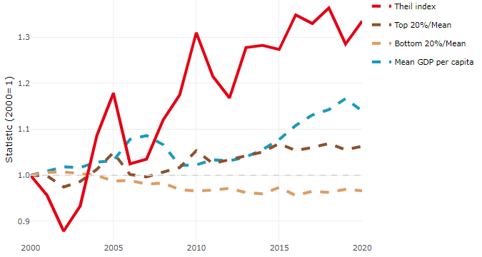

**Note**: Top/bottom calculated as population equivalent (top/bottom regions with at least 20% of the population). The interpretation of top/bottom 20% GDP per capita is that 20% of the population in the country holds 20% of the value. Top 20%/Mean calculated as mean GDP per capita in top 20% regions over mean TL3 GDP per capita in a given year. Bottom 20%/Mean calculated as mean TL3 GDP per capita in bottom 20% regions over mean TL3 GDP per capita in a given year. To improve data consistency, input series are aggregated when TL3 regions are part of the same FUA. To improve time series, TL3 missing values have been estimated based on the evolution at higher geographic level.

**Source**: OECD Regional Database (2022).

In 2020, the gap in GDP per capita between large metropolitan and non-large metropolitan regions was 1.487. For reference, the same value for OECD was 1.475. This gap increased by 0.11 percentage points between 2000 and 2020.

Meanwhile, in 2020, the gap in GDP per capita between metropolitan and non-metropolitan regions was 1.11. For reference, the same value for OECD was 1.325. This gap decreased by 0.004 percentage points since 2000.

In turn, the gap in GDP per capita between regions near and far a Functional Urban Area (FUA) of more than 250 thousand inhabitants was 1.184 in 2020 and increased by 0.008 percentage points since 2000.

**Figure 2. GDP per capita gap by type of region compared to the OECD average**

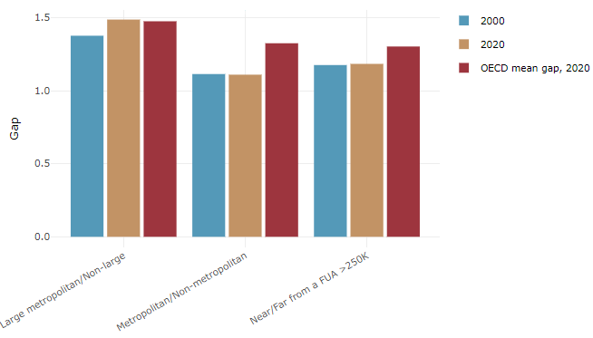

**Note**: Far from a FUA>250K includes regions near/with a small FUA and remote regions. OECD mean gap based on 1 586 TL3 regions in 27 countries with available data (no TL3 data for Australia, Canada, Chile, Colombia, Costa Rica, Iceland, Ireland, Israel, Mexico, Luxembourg and Switzerland).

**Source**: OECD Regional Database (2022).

In Denmark, the gap between the upper and the lower half of regions in terms of labour productivity increased between 2001 and 2019. Over this period labour productivity in the upper half of regions grew roughly by 18%, 6 percentage points more than in the lower half of regions. During 2020, the gap continued to widen. Nevertheless, more years of data are necessary to determine the long-term impact of the COVID-19 pandemic on labour productivity gaps in regions.

**Figure 3. Evolution of labour productivity, TL3 OECD regions**

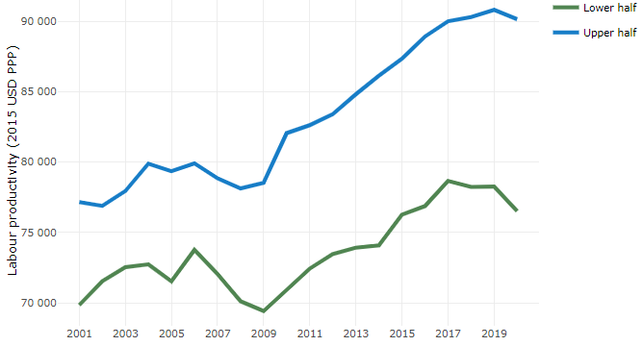

**Note**: A region is in the “upper half” if labour productivity was above the country median in the first year with available data and “lower half” if productivity was below the country median. Labour productivity in each group is equal to the sum of Gross Value Added, expressed in USD at constant prices and PPP (base year 2015) within the group, divided by the sum of total employment in regions within the group. Regions are small (TL3) regions, except for Australia, Canada, Chile, Colombia, Ireland, Mexico, Norway, Switzerland, Türkiye and the United States where they are large (TL2) regions due to data availability.

**Source**: OECD Regional Database (2022).

Regions where the economic activity shifts towards tradable activities, such as industry and tradable services, tend to grow faster in terms of labour productivity. In Denmark, between 2001 and 2020, the share of workers in the industrial sector went down in all regions but more so in regions that were already in the lower half of the labour productivity distribution. Hence, the evolution of employment shares in the industrial sector widened the labour productivity gap between regions. At the same time, the share of workers in the tradable services sector went up in all regions, approximately by the same amount.

**Figure 4. Share of workers in most productive (tradable) sectors, TL3 OECD regions**

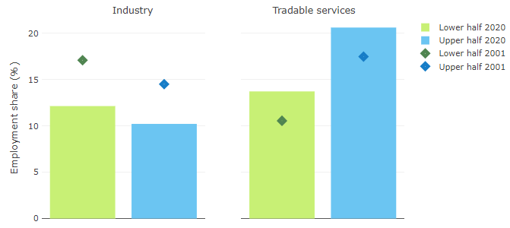

**Note**: A region is in the “upper half” if labour productivity was above the country median in the first year with available data and “lower half” if productivity was below the country median. The share of workers in a given sector for a group of regions is defined as the sum of employment in that sector within the group divided by the sum of total employment within the group. Regions are small (TL3) regions, except for Australia, Canada, Chile, Ireland, Mexico, Norway, Switzerland, Türkiye and the United States where they are large (TL2) regions due to data availability. Industry includes the following tradable goods sectors: Mining and quarrying (B), Manufacturing (C), Electricity, gas, steam and air conditioning supply (D) and Water supply; sewerage; waste management and remediation activities (E) NACE macro sectors. Tradable services include Information and communication (J), Financial and insurance activities (K), Real estate activities (L), Professional, scientific and technical activities (M), Administrative and support service activities (N).

**Source**: OECD Regional Database (2022).

## Recent policy developments

In 2020, the national government implemented an equalisation reform at the municipal level evening out the revenues of the municipalities based on each muncipality's expenditure level.

In 2022, the national government, along with the majority of the other elected parties, agreed on a reform with the purpose of making it possible to obtain higher education in all parts of the country, rather than just in the major cities.

A property tax reform was approved in 2017 and became fully effective in 2021. The reform included new valuations of property to reflect the property market values more accurately, thereby ending the property valuation freeze in place since 2002, which has led to falling effective tax rates for homes experiencing increase in value.