# ESTONIA

The [OECD Regional Outlook](https://www.oecd-ilibrary.org/urban-rural-and-regional-development/oecd-regional-outlook_2dafc8cf-en) reviews recent trends, policy developments, and prospects across OECD regions, including the underlying causes driving regional inequalities in performance and well-being. The report offers evidence, guidance and policy recommendations on how to improve competitiveness and productivity, promote inclusive growth, accelerate the net-zero transition and raise well-being standards through effective regional development policy and multi-level governance.

## Territorial definitions

The data in this note reflect different sub-national geographic levels in OECD countries. In particular, **regions** are classified on two territorial levels reflecting the administrative organisation of countries: large regions (TL2) and small regions (TL3). In Canada, TL2 corresponds to the provinces and territories.

Small regions are classified according to their access to metropolitan areas (Fadic et al. 2019). The typology classifies small (TL3) regions into metropolitan and non-metropolitan regions according to the following criteria:

* **Metropolitan regions**, if more than half of the population live in a FUA. Metropolitan regions are further classified into **metropolitan large**, if more than half of the population live in a (large) FUA of at least 1.5 million inhabitants; and **metropolitan midsize**, if more than half of the population live in a (midsize) FUA of at 250 000 to 1.5 million inhabitants.
* **Non-metropolitan regions**, if less than half of the population live in a midsize/large FUA. These regions are further classified according to their level of access to FUAs of different sizes: **near a midsize/large FUA** if more than half of the population live within a 60-minute drive from a midsize/large FUA (of more than 250 000 inhabitants) or if the TL3 region contains more than 80% of the area of a midsize/large FUA; **near a small FUA** if the region does not have access to a midsize/large FUA and at least half of its population have access to a small FUA (i.e. between 50 000 and 250 000 inhabitants) within a 60-minute drive, or contains 80% of the area of a small FUA; and **remote**, otherwise.

Disclaimer: <https://oecdcode.org/disclaimers/territories.html>

Overview

|  |  |
| --- | --- |
| Population *(specify date)* and territory | 1 357 739 (1 January 2023), 45,339 km2 |
| Administrative structure *(unitary/federal)* | Unitary |
| Regional or state-level governments *(number)* | 1 |
| Intermediate-level governments *(number)* | 0 |
| Municipal-level governments *(number)* | 79 |
| Share of subnational government in total expenditure/revenues (2021) | 24.4% of total expenditure  25.0% of total revenues  [Source: [Subnational governments in OECD countries: key data, 2023 edition](https://stats.oecd.org/Index.aspx?DataSetCode=SNGF)] |
| Key regional development challenges | • Large regional disparities in socio-economic development, despite the small size of the country (for example in GDP, business performance indicators, demographic trends, incomes in particular). There has been no significant trend towards territorially more balanced development in recent years also.  • More active economic activity and attractive/profitable jobs are concentrating in larger urban regions, and regional differences in economic growth are deepening.  • Demographic changes, especially internal migration of younger people towards largest urban areas are generating regional shrinkage outside major urban areas and is weakening the development prospects of these shrinking regions.  • Local governance, investment and development capacity (e.g in delivery of quality public services) is still uneven across municipalities. Municipalities in larger urban areas with more favourable demographic structure have normally higher and remote, sparsely populated municipalities located further away from cities lower capacity.  • There are still shortcomings in the coordination of the regional impact of sectoral policies in the goals of balanced regional development. |
| Objectives of regional policy | • Diminishing regional development disparities;  • Strengthening cities’ role in development of larger regions through proximity effects/urban-rural interactions and promoting smart shrinkage of regions facing depopulation;  • Strengthening coordination of regional policy objectives across national sectorial policies and levels of governance (as multilevel governance of regional development);  • Promoting financial autonomy of local municipalities and reducing the political dependency from the central government when it comes to the formation of their tax base;  •Transferring some complementary state government responsibilities/functions to local municipalities and increasing decentralisation in public governance, along with ensuring the necessary revenue base;  • Increasing the role of local governments and their responsibilities in the development of the business environment and ensuring appropriate instruments and funds |
| Legal/institutional framework for regional policy | The Ministry of Regional Affairs and Agriculture is responsible for developing, implementing, coordinating and monitoring regional development, spatial planning and territorial administration policy and developing and counselling local municipalities of Estonia. The Ministry is also in charge of the issues of territorial administration and setting financial management principles for local authorities. The Ministry also designs and coordinates the implementation of regional development (e.g. rural and urban areas) grant schemes and development of regional public transport.  The other ministries also contribute to development of regions and cities by coordinating specific sectorial policies having a stronger territorial relevance:  • Ministry of Economic Affairs and Communications is responsible for business development, ICT and digital society, labour market policies and relevant grand schemes having significant importance to development of regions;  • Ministry of Climate, as coordinating environmental, sustainable development, adaptation/mitigation of climate change, circular economy and mobility, as well as housing and energy policies;  • Ministry of Social Affairs, as being responsible for social protection and care, medical and health policy.  • Ministry of Education and Research, as being responsible for education policy, school network and R&D policies and relevant funding instruments.  Local municipalities are responsible for spatial and strategic development planning and provision of local public services within their territories. Local municipalities also coordinate strategic development at county level jointly through County Development Organisations. |
| Budget allocated to regional development (i.e., amount) and fiscal equalisation mechanisms between jurisdictions (if any) | Presumably around 70-80 million euros will be allocated to regional development annually during the next 7-years implementation period of the EU funds specifically through the regional development grant schemes (funded from the EU funds as well as from the national budget). This calculation does not include the other sectorial policy grants reaching also to different regions of Estonia.  The fiscal equalisation mechanism forms 107,4 million euros (2023), which represents 3,6% of total local government income. |
| National regional development policy framework | Since 2021 we have no longer had a holistic national regional development strategy being valid for all sectorial ministries. Nevertheless, regional development goals, e.g to ensure a more balanced territorial development and consideration of different territorial needs through sectorial policy strategies is set within the National Development Strategy “Estonia 2035”.  There is also a new Regional Development Action Plan (RDAP) in place since 2022. The RPAP defines the most eminent socio-economic inequalities of regional development seen as major challenges/root-problems of regional development in Estonia, and creates a framework for monitoring these processes. It also sets more detailed 4-year action plan covering different sectorial policy activities to alleviate these root problems and support more even regional development.  Besides, there is a regional development program for 4-year period (being updated annual-basis), which sets up the implementation plan for the ministry responsible for regional policy in Estonia (Ministry of Regional Affairs and Agriculture). This document is also a basis for planning 4-years state budget strategy.  At regional level there are 15 county[1] development strategies in place, developed jointly by the local municipalities of the county. Although there is a general requirement that the county development strategies and national level policy strategies are consistent and consider each other’s priorities, there are no binding mechanisms to ensure this in practice.  There is no official regional policy council or advisory group or other such institution currently in Estonia at government level coordinating the development and implementation of regional policy across sectorial ministries and levels of governance. |
| Urban policy framework | Estonia does not have an explicit national urban policy or national strategy for urban development. The urban development issues have addressed within a broader national regional policy framework.  E.g. specific grant schemes for development of 5 largest urban areas of Estonia are applied being funded from the European Regional Development Fund of 2021-27. These grant schemes aim to support investments in innovative digital solutions and green infrastructure of Estonian largest urban areas and revitalization of the largest urban areas in North-Eastern Estonia.  One soft coordination initiative is a national network of urban development specialists. This is an informal multilevel governance and collaboration platform, assembling officials of urban municipalities in charge or strategic development and spatial planning of their cities/towns and the Association of Estonian Cities and Municipalities. And involving also the representatives from central government body responsible for regional and urban development policy, other relevant ministries. |
| Rural policy framework | Rural development policy is being implemented primarily under the national strategy for Rural Development and Fishery 2030.  Rural development is under the primary responsibility of the Ministry of Rural Affairs and Agriculture. The ministry e.g. coordinates Estonia’s rural development policy, implements the European Union’s Common Agricultural Policy for Estonia and develops/implements the Estonian strategic Rural Development Plans.  Rural development is also an integral part of the national regional policy and its incentives. The Ministry of Rural Affairs and Agriculture is in charge of designing and implementing territorial development policies which is largely addressed to specificities and challenges of rural areas.  Besides, other ministries have their own sectorial responsibilities related to developments in rural areas. |
| Major regional policy tools (e.g., funds, plans, policy initiatives, institutional agreements, etc.) | • Regional development grant schemes (funded from the EU funds as well as from the national budget);  • Fiscal equalisation mechanism to local governments;  • National Regional Development Action Plan;  • National Development Plans for North-Eastern and South-Eastern regions of Estonia until 2030;  • A mechanism and guideline document for impact assessment of legislative acts and national policy strategies, which e.g requires assessment of impacts on regional development and rural areas and provides a respective check-out questionnaire. |
| Policy co-ordination tools at national level | • National Regional Development Action Plan (RDAP) aimed at facilitating the cross-sectorial coordination of policy incentives in regional policy and balanced territorial development goals. The RDAP consolidates the most important activities of the central government in order to alleviate the problems of regional development and ensure territorially more balanced development.  • National Development Plans for North-Eastern and South-Eastern regions of Estonia until 2030;  • According to the Government of the Republic Act planning and general co-ordination of regional development lies under the responsibility of the Ministry of Regional Affairs and Agriculture.  • Mechanism and guideline document for impact assessment of legislative acts and national policy strategies, which e.g requires assessment of impacts on regional development and rural areas.  • The national Government has given a task to the sectorial ministries to take into account the regional development challenges and impacts in designing foreign aid support measures funded from the EU funds of 2021-2027 and plan concrete solutions to strengthen their compliance with the balanced territorial development target. A special guideline has also been prepared for this process with providing potential solutions how to promote this compliance in practice. |
| Multi-level governance mechanisms between national and subnational levels (e.g., institutional agreements, Committees, etc.) | • Annual National Budget negotiation format between national Government and National Association of Cities and Municipalities.  • A national network of County Development Organisations (as soft coordination mechanism), which represent local municipalities of each certain county and performs also as a multilevel collaboration and policy discussions with ministries. The network convenes regularly mainly to exchange important information, best practices, initiate consultations on different territorial development related issues between counties (horizontally) and with the ministries (vertically).  • Similar national network of urban development specialists also exists assembling officials of urban municipalities in charge or strategic development and spatial planning of their cities/towns and the Association of Estonian Cities and Municipalities. And involving also the representatives from central government body responsible for regional and urban development policy, other relevant ministries.  • The principles of how national level sectoral development strategies, county development strategies and local government development plans have to consider and support each other's priorities and strive towards stronger coherence are specified in new draft of Local Governments Act, the strategic planning guidelines issued by the State Government Office and guidelines for preparation of county development strategies.  • Recently established (in 2022) steering group at national level for coordinating the capacity building of local government employees for planning, implementing and monitoring the specific Action-Plan for local governments capacity building. |
| Policy co-ordination tools at regional level | • County development strategies act as multilevel governance instruments also. In principle these strategies should give an input to national level sectorial development strategies/action plans and the state budget strategy. Nevertheless, in practice this coordination mechanism has remained weak and has had some influence as a soft multi-level cooperation instrument.  • National cross-sectorial action plans for North-East and South-East regions of Estonia until 2030 to accelerate the development of these two socio-economically less advanced regions. Both documents bring together incentives of different ministries/sectoral policies for development of these regions and include only activities initiated by the central government.  • As a new initiative, the Ministry of Regional Affairs and Agriculture is piloting regional development agreements/’deals’ in parallel with setting up regional councils mandated for coordination of their further elaboration and implementation, starting with the pilot areas of Central- and South-Estonia. The regional agreements will be anticipated to become agreements between central and local governments and other regional stakeholders on the objectives, key economic sectors and activities and financing for increasing regional economic competitiveness in region larger than a county. |
| Evaluation and monitoring tools | Territorial development trends are being regularly observed within the monitoring framework of the national Regional Development Action Plan. There are around 15-20 indicators to monitor regional disparities in major regional policy challenges/root problems. These indicators have been set in accordance with the strategic objectives of the „Estonia 2035“ strategy and their monitoring indicators at national level. Thereby monitoring the implementation of the Regional Development Action Plan simultaneously enables to assess also how the goals of the national development strategy are reached in territorial dimension.  Monitoring dashboard minuomavalitsus.ee (<https://minuomavalitsus.fin.ee/en>). The aim is observe the quality and satisfaction with local governments’ services all over Estonia. The dashboard analyses and visualises hundreds of criteria of the state of local governments’ services. It enables to get an overview of the state of services and development possibilities in each local government, compare local governments’ service levels which contributes to sharing experiences, raise public awareness of the organisation of local services and increase citizens’ informed involvement in discussing local development priorities and needs.  Other need-based assessments having territorial relevance, like e.g interim and ex-post assessments of the impacts of EU structural funds, the achievement of EU Cohesion Policy goals, or certain governance area or case-specific monitoring exercises (state audit reports, etc). |
| Future orientations of regional policy | • Strengthening coordination of regional policy objectives and impacts to regional development across national sectorial policies - like e.g by developing/implementing new cross-sectorial Regional Development Action Plan; guidelines for sectorial ministries to strengthen the positive impacts of new financial support measures to balanced territorial development; facilitating territorial impacts assessment of sectorial policy strategies and regulations).  • Facilitating multilevel governance and sectorial coordination at regional level larger than counties - by piloting regional development agreements/’deals’ and setting up regional councils mandated for coordination of their further elaboration and implementation.  • Promoting financial capacity and autonomy of local municipalities and reducing the political and fiscal dependency from the central government.  • Increasing the role of local governments and their responsibilities in the development of the business environment.  • A shift towards more flexible and efficient allocation of regional development grant schemes, also by decreasing their fragmentation. A number of smaller and thematically more narrow grant schemes are being combined and applied more flexibly according to priorities of counties’ and other territorial strategies. |

## Regional Inequality Trends

Estonia experienced an increase in the Theil index of GDP per capita over 2000-2020. Inequality reached its maximum in 2016. The figures are normalized, with values in the year 2000 set to 1.

The Top 20%/Mean ratio was 0.052 higher in 2020 compared to 2000, indicating increased polarisation. The Bottom 20%/Mean ratio was 0.039 lower in the same period, indicating bottom divergence.

**Figure 1. Trends in GDP per capita inequality indicators, TL3 OECD regions**

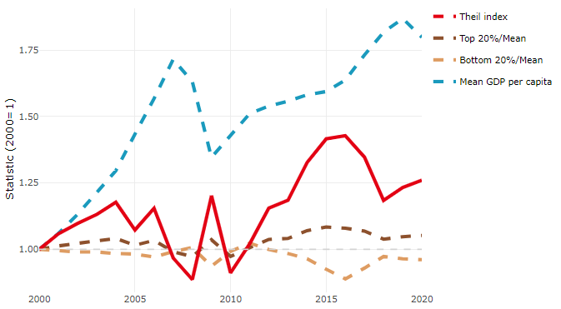

**Note**: Top/bottom calculated as population equivalent (top/bottom regions with at least 20% of the population). The interpretation of top/bottom 20% GDP per capita is that 20% of the population in the country holds 20% of the value. Top 20%/Mean calculated as mean GDP per capita in top 20% regions over mean TL3 GDP per capita in a given year. Bottom 20%/Mean calculated as mean TL3 GDP per capita in bottom 20% regions over mean TL3 GDP per capita in a given year. To improve data consistency, input series are aggregated when TL3 regions are part of the same FUA. To improve time series, TL3 missing values have been estimated based on the evolution at higher geographic level.

**Source**: OECD Regional Database (2022).

There is no data for the gap in GDP per capita between large metropolitan and non-large metropolitan regions for 2000 and 2020.

Meanwhile, in 2020, the gap in GDP per capita between metropolitan and non-metropolitan regions was 2.337. For reference, the same value for OECD was 1.325. This gap increased by 0.178 percentage points since 2000.

In turn, the gap in GDP per capita between regions near and far a Functional Urban Area (FUA) of more than 250 thousand inhabitants was 2.337 in 2020 and increased by 0.178 percentage points since 2000.

**Figure 2. GDP per capita gap by type of region compared to the OECD average**

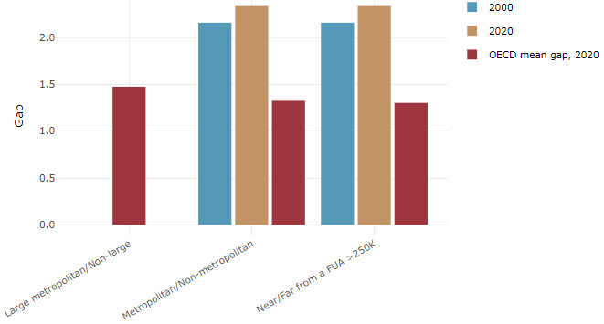

**Note**: Far from a FUA>250K includes regions near/with a small FUA and remote regions. OECD mean gap based on 1 586 TL3 regions in 27 countries with available data (no TL3 data for Australia, Canada, Chile, Colombia, Costa Rica, Iceland, Ireland, Israel, Mexico, Luxembourg and Switzerland).

**Source**: OECD Regional Database (2022).

In Estonia, the gap between the upper and the lower half of regions in terms of labour productivity decreased between 2001 and 2019. Over this period labour productivity in the upper half of regions grew roughly by 57%, 38 percentage points less than in the lower half of regions. During 2020, the gap widened again. Nevertheless, more years of data are necessary to determine the long-term impact of the COVID-19 pandemic on labour productivity gaps in regions.

**Figure 3. Evolution of labour productivity, TL3 OECD regions**

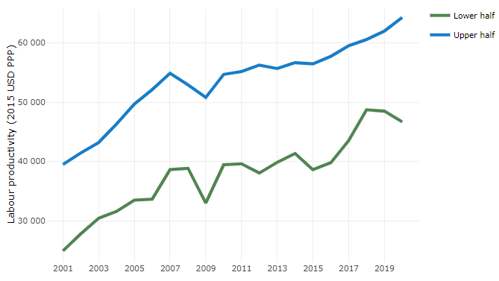

**Note**: A region is in the “upper half” if labour productivity was above the country median in the first year with available data and “lower half” if productivity was below the country median. Labour productivity in each group is equal to the sum of Gross Value Added, expressed in USD at constant prices and PPP (base year 2015) within the group, divided by the sum of total employment in regions within the group. Regions are small (TL3) regions, except for Australia, Canada, Chile, Colombia, Ireland, Mexico, Norway, Switzerland, Türkiye and the United States where they are large (TL2) regions due to data availability.

**Source**: OECD Regional Database (2022).

Regions where the economic activity shifts towards tradable activities, such as industry and tradable services, tend to grow faster in terms of labour productivity. In Estonia, between 2001 and 2020, the share of workers in the industrial sector went down in all regions but more so in regions that were already in the lower half of the labour productivity distribution. At the same time, the share of workers in the tradable services sector went up in regions already located in the upper half of the labour productivity distribution while it went down in regions located in the lower half. Hence, the evolution of employment shares both in the industrial and in the tradable services sectors widened the labour productivity gap between regions.

**Figure 4. Share of workers in most productive (tradable) sectors, TL3 OECD regions**

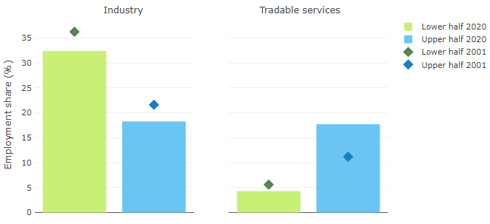

**Note**: A region is in the “upper half” if labour productivity was above the country median in the first year with available data and “lower half” if productivity was below the country median. The share of workers in a given sector for a group of regions is defined as the sum of employment in that sector within the group divided by the sum of total employment within the group. Regions are small (TL3) regions, except for Australia, Canada, Chile, Ireland, Mexico, Norway, Switzerland, Türkiye and the United States where they are large (TL2) regions due to data availability. Industry includes the following tradable goods sectors: Mining and quarrying (B), Manufacturing (C), Electricity, gas, steam and air conditioning supply (D) and Water supply; sewerage; waste management and remediation activities (E) NACE macro sectors. Tradable services include Information and communication (J), Financial and insurance activities (K), Real estate activities (L), Professional, scientific and technical activities (M), Administrative and support service activities (N).

**Source**: OECD Regional Database (2022).

## Recent policy developments

The number of national-level strategic policy documents was reduced and there is no regional policy strategy in place since 2021. Instead, a Regional Development Action Plan (RDAP) was prepared and identifies the most eminent regional socio-economic inequalities which are considered major challenges/ of regional development in Estonia and sets a 4-year action plan covering different sectoral policy activities to address these challenges and support more balanced regional development in the country. Furthermore, the goals of regional balance in the country's strategic development goals are set in the strategy "Estonia 2035" (approved in 2021), which is also further addressed by the country's sectoral development plans.

Estonia recently started preparing a new national spatial plan, which is scheduled to be finalised by 2026, replacing the current national spatial plan “Estonia 2030”.

New regional development support measures have been prepared for the EU Cohesion Policy funds in 2021-27 (around 220 million of euros in total). These measures aim to support balanced territorial development and competitiveness in regions and cities. New specific support measures have also been launched in recent years for regions with the biggest development challenges under the Ida-Virumaa and South-East Estonia programs.

A special territorial transition plan for North-Eastern Estonia was endorsed by the European Commission in 2022 and plans for various grant schemes and other support activities to promote the economic and labour market restructuring (around 80% of funding) and social and living environment transition processes (around 20% of funding) in this area. The plan will be funded by the EU Just Transition Fund (340 million euros), i.e., around 2500 euros per inhabitant. North-Eastern Estonia is an area of oil-shale energy production and other carbon-intensive industries that has contributed to the largest share of Estonian carbon emissions and is thereby also most remarkably influenced by decarbonisation processes and transition towards green and carbon-neutral economy and energy production.

The national Government has assigned sectorial ministries to take the regional development challenges and impacts into account when designing foreign aid support measures funded by the EU funds of 2021-2027 and to plan concrete solutions to strengthen their compliance with the balanced territorial development target and a special guideline was prepared to support this process.

To strengthen the fiscal capacity of local governments, the income tax allocated to local governments was increased by 0.3% (about 34 million euros more in each financial year in 2021 prices) and the equalisation fund added another 25 million euros. In total, the revenue of local governments from the income tax and equalisation fund increased by 4.2% in 2021.

The national government supported local governments in times of crises. During the COVID-19 crisis (2020-21), local governments received 176 million euros of additional dedicated support. In 2022, 2.5 million euros were allocated to local governments for providing emergency assistance to the Ukrainian war refugees and about 80 million for the provision of services.

In 2022, Estonia launched regional development agreements/’deals’ for the pilot areas of Central- and South-Easter Estonia in parallel with setting up regional councils mandated to coordinate their elaboration and implementation. The regional agreements are anticipated to become agreements between central and local governments and other regional stakeholders on the objectives, key economic sectors and activities and financing for increasing regional economic competitiveness in regions larger than a county..

1. In Estonia there is one tier of local governance system. Counties are not municipal administrative units as such, but territories where local governments jointly plan and implement development activities of broader regional importance and manage some public services (public transport for instance).