# FRANCE

The [OECD Regional Outlook](https://www.oecd-ilibrary.org/urban-rural-and-regional-development/oecd-regional-outlook_2dafc8cf-en) reviews recent trends, policy developments, and prospects across OECD regions, including the underlying causes driving regional inequalities in performance and well-being. The report offers evidence, guidance and policy recommendations on how to improve competitiveness and productivity, promote inclusive growth, accelerate the net-zero transition and raise well-being standards through effective regional development policy and multi-level governance.

## Territorial definitions

The data in this note reflect different sub-national geographic levels in OECD countries. In particular, **regions** are classified on two territorial levels reflecting the administrative organisation of countries: large regions (TL2) and small regions (TL3). In Canada, TL2 corresponds to the provinces and territories.

Small regions are classified according to their access to metropolitan areas (Fadic et al. 2019). The typology classifies small (TL3) regions into metropolitan and non-metropolitan regions according to the following criteria:

* **Metropolitan regions**, if more than half of the population live in a FUA. Metropolitan regions are further classified into **metropolitan large**, if more than half of the population live in a (large) FUA of at least 1.5 million inhabitants; and **metropolitan midsize**, if more than half of the population live in a (midsize) FUA of at 250 000 to 1.5 million inhabitants.
* **Non-metropolitan regions**, if less than half of the population live in a midsize/large FUA. These regions are further classified according to their level of access to FUAs of different sizes: **near a midsize/large FUA** if more than half of the population live within a 60-minute drive from a midsize/large FUA (of more than 250 000 inhabitants) or if the TL3 region contains more than 80% of the area of a midsize/large FUA; **near a small FUA** if the region does not have access to a midsize/large FUA and at least half of its population have access to a small FUA (i.e. between 50 000 and 250 000 inhabitants) within a 60-minute drive, or contains 80% of the area of a small FUA; and **remote**, otherwise.

Disclaimer: <https://oecdcode.org/disclaimers/territories.html>

Overview

|  |  |
| --- | --- |
| Population *(specify date)* and territory | 68 million (2020), 549 087 km2 (2018) |
| Administrative structure *(unitary/federal)* | Unitary |
| Regional or state-level governments *(number)* | 18 regions (including 5 overseas departments and regions) + 5 overseas collectivities (COM) which replaced the overseas territories following the 2003 constitutional revision (Saint-Pierre and Miquelon, Wallis and Futuna, French Polynesia, Saint-Barthélémy, Saint-Martin). New Caledonia is a sui generis overseas collectivity because of its greater autonomy. The French Southern and Antarctic Lands (TAAF), which have no permanent population, are also a sui generis collectivity. The COMs are not part of the European Union, with the exception of Saint-Martin which, like the 5 DROMs, is an ultra-peripheral region (RUP). As Overseas Countries and Territories (OCTs), along with New Caledonia and the TAAFs, the COMs benefit from an "association regime", meaning that they are eligible for European development funds while not being subject to Community law. |
| Intermediate-level governments *(number)* | 101 departments |
| Municipal-level governments *(number)* | 34,955 municipalities |
| Share of subnational government in total expenditure/revenues (2021) | 19.0% of total expenditure  21.3% of total revenues  [Source: [Subnational governments in OECD countries: key data, 2023 edition](https://stats.oecd.org/Index.aspx?DataSetCode=SNGF)] |
| Key regional development challenges | In its current form, the national policy on regional development has been defined by a partnership agreement between the State and the Regions signed in 2020, which identifies three main issues:   * Boosting the companies hardest hit by the crisis; * Greater regional resilience; * A genuine ecological and energy transition for a low-carbon economy   These challenges are considered in European cohesion policy for both the 2014-2020 (notably via REACT EU credits) and 2021-2027 programming periods.  In addition, the eleven thematic objectives of cohesion policy for the 2014-2020 period have been replaced by five strategic objectives (SO), in line with the themes supported in 2014-2020, with a stronger focus on territorial development:   * a more competitive and intelligent Europe by encouraging smart, innovative economic transformation and regional ICT connectivity; * a greener, more resilient and low-carbon Europe moving towards a carbon-free economy, by promoting a clean and equitable energy transition, green and blue investments, the circular economy, climate change mitigation and adaptation, risk prevention and management, and sustainable urban mobility; * a more connected Europe through improved mobility; * a more social and inclusive Europe implementing the European social rights base; * a Europe closer to its citizens, by promoting the sustainable and integrated development of all types of territory and local initiatives.   The principle of concentrating funding on a few themes has also been retained, with the first two Strategic Objectives specifically targeted for the European Regional development Fund ( ERDF). The degree of financial concentration varies according to the category of regions assisted, with the more developed regions having to allocate up to 85% or more of their ERDF resources to these two Specific Objectives.  Other financial concentration targets have also been set for the ERDF:   * At least 8% of ERDF resources allocated at national level must be allocated to sustainable urban development; * At least 30% of the total ERDF budget must contribute to climate protection objectives; * 7.5% of annual expenditure under the multiannual financial framework must contribute to biodiversity objectives in 2024, and 10% in 2026 and 2027. While no quantified target has been set for ERDF funding, programs are expected to contribute to this objective. |
| Objectives of regional policy | Four major objectives have been jointly defined through the joint mobilization of the State and the regions to :  1.Revitalizing the economic sectors most affected by the consequences of the Covid crisis, through coordination between national cross-sectoral emergency measures and regional strategies.  2. Strategic priorities within the framework of State-Region Plan Contracts (CPER) and stimulus packages to build "the world after":   * *Ecological transitions* (decarbonization of the economy, energy renovation of public buildings, strengthening economic sovereignty and amplifying the momentum in favor of the circular economy, strengthening the resilience and food sovereignty of territories, protecting and investing in biodiversity, anticipating and creating the conditions for territories to adapt to future crises, whether climatic, health or social, for example; accelerating the sustainable transition of the tourism offering). * *Research, innovation and education* (in the fields of campus renovation and the development of high-quality student social housing; digital transition; healthcare; the creation of innovation ecosystems) * *Social and territorial cohesion* (through the reduction of territorial inequalities, the strengthening of small and medium-sized centralities and the revitalization of town centers, accessibility to local services, culture and healthcare; the promotion of clean, soft mobility; the development of digital uses and the fight against illiteracy; the development of cooperation between territories; the fight against land artificialisation and the development of sustainable urban planning). * *Reducing social and territorial inequalities in access to healthcare* * *Global economic recovery* (boosting competitiveness and attractiveness while consolidating companies' financial position; investing in cutting-edge technologies, strengthening resilience and economic sovereignty; accelerating environmental transition and decarbonization of the economy; assisting the most vulnerable and supporting professional transitions; strengthening companies' equity capital; resilience of supply and value chains). * *Strengthening sustainable, resilient and diversified agriculture and territorial food programs* * *Renovation and promotion of historical heritage*; support for responsible tourism, enabling inclusive growth that respects local people, the region and biodiversity; and for sport, particularly through the Olympic and Paralympic Games as a lever for social and territorial cohesion.   3. A territorialized and differentiated approach to recovery through:   * *A renewed contractual approach to implement the orientations of the partnership agreement* * *Better coordination between national contractualization and European funds* to better support regional projects * *The implementation of an integrative contractual approach on a sub-regional scale* (contracts and programs already existing on this local scale) through ecological recovery and transition contracts (CRTE). * *Mobilizing government agencies* * *Monitoring and evaluation systems strengthened by the State*   4. More resources to build the recovery through:   * *State and regional commitments to guarantee greater financial capacity for investment* * *Immediate support to boost the economy and business activity* * *Mobilizing European funds as part of regional stimulus packages.* |
| Legal/institutional framework for regional policy | * Article 1 of the Constitution states that the French Republic is organized on a decentralized basis. * The law of March 2 1982 on the rights and freedoms of communes, départements and regions, which created the regions as fully-fledged territorial authorities and granted them a general competence clause. * The law of January 16, 2015 relating to the delimitation of regions, regional and departmental elections and modifying the electoral calendar, which reduced the number of metropolitan regions from 22 to 131. * The law of August 7, 2015 on the new territorial organization of the Republic (NOTRe), which redefined the powers assigned to each territorial authority   The law of May 21, 2021 on the protection of regional languages and their promotion, which recognizes the cultural value of regional languages and provides them with support measures in the fields of heritage, education and public services. |
| Budget allocated to regional development (i.e., amount) and fiscal equalisation mechanisms between jurisdictions (if any) | The annual Finance Act governs the vertical equalization mechanism, which applies to all local authorities and is set each year. Transfers to local governments through the general operating grant (DGF) and other transfers were reduced between 2014 and 2018 in line with fiscal consolidation policies. In return, equalization grants have been strengthened to support the weakest sub-national governments.  There are several other equalization mechanisms (vertical and horizontal) in France. (i) Vertical equalization mechanisms include the urban solidarity grant and the rural solidarity grant. (ii) Horizontal mechanisms include the départements' equalization funds (one based on transfer duties and the other on Company value-added tax - CVAE) and the Equalization fund for intercommunal and municipal resources *(Fonds de péréquation des ressources intercommunales et communales* - FPIC). The replacement of the CVAE by a share of VAT (Value added tax) for the regions from 2021 is accompanied by a new regional equalization fund based on VAT. The Finance Bill 2022 also reforms the financial indicators on which the distribution of endowments and equalization funds is based, in order to better assess the wealth of territories (i.e. fiscal and financial potential, tax effort, tax integration coefficient). |
| National regional development policy framework | State-Region partnership agreement of September 28, 2020  French partnership agreement on the strategic guidelines and implementation of the 2021-2027 ERDF, ESF+, JTF (just transition fund) and EMFAF (European Maritime, Fisheries and Aquaculture Fund) programming adopted by the European Commission on June 2, 2022. |
| Urban policy framework | * City policy and city contracts (National Agency for the territorial cohesion – ANCT) * Small towns of tomorrow towns (ANCT) * Action cœur de ville (medium-sized towns) (ANCT) * Energy recovery and transition contract (ANCT) |
| Rural policy framework | National Rural Agenda is steered by the ANCT. Since September 2019, numerous measures have been implemented:   * support for small railroad lines ; * recruitment of salaried doctors in under-serviced areas, particularly in rural areas; * set up 200 micro-folies, third-party cultural venues ; * roll-out of “Boussole des jeunes”, an online information platform for young people on mobility, career guidance, training, etc.   The ANCT itself implements a number of measures, notably in favor of trade, third-party sites, youth mobility and the educational success of rural pupils. It also supports local authorities in their contractual and cooperative projects with other territories.  At national level, the Agency is monitoring the current first generation of rurality contracts (2016-2020), in conjunction with the program's partners. Territorial delegates support local authorities in drawing up their territorial project and structuring the rurality contract. |
| Major regional policy tools (e.g., funds, plans, policy initiatives, institutional agreements, etc.) | National policy concerning the regions is essentially implemented through the State-Region Plan Contracts (see below).  Cohesion funds support regional development strategies. For the 2021-2027 programming period:  The total ERDF, ESF+ (European social fund +) and JTF envelope for France amounts to 16.8 billion euros for the period 2021-2027. To this must be added 1.1 billion euros for Interreg cooperation programs managed by French authorities.  Thus, despite a significant reduction in the overall cohesion budget, the allocation for France shows an overall increase of more than 8% compared to 2014-2020. This dynamic is driven in particular by the regional JTF strand and by an increase in ERDF envelopes.  ESF+ credits, on the other hand, show a very slight decrease, even when the national JFT component is included, compared with the ESF, EYE (European Youth Event) and EAFRD (European agricultural fund for rural development) 2014-2020 amounts.  These endowments were made to national and regional management authorities on the basis of population size and regional wealth, with a view to showing solidarity with France's least developed regions (the outermost regions – *regions ultrapériphériques* RUPs).  Earmarked resources are granted to three different categories of regions:   * More developed regions, with per capita GDP above 90% of the EU average; * Transition regions, whose per capita GDP is between 75% and 90% of the EU average; * Less developed regions, whose per capita GDP is less than 75% of the EU average.   Less developed regions will benefit from co-financing rates of up to 85% of project costs. Co-financing rates for transitional and more developed regions will be 60% and 40% respectively.  Including this co-financing, a total of 30 billion euros of investment in eligible expenditure is planned over the 2014-2020 period, or more than 4 billion per year. A potentially even greater leverage effect is anticipated, considering the multiplier effect of financial instruments.  These amounts (EU) represent around 250 euros per inhabitant at national level, or almost 450 euros in total cost (including co-financing ). The difference in distribution between the inhabitants of the outermost regions and those of the hexagonal regions is significant, since the amounts (EU) represent an average of around 1,810 euros per inhabitant of the outermost regions, compared with around 156 euros per inhabitant of the hexagonal regions.  Within the national framework, regional councils must draw up:  - SRADDET (*Schéma régional d'aménagement, de développement durable et d'égalité des territoires*) is a regional planning document that sets out the region's strategy, objectives and rules in a number of areas, such as regional balance and equality, the location of various infrastructures of regional interest, the opening-up of rural areas, housing, the economic management of space, inter-modality and the development of transport, energy management and development, the fight against climate change, air, the protection and restoration of biodiversity, waste prevention and management, etc.  - The regional scheme for economic development, innovation and internationalization (SRDEII), which sets out guidelines for business aid, support for internationalization, real estate investment aid, innovation aid and guidelines for the attractiveness of the regional territory.  - The regional plan for higher education, research and innovation (SRESRI) is a document that defines the strategic orientations for higher education, research and innovation for a period of five to ten years.  These strategic documents are drawn up by regional councils in consultation with other local authorities, socio-economic players and European partners. They are subject to an environmental assessment and a public inquiry before final adoption. |
| Policy co-ordination tools at national level | State-Region Plan Contracts (CPER) and State-Region Inter-Regional Plan Contracts (CPIER) define the actions that the State and each of the regional councils undertake to carry out and finance jointly - over a period of six to seven years - to promote regional planning and development.  Since January 1er 2020, the Directorate General for Local Authorities (DGCL) has been responsible for the inter-ministerial and regional management of these contracts.  These were negotiated between the French government, represented by the regional prefect, and each regional council.  Almost all the 2021-2027 CPERs and CPIERs were signed in 2022 or early 2023.  As part of its role as national coordinator of the CPERs and CPIERs, the DGCL coordinates and coordinates the departments involved in implementing the contracts, both at national inter-ministerial level and at regional level. The DGCL reports annually to Parliament and the “Cour des Comptes” on the qualitative and quantitative implementation of CPERs and CPIERs.  The creation of the ANCT by law reflects the central government's action to support sub-national governments in promoting their projects while taking account of current challenges (e.g. cohesion, digital, ecological and demographic transition). ANCT facilitates access by sub-national governments to the resources they need to carry out their projects, notably by providing them with engineering resources (studies, forward-looking workshops, training, co-financing of prime contractors, etc.). It also implements programs to strengthen territorial cohesion by directing public investment towards small and medium-sized towns, disadvantaged areas, the development of the circular economy, industrial renewal (particularly in rural areas) and local public services. ANCT is also heavily involved in the digitization of territories, setting up dedicated infrastructures and supporting various uses (from the fight against illiteracy to the development of new technologies).  As the coordinating authority for European funds, ANCT has a "European Cohesion Centre", whose main role is to monitor and coordinate the authorities responsible for managing the funds. In addition, two other bodies monitor the use of European funds: (i) the State-Region "interfund" committee, co-chaired by the Prime Minister and the President of *Régions de France*, which coordinates the actions of the various players involved in fund management and control; (ii) the National partnership consultation body (*Instance nationale de concertation partenariale* -INCOPAP), which reports to the national partnership on fund implementation. This body, co-chaired by ANCT and Régions de France, brings together around 100 representatives of central government (including the fund management and coordination authorities), local authorities, social partners and civil society players. INCOPAP meets as often as necessary, in particular to draw up the strategic and progress reports requested by the European Commission. It monitors the implementation of the funds in France and responds to questions and requests from the national partnership concerning the implementation of the funds. |
| Multi-level governance mechanisms between national and subnational levels (e.g., institutional agreements, Committees, etc.) | Most local authority investment is carried out within the framework of contractual agreements involving all levels of government, known as State-Region Plan Contracts (CPER), which cover seven-year cycles. These contracts are a tool between the State and the regions, enabling funds to be channelled towards projects that will promote regional development and territorial equality, and reinforce the coherence of public policies at regional level. There are also State-Region Interregional Plan Contracts (CPIER), designed to finance projects with a leverage effect on local investment, and to ensure the implementation of public policies beyond regional borders. The projects covered by these contracts are based on themes defined by the regional prefect and the regional council. CPERs and CPIERs are drawn up using a bottom-up approach, based on local needs and expectations. As a result, the content of each contract differs according to regional issues. In addition, the 7e generation of CP(I)ER, covering the period 2021-2027, extends the scope of contractualisation to new themes (such as gender equality or maritime issues). |
| Policy co-ordination tools at regional level | At both regional and departmental level, France has maintained a strong administration headed by prefects, as well as local branches of various ministries placed under their authority, known as "deconcentrated services". According to the Constitution, the prefect is the direct representative of the Prime Minister and of each minister at regional and departmental level. The Prefect plans and implements government policies. He is responsible for national interests, administrative control, law enforcement and public order.  The regional prefects are signatories to the CPERs, responsible for negotiating them with the region and monitoring them from the government's point of view.  Prefects are also the local representatives of the ANCT. |
| Evaluation and monitoring tools | The government pays particular attention to the monitoring and evaluation of contractual arrangements between the State and local authorities, in order to ensure both the efficient execution of State appropriations and their real impact on local areas. Within this framework, the DGCL produces instructions for prefects and ministries, aimed at providing a framework for the preparation, monitoring and evaluation of CP(I)ERs.  As part of the process of drawing up the CP(I)ER 2021-2027, particular attention is being paid to their environmental assessment.  In addition, the DGCL is implementing an information system for steering and monitoring CPER and CPIER contracts, called “*Contrats-Territoires*”. This tool will be open to all departments involved in these contracts.  The ANCT provides a territorial observatory which, among other things, enables you to monitor the deployment of territorial challenges. |
| Future orientations of regional policy |  |

## Regional Inequality Trends

France experienced an increase in the Theil index of GDP per capita over 2000-2020. Inequality reached its maximum in 2019. The figures are normalized, with values in the year 2000 set to 1.

The Top 20%/Mean ratio was 0.078 higher in 2020 compared to 2000, indicating increased polarisation. The Bottom 20%/Mean ratio was 0.004 lower in the same period, indicating bottom divergence.

**Figure 1. Trends in GDP per capita inequality indicators, TL3 OECD regions**

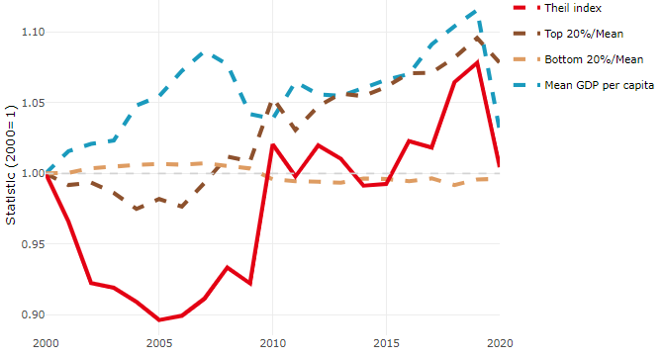

**Note**: Top/bottom calculated as population equivalent (top/bottom regions with at least 20% of the population). The interpretation of top/bottom 20% GDP per capita is that 20% of the population in the country holds 20% of the value. Top 20%/Mean calculated as mean GDP per capita in top 20% regions over mean TL3 GDP per capita in a given year. Bottom 20%/Mean calculated as mean TL3 GDP per capita in bottom 20% regions over mean TL3 GDP per capita in a given year. To improve data consistency, input series are aggregated when TL3 regions are part of the same FUA. To improve time series, TL3 missing values have been estimated based on the evolution at higher geographic level.

**Source**: OECD Regional Database (2022).

In 2020, the gap in GDP per capita between large metropolitan and non-large metropolitan regions was 1.992. For reference, the same value for OECD was 1.475. This gap increased by 0.195 percentage points between 2000 and 2020.

Meanwhile, in 2020, the gap in GDP per capita between metropolitan and non-metropolitan regions was 1.26. For reference, the same value for OECD was 1.325. This gap increased by 0.04 percentage points since 2000.

In turn, the gap in GDP per capita between regions near and far a Functional Urban Area (FUA) of more than 250 thousand inhabitants was 1.201 in 2020 and increased by 0.017 percentage points since 2000.

**Figure 2. GDP per capita gap by type of region compared to the OECD average**

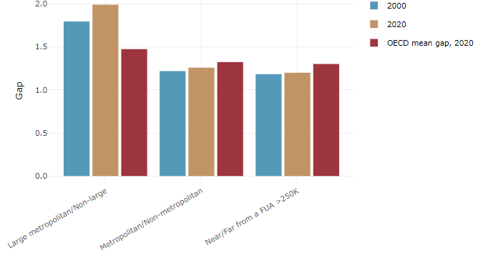

**Note**: Far from a FUA>250K includes regions near/with a small FUA and remote regions. OECD mean gap based on 1 586 TL3 regions in 27 countries with available data (no TL3 data for Australia, Canada, Chile, Colombia, Costa Rica, Iceland, Ireland, Israel, Mexico, Luxembourg and Switzerland).

**Source**: OECD Regional Database (2022).

In France, the gap between the upper and the lower half of regions in terms of labour productivity increased between 2001 and 2019. Over this period labour productivity in the upper half of regions grew roughly by 15%, 2 percentage points more than in the lower half of regions. During 2020, the gap narrowed down. Nevertheless, more years of data are necessary to determine the long-term impact of the COVID-19 pandemic on labour productivity gaps in regions.

**Figure 3. Evolution of labour productivity, TL3 OECD regions**

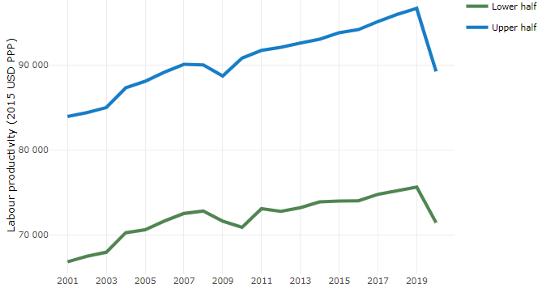

**Note**: A region is in the “upper half” if labour productivity was above the country median in the first year with available data and “lower half” if productivity was below the country median. Labour productivity in each group is equal to the sum of Gross Value Added, expressed in USD at constant prices and PPP (base year 2015) within the group, divided by the sum of total employment in regions within the group. Regions are small (TL3) regions, except for Australia, Canada, Chile, Colombia, Ireland, Mexico, Norway, Switzerland, Türkiye and the United States where they are large (TL2) regions due to data availability.

**Source**: OECD Regional Database (2022).

Regions where the economic activity shifts towards tradable activities, such as industry and tradable services, tend to grow faster in terms of labour productivity. In France, between 2001 and 2020, the share of workers in the industrial sector went down in all regions, approximately by the same amount. At the same time, the share of workers in the tradable services sector went up in all regions, approximately by the same amount.

**Figure 4. Share of workers in most productive (tradable) sectors, TL3 OECD regions**

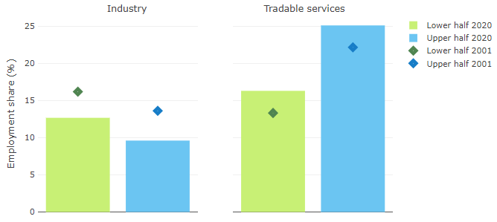

**Note**: A region is in the “upper half” if labour productivity was above the country median in the first year with available data and “lower half” if productivity was below the country median. The share of workers in a given sector for a group of regions is defined as the sum of employment in that sector within the group divided by the sum of total employment within the group. Regions are small (TL3) regions, except for Australia, Canada, Chile, Ireland, Mexico, Norway, Switzerland, Türkiye and the United States where they are large (TL2) regions due to data availability. Industry includes the following tradable goods sectors: Mining and quarrying (B), Manufacturing (C), Electricity, gas, steam and air conditioning supply (D) and Water supply; sewerage; waste management and remediation activities (E) NACE macro sectors. Tradable services include Information and communication (J), Financial and insurance activities (K), Real estate activities (L), Professional, scientific and technical activities (M), Administrative and support service activities (N).

**Source**: OECD Regional Database (2022).

## Recent policy developments

On average, regional managing authorities plan to allocate over 9% of their ERDF funding to SO5 (a Europe closer to its citizens), with significant variations between programs (from 0% to 23%). All operations financed under this strategic objective will benefit integrated local/territorial development. More than half of the regions plan to rely on integrated territorial investments (ITI) or local development led by local players (in New Aquitaine and French Guiana only). The other authorities will be relying on pre-existing integrated territorial strategies, in particular territorial contracts concluded by the Regions, and more marginally on ecological recovery and transition contracts concluded with the State or city contracts.

In terms of integrated urban development, the target areas vary from region to region. While large cities and metropolises remain the main urban areas concerned in most regional programs, others choose to target more restricted areas: priority districts identified by the Urban Policy or city centers. ERDF investment in integrated urban development amounts to over 1.1 billion euros over the period, i.e. more than 12.5% of the ERDF budget, most of which is allocated via OS5 or OS2. This average masks major differences between regions, ranging from 7% to over 30% for the most urbanized regions or those that have opted for strategic targeting of urban areas.

This amount is up on 2014-2020, with around 897 million euros of ERDF initially allocated to urban development, or just over 10% (+62 million euros of ESF). In line with the 2014-2020 programming, regional programs will be heavily involved in the themes of a greener Europe, with a forecast 40% of ERDF credits dedicated to urban development. Regional programs will support urban areas in meeting the challenges of ecological transition, attractiveness and revitalization, and the reduction of territorial disparities (including mobility, health and public services).

While all regions plan to support integrated territorial development in urban areas, more than half (12 programs) also plan to support territorial development initiatives in rural areas, which will need to be coordinated with the EAFRD and LEADER ("*Liaison Entre Actions de Développement de l'Économie Rurale*", meaning 'Links between the rural economy and development actions”) in particular. In total, almost 371 million euros of ERDF funding are earmarked for rural areas and allocated to a variety of themes. Most regions plan to mobilize OS5.2 to target support for integrated territorial strategies in rural areas, on themes such as health, tourism, territorial attractiveness or biodiversity. Several managing authorities are also planning to support the development of rural areas through other SOs via dedicated territorial approaches.