# GERMANY

The [OECD Regional Outlook](https://www.oecd-ilibrary.org/urban-rural-and-regional-development/oecd-regional-outlook_2dafc8cf-en) reviews recent trends, policy developments, and prospects across OECD regions, including the underlying causes driving regional inequalities in performance and well-being. The report offers evidence, guidance and policy recommendations on how to improve competitiveness and productivity, promote inclusive growth, accelerate the net-zero transition and raise well-being standards through effective regional development policy and multi-level governance.

## Territorial definitions

The data in this note reflect different sub-national geographic levels in OECD countries. In particular, **regions** are classified on two territorial levels reflecting the administrative organisation of countries: large regions (TL2) and small regions (TL3). In Canada, TL2 corresponds to the provinces and territories.

Small regions are classified according to their access to metropolitan areas (Fadic et al. 2019). The typology classifies small (TL3) regions into metropolitan and non-metropolitan regions according to the following criteria:

* **Metropolitan regions**, if more than half of the population live in a FUA. Metropolitan regions are further classified into **metropolitan large**, if more than half of the population live in a (large) FUA of at least 1.5 million inhabitants; and **metropolitan midsize**, if more than half of the population live in a (midsize) FUA of at 250 000 to 1.5 million inhabitants.
* **Non-metropolitan regions**, if less than half of the population live in a midsize/large FUA. These regions are further classified according to their level of access to FUAs of different sizes: **near a midsize/large FUA** if more than half of the population live within a 60-minute drive from a midsize/large FUA (of more than 250 000 inhabitants) or if the TL3 region contains more than 80% of the area of a midsize/large FUA; **near a small FUA** if the region does not have access to a midsize/large FUA and at least half of its population have access to a small FUA (i.e. between 50 000 and 250 000 inhabitants) within a 60-minute drive, or contains 80% of the area of a small FUA; and **remote**, otherwise.

Disclaimer: <https://oecdcode.org/disclaimers/territories.html>

Overview

|  |  |
| --- | --- |
| Population *(specify date)* and territory | 84 270 625 (30.09.2022); 357 592 km2 |
| Administrative structure *(unitary/federal)* | Federal (“Bund”) |
| Regional or state-level governments *(number)* | 16 Federal states (“Länder”) |
| Intermediate-level governments *(number)* | 294 districts and 107 independent towns |
| Municipal-level governments *(number)* | 10.787 municipalities (in 2022) |
| Share of subnational government in total expenditure/revenues (2021) | 48.2% of total expenditure  52.4% of total revenues  [Source: [Subnational governments in OECD countries: key data, 2023 edition](https://stats.oecd.org/Index.aspx?DataSetCode=SNGF)] |
| Key regional development challenges | * Regional disparities in economic performance and living conditions * Local effects of energy crisis and transition towards a climate-neutral economy * Demographic changes and resulting labour shortages might particularly affect structurally weak regions |
| Objectives of regional policy | * Promoting growth, productivity and jobs by strengthening the economic development potential of structurally weak regions and their ability to cope with transformation processes * Promoting the green transformation * Reduction of economic and social disparities * Contribution to equivalent living conditions across Germany * Political goals of EU Structural Funds as of EU regulation 2021/1060 Art. 5 (1), a), b), d), e) |
| Legal/institutional framework for regional policy | * Constitution: The Länder (States) are primarily responsible for regional policy; the federation is under certain circumstances entitled to engage in regional policy. * Federal Regional Planning Act * Treaty on the Functioning of the European Union, Article 174 |
| Budget allocated to regional development (i.e., amount) and fiscal equalisation mechanisms between jurisdictions (if any) | * Annual budget of the Joint Federal/Länder Task for the Improvement of Economic Structures (Gemeinschaftsaufgabe zur Verbesserung der regionalen Wirtschaftsstruktur, GRW) for 2023: 1.3 billion EUR (financed half and half by the Federation and the Länder) * Funds allocated to regional development within the Federal Funding System for structural development regions * Länder budgets for regional development * EU Structural Funds consisting of 10.8 billion Euro for ERDF, 6.5 billion Euro for ESF+, 2.5 billion Euro for JTF and 0.2 Billion for Euro for EMFAF * Fiscal equalisation mechanism of two components: one allocating budget from the federal governments to the federal states of 10.7 billion Euro (preliminary values for 2022) and a horizontal component of budget reallocation between the federal states. * Structural Strengthening Act provides up to 41 billion EUR for regions affected by the coal phase-out until 2038 (up to 14 bn EUR of financial transfers to Länder; up to 26 bn EUR for projects of federal government; up to 1 bn EUR for communities with hard coal power plants) |
| National regional development policy framework | * National regional policy promotes economic development, well-being and resilience in structurally weak regions through support for private investments, targeted public investments and public service provision in structurally weak regions. Structurally weak regions are identified based on an indicator model which takes into account regional GDP, underemployment, infrastructure and demographic change. The Map of Assisted Areas shows the regions which are eligible for support. * Partnership Agreement 2021-2027 for Germany’s implementation of EU Structural Funds covers 2 national programmes, 31 regional programmes and 23 INTERREG programmes (concerning territorial cooperation). |
| Urban policy framework | National Urban Development Policy as a joint initiative of the Federal, the regional and the local level to foster integrated urban development strategies, with these strands:   * Regulatory framework * Urban Development Assistance Programmes * Pilot projects, urban labs, innovation * Communication platform |
| Rural policy framework | CAP Strategic Plan 2023-2027  Joint Task for the Improvement of Agricultural Structures and Coastal Protection 2023-2026 (GAK 2023-2026)  Federal Rural Development and Regional added value Scheme 2023 (BULE+)  Rural Perspectives 2030 |
| Major regional policy tools (e.g., funds, plans, policy initiatives, institutional agreements, etc.) | * Joint Federal/Länder Task for the Improvement of Economic Structures (GRW) * Federal Funding System for Structural Development Regions (largest programme in the Federal Funding System: GRW) * European Structural Funds * Structural Strengthening Act for coal regions |
| Policy co-ordination tools at national level | Federal Ministry for Economic Affairs and Climate Action |
| Multi-level governance mechanisms between national and subnational levels (e.g., institutional agreements, Committees, etc.) | * Coordination Committee for the Joint Task for the Improvement of Economic Structures (GRW, members: Federal Minister for Economic Affairs and Climate Action (chair), the Federal Minister of Finance and the economic affairs ministers of the Länder), the respective GRW-subcommittee and working groups * Committees on managing and control systems of EU Structural Funds representing the federal government and the manging authorities of the funds in the federal states * Bund-Länder Coordination Body ensures the implementation of the Structural Strengthening Act |
| Policy co-ordination tools at regional level | * Länder strategies and programmes * Regional Development Concepts |
| Evaluation and monitoring tools | * Regular Evaluation of the Joint Task for the Improvement of Economic Structures (GRW) (as provided by the GRW Coordination Framework) * Reports on the Federal Funding System * Planned evaluation of the Federal Funding System as part of the planned Report on Equivalent Living Conditions of the Federal Government * Monitoring an evaluation system linked to the European Structural Funds (EU regulation 2021/1060) * Obligatory midterm review of all programmes of EU structural funds in 2025 * Biannual evaluation of the Structural Strengthening Act |
| Future orientations of regional policy | * The indicator model which defines structurally weak regions in the Joint Task for the Improvement of Economic Structures (GRW) takes regional demographic changes into account. * Design and planning of Cohesion Policy investments for 2021-2027 take the country-specific recommendations of the European Semester into account. |

## Regional Inequality Trends

Germany experienced a decline in the Theil index of GDP per capita over 2000-2020. Inequality reached its maximum in 2001. The figures are normalized, with values in the year 2000 set to 1.

The Top 20%/Mean ratio was 0.092 lower in 2020 compared to 2000, indicating decreased polarisation. The Bottom 20%/Mean ratio was 0.087 higher in the same period, indicating bottom convergence.

**Figure 1. Trends in GDP per capita inequality indicators, TL3 OECD regions**

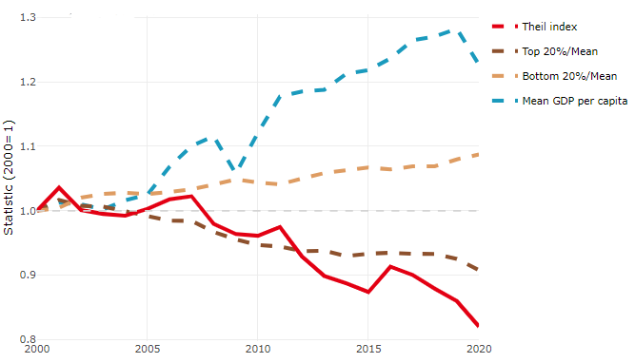

**Note**: Top/bottom calculated as population equivalent (top/bottom regions with at least 20% of the population). The interpretation of top/bottom 20% GDP per capita is that 20% of the population in the country holds 20% of the value. Top 20%/Mean calculated as mean GDP per capita in top 20% regions over mean TL3 GDP per capita in a given year. Bottom 20%/Mean calculated as mean TL3 GDP per capita in bottom 20% regions over mean TL3 GDP per capita in a given year. To improve data consistency, input series are aggregated when TL3 regions are part of the same FUA. To improve time series, TL3 missing values have been estimated based on the evolution at higher geographic level.

**Source**: OECD Regional Database (2022).

In 2020, the gap in GDP per capita between large metropolitan and non-large metropolitan regions was 1.365. For reference, the same value for OECD was 1.475. This gap decreased by 0.188 percentage points between 2000 and 2020.

Meanwhile, in 2020, the gap in GDP per capita between metropolitan and non-metropolitan regions was 1.15. For reference, the same value for OECD was 1.325. This gap decreased by 0.08 percentage points since 2000.

In turn, the gap in GDP per capita between regions near and far a Functional Urban Area (FUA) of more than 250 thousand inhabitants was 1.033 in 2020 and decreased by 0.089 percentage points since 2000.

**Figure 2. GDP per capita gap by type of region compared to the OECD average**

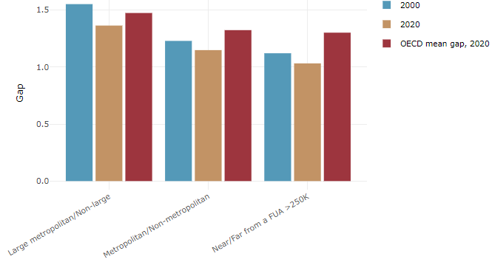

**Note**: Far from a FUA>250K includes regions near/with a small FUA and remote regions. OECD mean gap based on 1 586 TL3 regions in 27 countries with available data (no TL3 data for Australia, Canada, Chile, Colombia, Costa Rica, Iceland, Ireland, Israel, Mexico, Luxembourg and Switzerland).

**Source**: OECD Regional Database (2022).

In Germany, the gap between the upper and the lower half of regions in terms of labour productivity decreased between 2001 and 2019. Over this period labour productivity in the upper half of regions grew roughly by 8%, 12 percentage points less than in the lower half of regions. During 2020, the gap continued to narrow. Nevertheless, more years of data are necessary to determine the long-term impact of the COVID-19 pandemic on labour productivity gaps in regions.

**Figure 3. Evolution of labour productivity, TL3 OECD regions**

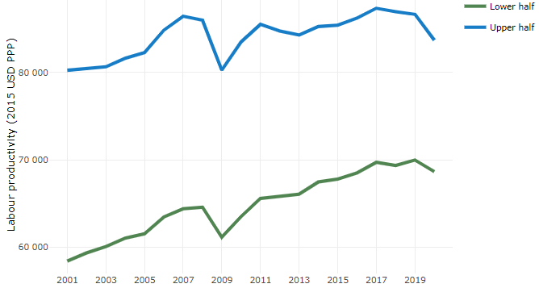

**Note**: A region is in the “upper half” if labour productivity was above the country median in the first year with available data and “lower half” if productivity was below the country median. Labour productivity in each group is equal to the sum of Gross Value Added, expressed in USD at constant prices and PPP (base year 2015) within the group, divided by the sum of total employment in regions within the group. Regions are small (TL3) regions, except for Australia, Canada, Chile, Colombia, Ireland, Mexico, Norway, Switzerland, Türkiye and the United States where they are large (TL2) regions due to data availability.

**Source**: OECD Regional Database (2022).

Regions where the economic activity shifts towards tradable activities, such as industry and tradable services, tend to grow faster in terms of labour productivity. In Germany, between 2001 and 2020, the share of workers in the industrial sector went down in regions that used to be located in the upper half of the labour productivity distribution while it remained stable in the rest. Hence, the evolution of employment shares in the industrial sector reduced the labour productivity gap between regions. At the same time, the share of workers in the tradable services sector went up in all regions, approximately by the same amount.

**Figure 4. Share of workers in most productive (tradable) sectors, TL3 OECD regions**

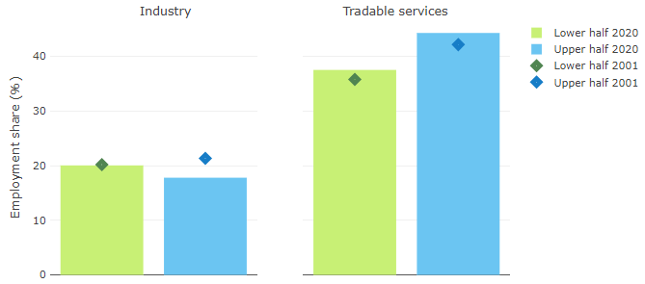

**Note**: A region is in the “upper half” if labour productivity was above the country median in the first year with available data and “lower half” if productivity was below the country median. The share of workers in a given sector for a group of regions is defined as the sum of employment in that sector within the group divided by the sum of total employment within the group. Regions are small (TL3) regions, except for Australia, Canada, Chile, Ireland, Mexico, Norway, Switzerland, Türkiye and the United States where they are large (TL2) regions due to data availability. Industry includes the following tradable goods sectors: Mining and quarrying (B), Manufacturing (C), Electricity, gas, steam and air conditioning supply (D) and Water supply; sewerage; waste management and remediation activities (E) NACE macro sectors. Tradable services include Information and communication (J), Financial and insurance activities (K), Real estate activities (L), Professional, scientific and technical activities (M), Administrative and support service activities (N).

**Source**: OECD Regional Database (2022).

## Recent policy developments

Reform of the Joint Federal/Länder Task for the Improvement of Regional Economic Structures (GRW): The Joint Federal/Länder Task for the Improvement of Regional Economic Structures (GRW) serves as the backbone of regional structural policy in Germany and addresses structurally weak regions. The Joint Task offers a broad range of funding instruments for private and public investment and strategies that regions can use to meet their specific needs. It is based on the cooperation between the Federation and the Länder anchored in the German Constitution and was established more than five decades ago. In view of changed global and local challenges, the Federation and the Länder have adopted a major reform of the Coordination Framework of the Joint Task which serves as the basis for the respective Länder funding guidelines on 13 December 2022.

Throughout the entire process, the expertise of representatives from academia and from companies, associations, trade unions, municipalities and other interested organisations was taken on board. The scope of the reform is large. Main changes include an extension of the objectives of the programme: So far, the focus was on securing and creating jobs. Now, three main objectives are pursued: (1) creating and safeguarding jobs, boosting growth and prosperity; (2) offsetting disadvantages affecting commercial activity; (3) accelerating the transition to a climate-neutral and sustainable economy. In line with this, the reform enables better support for green investments both in terms of eligible projects and funding intensity. Also, the reform leads to a better recognition of local value chains: It is not decisive any longer, whether firms operate primarily locally or transregionally; instead, investment projects are eligible for funding, if they make a significant contribution to attaining the programme objectives. Another major change is the introduction of support for regional services of general interest in order to strengthen regional attractiveness for firms and employees. With respect to infrastructure investments, more effort is placed on regional development concepts in order to stimulate an integrated regional development. Following on the reform of the Joint Task, the federal government will continue to further develop regional policy in Germany.

EU structural funds: The German Partnership Agreement and the programmes for the EU structural funds for the funding period 2021-2027 have been adopted in 2022 and implementation gathers pace. The European Regional Development Fund (ERDF) is focused on innovation, digitization and economic transformation (56% of the budget). Investments target the competitiveness of SME, knowledge and technology transfer and the improvement of public and private research infrastructure. In comparison to the last funding period the importance of climate and environmental goals in the ERDF further increased (34% of the funding). Investments target energy efficient production processes and renovation of public buildings, adaptation to climate change, risk management and disaster prevention including nature-based solutions. The new Just Transition Fund supports coal regions in four German federal states with additional means to master structural change. The investments of the European Social Fund Plus target skill development and social inclusion.

Structural Strengthening Act: The Structural Strengthening Act has been introduced in 2020 to provide financial support to the regions most affected by the coal phase-out. Until the end of 2022 the federal government has approved projects of the Länder totaling 6.4 bn EUR. The majority of funds are allocated to projects related to improving locations for businesses, research and development as well as education. The Bund-Länder Coordination Body has approved 107 projects of the federal government totaling up to 19.5 bn EUR. This includes R&D projects and institutions, transport infrastructure and the relocation of federal agencies (4415 full time-equivalents have been planned so far). The first evaluation of the Structural Strengthening Act is ongoing and will be published in June.