# HUNGARY

The [OECD Regional Outlook](https://www.oecd-ilibrary.org/urban-rural-and-regional-development/oecd-regional-outlook_2dafc8cf-en) reviews recent trends, policy developments, and prospects across OECD regions, including the underlying causes driving regional inequalities in performance and well-being. The report offers evidence, guidance and policy recommendations on how to improve competitiveness and productivity, promote inclusive growth, accelerate the net-zero transition and raise well-being standards through effective regional development policy and multi-level governance.

## Territorial definitions

The data in this note reflect different sub-national geographic levels in OECD countries. In particular, **regions** are classified on two territorial levels reflecting the administrative organisation of countries: large regions (TL2) and small regions (TL3). In Canada, TL2 corresponds to the provinces and territories.

Small regions are classified according to their access to metropolitan areas (Fadic et al. 2019). The typology classifies small (TL3) regions into metropolitan and non-metropolitan regions according to the following criteria:

* **Metropolitan regions**, if more than half of the population live in a FUA. Metropolitan regions are further classified into **metropolitan large**, if more than half of the population live in a (large) FUA of at least 1.5 million inhabitants; and **metropolitan midsize**, if more than half of the population live in a (midsize) FUA of at 250 000 to 1.5 million inhabitants.
* **Non-metropolitan regions**, if less than half of the population live in a midsize/large FUA. These regions are further classified according to their level of access to FUAs of different sizes: **near a midsize/large FUA** if more than half of the population live within a 60-minute drive from a midsize/large FUA (of more than 250 000 inhabitants) or if the TL3 region contains more than 80% of the area of a midsize/large FUA; **near a small FUA** if the region does not have access to a midsize/large FUA and at least half of its population have access to a small FUA (i.e. between 50 000 and 250 000 inhabitants) within a 60-minute drive, or contains 80% of the area of a small FUA; and **remote**, otherwise.

Disclaimer: <https://oecdcode.org/disclaimers/territories.html>

Overview

|  |  |
| --- | --- |
| Population and territory | 9 689 010 (01.01.2022), 93 030 km2 |
| Administrative structure *(unitary/federal)* | unitary |
| Regional or state-level governments *(number)* |  |
| Intermediate-level governments *(number)* | Budapest (capital city) + 19 counties |
| Municipal-level governments *(number)* | 3 178 municipalities (települési önkormányzatok)  (of which: 3 155 settlements and 23 individual districts in the capital city) |
| Share of subnational government in total expenditure/revenues (2021) | 12.4% of total expenditure  14.9% of total revenues  [Source: [Subnational governments in OECD countries: key data, 2023 edition](https://stats.oecd.org/Index.aspx?DataSetCode=SNGF)] |
| Key regional development challenges | Territorial differences in level of development still exist and are relatively constant over time, they are similar to European regional trends and types of regional disparities:  • Strong Northwest/Central and Southwest/Southeast/Northeast divide  • The economic and social role of Budapest is dominant, the area of the agglomeration is increasing  • Low competitiveness of rural areas, labour market tensions and depopulation because of low population retention potential of agriculture  • 109 out of 197 districts are classified as having a disadvantaged status  • Strong urban-rural divide  The integration of the most vulnerable groups into the labour market and participation of disadvantaged groups in quality education.  Loss of economic functions of some areas and lack of cities functioning as real economic, functional centers. |
| Objectives of regional policy | • Sustainable spatial structure based on territorial potential  • Strengthening the country’s macro-regional role  • A city network that creates a polycentric spatial structure  • Increasing the capacity of rural areas to support the population living there  • Development of territories with outstanding landscape values  • Decreasing territorial differences; territorial integration and economic stimulus  • Connected spaces: ensuring accessibility and mobility |
| Legal/institutional framework for regional policy | Act XXI of 1996 on Regional Development and Spatial Planning  Parliament Resolution No. 1/2014. (I. 3.) OGY  (National Development 2030 - National Development and Territorial Development Concept) |
| Budget allocated to regional development (i.e., amount) and fiscal equalisation mechanisms between jurisdictions (if any) | • Cohesion Policy Partnership Agreement 2021-2027: €21.8 billion of EU Structural Funds (ERDF, ESF+, CF, JTF) and €4.4 billion of national co-financing. Of which Territorial and Settlement Development Operational Programme Plus (TSDOP or TOP Plus): €4.3 billion of EU Structural Funds and €0.9 billion of national co-financing.  • Hungarian Villages Programme (since 2019, for settlements with less than 5000 inhabitants), 300 billion HUF  • Modern Cities Programme (2015-2023), 3500 billion HUF  • Pest County Compensation Programme 2016-2021, 90 billion HUF  • Tokaj-Zemplén Area Development Program 2020-2024, 150 billion HUF  • Tisza-lake Development Programme (since 2019), 1,7 billion HUF  • Velence-Vértes area development programme (since 2019) 2 billion HUF  • Catch-up Settlements Development Programme (since 2019) |
| National regional development policy framework | • The Partnership Agreement for Hungary, 2021-2027 (7+1 OPs and 13 INTERREG programmes)  • Territorial and Settlement Development Operational Programme Plus 2021-2027 (TSDOP/TOP Plus)  • National Development 2030 - National Development and Territorial Development Concept |
| Urban policy framework | There is no independent urban policy framework, but the National Development and Territorial Development Concept includes urban development objectives and directions. |
| Rural policy framework | • CAP Strategic Plan 2023-2027  • National Rural Strategy 2012-2020  • National Landscape Strategy 2017-2026 |
| Major regional policy tools (e.g., funds, plans, policy initiatives, institutional agreements, etc.) | *Territorial Plans:*  Territorial development programmes of the counties and special functional areas  Integrated territorial development programmes for implementing TOP Plus  Urban development strategies, integrated urban development programmes  Strategies for economic development zones  Territorial dimension of sectoral development strategies  *Funds:*  European Structural Funds and national co-funding  National budget appropriations (see above the programmes, eg. Compensatory Programme for Pest County, Hungarian Villages Programme, institutional tasks related to territorial development policy)  *Other tools:*  Beneficiary districts and settlements (lists based on indicators)  Free Economic Zones  Functional Area Development Councils  EGTC, European Groupings of Territorial Co-operations |
| Policy co-ordination tools at national level | Minister for Regional Development (Prime Minister’s Office)  National Territorial Reconciliation Forum |
| Multi-level governance mechanisms between national and subnational levels (e.g., institutional agreements, Committees, etc.) | Partnership Agreement Monitoring Committee  TSDOP Plus Monitoring Committee  National Territorial Reconciliation Forum  The representative of the minister for regional development is a member of all the functional area development councils |
| Policy co-ordination tools at regional level | Functional Area Development Councils  Regional Consultation Forums (reconciliation of interests)  County level local governments (they have coordinating role in development policy according to Act XXI of 1996) |
| Evaluation and monitoring tools | Based on the Act XXI of Regional Development and Spatial Planning:  • the Government reports to the Parliament every 4 years on the evolution of the country's territorial processes and the effects of the territorial development policy and the realisation of spatial plans, the use of funds for territorial development, as well as international and cross-border territorial development and spatial planning activities  • the Minister for Regional Development reports annually to the Government on the territorial development tasks of the county local governments and the operation of the functional area development councils.  • The county local governments and functional area development councils themselves report annually on the territorial development tasks and their operation  • Operation of the national territorial information system (TeIR) based on Government decree of the territorial monitoring system No. 37/2010. (II. 26.)  • Evaluations of the 2014-2020 territorial development programmes and of policy areas and related activities (e.g. evaluation of integrated territorial development programmes, review of the territorial resource allocation) |
| Future orientations of regional policy | The 2021-2027 Cohesion Policy investments are planned in close coordination with the National Recovery and Resilience Plan, with an emphasis on effective multi-level governance mechanisms in the implementation and monitoring of the policy.  Ensuring policy coherence with the necessary sectoral policies (education, healthcare, transport etc.), taking into account regional needs and opportunities.  Implementation of spatially and functionally coordinated development along the main directions below:  • integrated local development plans and programmes with economic, social, human, infrastructure elements  • higher added value local economy, including training  • ensuring equal access to public services  • social inclusion  • better regional and local accessibility between the city and the villages  • smart cities and villages  • improvement of city liveability, sustainability and climate adaptation  • sustainable urban development in large cities (with their functional area) |

## Regional Inequality Trends

Hungary experienced a decline in the Theil index of GDP per capita over 2000-2020. Inequality reached its maximum in 2007. The figures are normalized, with values in the year 2001 set to 1.

The Top 20%/Mean ratio was 0.04 higher in 2020 compared to 2000, indicating increased polarisation. The Bottom 20%/Mean ratio was 0.052 higher in the same period, indicating bottom convergence.

**Figure 1. Trends in GDP per capita inequality indicators, TL3 OECD regions**

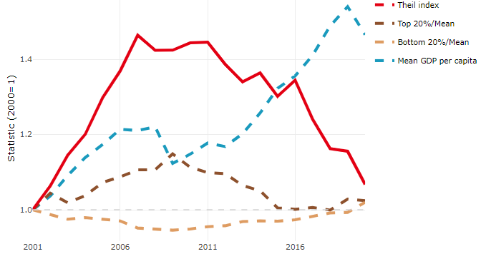

**Note**: Top/bottom calculated as population equivalent (top/bottom regions with at least 20% of the population). The interpretation of top/bottom 20% GDP per capita is that 20% of the population in the country holds 20% of the value. Top 20%/Mean calculated as mean GDP per capita in top 20% regions over mean TL3 GDP per capita in a given year. Bottom 20%/Mean calculated as mean TL3 GDP per capita in bottom 20% regions over mean TL3 GDP per capita in a given year. To improve data consistency, input series are aggregated when TL3 regions are part of the same FUA. To improve time series, TL3 missing values have been estimated based on the evolution at higher geographic level.

**Source**: OECD Regional Database (2022).

In 2020, the gap in GDP per capita between large metropolitan and non-large metropolitan regions was 2.026. For reference, the same value for OECD was 1.475. This gap increased by 0.112 percentage points between 2000 and 2020.

Meanwhile, in 2020, the gap in GDP per capita between metropolitan and non-metropolitan regions was 1.237. For reference, the same value for OECD was 1.325. This gap increased by 0.03 percentage points since 2000.

In turn, the gap in GDP per capita between regions near and far a Functional Urban Area (FUA) of more than 250 thousand inhabitants was 1.274 in 2020 and increased by 0.095 percentage points since 2000.

**Figure 2. GDP per capita gap by type of region compared to the OECD average**

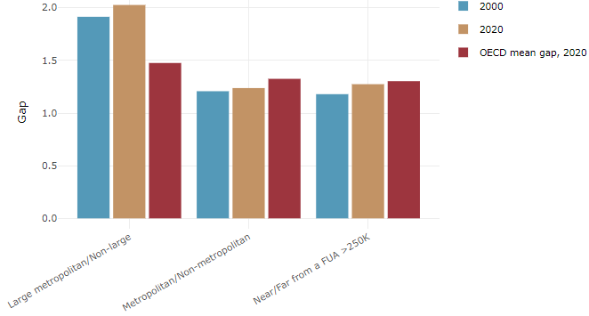

**Note**: Far from a FUA>250K includes regions near/with a small FUA and remote regions. OECD mean gap based on 1 586 TL3 regions in 27 countries with available data (no TL3 data for Australia, Canada, Chile, Colombia, Costa Rica, Iceland, Ireland, Israel, Mexico, Luxembourg and Switzerland).

**Source**: OECD Regional Database (2022).

In Hungary, the gap between the upper and the lower half of regions in terms of labour productivity decreased between 2001 and 2019. Over this period labour productivity in the upper half of regions grew roughly by 35%, 4 percentage points less than in the lower half of regions. During 2020, the gap continued to narrow. Nevertheless, more years of data are necessary to determine the long-term impact of the COVID-19 pandemic on labour productivity gaps in regions.

**Figure 3. Evolution of labour productivity, TL3 OECD regions**

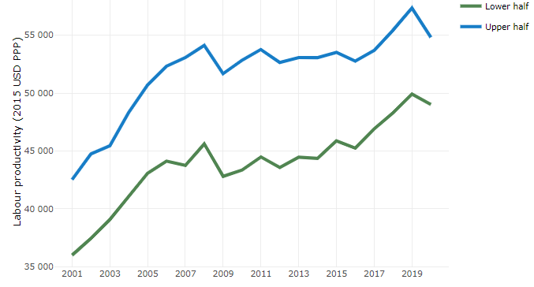

**Note**: A region is in the “upper half” if labour productivity was above the country median in the first year with available data and “lower half” if productivity was below the country median. Labour productivity in each group is equal to the sum of Gross Value Added, expressed in USD at constant prices and PPP (base year 2015) within the group, divided by the sum of total employment in regions within the group. Regions are small (TL3) regions, except for Australia, Canada, Chile, Colombia, Ireland, Mexico, Norway, Switzerland, Türkiye and the United States where they are large (TL2) regions due to data availability.

**Source**: OECD Regional Database (2022).

Regions where the economic activity shifts towards tradable activities, such as industry and tradable services, tend to grow faster in terms of labour productivity. In Hungary, between 2001 and 2020, the share of workers in the industrial sector went down in all regions but more so in regions that used to be in the upper half of the labour productivity distribution. At the same time, the share of workers in the tradable services sector went up in all regions but more so in regions that were already in the upper half of the labour productivity distribution. Hence, the evolution of employment shares in the tradable services sector widened the labour productivity gap between regions while the opposite was true for the industrial sector.

**Figure 4. Share of workers in most productive (tradable) sectors, TL3 OECD regions**

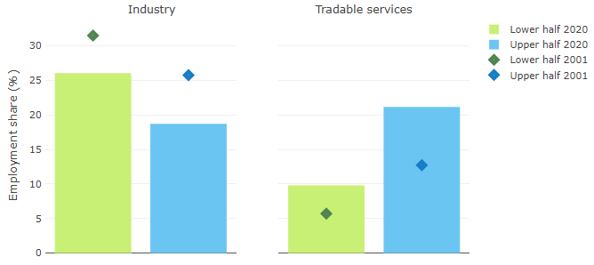

**Note**: A region is in the “upper half” if labour productivity was above the country median in the first year with available data and “lower half” if productivity was below the country median. The share of workers in a given sector for a group of regions is defined as the sum of employment in that sector within the group divided by the sum of total employment within the group. Regions are small (TL3) regions, except for Australia, Canada, Chile, Ireland, Mexico, Norway, Switzerland, Türkiye and the United States where they are large (TL2) regions due to data availability. Industry includes the following tradable goods sectors: Mining and quarrying (B), Manufacturing (C), Electricity, gas, steam and air conditioning supply (D) and Water supply; sewerage; waste management and remediation activities (E) NACE macro sectors. Tradable services include Information and communication (J), Financial and insurance activities (K), Real estate activities (L), Professional, scientific and technical activities (M), Administrative and support service activities (N).

**Source**: OECD Regional Database (2022).

## Recent policy developments

Since 2022, territorial development has gained prominence in the policy agenda, and accordingly, its tasks and powers evolved. As of May 2022, the Minister for Regional Development is a member of the government with unified development policy responsibilities.

In order to prepare for the EU Cohesion Policy programming period 2021-2027, the objectives of the National Development and Territorial Development Concept (NDTDC) and the national development priorities for the period post-2020 have been revised as well as the related sectoral and territorial development tasks. The ambition is to renew the regional development approach and planning environment in order to start the 2028-2034 EU budget period in a new planning and development ecosystem that can respond more quickly and efficiently to challenges and with a more explicit territorial approach. It is necessary to rethink the territorial objectives of the NDTDC, the development challenges of the country, and make the system of tools and institutions for territorial development suitable and resilient to manage new challenges.

As part of the preparation for the next programming period and in compliance with the plan renewal obligations laid down in the relevant legislation, the review of the territorial development concepts of the counties, the special functional areas and of the capital, and the elaboration of the related territorial development programmes were completed during 2020-2021. The planning documents were adopted by the county and capital assemblies.

Following negotiations with the European Commission and a social consultation, Hungary officially submitted the Partnership Agreement to the European Commission on 30 December 2021, which was adopted by the Commission in December 2022, together with the operational programmes. The Partnership Agreement lays down the developments on which the country will spend the cohesion funds coming to Hungary from the EU's multiannual financial framework (21.7 billion euros). The focus will continue to be on economic development, competitiveness, infrastructure development and job creation. Another essential element of this strategic document is that it states that, in order to facilitate catch-up, at least 65 percent of the resources must be used in the four most disadvantaged Hungarian regions.

A territorial operational program was prepared for the period 2021-2027, “Territorial and Settlement Development Operational Programme Plus” (TOP Plus). TOP Plus manages both place-based developments of the less-developed regions and Budapest being a developed region, using ERDF and ESF+ funds. The TOP Plus continues the 2014-2020 TOP themes and its model realised through integrated territorial programmes with a budget of €4.3 billion. It maintains the themes and tools of supporting local government developments, integrated county planning, the territorial selection procedure, and the active involvement of regional actors (county level local governments and the capital city local government) in planning and implementation. TOP Plus was adopted in December 2022.

The planning of the county and capital integrated territorial programmes (ITPs) took place in parallel to TOP Plus programming, based on the principles and budget framework of TOP Plus, and with the guidelines of the relevant sectoral ministries. This parallel planning method created the territorial legitimacy of TOP Plus. The preliminary ITPs were adopted by the Government in 2022, and their content will be finalised in the first semester of 2023.

A sustainable urban development strategy (SUD) is being prepared in 42 cities (among them 3 functional urban areas) selected in the county integrated territorial programmes and they are allocated 8% of the national ERDF framework and related ESF+ funds. The SUD has a complex approach and is in line with the city's integrated settlement development strategy. The indicative budget for the cities designated in the framework of the sustainable urban development tool is set in the 1658/2021. (IX. 24.) Government decision. The action plan developed by SUD for TOP+ resources is the TOP+ Urban Development Program Plan.