# ITALY

The [OECD Regional Outlook](https://www.oecd-ilibrary.org/urban-rural-and-regional-development/oecd-regional-outlook_2dafc8cf-en) reviews recent trends, policy developments, and prospects across OECD regions, including the underlying causes driving regional inequalities in performance and well-being. The report offers evidence, guidance and policy recommendations on how to improve competitiveness and productivity, promote inclusive growth, accelerate the net-zero transition and raise well-being standards through effective regional development policy and multi-level governance.

## Territorial definitions

The data in this note reflect different sub-national geographic levels in OECD countries. In particular, **regions** are classified on two territorial levels reflecting the administrative organisation of countries: large regions (TL2) and small regions (TL3). In Canada, TL2 corresponds to the provinces and territories.

Small regions are classified according to their access to metropolitan areas (Fadic et al. 2019). The typology classifies small (TL3) regions into metropolitan and non-metropolitan regions according to the following criteria:

* **Metropolitan regions**, if more than half of the population live in a FUA. Metropolitan regions are further classified into **metropolitan large**, if more than half of the population live in a (large) FUA of at least 1.5 million inhabitants; and **metropolitan midsize**, if more than half of the population live in a (midsize) FUA of at 250 000 to 1.5 million inhabitants.
* **Non-metropolitan regions**, if less than half of the population live in a midsize/large FUA. These regions are further classified according to their level of access to FUAs of different sizes: **near a midsize/large FUA** if more than half of the population live within a 60-minute drive from a midsize/large FUA (of more than 250 000 inhabitants) or if the TL3 region contains more than 80% of the area of a midsize/large FUA; **near a small FUA** if the region does not have access to a midsize/large FUA and at least half of its population have access to a small FUA (i.e. between 50 000 and 250 000 inhabitants) within a 60-minute drive, or contains 80% of the area of a small FUA; and **remote**, otherwise.

Disclaimer: <https://oecdcode.org/disclaimers/territories.html>

Overview

|  |  |
| --- | --- |
| Population and territory | 58 983 122 (as of January 1, 2022), 302 070 km2 |
| Administrative structure | Unitary country |
| Regional or state-level governments | 19 Regions and 2 Autonomous Provinces |
| Intermediate-level governments | -- |
| Municipal-level governments | 7 904 Municipalities (*Comuni*) |
| Share of subnational government in total expenditure/revenues (2021) | 26.2% of total expenditure  30.9% of total revenues  [Source: [Subnational governments in OECD countries: key data, 2023 edition](https://stats.oecd.org/Index.aspx?DataSetCode=SNGF)] |
| Key challenges | • Large and persistent inequalities in economic performance and well-being between regions, cities and inner areas, with a particular focus on the Southern areas (Mezzogiorno)  • More recently, rising inflationary pressures and supply-side bottlenecks are challenging an already fragile and uneven recovery, with implications for regional development policies. |
| Objectives of regional policy | • Achieve socio-economic rebalancing (Constitution)  • Reduce regional disparities by re-launching public and private investments; focus on institutional capacities and access to essential services  • Invest in human capital  • Promote key factors of growth in all regions |
| Legal/institutional framework for regional policy | Italian Constitution, Article 119, paragraph 5.  Treaty on the Functioning of the European Union, Article 174 |
| Budget allocated to regional development (i.e., amount) and fiscal equalisation mechanisms between jurisdictions (if any) | • Cohesion Policy Partnership Agreement 2021-2027: €42.7 billion of EU Structural Funds (ERDF, ESF+, JTF, EMFAF) and €32.4 of national co-financing.  • Cohesion and Development Fund 2021-2027 (*Fondo Sviluppo e Coesione*): €66,5 billion (80 per cent to the Southern Regions)  • Infrastructural Equalisation Fund: €4.6 billion for the period 2022-2033 |
| National regional development policy framework | • The Partnership Agreement 2021-2027 for Italy covers 49 programmes (11 national programmes and 38 regional programmes) and 19 INTERREG programmes (concerning territorial cooperation).  Cohesion Policy investments for 2021-2027 are planned in strong coordination with the National Recovery and Resilience Plan. |
| Urban policy framework | • National programme “Metro Plus and Southern Medium-sized Cities, 2021-2027” |
| Rural policy framework | • CAP Strategic Plan 2023-2027 (Ministry of Agriculture)  • National Strategy for Inner Areas |
| Major regional policy tools (e.g., funds, plans, policy initiatives, institutional agreements, etc.) | • European Structural Funds and national co-funding.  • Development and Cohesion Fund  • Infrastructural equalisation Fund  • Regional State Aid  • Institutional Agreements and Framework Programme Agreements.  • National Plan for the Development of the South  • Strategy for Inner Areas  • Special Economic Zones  • Institutional Development Contracts (*Contratti Istituzionali di Sviluppo*)  • Policies for employment and enterprise (women and youth employment; investment-related tax credit measures in the South; SMEs)  • Plan for the valorisation of exemplary confiscated assets in Southern Regions  • Public Administration enhancement measures (e.g . Territorial planning fund; Recruitment of highly specialized professionals and personnel to be assigned to local authorities in the Southern Regions  • Special Measures for Areas affected by seismic events |
| Policy co-ordination at national level | • Department for Cohesion Policy (DPCoe), Presidency of Italy’s Council of Ministers (Prime Minister’s Office),  • Agency for Territorial Cohesion  • Inter-Ministerial Committee for Urban Policy |
| Multi-level governance mechanisms between national and subnational levels (e.g., institutional agreements, Committees, etc.) | • Institutional Agreements and Framework Programme Agreements  • National Committee for the Co-ordination and Monitoring of the Regional Policy (Partnership Agreement Committee) |
| Policy co-ordination at regional level | • Integrated regional strategies and programmes  • Inter-regional operational programmes. |
| Evaluation and monitoring | • Programming, Evaluation and Analysis Unit (within the Department for Cohesion Policy, Presidency of Italy’s Council of Ministers) and the National Evaluation System  • Regional systems of evaluation and monitoring  • System of territorial indicators and targets linked to the Partnership Agreement |
| Future orientations of regional policy | Cohesion policy funds promote economic development, well-being, environmental sustainability and resilience in all regions, while supporting the most fragile areas and vulnerable groups through targeted public investments and public service provision.  Future orientations include:  • Enhancing complementarities between the different policy instruments and funds, exploiting their characteristics to adapt them to the specific needs of regions and places.  Cohesion Policy investments for 2021-2027 are designed and planned in strong coordination with Italy’s National Recovery and Resilience Plan, placing emphasis on effective multi-level governance mechanisms in policy implementation and monitoring, and focusing on administrative and technical capacities at all levels of government.  • Ensuring policy coherence with the necessary sectoral policies (for education, health, transports) to take into account territorial needs and opportunities. |

## Regional Inequality Trends

Italy experienced an increase in the Theil index of GDP per capita over 2000-2020. Inequality reached its maximum in 2019. The figures are normalized, with values in the year 2000 set to 1.

The Top 20%/Mean ratio was 0.044 higher in 2020 compared to 2000, indicating increased polarisation. The Bottom 20%/Mean ratio was 0.006 higher in the same period, indicating bottom convergence.

**Figure 1. Trends in GDP per capita inequality indicators, TL3 OECD regions**

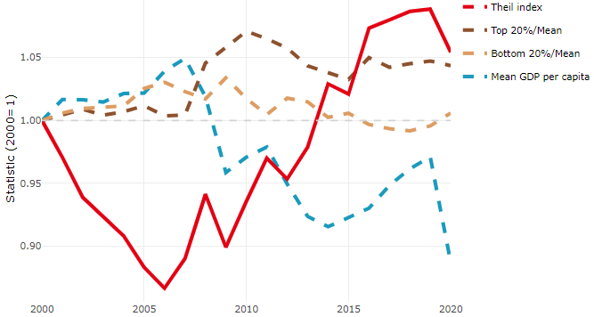

**Note**: Top/bottom calculated as population equivalent (top/bottom regions with at least 20% of the population). The interpretation of top/bottom 20% GDP per capita is that 20% of the population in the country holds 20% of the value. Top 20%/Mean calculated as mean GDP per capita in top 20% regions over mean TL3 GDP per capita in a given year. Bottom 20%/Mean calculated as mean TL3 GDP per capita in bottom 20% regions over mean TL3 GDP per capita in a given year. To improve data consistency, input series are aggregated when TL3 regions are part of the same FUA. To improve time series, TL3 missing values have been estimated based on the evolution at higher geographic level.

**Source**: OECD Regional Database (2022).

In 2020, the gap in GDP per capita between large metropolitan and non-large metropolitan regions was 1.324. For reference, the same value for OECD was 1.475. This gap increased by 0.027 percentage points between 2000 and 2020.

Meanwhile, in 2020, the gap in GDP per capita between metropolitan and non-metropolitan regions was 1.198. For reference, the same value for OECD was 1.325. This gap increased by 0.012 percentage points since 2000.

In turn, the gap in GDP per capita between regions near and far a Functional Urban Area (FUA) of more than 250 thousand inhabitants was 1.163 in 2020 and decreased by 0.043 percentage points since 2000.

**Figure 2. GDP per capita gap by type of region compared to the OECD average**

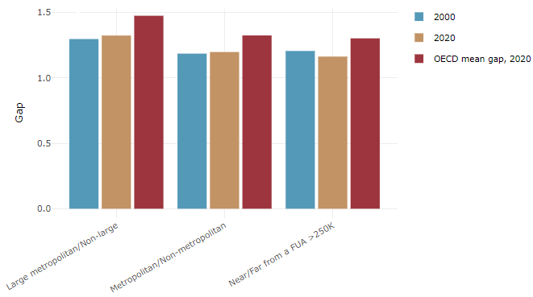

**Note**: Far from a FUA>250K includes regions near/with a small FUA and remote regions. OECD mean gap based on 1 586 TL3 regions in 27 countries with available data (no TL3 data for Australia, Canada, Chile, Colombia, Costa Rica, Iceland, Ireland, Israel, Mexico, Luxembourg and Switzerland).

**Source**: OECD Regional Database (2022).

In Italy, the gap between the upper and the lower half of regions in terms of labour productivity decreased between 2001 and 2019. Over this period labour productivity in the upper half of regions declined roughly by 6%, while it declined only by 4% in the lower half of regions. During 2020, the gap remained unchanged. Nevertheless, more years of data are necessary to determine the long-term impact of the COVID-19 pandemic on labour productivity gaps in regions.

**Figure 3. Evolution of labour productivity, TL3 OECD regions**

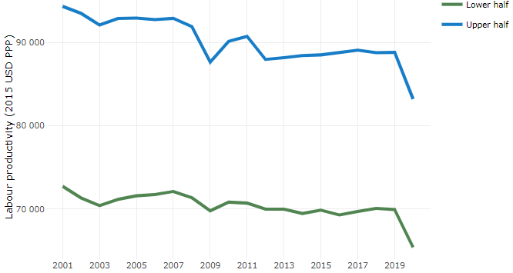

**Note**: A region is in the “upper half” if labour productivity was above the country median in the first year with available data and “lower half” if productivity was below the country median. Labour productivity in each group is equal to the sum of Gross Value Added, expressed in USD at constant prices and PPP (base year 2015) within the group, divided by the sum of total employment in regions within the group. Regions are small (TL3) regions, except for Australia, Canada, Chile, Colombia, Ireland, Mexico, Norway, Switzerland, Türkiye and the United States where they are large (TL2) regions due to data availability.

**Source**: OECD Regional Database (2022).

Regions where the economic activity shifts towards tradable activities, such as industry and tradable services, tend to grow faster in terms of labour productivity. In Italy, between 2001 and 2020, the share of workers in the industrial sector went down in all regions but more so in regions that used to be in the upper half of the labour productivity distribution. Hence, the evolution of employment shares in the industrial sector reduced the labour productivity gap between regions. At the same time, the share of workers in the tradable services sector went up in all regions, approximately by the same amount.

**Figure 4. Share of workers in most productive (tradable) sectors, TL3 OECD regions**

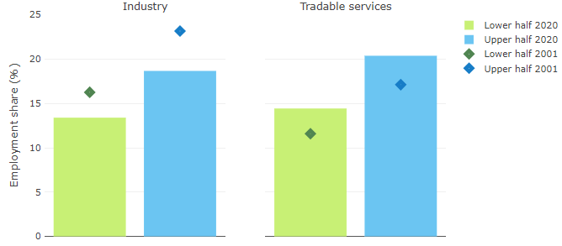

**Note**: A region is in the “upper half” if labour productivity was above the country median in the first year with available data and “lower half” if productivity was below the country median. The share of workers in a given sector for a group of regions is defined as the sum of employment in that sector within the group divided by the sum of total employment within the group. Regions are small (TL3) regions, except for Australia, Canada, Chile, Ireland, Mexico, Norway, Switzerland, Türkiye and the United States where they are large (TL2) regions due to data availability. Industry includes the following tradable goods sectors: Mining and quarrying (B), Manufacturing (C), Electricity, gas, steam and air conditioning supply (D) and Water supply; sewerage; waste management and remediation activities (E) NACE macro sectors. Tradable services include Information and communication (J), Financial and insurance activities (K), Real estate activities (L), Professional, scientific and technical activities (M), Administrative and support service activities (N).

**Source**: OECD Regional Database (2022).

## Recent policy developments

The Cohesion Policy Partnership Agreement between the EU Commission and Italy, adopted in July 2022, sets out investment priorities for the period 2021-2027 to promote national cohesion and sustainable development, with a particular focus on the Southern Regions. Around €75 billion of EU funds and national co-financing sustain the green and digital transition, while supporting the most fragile territories and vulnerable groups. To this aim, the Partnership Agreement promotes the implementation of policies that are tailored to the relevant territorial scales and effective multi-level governance to ensure a more even distribution of essential services and economic opportunities.

In particular, the Partnership Agreement continues to support the National Strategy for Inner Areas, to make them more resilient to natural risks, developing employment opportunities, improving the quality of services (education, healthcare, mobility), and promoting municipal associations in the territories involved. The National Programme for Metropolitan Cities and Southern medium-sized Cities 2021-2027 addresses the challenges of fighting climate change and socio-economic inequalities, re-generating marginal urban areas and supporting social innovation projects, public housing and the development of digital services. The Just Transition Fund (€1,2 billion of EU and national resources) supports the diversification of the economic activities currently based on carbon intensive industries in the areas of “Sulcis Iglesiente” in Sardinia and Taranto in Apulia.

Within Cohesion Policy Partnership Agreement, the collaboration between the Italian National Institute of Statistics (ISTAT) and the Department of Cohesion Policy ensures the production of subnational statistics and indicators at the level of granularity needed to assess the contribution of policies in different places. In recent years, a significant investment has been made to expand the breadth and depth of data and indicators available for regions, cities and rural areas in many domains, including SDGs, well-being, environmental quality, business environment.

As concerns the EU Recovery and Resilience Facility (RRF), one of its key objectives is to promote social and territorial cohesion. Italy’s National Recovery and Resilience Plan (NRRP) allocates 40 per cent of investments with a territorial destination to the Southern Regions (around €82 billion out of a total of €206 billion). In particular, the Ministry for Infrastructure and Transport has allocated 55 per cent of its NRRP and complementary resources (€61,5 billion) to projects in the Southern regions (railway infrastructures, ports and logistics, sustainable urban mobilty, water infrastructures, public housing), in line with the objectives of territorial cohesion and inequality reduction. This threshold represents a relevant ambitious objective: under national public investment programmes, 34 per cent of capital resources are allocated to the South (in proportion to the resident population).

In general, the use of the RRF versus Cohesion Policy funds is guided by eligibility, national/regional competences, timing and investment scale. The Italian Government has put a significant investment in human resources within administrations at the centre of the Recovery and Resilience Plan, strengthening the capacities for effective management of public investment particularly at territorial level (including procurement processes, evaluation and project design, management of contracts and project delivery approaches).

The Infrastructural Equalisation Fund, “Fondo perequativo infrastrutturale” (€4,6 billion from 2022 to 2033) has the objective of rebalancing the infrastructural divide between different areas, with a particular focus on the Southern Regions.