# LATVIA

The [OECD Regional Outlook](https://www.oecd-ilibrary.org/urban-rural-and-regional-development/oecd-regional-outlook_2dafc8cf-en) reviews recent trends, policy developments, and prospects across OECD regions, including the underlying causes driving regional inequalities in performance and well-being. The report offers evidence, guidance and policy recommendations on how to improve competitiveness and productivity, promote inclusive growth, accelerate the net-zero transition and raise well-being standards through effective regional development policy and multi-level governance.

## Territorial definitions

The data in this note reflect different sub-national geographic levels in OECD countries. In particular, **regions** are classified on two territorial levels reflecting the administrative organisation of countries: large regions (TL2) and small regions (TL3). In Canada, TL2 corresponds to the provinces and territories.

Small regions are classified according to their access to metropolitan areas (Fadic et al. 2019). The typology classifies small (TL3) regions into metropolitan and non-metropolitan regions according to the following criteria:

* **Metropolitan regions**, if more than half of the population live in a FUA. Metropolitan regions are further classified into **metropolitan large**, if more than half of the population live in a (large) FUA of at least 1.5 million inhabitants; and **metropolitan midsize**, if more than half of the population live in a (midsize) FUA of at 250 000 to 1.5 million inhabitants.
* **Non-metropolitan regions**, if less than half of the population live in a midsize/large FUA. These regions are further classified according to their level of access to FUAs of different sizes: **near a midsize/large FUA** if more than half of the population live within a 60-minute drive from a midsize/large FUA (of more than 250 000 inhabitants) or if the TL3 region contains more than 80% of the area of a midsize/large FUA; **near a small FUA** if the region does not have access to a midsize/large FUA and at least half of its population have access to a small FUA (i.e. between 50 000 and 250 000 inhabitants) within a 60-minute drive, or contains 80% of the area of a small FUA; and **remote**, otherwise.

Disclaimer: <https://oecdcode.org/disclaimers/territories.html>

Overview

|  |  |
| --- | --- |
| Population and territory | 1 875 757 (early 2022) and 64 589 km² |
| Administrative structure *(unitary/federal)* | Unitary |
| Regional or state-level governments *(number)* | 5 |
| Intermediate-level governments *(number)* | 0 |
| Municipal-level governments *(number)* | 43 |
| Share of subnational government in total expenditure/revenues (2021) | 24.5% of total expenditure  28.5% of total revenues  [Source: [Subnational governments in OECD countries: key data, 2023 edition](https://stats.oecd.org/Index.aspx?DataSetCode=SNGF)] |
| Key regional development challenges | Regional disparities |
| Objectives of regional policy | Regional policy aims at developing the potential of all regions and reducing socio-economic disparities by strengthening their internal and external competitiveness, as well as providing solutions tailored to the specificities of territories for development of population and quality living environment. |
| Legal/institutional framework for regional policy Ministry of Environmental Protection and Regional Development | Institution responsible for development and implementation of regional policy is Ministry of Environmental Protection and Regional Development. Municipalities and planning regions are involved in the elaboration and implementation of regional policy. |
| Budget allocated to regional development (i.e., amount) and fiscal equalisation mechanisms between jurisdictions (if any) | Proposal prepared by Ministry of Environmental Protection and Regional Development envisage provision of EU funding of 2021-2027 planning period amounting to 1 021 909 159 Euros to measures to be implemented according to place-based approach. Amount of funding can be altered in the coordination process with sectoral ministries.  FISCAL EQUALISATION MECHANISMS BETWEEN JURISDICTIONS  In 2023, local governments are provided with an increase in equalized revenues by 15.2% on average. The total amount of the local government financial equalization fund, comparing to 2022, has increased by 15.6% or 33.2 million euros. No municipality has a reduction in equalized revenues comparing to previous year.   * The purpose of the local government equalization is, taking into consideration the socioeconomic differences between local governments, to create similar possibilities for local governments to perform their functions laid down in law, as well as to promote their initiative and independence in the creation of their financial resources. * Revenue of the equalisation fund shall consist of the local government payments specified as a result of calculation of the equalisation of local government finances and of the State budget grant. * The assessed revenue of each local government and the criteria characterising local government expenditure shall be used for calculating the equalisation of local government finances. * The assessed revenue of a local government consist of the revenue from the immovable property tax forecasted by local government, and the share of the allocation of the revenue from the personal income tax determined for the budgets of local governments in the Annual State Budget Law. * The number of equalising units are used for calculating the equalisation of local government finances which includes information regarding local government expenditure related to the criteria characterising local government expenditure. The calculated number of equalising units for each local government include demographic and territorial differences of the particular local government. * Calculation of the equalisation of local government finances shall be performed, taking into account the following principles: * a local government whose assessed revenue per one equalising unit is smaller than the average assessed revenue per one equalising unit in local governments in total receives a grant from the equalisation fund which is 60 percent of the difference between the average assessed revenues and the assessed revenues in a particular municipality per one equalising unit . * local government whose assessed revenue per one equalising unit is larger than the average assessed revenue per one equalising unit in local governments in total makes a payment into the equalisation fund which is 60 percent of the difference between the average assessed revenues and the assessed revenues in a particular municipality per one equalising unit . * the difference between the assessed revenue of a local government per one equalising unit and the assessed revenue of the local government per one equalising unit which has the largest revenue shall be reduced proportionally by means of the State budget grant. * As a result of the equalisation of local government finances the equalised revenue of a local government shall consist of the assessed revenue of the local government reduced by the calculated payment into the equalisation fund or increased by the calculated grant from the equalisation fund. |
| National regional development policy framework | Regional policy is defined in regional policy strategy document Regional Policy Guidelines 2021-2027. |
| Urban policy framework | Urban policy is part of regional policy, there are no separate documents for urban policy. |
| Rural policy framework | Rural policy is part of regional policy, described in Regional Policy Guidelines 2021-2027.  Additionally, rural policy is included in:   * CAP Strategic Plan 2023-2027 (Ministry of Agriculture) * Programme for Fisheries Development 2021-2027 * Local area development strategies prepared by Local action groups |
| Major regional policy tools (e.g., funds, plans, policy initiatives, institutional agreements, etc.) | Regional policy includes measures co-financed by funds of European Union Cohesion policy. |
| Policy co-ordination tools at national level | Regional Policy Guidelines 2021-2027 were discussed with sectoral ministries, planning regions and municipalities. Ministry of Environmental Protection and Regional Development cooperates with other ministries concerning regional policy issues. |
| Multi-level governance mechanisms between national and subnational levels (e.g., institutional agreements, Committees, etc.) |  |
| Policy co-ordination tools at regional level | Planning regions are involved in the elaboration and implementation of regional policy |
| Evaluation and monitoring tools | There are indicators defined in Regional Policy Guidelines 2021-2027 |
| Future orientations of regional policy | Regional Policy Guidelines 2021-2027 specify regional policy activities until 2027. |

## Regional Inequality Trends

Latvia experienced a decline in the Theil index of GDP per capita over 2000-2020. Inequality reached its maximum in 2006. The figures are normalized, with values in the year 2000 set to 1.

The Top 20%/Mean ratio was 0.018 lower in 2020 compared to 2000, indicating decreased polarisation. The Bottom 20%/Mean ratio was 0.083 higher in the same period, indicating bottom convergence.

**Figure 1. Trends in GDP per capita inequality indicators, TL3 OECD regions**

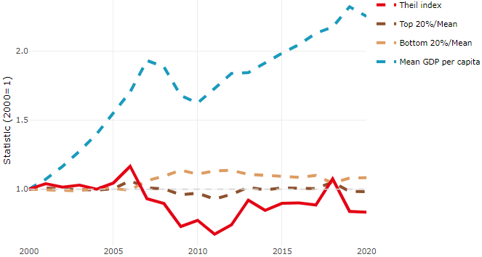

**Note**: Top/bottom calculated as population equivalent (top/bottom regions with at least 20% of the population). The interpretation of top/bottom 20% GDP per capita is that 20% of the population in the country holds 20% of the value. Top 20%/Mean calculated as mean GDP per capita in top 20% regions over mean TL3 GDP per capita in a given year. Bottom 20%/Mean calculated as mean TL3 GDP per capita in bottom 20% regions over mean TL3 GDP per capita in a given year. To improve data consistency, input series are aggregated when TL3 regions are part of the same FUA. To improve time series, TL3 missing values have been estimated based on the evolution at higher geographic level.

**Source**: OECD Regional Database (2022).

There is no data for the gap in GDP per capita between large metropolitan and non-large metropolitan regions for 2000 and 2020.

Meanwhile, in 2020, the gap in GDP per capita between metropolitan and non-metropolitan regions was 2.065. For reference, the same value for OECD was 1.325. This gap decreased by 0.057 percentage points since 2000.

In turn, the gap in GDP per capita between regions near and far a Functional Urban Area (FUA) of more than 250 thousand inhabitants was 2.065 in 2020 and decreased by 0.057 percentage points since 2000.

**Figure 2. GDP per capita gap by type of region compared to the OECD average**

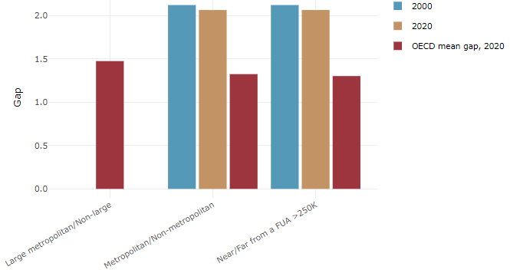

**Note**: Far from a FUA>250K includes regions near/with a small FUA and remote regions. OECD mean gap based on 1 586 TL3 regions in 27 countries with available data (no TL3 data for Australia, Canada, Chile, Colombia, Costa Rica, Iceland, Ireland, Israel, Mexico, Luxembourg and Switzerland).

**Source**: OECD Regional Database (2022).

In Latvia, the gap between the upper and the lower half of regions in terms of labour productivity decreased between 2001 and 2019. Over this period labour productivity in the upper half of regions grew roughly by 79%, 42 percentage points less than in the lower half of regions. During 2020, the gap remained unchanged. Nevertheless, more years of data are necessary to determine the long-term impact of the COVID-19 pandemic on labour productivity gaps in regions.

**Figure 3. Evolution of labour productivity, TL3 OECD regions**

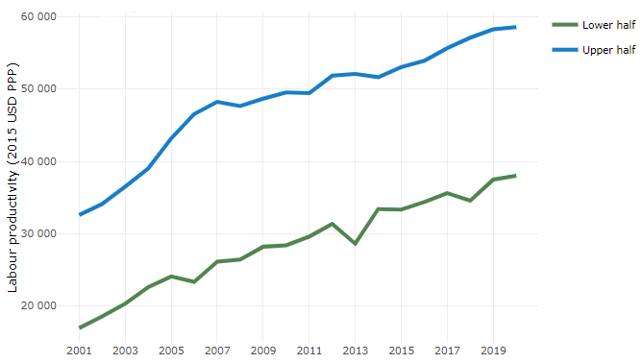

**Note**: A region is in the “upper half” if labour productivity was above the country median in the first year with available data and “lower half” if productivity was below the country median. Labour productivity in each group is equal to the sum of Gross Value Added, expressed in USD at constant prices and PPP (base year 2015) within the group, divided by the sum of total employment in regions within the group. Regions are small (TL3) regions, except for Australia, Canada, Chile, Colombia, Ireland, Mexico, Norway, Switzerland, Türkiye and the United States where they are large (TL2) regions due to data availability.

**Source**: OECD Regional Database (2022).

Regions where the economic activity shifts towards tradable activities, such as industry and tradable services, tend to grow faster in terms of labour productivity. In Latvia, between 2001 and 2020, the share of workers in the industrial sector went down in all regions but more so in regions that used to be in the upper half of the labour productivity distribution. At the same time, the share of workers in the tradable services sector went up in all regions but more so in regions that were already in the upper half of the labour productivity distribution. Hence, the evolution of employment shares in the tradable services sector widened the labour productivity gap between regions while the opposite was true for the industrial sector.

**Figure 4. Share of workers in most productive (tradable) sectors, TL3 OECD regions**

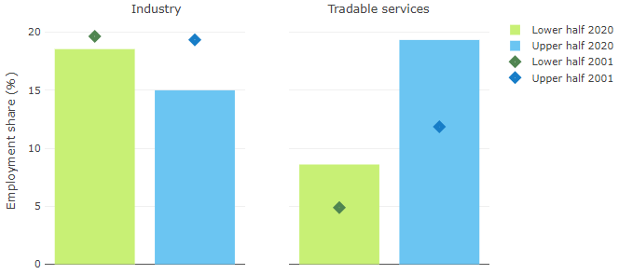

**Note**: A region is in the “upper half” if labour productivity was above the country median in the first year with available data and “lower half” if productivity was below the country median. The share of workers in a given sector for a group of regions is defined as the sum of employment in that sector within the group divided by the sum of total employment within the group. Regions are small (TL3) regions, except for Australia, Canada, Chile, Ireland, Mexico, Norway, Switzerland, Türkiye and the United States where they are large (TL2) regions due to data availability. Industry includes the following tradable goods sectors: Mining and quarrying (B), Manufacturing (C), Electricity, gas, steam and air conditioning supply (D) and Water supply; sewerage; waste management and remediation activities (E) NACE macro sectors. Tradable services include Information and communication (J), Financial and insurance activities (K), Real estate activities (L), Professional, scientific and technical activities (M), Administrative and support service activities (N).

**Source**: OECD Regional Database (2022).

## Recent policy developments

Currently, rules are being elaborated to implement EU Cohesion Policy measures for territorial development, according to the Regional Policy Guidelines 2021-2027.