# LITHUANIA

The [OECD Regional Outlook](https://www.oecd-ilibrary.org/urban-rural-and-regional-development/oecd-regional-outlook_2dafc8cf-en) reviews recent trends, policy developments, and prospects across OECD regions, including the underlying causes driving regional inequalities in performance and well-being. The report offers evidence, guidance and policy recommendations on how to improve competitiveness and productivity, promote inclusive growth, accelerate the net-zero transition and raise well-being standards through effective regional development policy and multi-level governance.

## Territorial definitions

The data in this note reflect different sub-national geographic levels in OECD countries. In particular, **regions** are classified on two territorial levels reflecting the administrative organisation of countries: large regions (TL2) and small regions (TL3). In Canada, TL2 corresponds to the provinces and territories.

Small regions are classified according to their access to metropolitan areas (Fadic et al. 2019). The typology classifies small (TL3) regions into metropolitan and non-metropolitan regions according to the following criteria:

* **Metropolitan regions**, if more than half of the population live in a FUA. Metropolitan regions are further classified into **metropolitan large**, if more than half of the population live in a (large) FUA of at least 1.5 million inhabitants; and **metropolitan midsize**, if more than half of the population live in a (midsize) FUA of at 250 000 to 1.5 million inhabitants.
* **Non-metropolitan regions**, if less than half of the population live in a midsize/large FUA. These regions are further classified according to their level of access to FUAs of different sizes: **near a midsize/large FUA** if more than half of the population live within a 60-minute drive from a midsize/large FUA (of more than 250 000 inhabitants) or if the TL3 region contains more than 80% of the area of a midsize/large FUA; **near a small FUA** if the region does not have access to a midsize/large FUA and at least half of its population have access to a small FUA (i.e. between 50 000 and 250 000 inhabitants) within a 60-minute drive, or contains 80% of the area of a small FUA; and **remote**, otherwise.

Disclaimer: <https://oecdcode.org/disclaimers/territories.html>

Overview

|  |  |
| --- | --- |
| Population *(specify date)* and territory | 2 805 998 (as of January 1, 2022), 65 284 km² |
| Administrative structure *(unitary/federal)* | Unitary country |
| Regional or state-level governments *(number)* | - |
| Intermediate-level governments *(number)* | 10 Regional Development Councils (joint municipal cooperation body) |
| Municipal-level governments *(number)* | 60 Municipalities |
| Share of subnational government in total expenditure/revenues (2021) | 24.2% of total expenditure  25.8% of total revenues  [Source: [Subnational governments in OECD countries: key data, 2023 edition](https://stats.oecd.org/Index.aspx?DataSetCode=SNGF)] |
| Key regional development challenges | * Different regional economic growth potential and uneven economic development * Certain regions in Lithuania are at risk of greater poverty and social exclusion * An insufficiently sustainable environment, which negatively affects the attractiveness of the regions |
| Objectives of regional policy | Objectives of national regional policy (Law on Regional development) are:   * Promote the adaptation of regions to the changing conditions of the economic and social environment by exploiting and strengthening the competitive advantage and competence of each region * Increase the efficiency of the infrastructure and/or service network of functional zones, ensure that all residents could use this infrastructure and services * Reduce social and economic disparities across and within the regions. |
| Legal/institutional framework for regional policy | * The Law on Regional Development * The Law on Strategic Management * The Strategic Management Methodology |
| Budget allocated to regional development (i.e., amount) and fiscal equalisation mechanisms between jurisdictions (if any) | Budget:   * Regional Development Programme for 2022-2030 (RDP) and Programme for the European Union funds’ investments in 2021-2027 for the implementation of Regional Development Plans (€1623.9 million of EU Structural Funds (ERDF, CF, ESF+) and €378.1 million of national co-financing.)   Fiscal equalisation mechanism between the state and municipalities:   * The Law on Methodology of Determination of Municipal Revenue, Articles 6-8. |
| National regional development policy framework | * The National Progress Plan (NPP) – national document that identifies the main strategic goals and objectives to be achieved in all public policy areas. Strategic objective of the NPP #7: Sustainable and balanced development of the territory of Lithuania and reduction of regional exclusion. The basis for the Regional Development Programme (RDP). * The Regional Development Programme for 2022–2030 (RDP) – based on strategic objectives, identified in the NPP, indicates the directions of implementation of objectives, for which Regional Development Councils and/or municipalities are responsible along to the competence established in regulations. * 10 Regional Development Plans (RDPLs) – each region represented by Regional Development Council identifies social, economic and environmental problems and their causes within the region, determines the goals, objectives of regional development and indicators of monitoring, and plans the progress measures and preliminary funds. |
| Urban policy framework | * Objectives of a national urban policy are integrated into the National Progress Plan (NPP) and the Regional Development Programme for 2022–2030 (RPP) |
| Rural policy framework | * Objectives of a national rural policy are integrated into the National Progress Plan (NPP) and the Regional Development Programme for 2022–2030 (RPP) * CAP Strategic Plan of Lithuania for 2023–2027 |
| Major regional policy tools (e.g., funds, plans, policy initiatives, institutional agreements, etc.) | * European Structural Funds and national co-funding (27% of EUSF dedicated to Regional Development Programme for 2022–2030 and Regional Development Plans) * The Regional Development Programme for 2022­–2030 (RDP) * The Regional Development Plans (RDPLs) |
| Policy co-ordination tools at national level | * Ministry of Interior (national regional policy formation, organization, coordination and monitoring of its implementation) * National Regional Development Council (it is the collegial advisory body for the Government and the Ministry of Interior in the area of national regional policy formulation and implementation. It consists from representatives of ministries, public authorities, the Association of Local Authorities in Lithuania, employers’ and trade unions’ organizations selected to the Tripartite Council, representatives of the Council of Non-Governmental Organisations and the National Council of Community Organizations, chairs of Regional Development Councils (RDCs)). |
| Multi-level governance mechanisms between national and subnational levels (e.g., institutional agreements, Committees, etc.) | * National Regional Development Council (It is empowered to discuss and consider the projects of planning documents being approved by the Government, including the Regional Development Programme, and regulations that may affect the regional development, and provide conclusions on these projects, also consider the progress of the implementation of these planning documents and, if necessary, submit proposals to the Government and the Ministry of Interior for the improvement of these documents, and consider other issues in the area of national regional policy formation and implementation) |
| Policy co-ordination tools at regional level | * 10 Regional Development Councils (RDCs), one Council in each region, are legal entities established through an agreement between municipalities. RDCs are supra-municipal institutions. The body of RDC is the General meeting of participants; the governing bodies are the Panel (composed of the Mayors and members of the Municipal Councils) and the Administrative Director of RDC. Representing the region, their main competencies include: to plan and coordinate the implementation of the national regional policy in their respective region; to encourage social, economic development of the region, sustainable development of urbanised territories, decrease social and economic disparities within and across regions; and to encourage cooperation among municipalities in order to increase the efficiency of public services provision. The Administrative Director of RDC with small team (4-6 persons) acts as the secretariat of RDC. Also, RDC has an advisory Partner Group, that are engaged in delivering conclusions and opinions to the Panel regarding the projects of planning documents and other issues in the area of regional policy. * 10 Regional Development Plans (RDPLs) prepared and approved by Regional Development Councils * Sustainable Urban Development Strategies are prepared and implemented by urban municipalities in order to achieve the sustainable development of regional centres by solving social, economic, environmental and climate change challenges and in compliance with the principles of integrated approach. * Agreements on Functional Zones among municipalities and Strategies for Sustainable Development of Functional Zones. Functional Zones are established and their strategies are prepared and implemented in order to increase the efficiency of the municipalities’ infrastructure and/or service network, to ensure the access to this infrastructure and services for all functional zone residents, and to create conditions for the joint actions of several municipalities and the implementation of joint investment projects. |
| Evaluation and monitoring tools | * Ministry of Interior (monitoring the progress of implementation of the Regional Development Programme for 2022-2030, consulting RDCs on the consistency of RDPLs with the aim and objectives of the national regional policy, other issues of RDPLs preparation, implementation and monitoring in the area of Ministry competence) * Central Project Management Agency (methodical guidance for strategic planning, project management, monitoring, supervision, evaluation, financial management, progress reporting) * System of indicators and targets along to the 2021-2030 National Progress Plan (NPP), the Regional Development Programme for 2022–2030 and 10 Regional Development Plans |
| Future orientations of regional policy | Future orientations of regional policy focus on following issues:   * Decrease **inter**regional social and economic disparities by strengthening regions in most vulnerable areas in terms of target groups, public services, transportation and environmental issues. * Decrease **intra**regional social and economic disparities by implementing the measures within the region towards economic, social or environmental issues in particular territory. |

## Regional Inequality Trends

Lithuania experienced an increase in the Theil index of GDP per capita over 2000-2020. Inequality reached its maximum in 2007. The figures are normalized, with values in the year 2000 set to 1.

The Top 20%/Mean ratio was 0.177 higher in 2020 compared to 2000, indicating increased polarisation. The Bottom 20%/Mean ratio was 0.064 lower in the same period, indicating bottom divergence.

**Figure 1. Trends in GDP per capita inequality indicators, TL3 OECD regions**

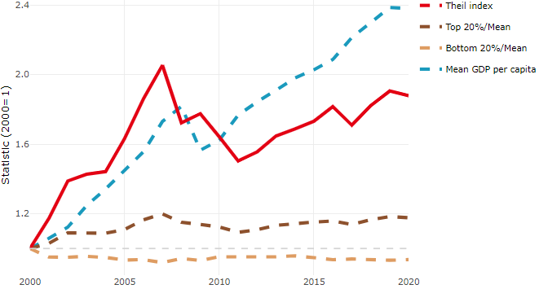

**Note**: Top/bottom calculated as population equivalent (top/bottom regions with at least 20% of the population). The interpretation of top/bottom 20% GDP per capita is that 20% of the population in the country holds 20% of the value. Top 20%/Mean calculated as mean GDP per capita in top 20% regions over mean TL3 GDP per capita in a given year. Bottom 20%/Mean calculated as mean TL3 GDP per capita in bottom 20% regions over mean TL3 GDP per capita in a given year. To improve data consistency, input series are aggregated when TL3 regions are part of the same FUA. To improve time series, TL3 missing values have been estimated based on the evolution at higher geographic level.

**Source**: OECD Regional Database (2022).

There is no data for the gap in GDP per capita between large metropolitan and non-large metropolitan regions for 2000 and 2020.

Meanwhile, in 2020, the gap in GDP per capita between metropolitan and non-metropolitan regions was 1.804. For reference, the same value for OECD was 1.325. This gap increased by 0.414 percentage points since 2000.

In turn, the gap in GDP per capita between regions near and far a Functional Urban Area (FUA) of more than 250 thousand inhabitants was 1.804 in 2020 and increased by 0.414 percentage points since 2000.

**Figure 2. GDP per capita gap by type of region compared to the OECD average**

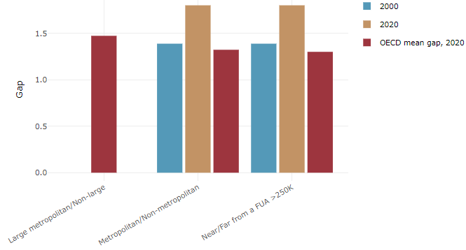

**Note**: Far from a FUA>250K includes regions near/with a small FUA and remote regions. OECD mean gap based on 1 586 TL3 regions in 27 countries with available data (no TL3 data for Australia, Canada, Chile, Colombia, Costa Rica, Iceland, Ireland, Israel, Mexico, Luxembourg and Switzerland).

**Source**: OECD Regional Database (2022).

In Lithuania, the gap between the upper and the lower half of regions in terms of labour productivity decreased between 2001 and 2019. Over this period labour productivity in the upper half of regions grew roughly by 89%, 12 percentage points less than in the lower half of regions. During 2020, the gap remained unchanged. Nevertheless, more years of data are necessary to determine the long-term impact of the COVID-19 pandemic on labour productivity gaps in regions.

**Figure 3. Evolution of labour productivity, TL3 OECD regions**

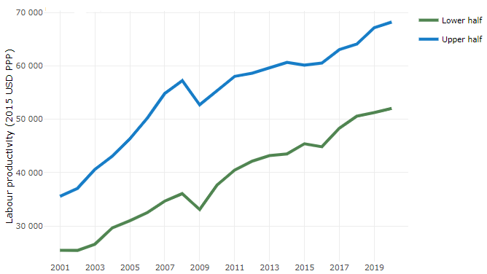

**Note**: A region is in the “upper half” if labour productivity was above the country median in the first year with available data and “lower half” if productivity was below the country median. Labour productivity in each group is equal to the sum of Gross Value Added, expressed in USD at constant prices and PPP (base year 2015) within the group, divided by the sum of total employment in regions within the group. Regions are small (TL3) regions, except for Australia, Canada, Chile, Colombia, Ireland, Mexico, Norway, Switzerland, Türkiye and the United States where they are large (TL2) regions due to data availability.

**Source**: OECD Regional Database (2022).

Regions where the economic activity shifts towards tradable activities, such as industry and tradable services, tend to grow faster in terms of labour productivity. In Lithuania, between 2001 and 2020, the share of workers in the industrial sector went down in regions that used to be located in the upper half of the labour productivity distribution while it went up in regions located in the lower half. At the same time, the share of workers in the tradable services sector went up in all regions but more so in regions that were already in the upper half of the labour productivity distribution. Hence, the evolution of employment shares in the tradable services sector widened the labour productivity gap between regions while the opposite was true for the industrial sector.

**Figure 4. Share of workers in most productive (tradable) sectors, TL3 OECD regions**

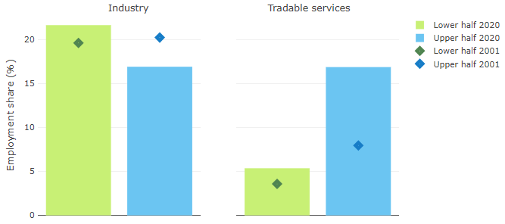

**Note**: A region is in the “upper half” if labour productivity was above the country median in the first year with available data and “lower half” if productivity was below the country median. The share of workers in a given sector for a group of regions is defined as the sum of employment in that sector within the group divided by the sum of total employment within the group. Regions are small (TL3) regions, except for Australia, Canada, Chile, Ireland, Mexico, Norway, Switzerland, Türkiye and the United States where they are large (TL2) regions due to data availability. Industry includes the following tradable goods sectors: Mining and quarrying (B), Manufacturing (C), Electricity, gas, steam and air conditioning supply (D) and Water supply; sewerage; waste management and remediation activities (E) NACE macro sectors. Tradable services include Information and communication (J), Financial and insurance activities (K), Real estate activities (L), Professional, scientific and technical activities (M), Administrative and support service activities (N).

**Source**: OECD Regional Database (2022).

## Recent policy developments

In June 2022, the Government of Lithuania approved the Regional Development Programme for 2022-2030. Along with the Partnership Agreement on EU Funds for 2021-2027 and 2021-2027 EU Funds’ Investment programme, it created the strategic framework for Regional Development Councils to set the goals of regional cohesion and put them into Regional Development Plans. Bottom-up approach allows regions (Regional Development Councils) to make decisions, what and to what extent the identified social, economic, environmental, territorial problems within the region to address. Regional Development Programme provides investments that are devoted to education, health, social services, sustainable mobility, environment, access to public services, investment attractiveness, business environment etc. (27% of total EU structural funds).

The next step of the regional policy implementation was taken in January 2023, by approving the Description of the Procedure for Preparation and Implementation Monitoring of Sustainable Urban Development Strategies and Functional Zones’ Strategies. Regional centres (cities) are preparing Sustainable Urban Development Strategies to address social, economic, environmental and climate change challenges. Functional zones are created, and their strategies are prepared jointly by municipalities in order to increase the efficiency of the infrastructure and/or service network within the functional zones, to ensure all residents the access to this infrastructure and services, to create opportunities for joint actions of several municipalities covered by functional zone, and to implement joint investment projects.