# NETHERLANDS

The [OECD Regional Outlook](https://www.oecd-ilibrary.org/urban-rural-and-regional-development/oecd-regional-outlook_2dafc8cf-en) reviews recent trends, policy developments, and prospects across OECD regions, including the underlying causes driving regional inequalities in performance and well-being. The report offers evidence, guidance and policy recommendations on how to improve competitiveness and productivity, promote inclusive growth, accelerate the net-zero transition and raise well-being standards through effective regional development policy and multi-level governance.

## Territorial definitions

The data in this note reflect different sub-national geographic levels in OECD countries. In particular, **regions** are classified on two territorial levels reflecting the administrative organisation of countries: large regions (TL2) and small regions (TL3). In Canada, TL2 corresponds to the provinces and territories.

Small regions are classified according to their access to metropolitan areas (Fadic et al. 2019). The typology classifies small (TL3) regions into metropolitan and non-metropolitan regions according to the following criteria:

* **Metropolitan regions**, if more than half of the population live in a FUA. Metropolitan regions are further classified into **metropolitan large**, if more than half of the population live in a (large) FUA of at least 1.5 million inhabitants; and **metropolitan midsize**, if more than half of the population live in a (midsize) FUA of at 250 000 to 1.5 million inhabitants.
* **Non-metropolitan regions**, if less than half of the population live in a midsize/large FUA. These regions are further classified according to their level of access to FUAs of different sizes: **near a midsize/large FUA** if more than half of the population live within a 60-minute drive from a midsize/large FUA (of more than 250 000 inhabitants) or if the TL3 region contains more than 80% of the area of a midsize/large FUA; **near a small FUA** if the region does not have access to a midsize/large FUA and at least half of its population have access to a small FUA (i.e. between 50 000 and 250 000 inhabitants) within a 60-minute drive, or contains 80% of the area of a small FUA; and **remote**, otherwise.

Disclaimer: <https://oecdcode.org/disclaimers/territories.html>

Overview

|  |  |
| --- | --- |
| Population *(specify date)* and territory | 17 813 121 (November 2022) - 41,543 km2 |
| Administrative structure *(unitary/federal)* | Unitary |
| Regional or state-level governments *(number)* | 12 |
| Intermediate-level governments *(number)* | N/A |
| Municipal-level governments *(number)* | 342 (January 2023) |
| Share of subnational government in total expenditure/revenues (2021) | 29.0% of total expenditure  30.9% of total revenues  [Source: [Subnational governments in OECD countries: key data, 2023 edition](https://stats.oecd.org/Index.aspx?DataSetCode=SNGF)] |
| Key regional development challenges | See further details below |
| Objectives of regional policy | See further details below |
| Legal/institutional framework for regional policy | No explicit regional development framework. |
| Budget allocated to regional development (i.e., amount) and fiscal equalisation mechanisms between jurisdictions (if any) | N/A |
| National regional development policy framework | There is no explicit regional development framework. The Netherlands currently does not have an explicit regional policy but applies a regional focus to several policy domains. The focus on regional strengths and attention to regional differences has been followed up and strengthened by the new government formed in October 2017. The new Regional Budget, for example, is a financial instrument that allows co-operation and collaboration between the national government, regional governments, the business community, academia and civil society on addressing specific regional challenges. In addition, the Ministry of Interior and Kingdom Relations co-ordinates the National Urban Agenda (*Agenda Stad*), which includes measures to boost economic growth, quality of life and innovation in Dutch cities and supports the  creation of city deals. |
| Urban policy framework | There is no explicit national urban policy framework. |
| Rural policy framework | Rural Development Program |
| Major regional policy tools (e.g., funds, plans, policy initiatives, institutional agreements, etc.) | See further details below |
| Policy co-ordination tools at national level | See further details below |
| Multi-level governance mechanisms between national and subnational levels (e.g., institutional agreements, Committees, etc.) | See further details below |
| Policy co-ordination tools at regional level | See further details below |
| Evaluation and monitoring tools | N/A |
| Future orientations of regional policy | See further details below |

## Regional Inequality Trends

The Netherlands experienced a decline in the Theil index of GDP per capita over 2000-2020. Inequality reached its maximum in 2013. The figures are normalized, with values in the year 2000 set to 1.

The Top 20%/Mean ratio was 0.006 lower in 2020 compared to 2000, indicating decreased polarisation. The Bottom 20%/Mean ratio was 0.053 higher in the same period, indicating bottom convergence.

**Figure 1. Trends in GDP per capita inequality indicators, TL3 OECD regions**

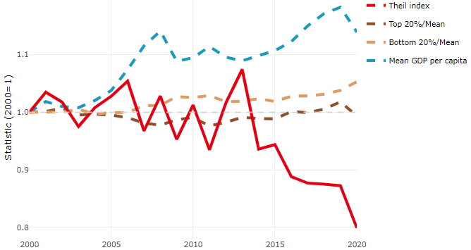

**Note**: Top/bottom calculated as population equivalent (top/bottom regions with at least 20% of the population). The interpretation of top/bottom 20% GDP per capita is that 20% of the population in the country holds 20% of the value. Top 20%/Mean calculated as mean GDP per capita in top 20% regions over mean TL3 GDP per capita in a given year. Bottom 20%/Mean calculated as mean TL3 GDP per capita in bottom 20% regions over mean TL3 GDP per capita in a given year. To improve data consistency, input series are aggregated when TL3 regions are part of the same FUA. To improve time series, TL3 missing values have been estimated based on the evolution at higher geographic level.

**Source**: OECD Regional Database (2022).

In 2020, the gap in GDP per capita between large metropolitan and non-large metropolitan regions was 1.33. For reference, the same value for OECD was 1.475. This gap increased by 0.044 percentage points between 2000 and 2020.

Meanwhile, in 2020, the gap in GDP per capita between metropolitan and non-metropolitan regions was 1.238. For reference, the same value for OECD was 1.325. This gap decreased by 0.061 percentage points since 2000.

There is no data for the gap in GDP per capita between regions near and far a Functional Urban Area (FUA) of more than 250 thousand inhabitants for 2000 and 2020.

**Figure 2. GDP per capita gap by type of region compared to the OECD average**

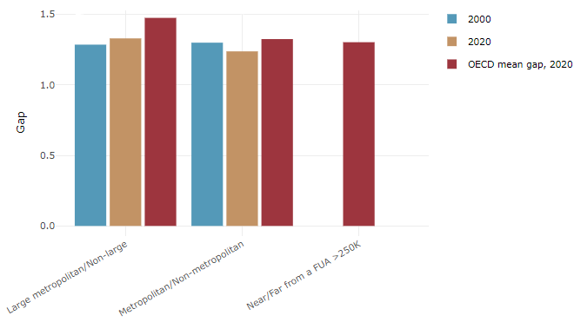

**Note**: Far from a FUA>250K includes regions near/with a small FUA and remote regions. OECD mean gap based on 1 586 TL3 regions in 27 countries with available data (no TL3 data for Australia, Canada, Chile, Colombia, Costa Rica, Iceland, Ireland, Israel, Mexico, Luxembourg and Switzerland).

**Source**: OECD Regional Database (2022).

In the Netherlands, the gap between the upper and the lower half of regions in terms of labour productivity increased between 2001 and 2019. Over this period labour productivity in the upper half of regions grew roughly by 14%, 4 percentage points more than in the lower half of regions. During 2020, the gap narrowed down. Nevertheless, more years of data are necessary to determine the long-term impact of the COVID-19 pandemic on labour productivity gaps in regions.

**Figure 3. Evolution of labour productivity, TL3 OECD regions**

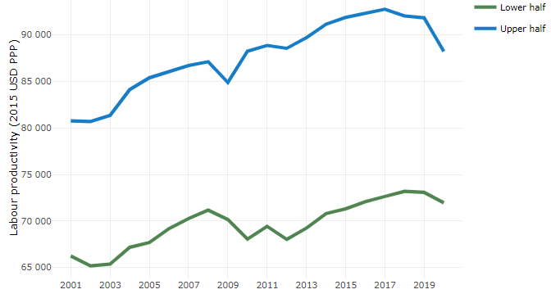

**Note**: A region is in the “upper half” if labour productivity was above the country median in the first year with available data and “lower half” if productivity was below the country median. Labour productivity in each group is equal to the sum of Gross Value Added, expressed in USD at constant prices and PPP (base year 2015) within the group, divided by the sum of total employment in regions within the group. Regions are small (TL3) regions, except for Australia, Canada, Chile, Colombia, Ireland, Mexico, Norway, Switzerland, Türkiye and the United States where they are large (TL2) regions due to data availability.

**Source**: OECD Regional Database (2022).

Regions where the economic activity shifts towards tradable activities, such as industry and tradable services, tend to grow faster in terms of labour productivity. In the Netherlands, between 2001 and 2020, the share of workers in the industrial sector went down in all regions but more so in regions that were already in the lower half of the labour productivity distribution. At the same time, the share of workers in the tradable services sector went up in all regions but more so in regions that used to be in the lower half of the labour productivity distribution. Hence, the evolution of employment shares in the industrial sector widened the labour productivity gap between regions while the opposite was true for tradable services.

**Figure 4. Share of workers in most productive (tradable) sectors, TL3 OECD regions**

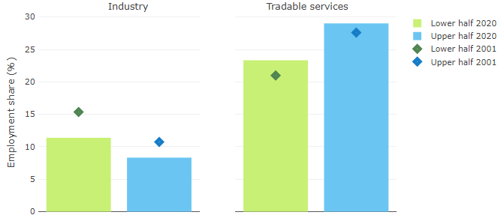

**Note**: A region is in the “upper half” if labour productivity was above the country median in the first year with available data and “lower half” if productivity was below the country median. The share of workers in a given sector for a group of regions is defined as the sum of employment in that sector within the group divided by the sum of total employment within the group. Regions are small (TL3) regions, except for Australia, Canada, Chile, Ireland, Mexico, Norway, Switzerland, Türkiye and the United States where they are large (TL2) regions due to data availability. Industry includes the following tradable goods sectors: Mining and quarrying (B), Manufacturing (C), Electricity, gas, steam and air conditioning supply (D) and Water supply; sewerage; waste management and remediation activities (E) NACE macro sectors. Tradable services include Information and communication (J), Financial and insurance activities (K), Real estate activities (L), Professional, scientific and technical activities (M), Administrative and support service activities (N).

**Source**: OECD Regional Database (2022).

## Recent policy developments

The Netherlands is a small and densely populated country with a rich urban structure. Cities and particularly functional urban areas are key pillars of the Dutch economy, hosting almost 75-80% of the national population. The structure of cities comprises a rich and very polycentric urban structure. In addition to the urban structure, the Netherlands is known for its polders and meadows. Almost half of the surface of this densely populated country has an agricultural function. The Netherlands has a diverse set of landscapes, with varying water and soil structures. The different landscapes face different challenges, related to its functions and water and soil structures.

The Netherlands is a decentralised unitary State. It consists of national government, 12 provinces, 342 municipalities, 21 water boards, 2 metropolitan areas and many functional urban areas. There are housing associations and there is more regionalism along the lines of public order and safety, mobility, labor, health (not always congruent). The central government creates the legal framework and pre-conditions (including laws, regulations and funding).

The decentralisation reinforced the provincial role in regional development and the municipal role in social and welfare services. However, the decentralisation did not (yet) go hand in hand with broad fiscal reforms, which provide more income and spending autonomy to the subnational governments.   
The Netherlands has a tradition of close cooperation between different layers of government in planning including the Dutch ‘polder model’ and cooperation between governmental levels. Public-sector authorities, companies and knowledge institutes join forces across sectors by means of permanent partnerships (each partner has its own role). Cooperation is based on policy and task orientation. The Dutch Approach is a combination of fostering self-reliance and protect/caring for the vulnerable whilst striving for economic growth.

In a letter to Parliament[[1]](#footnote-1), the current government has expressed the need to take back control on spatial planning. This means that national government has the final say in the field of energy structures, urbanisation and rural areas.

***Urban and Rural strategy***

There is no explicit national urban policy framework, it is part of a broader policy. Next to the urban and rural areas, there is also attention for networks of areas. Many departments and levels of government and stakeholders are involved. Involvement of civil society is pursued. The energy transition and circular economy are aspects that are difficult to fit in both urban and rural areas.   
The national government creates the legal framework and preconditions *(Environmental Planning Act (2022)*) that determines the responsibilities of individual actors. It works based on a principle of subsidiarity, i.e., it gives powers to the lowest level of government if possible and to a higher level if necessary.

The [National Strategy on Spatial Planning and the Environment](https://denationaleomgevingsvisie.nl/publicaties/english+french+and+german+version/default.aspx) ('NOVI')is the long-term (30 years) vision on the future development of the living environment in the Netherlands. The current government will update this strategy, in part due to increased challenges and complexity in accommodating current and future spatial claims to accommodate the energy and agricultural transitions and provide enough housing and working locations for an increasing population.

* With an integrated approach to spatial (and urban) planning.
* National strategy, place based.
* Shared responsibility and good governance.
* Now working on an (adaptive) implementation agenda.

On urban and rural matters, the strategy focusses on two priorities: (1) urban strategy ‘Strong and healthy cities and regions’ and (2) rural strategy ‘Future proof development of rural areas’. The strategy has two special points of attention/s: (1) urban strategy ‘Strong and healthy cities and regions’ and (2) rural strategy ‘Future proof development of rural areas’:

* *Urban strategy:* The Netherlands continues to work towards the development and expansion of the Netherlands Urban Network, with the aim of creating an easily accessible network of cities and regions.[[1]](" \l "_ftn1) (integrated urbanization strategy for development and quality improvement; urbanization ladder; urban regions: seven regional strategies for a coherent approach to housing, working/employment, mobility, and quality of the living environment in these regions; in these regions 17 development areas for large scale additional housing + ca. 400.000 in 10 years.)
* *Rural strategy:* Important to recognise the critical thematic fields such as agriculture, nature, water and biodiversity and cultural heritage.Goal is to a) contribute to optimal and integrated planning of all functions in these areas (for example agriculture, living, tourism, nature/biodiversity, energy transition); b.) to Influence the design of living environment in the rural areas towards & with public and private parties involved. This government started a long term program ‘national program rural areas’ (i.e., to meet international goals for nature, water and climate and to solve the nitrogen problem that blocks nature restoration).

In the updated NOVI, in addition to Urban and Rural, a third corner stone will be the necessary infrastructure for the energy transition and a transition to a circular economy. The Netherlands recognises the importance of the connection between urban and rural areas to seize opportunities for rural areas.

Land is scarce in the Netherlands, so the whole of the country (land, water and airspace) is needed to cope with current challenges, such as climate change adaptation, energy transition and sustainable development. These are issues of enormous size and complexity. It is therefore very important that attention remains for the balanced development of all parts of the country. An area-specific effort is required for a longer period, because the resolving capacity differs per area depending on (among other things) the location, culture and the composition of the population.

Today, the challenges that we face in the living environment have gotten more urgent. The demographic growth, economic growth and changing climate, combined with the challenges towards a climate neutral and circular economy and the international laws and regulations lead to an accumulation of spatial challenges. Therefore the national government is working on a new spatial strategy, an updated version of the NOVI. This new version, the ‘Nota Ruimte’, has three goals:

* Taking control of national responsibility in spatial planning;
* Working on the execution of spatial vision towards a new time;
* Values towards spatial quality.

The water and soil system, the landscapes and the country’s rich urban structure will be the basis for the spatial strategy. The Netherlands will move towards a new balance between a thriving rural area, agricultural sector and nature. A future-proof transition regarding energy, raw materials, the circular economy and mobility is needed. The Netherlands strive towards strong cities and region with space for living and working.

**Three-pronged approach to urban and rural policy**

The Netherlands’ policy approach to urban and rural development rests on three pillars:

* *Pillar 1 – Generic policy development:* sectoral approach to laws/regulations/funding.
* *Pillar 2 – Place-based approach*: integrated, multilevel with a combination of the physical domain and economic and social aspects, such as:
  + As part of the execution program of the National Strategy on Spatial Planning and the Environment (NOVEX), the national and provincial governments work towards ‘spatial arrangements’ in which the main challenges concerning spatially accommodating different developments (amongst others urbanisation, nature and agricultural transition, energy transition and circular economy) are identified and agreements are made how to accommodate these developments in a way that spatial quality is maintained and increased;
  + Regional energy strategy and agenda;
  + National programmes, e.g., Rotterdam South and Groningen;
  + “Regiodeals”: former government EUR 1-billion deals aimed to increase social/physical living environment, based on regional specific insights in growth, prosperity beyond GDP and multilevel cooperation. The new government MEUR 900 deals to 2025 aim to strengthen regions beyond GDP based on regional specific co-financing.
  + Action programmes, such as for ‘Demographic decline areas’ and for Border areas (incl Crossborder area agendas), notably the 2022 combined programme ‘Regions at the border’.
  + Housing deals: 1 million houses needed by 2030. Performance agreements building, transformation and renovation per region as part of the Building Programme, which includes financial instruments[[2]](" \l "_ftn2) and looks at speeding up building process/regulations.
  + (New) deprived areas (in cities) approach: it will integrate spatial, social, economic and safety dimensions, based on the 2022 National programme ‘Liveability and Safety’. In 20 districts, the goal is to increase the liability and safety of the most vulnerable areas in the Netherlands over the next 20 years, based on the experience of Rotterdam South.
  + NOVEX areas: As part of the NOVI execution program (NOVEX), 16 NOVEX areas have been appointed where the national government provides additional execution force in cooperation with regional and local governments to cope with spatial challenges. In these areas, a combination of spatial challenges leads to a complex interaction between several domains in which close cooperation is needed to provide solutions. In 2023, implementation agendas will be drawn up[[2]](#footnote-2). NOVEX areas are generally divided into three types:
    - Urbanisation NOVEX areas, mostly related to challenges of housing, accommodating working locations, energy transition, climate change and nature development.
    - Rural NOVEX areas, mostly related to challenges of soil subsidence, agricultural transition and livelihoods, shortages of water and (re)development of nature.
    - Harbor areas, mostly related to the energy transition and transition to a circular economy (physically and environmentally) in already densely build up areas.
* *Pillar 3 – Thematic partnerships & innovation City Deals****:*** Like within the EU, with the Urban Agenda for the EU Thematic Partnerships, the Netherlands has an national urban agenda and city deals (total 25 ongoing/ended). Examples include [[3]](" \l "_ftn3):
  + Follow-up programme for 4 years – start 2021 (Based on experience with 25 city deals);
  + City deals for regions/big/medium and small cities: coalition of willing & frontrunners, multi-level cooperation/stakeholder incl. business, new issues that cannot be resolved in the classic way; learning by doing, action orientated.
  + The objectives of City Deals are to strengthen growth, innovation and quality of life in Dutch cities. In City Deals, concrete cooperation agreements are anchored between cities, central government, other authorities, companies and social organizations. These deals must lead to innovative solutions to social issues and / or contain measures to strengthen the economic ecosystem of the urban region(s). The aim is to connect ambitious and powerful players in the urban network
  + In contrast to the Regio Deals, in the City Deal the central government does not provide co-financing for project/execution but makes process money available.

In the Netherlands, deal-making has become an important multi-level governance instrument with which different layers of government can form a partnership to address common socio-economic challenges at the regional level. One of these challenges is the recovery from the impact and inequalities brought forth by COVID-19.  Characteristics of regional dealmaking in the Netherlands that contribute to the recovery of the COVID-19 impact include:

* The main focus is the well-being of citizens in a broad socio-economic sense that goes beyond GDP (‘brede welvaart’). The instrument is deployed as a means to tackle complex multi-faceted challenges on the regional level which existing sectoral policies are unable to adequately address.
* The approach is bottom-up: the objectives and plans have been drawn up by the regions themselves. The central government facilitates with co-financing, knowledge networks and sometimes by allowing some degree of flexibility in specific laws and regulations. This approach does justice to the existing regional differences and strengthens the vitality of the region at the same time.
* Co-financing from the central and local governments work as a catalyst for additional private investments.

1. [Ruimtelijke Ordeningsbrief, 22th of May 2022.](https://open.overheid.nl/documenten/ronl-0b9aacc522c561fc898c43812fec9d8a759259d0/pdf) [↑](#footnote-ref-1)
2. NB: f and g part of National Housing and Building Agenda: Minister Housing and Spatial Planning.

   NB 2: Minister of Interior responsible for d and e.

   [[1]](#_ftnref1) “sustainable cities and regions that make an optimum contribution to the strength of the Netherlands as a whole and that offer a healthy and climate-resilient environment for everyone who lives, works and spends time there. These major tasks are so intertwined that in every city and region, they require a more integrated approach and a quality boost in a number of aspects of the urban living environment.”

   [[2]](" \l "_ftnref2) Woningbouwimpuls, het gebiedsbudget/volkshuisvestingsfonds en het Mobiliteitsfonds

   [[3]](" \l "_ftnref3) In 2020, a number of cities from the G40 network jointed national government and the private sector and knowledge institutions to sign the City Deal ‘A smart city, that’s how it’s done’ (‘Een slimme stad, zo doe je dat’). This City Deal is investigating how digitalisation and the spreading of technology are leading to change in our cities, regions and villages and which tools we need to improve the liveability of our cities, while guaranteeing our democratic values. [↑](#footnote-ref-2)