# POLAND

The [OECD Regional Outlook](https://www.oecd-ilibrary.org/urban-rural-and-regional-development/oecd-regional-outlook_2dafc8cf-en) reviews recent trends, policy developments, and prospects across OECD regions, including the underlying causes driving regional inequalities in performance and well-being. The report offers evidence, guidance and policy recommendations on how to improve competitiveness and productivity, promote inclusive growth, accelerate the net-zero transition and raise well-being standards through effective regional development policy and multi-level governance.

## Territorial definitions

The data in this note reflect different sub-national geographic levels in OECD countries. In particular, **regions** are classified on two territorial levels reflecting the administrative organisation of countries: large regions (TL2) and small regions (TL3). In Canada, TL2 corresponds to the provinces and territories.

Small regions are classified according to their access to metropolitan areas (Fadic et al. 2019). The typology classifies small (TL3) regions into metropolitan and non-metropolitan regions according to the following criteria:

* **Metropolitan regions**, if more than half of the population live in a FUA. Metropolitan regions are further classified into **metropolitan large**, if more than half of the population live in a (large) FUA of at least 1.5 million inhabitants; and **metropolitan midsize**, if more than half of the population live in a (midsize) FUA of at 250 000 to 1.5 million inhabitants.
* **Non-metropolitan regions**, if less than half of the population live in a midsize/large FUA. These regions are further classified according to their level of access to FUAs of different sizes: **near a midsize/large FUA** if more than half of the population live within a 60-minute drive from a midsize/large FUA (of more than 250 000 inhabitants) or if the TL3 region contains more than 80% of the area of a midsize/large FUA; **near a small FUA** if the region does not have access to a midsize/large FUA and at least half of its population have access to a small FUA (i.e. between 50 000 and 250 000 inhabitants) within a 60-minute drive, or contains 80% of the area of a small FUA; and **remote**, otherwise.

Disclaimer: <https://oecdcode.org/disclaimers/territories.html>

Overview

|  |  |
| --- | --- |
| Population *(specify date)* and territory | 37,827 thousand (June 30, 2022), 312.700 km2 |
| Administrative structure *(unitary/federal)* | Unitary |
| Regional or state-level governments *(number)* | 16 voivodeships |
| Intermediate-level governments *(number)* | 308 poviats plus 66 cities with the status of poviat |
| Municipal-level governments *(number)* | 2489 gminas |
| Share of subnational government in total expenditure/revenues (2021) | 32.1% of total expenditure  34.9% of total revenues  [Source: [Subnational governments in OECD countries: key data, 2023 edition](https://stats.oecd.org/Index.aspx?DataSetCode=SNGF)] |
| Key regional development challenges | Following challenges for regional policy until 2030 have been identified:  • Adapting to climate change and limiting risks for the environment.  • Counteracting the negative effects of demographic processes.  • Developing and supporting human and social capital.  • Increasing the productivity and innovativeness of regional economies.  • Developing infrastructure which increases competitiveness, investment attractiveness and living conditions in the regions.  • Increasing the effectiveness of development management (including financing development activities) and cooperation between local governments and between sectors.  • Counteracting territorial disparities and spatial concentration of development challenges and eliminating crisis situations in degraded areas. |
| Objectives of regional policy | In line with the National Strategy for Regional Development 2030 the main objective of the regional policy in Poland is: the effective use of endogenous potentials of territories and their specialisation to achieve sustainable development of the country which will create conditions for the growth of income of Polish residents while achieving coherence in the social, economic, environmental and spatial dimensions. Three specific objectives were also defined.  • Objective 1 Increasing the cohesion of country’s social, economic, environmental and spatial development.  • Objective 2 Strengthening regional competitive advantages.  • Objective 3 Improving quality of management and implementation of territorially targeted policies.  The main objective of the regional policy until 2030 will be implemented based on three specific objectivesthat complement one another.The role of the National Strategy for Regional Development 2030 is to connect and coordinate horizontal measures taken to implement objectives, which include strengthening the competitiveness of all regions, cities and rural areas (objectives 2 and 3) with objective 1 which ensures greater cohesion in the country’s development through providing support to areas that are economically weaker.  The regional policy until 2030 focuses actions on levelling up the living standard and development opportunities of medium-sized cities that struggle to cope with the effects of losing their industrial and administrative functions, and usually in rural areas – at risk of permanent marginalisation. It provides them with support that requires taking comprehensive measures tailored to the local character of actions. By supporting competitiveness of the regions, the policy assumes continued measures aimed at raising the quality of human and social capital and developing entrepreneurship and innovation. The strategy attaches great importance to developing competencies within public administration that are necessary for pursuing an effective development policy, in particular in territories with low development potential.  Horizontal matters addressed by the objectives:  • improving competitiveness of the regions based on making optimal use of their potential for development, having a proactive innovation policy, developing human and social capital in order to adjust their quality to the needs of the labour market and addressing infrastructural shortcomings,  • improving access to public services, building a culture of solidarity, shared responsibility and cooperation,  • improving the administrative potential and functioning of institutions, as well as their cooperation and active involvement in development activities. |
| Legal/institutional framework for regional policy | Treaty on the Functioning of the European Union, Article 174,  National Constitution Act on the principles of development policy,  Act on the principles of implementing tasks financed from European funds in the financial perspective 2021-2027 |
| Budget allocated to regional development (i.e., amount) and fiscal equalisation mechanisms between jurisdictions (if any) | In 2021 the state budget’s expenditures in the part 34 (regional development) amounted to PLN 2,083.6 million, while the expenditures of the *Budżet środków europejskich* (Budget of EU funds) under the part 34 of while the respective expenditures on PLN 23,180.2 million.  According to the budgetary bill for 2022 the equalization part of the state budget’s subsidy for *gminas* was planned at the level of PLN 9,6 billion, with the equalization part of the subsidy for voivodeships was planned at PLN 2.3 billion. |
| National regional development policy framework | National Strategy for Regional Development 2030  Strategy for Responsible Development for the period up to 2020 (including the perspective up to 2030)  The Partnership Agreement 2021-2027 for Poland covers 24 programmes (8 national programmes and 16 regional programmes) and 12 INTERREG programmes (concerning territorial cooperation). Cohesion Policy investments for 2021-2027 are planned in strong coordination with the National Recovery and Resilience Plan. |
| Urban policy framework | National Urban Policy 2030 |
| Rural policy framework | The Strategy for Sustainable Development of Rural Agriculture and Fisheries 2030 |
| Major regional policy tools (e.g., funds, plans, policy initiatives, institutional agreements, etc.) | Regional development strategies, supra-local development strategies, commune development strategies  Cohesion policy funds (Regional programmes 2021-2027, National programmes 2021-2027)  Development programmes and other instruments financed from national funds – the regional policy until 2030 using national public funds will be implemented through development programmes, including multi-annual programmes, which serve as an instrument for development strategy implementation.  The main mechanisms that strengthen the integrated approach to development and cooperation at local, regional and supra-regional level in the NSRD 2030: programming contract, sectoral contract and territorial agreement. |
| Policy co-ordination tools at national level | Cohesion policy funds (National programmes 2021-2027)  Strategic projects  Development programmes |
| Multi-level governance mechanisms between national and subnational levels (e.g., institutional agreements, Committees, etc.) | European Structural Funds and national co-funding  National programmes  Special Economic Zones  Monitoring committees for regional and national programmes  Partnership Agreement Committee  National Territorial Observatory  Regional Territorial Observatory  Programme contract  Sectoral contract  Territorial agreement  The main entities supporting the implementation of regional policy are: 1) the Coordinating Committee for Development Policy (CCDP) – a consultative and advisory body of the Prime Minister. The fundamental objective of the CCDP is to ensure coordination of the process of designing and implementing the development policy, as well as strategic monitoring and evaluation of the instruments serving its implementation.  2) the sub-committee for territorial dimension takes over tasks related to monitoring the NSRD. It also provides a broad forum for discussion and expert background for the implementation and monitoring of the country's regional policy. Its tasks include coordination of sectoral policies and instruments financed from various sources, for the socio-economic development of the country; formulation of recommendations concerning effectiveness, efficiency and usefulness of implemented intervention and applied instruments in sectoral policies and regional policy (including individual regions); co-ordination and formulation of recommendations concerning strategic projects indicated in the National Strategy for Regional Development and implemented on the basis of other strategic documents at the national level with a significant territorial impact.  Joint Central Government and Local Government Committee encompassing representatives of state units of the territorial government. The Committee develops economic and social priorities that condition development of communes, districts and regions, evaluates legal and financial circumstances for operation of the territorial government units and provide opinions on normative acts, programme documents and solutions related to the problems of the territorial government. |
| Policy co-ordination tools at regional level | Regional programmes 2021-2027  Programming contract  Territorial agreement  Co-ordination tools of regional policy implementation which have their source in the cohesion policy (ITI, CLLD, ATT)  Regional development strategies  Co-operation instruments inspired by the ITI mechanism (Local Government Contract), Regional Territorial Investments)  Regional Territorial Observatories  Voivodeship Regional Research Centres  Regional Social Dialog Councils |
| Evaluation and monitoring tools | NSRD monitoring is closely linked to the monitoring of public policies within the national system of development management. The process of monitoring the NSRD provides information on the progress and effects of strategy implementation, at the same time contributing to the process of monitoring the *Strategy for Responsible* Development.  The minister competent for regional development is in charge of organising the NSRD monitoring process and overseeing its proper functioning, and for that purpose once a year draws up a report on regional development in Poland. The report is a fundamental element of monitoring the NSRD.  Preparation of the report is coordinated by the National Territorial Observatory. In the process of monitoring the NSRD, the analytical and information infrastructure in the area pertaining to the socio-economic situation and processes in the country and in regions is provided by Statistics Poland. The analytical and monitoring system for regional policy also includes Regional Territorial Observatories and Voivodeship Regional Research Centres. In order to ensure the complementarity of undertaken monitoring activities, close cooperation will be pursued with units operating as part of the system for the evaluation of the cohesion policy, namely the National Evaluation Unit.  System of territorial indicators and targets linked to the Partnership Agreement.  Regional systems of evaluation and monitoring (Regional Territorial Observatories and Voivodeship Regional Research Centres). |
| Future orientations of regional policy | Increasing the territorial orientation of national and regional programming documents  Mainstream urban-rural linkages and functional approach in the urban, rural and regional development policy framework  Maintaining the role of the cohesion policy as a policy close to citizens, actually using the development potentials of the regions  Strengthening the system of multi-level development management between all levels: country - region - local level, in the field of programming, implementation and monitoring of development policies at each level of their implementation.  Greater inclusion of sectoral policies in the territorial dimension of regional policy implementation. |

## Regional Inequality Trends

Poland experienced an increase in the Theil index of GDP per capita over 2000-2020. Inequality reached its maximum in 2019. The figures are normalized, with values in the year 2000 set to 1.

The Top 20%/Mean ratio was 0.074 higher in 2020 compared to 2000, indicating increased polarisation. The Bottom 20%/Mean ratio was 0.045 lower in the same period, indicating bottom divergence.

**Figure 1. Trends in GDP per capita inequality indicators, TL3 OECD regions**

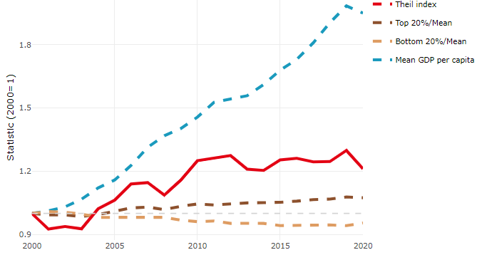

**Note**: Top/bottom calculated as population equivalent (top/bottom regions with at least 20% of the population). The interpretation of top/bottom 20% GDP per capita is that 20% of the population in the country holds 20% of the value. Top 20%/Mean calculated as mean GDP per capita in top 20% regions over mean TL3 GDP per capita in a given year. Bottom 20%/Mean calculated as mean TL3 GDP per capita in bottom 20% regions over mean TL3 GDP per capita in a given year. To improve data consistency, input series are aggregated when TL3 regions are part of the same FUA. To improve time series, TL3 missing values have been estimated based on the evolution at higher geographic level.

**Source**: OECD Regional Database (2022).

In 2020, the gap in GDP per capita between large metropolitan and non-large metropolitan regions was 1.954. For reference, the same value for OECD was 1.475. This gap increased by 0.004 percentage points between 2000 and 2020.

Meanwhile, in 2020, the gap in GDP per capita between metropolitan and non-metropolitan regions was 1.426. For reference, the same value for OECD was 1.325. This gap increased by 0.007 percentage points since 2000.

In turn, the gap in GDP per capita between regions near and far a Functional Urban Area (FUA) of more than 250 thousand inhabitants was 1.306 in 2020 and increased by 0.016 percentage points since 2000.

**Figure 2. GDP per capita gap by type of region compared to the OECD average**

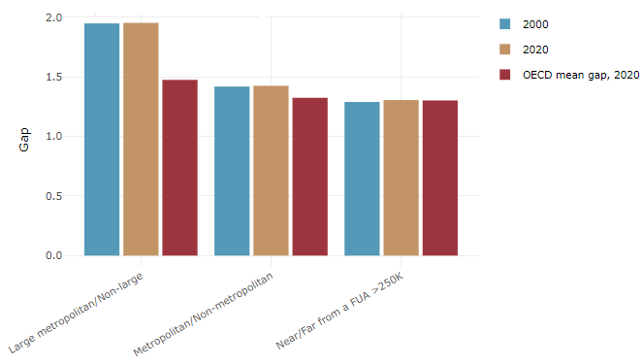

**Note**: Far from a FUA>250K includes regions near/with a small FUA and remote regions. OECD mean gap based on 1 586 TL3 regions in 27 countries with available data (no TL3 data for Australia, Canada, Chile, Colombia, Costa Rica, Iceland, Ireland, Israel, Mexico, Luxembourg and Switzerland).

**Source**: OECD Regional Database (2022).

In Poland, the gap between the upper and the lower half of regions in terms of labour productivity decreased between 2001 and 2019. Over this period labour productivity in the upper half of regions grew roughly by 66%, 17 percentage points less than in the lower half of regions. During 2020, the gap continued to narrow. Nevertheless, more years of data are necessary to determine the long-term impact of the COVID-19 pandemic on labour productivity gaps in regions.

**Figure 3. Evolution of labour productivity, TL3 OECD regions**

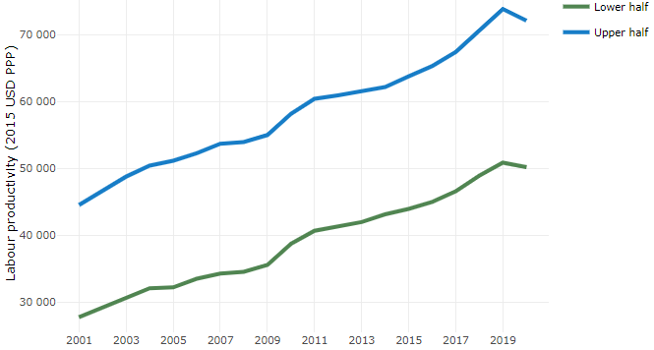

**Note**: A region is in the “upper half” if labour productivity was above the country median in the first year with available data and “lower half” if productivity was below the country median. Labour productivity in each group is equal to the sum of Gross Value Added, expressed in USD at constant prices and PPP (base year 2015) within the group, divided by the sum of total employment in regions within the group. Regions are small (TL3) regions, except for Australia, Canada, Chile, Colombia, Ireland, Mexico, Norway, Switzerland, Türkiye and the United States where they are large (TL2) regions due to data availability.

**Source**: OECD Regional Database (2022).

Regions where the economic activity shifts towards tradable activities, such as industry and tradable services, tend to grow faster in terms of labour productivity. In Poland, between 2001 and 2020, the share of workers in the industrial sector went down in regions that used to be located in the upper half of the labour productivity distribution while it went up in regions located in the lower half. At the same time, the share of workers in the tradable services sector went up in regions that used to be located in the lower half of the labour productivity distribution while it remained stable in the rest. Hence, the evolution of employment shares both in the industrial and in the tradable services sectors reduced the labour productivity gap between regions.

**Figure 4. Share of workers in most productive (tradable) sectors, TL3 OECD regions**

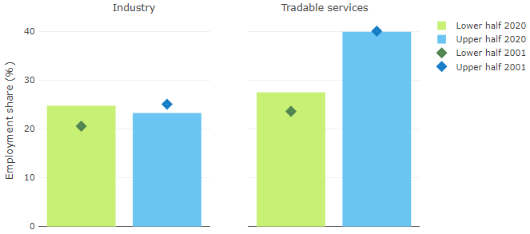

**Note**: A region is in the “upper half” if labour productivity was above the country median in the first year with available data and “lower half” if productivity was below the country median. The share of workers in a given sector for a group of regions is defined as the sum of employment in that sector within the group divided by the sum of total employment within the group. Regions are small (TL3) regions, except for Australia, Canada, Chile, Ireland, Mexico, Norway, Switzerland, Türkiye and the United States where they are large (TL2) regions due to data availability. Industry includes the following tradable goods sectors: Mining and quarrying (B), Manufacturing (C), Electricity, gas, steam and air conditioning supply (D) and Water supply; sewerage; waste management and remediation activities (E) NACE macro sectors. Tradable services include Information and communication (J), Financial and insurance activities (K), Real estate activities (L), Professional, scientific and technical activities (M), Administrative and support service activities (N).

**Source**: OECD Regional Database (2022).

## Recent policy developments

The Polish Government is embarking on a wide-ranging reappraisal of the institutional and policy context for regional development. Directions for the policy were set out in the Strategy for Responsible Development (SOR), launched in 2017 and the National Strategy for Regional Development 2030 (NSRD), launched in 2019. These included the objective of increased cohesion, with a mix of both regional and local integrated strategies, and place-based project intervention. Of particular note is an increased focus on ‘areas of strategic intervention’, increasing the emphasis on small and medium sized towns, medium sized cities losing their socio-economic functions and peripheral, rural or declining areas, alongside the main urban centres (areas at risk of permanent marginalisation). The persistence of territorial disparities in socio-economic, environmental and institutional conditions, particularly at sub-regional levels and the territorially differentiated impact of the pandemic has underlined the importance of these new policy directions. Over the past year, a range of measures have been undertaken to build on these initiatives with the overall aim of strengthening the territorial dimension in development policy. This is seen as central to successfully implementing Poland’s National Strategy for Regional Development, and to efficient use of EU Cohesion Policy. The regional strategies have been updated based on National Strategy for Regional Development. At the moment the work is underway on a new long-term vision document National Development Concept 2050. This will not act as a strategy with priorities and goals but rather sets out scenarios of development which will be used to update medium term strategy – the Strategy for Responsible Development and also the National Regional Development Strategy and sectoral strategies. The Concept is based on the identification of key issues (e.g., demographic change, climate change etc.) and it will develop scenarios around these with cross-cutting social, economic and territorial dimensions.

At supra-local level, a functional approach and cooperation of local governments is promoted, supra-local development strategies and strategies for EU territorial instruments are created.

In the Strategy for Responsible Development and the National Strategy for Regional Development the project approach is implemented as a way of implementation. As a result, various projects are being implemented to support development and local authorities, e.g. Local Development, the Advisory Support Centre, the Cities' Partnership Initiative. The Advisory Support Centre (ASD) is a NSRD strategic project with the main goal of strengthening the administrative efficiency of these local governments (municipalities and counties), including improving their competences in strategic management and initiating and implementing comprehensive development projects in partnership with neighbouring local governments. ASD pilot was launched in September 2020. The aim of this project is to support local government administration, especially this which are at risk of permanent marginalisation, in preparing development projects, multifaceted and integrated, which play a major role in improving the socio-economic situation in a functional area. The activities within the project contribute to improve administrative efficiency in local governments, and, as a result – better implementation of public policies. Continuation of ASD project is ASD Plus. The aim of the ASD Plus project is to strengthen the competences of municipalities and counties to manage strategic local development in socio-economic partnerships.

In the field of urban policy framework in Poland – the new guidelines for cities and central administration were adopted - National Urban Policy 2030 (NUP 2030). Since 2015, when the first Polish NUP was adopted, main urban challenges such as climate crisis, urban sprawl or house deficit have not disappeared but even intensified. In addition, urban areas must face new difficulties – pandemic, refugee crisis and economic instability. Having in mind the dynamically changing world and arising challenges Poland puts more emphasis on above topics and underlines the need for cities to be flexible, resilient and transformative. The National Urban Policy 2030 defines six goals that are part of the vision for long-term urban development. These goals are defined as: compact, green, productive, smart, accessible and efficient city. Moreover, NUP focuses on balancing territorial inequalities. An integrated territorial approach adopted in this document aims to affect both cities and their functional areas in order to bring improvement in the entire area, provide cohesion and ensures rational spending of money and minimization of social and environmental costs. An important part of NUP 2030 is the implementation plan. The document introduces a dedicated Executive Council for implementation of NUP composed of sectoral ministries and cities associations. The coordination and cooperation of different actors at national and regional level is the key to successful implementation of NUP 2030 goals.

National Urban Policy 2030 consists of several instruments, legal, organizational and financial solutions that help to implement goals set in the document. Within organisation of 11th World Urban Forum in Katowice, Poland developed one of the strategic projects of NUP 2030 - Action Plan for Cities initiative - under which over 100 cities received individual advisory support in the implementation of the Sustainable Development Goals at the local level. As part of the project was created "Action Plan for Cities" - a catalogue of projects implemented by the cities participating in the project; The "Handbook" - a collection of good practices in the implementation of the Sustainable Development Goals in cities and the "Toolbox for Local Communities", which is an online encyclopaedia for residents containing a knowledge base on how they can influence urban space and city management processes.

One of the strategic projects of the National Urban Policy 2030 is the Cities' Partnership Initiative (CPI). The CPI is a programme for the exchange and promotion of knowledge between cities and other actors involved in the formulation and implementation of urban policy also from national level. It is a response to the need voiced by local governments to exchange knowledge and experience between cities and other entities involved in shaping and implementing urban policy, as well as to obtain ideas on how to strengthen the development potential of Polish cities. The main objective of the initiative is to improve development conditions and to support integrated and sustainable development of Polish cities, including solutions useful for improving management efficiency. In the pilot edition of the project, 34 cities participated in the work of the three thematic networks on urban mobility, regeneration, and air quality between 2017 and 2019. In 2021, a new edition of the project was launched with 30 cities participating. This time, work is being carried out within the following thematic networks: Digital City, Green City, City of PPP initiatives. Further editions of the project are planned.