# PORTUGAL

The [OECD Regional Outlook](https://www.oecd-ilibrary.org/urban-rural-and-regional-development/oecd-regional-outlook_2dafc8cf-en) reviews recent trends, policy developments, and prospects across OECD regions, including the underlying causes driving regional inequalities in performance and well-being. The report offers evidence, guidance and policy recommendations on how to improve competitiveness and productivity, promote inclusive growth, accelerate the net-zero transition and raise well-being standards through effective regional development policy and multi-level governance.

## Territorial definitions

The data in this note reflect different sub-national geographic levels in OECD countries. In particular, **regions** are classified on two territorial levels reflecting the administrative organisation of countries: large regions (TL2) and small regions (TL3). In Canada, TL2 corresponds to the provinces and territories.

Small regions are classified according to their access to metropolitan areas (Fadic et al. 2019). The typology classifies small (TL3) regions into metropolitan and non-metropolitan regions according to the following criteria:

* **Metropolitan regions**, if more than half of the population live in a FUA. Metropolitan regions are further classified into **metropolitan large**, if more than half of the population live in a (large) FUA of at least 1.5 million inhabitants; and **metropolitan midsize**, if more than half of the population live in a (midsize) FUA of at 250 000 to 1.5 million inhabitants.
* **Non-metropolitan regions**, if less than half of the population live in a midsize/large FUA. These regions are further classified according to their level of access to FUAs of different sizes: **near a midsize/large FUA** if more than half of the population live within a 60-minute drive from a midsize/large FUA (of more than 250 000 inhabitants) or if the TL3 region contains more than 80% of the area of a midsize/large FUA; **near a small FUA** if the region does not have access to a midsize/large FUA and at least half of its population have access to a small FUA (i.e. between 50 000 and 250 000 inhabitants) within a 60-minute drive, or contains 80% of the area of a small FUA; and **remote**, otherwise.

Disclaimer: <https://oecdcode.org/disclaimers/territories.html>

Overview

|  |  |
| --- | --- |
| Population *(specify date)* and territory | 10.352.042 (2021); 92.225,61 Km2. |
| Administrative structure *(unitary/federal)* | Unitary country. |
| Regional or state-level governments *(number)* | 2 Autonomous Regions (“Regiões Autónomas”). |
| Intermediate-level governments *(number)* | --- |
| Municipal-level governments *(number)* | 308 municipalities (of which: 278 in mainland, 19 in RA Azores and 11 in RA Madeira). |
| Share of subnational government in total expenditure/revenues (2021) | 14.5% of total expenditure  14.8% of total revenues  [Source: [Subnational governments in OECD countries: key data, 2023 edition](https://stats.oecd.org/Index.aspx?DataSetCode=SNGF)] |
| Key regional development challenges | • The competitiveness and inclusive and sustainable growth in all regions.  • Regional disparities between coastal areas (including the 2 metropolitan areas) and the inland with low density of population, economic activity, and broadband infrastructure.  • Increasing ageing and depopulation, also impacting the urban centres.  • Delegation of competences to CCDR (DL n.º 36/2023) and an ongoing decentralization process from central government to municipalities.  • Implementing efficient multi-level governance systems.  • The capacity gaps for new competences and new models of delivering policies. |
| Objectives of regional policy | • Enhancing the regional attractiveness and competitiveness to improve inclusive and sustainable growth for all regions, notably promoting the endogenous resources and products, but also diversifying the economic base.  • Increase territorial cohesion between regions and within metropolitan areas by reducing the economic and social regional and intra-regional disparities, taking into account the demographic challenges.  • Enhance the double transition (energy and digital).  • Promote capacity building at all levels of administration. |
| Legal/institutional framework for regional policy | • Portuguese Republic Constitution, Article 6 and articles 225-262.  • [Strategy Portugal 2030](https://www.portugal.gov.pt/download-ficheiros/ficheiro.aspx?v=%3d%3dBQAAAB%2bLCAAAAAAABAAzNDC3NAEAkBRcpAUAAAA%3d) (RCM nº 98/2020)  • Treaty on the Functioning of the European Union, Article 174. |
| Budget allocated to regional development (i.e., amount) and fiscal equalisation mechanisms between jurisdictions (if any) | • Cohesion Policy Partnership Agreement 2021-2027: €23 billion of EU Structural Funds (ERDF, ESF+, JTF, EMFAF) and €8,5 billion of national co-financing.  • [National Recovery and Resilience Plan](https://recuperarportugal.gov.pt/wp-content/uploads/2021/10/PRR.pdf) (NRRP) in its territorial dimension.  • Decentralization Financing Fund (2023): €1,2 billion. |
| National regional development policy framework | • The [Partnership Agreement 2021-2027](https://portugal2030.pt/wp-content/uploads/sites/3/2022/07/sfc2021-PA-2021PT16FFPA001-2.0_vf.pdf) for Portugal covers 12 programmes (5 thematic programmes and 7 regional programmes) and 10 INTERREG programmes (concerning European Territorial Cooperation).  • Cohesion Policy investments for 2021-2027 are planned in strong coordination with the National Recovery and Resilience Plan (PRR). |
| Urban policy framework | • [National Spatial Planning Policy Program](https://pnpot.dgterritorio.gov.pt/sites/default/files/SQ_Vconc_PNPOT_0.pdf) (PNPOT).  • Regional Plans for Spatial Planning (PROT). |
| Rural policy framework | • [CAP Strategic Plan 2023-2027](https://www.gpp.pt/images/PEPAC/PEPAC_Submetido/Exportacao_SFC_versaoAprovao_29072022.pdf).  • National Spatial Planning Policy Program (PNPOT), Regional Plans for Spatial Planning (PROT).  • Program of the Valorisation of the Inland (PVI) (RCM nº 18/2020).  • Common Strategy for Cross-border Cooperation (ECDT). |
| Major regional policy tools (e.g., funds, plans, policy initiatives, institutional agreements, etc.) | • European Structural Funds and national co-funding.  • Regional State Aid. |
| Policy co-ordination tools at national level | • Presidency of Council of Ministers, Ministry for Territorial Cohesion (MCT), State Secretary for Regional Development (SEDR).  • Interministerial Coordination Commission (CIC) Portugal 2030.  • Territorial Consultation/Coordination Council (*Conselho de Concertação Territorial* - CCT).  • Development and Cohesion Agency (AD&C). |
| Multi-level governance mechanisms between national and subnational levels (e.g., institutional agreements, Committees, etc.) | • Territorial Consultation/Coordination Council (CCT).  • Decentralization Monitoring Commission.  • Monitoring Committees of EU Structural Funds Programmes, representing the national, regional/local government, civil stakeholders, and the managing authorities of Programmes in each region.  • Regional Dynamics Network (RDR). |
| Policy co-ordination tools at regional level | • Regional Councils.  • Regional Coordination and Development Commissions (CCDR).  • Regional Programmes (Cohesion Policy).  • Regional Smart Specialisation Strategies (RIS3).  • Territorial Instruments (e.g. ITI – Integrated Territorial Investments, Thematic ITI, Leader, etc.). |
| Evaluation and monitoring tools | • Reports on Territorial Instruments and Municipal Investments.  • Monitoring and evaluation plans linked to the European Structural Funds (EU regulation 2021/1060).  • Monitoring and Evaluation Network (RMA).  • Mandatory midterm review of all programmes of EU structural funds in 2025. |
| Future orientations of regional policy | • Portuguese government programme (2022-2026) has a chapter on the strategic challenge related to inequalities. It states the need to correct regional assymetries and to promote territorial cohesion.  • Administrative Decentralisation Reform to the Municipalities (Law n.º 50/2018, 16th of August) and related legislation.  • Administrative Deconcentration Reform to the CCDR. |

## Regional Inequality Trends

Portugal experienced a decline in the Theil index of GDP per capita over 2000-2020. Inequality reached its maximum in 2000. The figures are normalized, with values in the year 2000 set to 1.

The Top 20%/Mean ratio was 0.148 lower in 2020 compared to 2000, indicating decreased polarisation. The Bottom 20%/Mean ratio was 0.15 higher in the same period, indicating bottom convergence.

**Figure 1. Trends in GDP per capita inequality indicators, TL3 OECD regions**

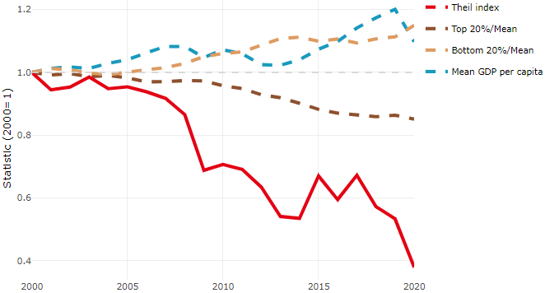

**Note**: Top/bottom calculated as population equivalent (top/bottom regions with at least 20% of the population). The interpretation of top/bottom 20% GDP per capita is that 20% of the population in the country holds 20% of the value. Top 20%/Mean calculated as mean GDP per capita in top 20% regions over mean TL3 GDP per capita in a given year. Bottom 20%/Mean calculated as mean TL3 GDP per capita in bottom 20% regions over mean TL3 GDP per capita in a given year. To improve data consistency, input series are aggregated when TL3 regions are part of the same FUA. To improve time series, TL3 missing values have been estimated based on the evolution at higher geographic level.

**Source**: OECD Regional Database (2022).

In 2020, the gap in GDP per capita between large metropolitan and non-large metropolitan regions was 1.481. For reference, the same value for OECD was 1.475. This gap decreased by 0.302 percentage points between 2000 and 2020.

Meanwhile, in 2020, the gap in GDP per capita between metropolitan and non-metropolitan regions was 1.236. For reference, the same value for OECD was 1.325. This gap decreased by 0.142 percentage points since 2000.

In turn, the gap in GDP per capita between regions near and far a Functional Urban Area (FUA) of more than 250 thousand inhabitants was 1.062 in 2020 and decreased by 0.005 percentage points since 2000.

**Figure 2. GDP per capita gap by type of region compared to the OECD average**

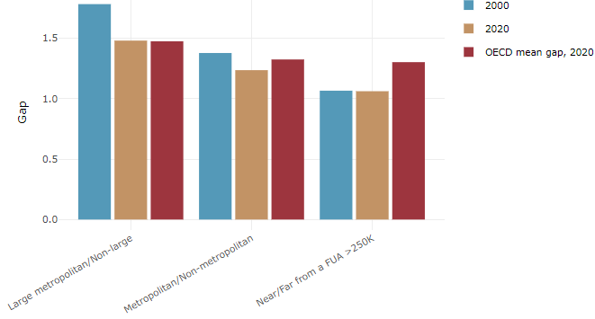

**Note**: Far from a FUA>250K includes regions near/with a small FUA and remote regions. OECD mean gap based on 1 586 TL3 regions in 27 countries with available data (no TL3 data for Australia, Canada, Chile, Colombia, Costa Rica, Iceland, Ireland, Israel, Mexico, Luxembourg and Switzerland).

**Source**: OECD Regional Database (2022).

In Portugal, the gap between the upper and the lower half of regions in terms of labour productivity decreased between 2001 and 2019. Over this period labour productivity in the upper half of regions grew roughly by 12%, 22 percentage points less than in the lower half of regions. During 2020, the gap continued to narrow. Nevertheless, more years of data are necessary to determine the long-term impact of the COVID-19 pandemic on labour productivity gaps in regions.

**Figure 3. Evolution of labour productivity, TL3 OECD regions**

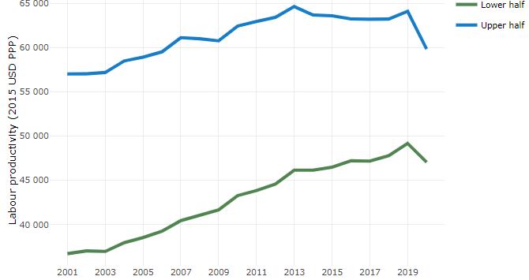

**Note**: A region is in the “upper half” if labour productivity was above the country median in the first year with available data and “lower half” if productivity was below the country median. Labour productivity in each group is equal to the sum of Gross Value Added, expressed in USD at constant prices and PPP (base year 2015) within the group, divided by the sum of total employment in regions within the group. Regions are small (TL3) regions, except for Australia, Canada, Chile, Colombia, Ireland, Mexico, Norway, Switzerland, Türkiye and the United States where they are large (TL2) regions due to data availability.

**Source**: OECD Regional Database (2022).

Regions where the economic activity shifts towards tradable activities, such as industry and tradable services, tend to grow faster in terms of labour productivity. In Portugal, between 2001 and 2020, the share of workers in the industrial sector went down in all regions but more so in regions that used to be in the upper half of the labour productivity distribution. At the same time, the share of workers in the tradable services sector went up in all regions but more so in regions that were already in the upper half of the labour productivity distribution. Hence, the evolution of employment shares in the tradable services sector widened the labour productivity gap between regions while the opposite was true for the industrial sector.

**Figure 4. Share of workers in most productive (tradable) sectors, TL3 OECD regions**

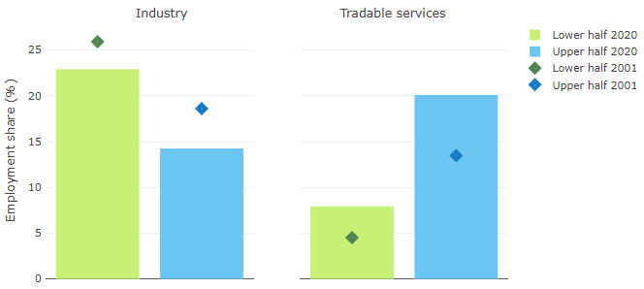

**Note**: A region is in the “upper half” if labour productivity was above the country median in the first year with available data and “lower half” if productivity was below the country median. The share of workers in a given sector for a group of regions is defined as the sum of employment in that sector within the group divided by the sum of total employment within the group. Regions are small (TL3) regions, except for Australia, Canada, Chile, Ireland, Mexico, Norway, Switzerland, Türkiye and the United States where they are large (TL2) regions due to data availability. Industry includes the following tradable goods sectors: Mining and quarrying (B), Manufacturing (C), Electricity, gas, steam and air conditioning supply (D) and Water supply; sewerage; waste management and remediation activities (E) NACE macro sectors. Tradable services include Information and communication (J), Financial and insurance activities (K), Real estate activities (L), Professional, scientific and technical activities (M), Administrative and support service activities (N).

**Source**: OECD Regional Database (2022).

## Recent policy developments

The main components of the policy mix – institutional framework and cohesion policy priorities and investments – are established in order to promote a balanced territorial development between different regions, between rural and urban areas, between coastal and the hinterland zones, in order to reduce long-lasting asymmetries and inequalities in Portugal that persist. The goal of promote growth in all regions is reflected in the vision defined in Strategy Portugal 2030 “Recover the economy and protect jobs, and make the next decade a recovery and convergence of Portugal with the European Union, ensuring greater resilience and social and territorial cohesion.” Promoting territorial cohesion will be mandatory to counteract territorial inequalities, as established in the integrated strategy for the valorisation of inland territories (RCM nº 18/2020), based on attracting/fixing population, promoting private investment to create jobs, stimulating the knowledge and innovation transfer from the academy to the socioeconomic tissue, and guaranteeing the provision of services of general interest.

***Institutional changes***

The current main developments related to the regional institutional framework, in Portugal, are the reforms on the administrative decentralization to the municipalites (as well to the intermunicipal cooperation and parishes) and administrative deconcentration to the CCDR (Regional Development and Coordination Commissions).

Portugal is expanding its subnational policy footprint through decentralization. The Law n. º 50/2018, of 16th of August, and related legislation have provided municipalities (in *lato sensu,* including metropolitan areas, intermunicipal communities and parishes, as well) with new competences, responsibilities and resources granting more proximity to its citizens and efficiency to the public policy. Traditionally, Portugal has highly centralized governmental structure with a lower proportion of public spending in the subnational levels, than the EU and OECD averages. This process might change the *status quo*, reinforcing local-based policies and stakeholders.

Recently, the Portuguese government approved the administrative deconcentrating reform to the CCDRs, which will acquire the status of special public institutes, with the objective of carrying out deconcentrated competences of the central administration and provide better public services to citizens, working as one-stop-shop in a regional level, and provider of services of general interest (e.g., health, education, culture, agriculture, and others) in its territory. In a country without regional level, in the mainland, this process is considered a steppingstone to a future debate about regionalisation process. Along with this, a process of revision for NUTS II was developed to make them coherent with the area covered by CCDR.

***EU Structural Funds***

The [Cohesion Policy Partnership Agreement](https://portugal2030.pt/wp-content/uploads/sites/3/2022/07/sfc2021-PA-2021PT16FFPA001-2.0_vf.pdf) (Portugal 2030) between the EU Commission and Portugal, adopted in July 2022, sets out investment priorities for the period 2021-2027 with a total of €23 billion to support the economic, social and territorial cohesion until the end of the decade. The [7 regional programmes](https://portugal2030.pt/programas/) will have a total of €9,7 billion and are particularly focused on territorial policies and investments, which are reinforced by the ongoing decentralization process in the mainland and contributes to the European strategic objectives: a Europe closer to citizens, a greener Europe and a more competitive Europe. The new Just Transition Fund will support three subregions impacted by the closure of two coal-fired power plant (in Médio Tejo and Alentejo Litoral) and one refinery (in Matosinhos, Metropolitan Area of Porto).

As concerns the EU Recovery and Resilience Facility (RRF), one of its key objectives is to promote social and territorial cohesion. Portugal’s [National Recovery and Resilience Plan](https://recuperarportugal.gov.pt/wp-content/uploads/2021/10/PRR.pdf) (NRRP) accounts to almost €17 billion, with more than €11 billion allocated to the “resilience dimension”, more than €3 billion destined to the “climate transition” and almost €2,5 billion to the “digital transition”. In general, the use of the RRF versus Cohesion Policy funds is guided by eligibility, competences, timing and investment scale. The national government has focussed its investment on human resources within administrations, strengthening the capacities for effective management of public investment particularly at territorial level.

***Public policy***

The [National Investment Programme 2030](https://www.portugal.gov.pt/download-ficheiros/ficheiro.aspx?v=%3d%3dBQAAAB%2bLCAAAAAAABAAzNDCzNAcAHS%2bXPAUAAAA%3d) (PNI 2030) aims to be the planning tool for the next cycle of strategic and structural investments at national level, to meet the needs and challenges of the next decade and decades to come. The scope of the PNI 2030 is multisectoral, focusing on the mobility and transport sectors, key factors for the country’s external competitiveness and internal cohesion, the environment, energy and irrigation, fundamental to face the challenges of decarbonization and energy transition.