# SLOVENIA

The [OECD Regional Outlook](https://www.oecd-ilibrary.org/urban-rural-and-regional-development/oecd-regional-outlook_2dafc8cf-en) reviews recent trends, policy developments, and prospects across OECD regions, including the underlying causes driving regional inequalities in performance and well-being. The report offers evidence, guidance and policy recommendations on how to improve competitiveness and productivity, promote inclusive growth, accelerate the net-zero transition and raise well-being standards through effective regional development policy and multi-level governance.

## Territorial definitions

The data in this note reflect different sub-national geographic levels in OECD countries. In particular, **regions** are classified on two territorial levels reflecting the administrative organisation of countries: large regions (TL2) and small regions (TL3). In Canada, TL2 corresponds to the provinces and territories.

Small regions are classified according to their access to metropolitan areas (Fadic et al. 2019). The typology classifies small (TL3) regions into metropolitan and non-metropolitan regions according to the following criteria:

* **Metropolitan regions**, if more than half of the population live in a FUA. Metropolitan regions are further classified into **metropolitan large**, if more than half of the population live in a (large) FUA of at least 1.5 million inhabitants; and **metropolitan midsize**, if more than half of the population live in a (midsize) FUA of at 250 000 to 1.5 million inhabitants.
* **Non-metropolitan regions**, if less than half of the population live in a midsize/large FUA. These regions are further classified according to their level of access to FUAs of different sizes: **near a midsize/large FUA** if more than half of the population live within a 60-minute drive from a midsize/large FUA (of more than 250 000 inhabitants) or if the TL3 region contains more than 80% of the area of a midsize/large FUA; **near a small FUA** if the region does not have access to a midsize/large FUA and at least half of its population have access to a small FUA (i.e. between 50 000 and 250 000 inhabitants) within a 60-minute drive, or contains 80% of the area of a small FUA; and **remote**, otherwise.

Disclaimer: <https://oecdcode.org/disclaimers/territories.html>

Overview

|  |  |
| --- | --- |
| Population *(specify date)* and territory | 2.116.972, 1.1.2023 km2 |
| Administrative structure *(unitary/federal)* | Unitary |
| Regional or state-level governments *(number)* | 1 |
| Intermediate-level governments *(number)* | 0 |
| Municipal-level governments *(number)* | 212 |
| Share of subnational government in total expenditure/revenues (2021) | 18.1% of total expenditure  20.1% of total revenues  [Source: [Subnational governments in OECD countries: key data, 2023 edition](https://stats.oecd.org/Index.aspx?DataSetCode=SNGF)] |
| Key regional development challenges | To reduce regional development disparities  To strengthen development capacities of regions on the basis of their own development potentials and global opportunities |
| Objectives of regional policy | 1. To increase the quality of life in all regions through balanced economic, social and environmental development based on the principles of sustainable development  2. Catching up with European regions  3. To realise development potentials and effective use of global opportunities with international territorial cooperation. |
| Legal/institutional framework for regional policy | Slovenian development strategy  Spatial development strategy of Slovenia  Promotion of balanced regional development act  Decree on the development council of cohesion region  Decree on the implementation of endogenous regional policy measures  Decree on regional development programs  Decree determining problem border areas  Decree on the regional aid map for 2022-2027  Rules on regional development agencies |
| Budget allocated to regional development (i.e., amount) and fiscal equalisation mechanisms between jurisdictions (if any) | Regional Development Agreements as the major regional development instrument for 7 years programming period amounted to 439 mio EUR (2014-2020). Beside this, several sectoral program measures are being implemented and influencing regional development. |
| National regional development policy framework | Measures defined in the Promotion of balanced regional development act |
| Urban policy framework | Urban development strategies for 12 Urban municipalities, led by the Ministry responsible for Spatial Development |
| Rural policy framework | Rural development programme, led by the Ministry responsible for agriculture |
| Major regional policy tools (e.g., funds, plans, policy initiatives, institutional agreements, etc.) | 2 Development Councils of both Cohesion Regions (NUTS 2)  12 Regional Development Councils (tripartite structure) (NUTS 3)  12 Regional Councils (majors) (NUTS 3)  Slovene regional development public fund, Ribnica  Slovene entrepreneurship Public Fund, Maribor  Baseline for development strategy for eastern cohesion region  Baseline for development strategy for western cohesion region  Regional Development Programmes for 12 regions  Governmental Programme for Border areas with specific features  Regional Development Agreements |
| Policy co-ordination tools at national level | Ministry of Cohesion and Regional Development as Managing Authority for EU Cohesion Funds  Territorial and Sectoral Development Dialogue within process Regional Development Agreements |
| Multi-level governance mechanisms between national and subnational levels (e.g., institutional agreements, Committees, etc.) | 12 Regional Development Agreements between regions and Ministry responsible for regional development |
| Policy co-ordination tools at regional level | Territorial Development Dialogue within the process of preparing of Regional Development Agreements |
| Evaluation and monitoring tools | Yearly Reports from 12 Regional Development Agencies on implementation of general regional development responsibilities  Regular Evaluation Programmes |
| Future orientations of regional policy | To create conditions for dynamic and creative regions with their own identity and managed effectively and capable to recognise and to use global development challenges |

## Regional Inequality Trends

Slovenia experienced an increase in the Theil index of GDP per capita over 2000-2020. Inequality reached its maximum in 2009. The figures are normalized, with values in the year 2000 set to 1.

The Top 20%/Mean ratio was 0.079 higher in 2020 compared to 2000, indicating increased polarisation. The Bottom 20%/Mean ratio was 0.009 lower in the same period, indicating bottom divergence.

**Figure 1. Trends in GDP per capita inequality indicators, TL3 OECD regions**

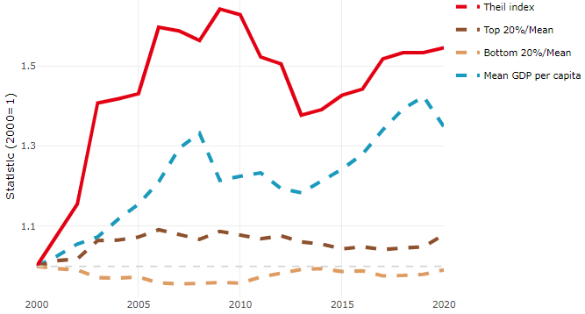

**Note**: Top/bottom calculated as population equivalent (top/bottom regions with at least 20% of the population). The interpretation of top/bottom 20% GDP per capita is that 20% of the population in the country holds 20% of the value. Top 20%/Mean calculated as mean GDP per capita in top 20% regions over mean TL3 GDP per capita in a given year. Bottom 20%/Mean calculated as mean TL3 GDP per capita in bottom 20% regions over mean TL3 GDP per capita in a given year. To improve data consistency, input series are aggregated when TL3 regions are part of the same FUA. To improve time series, TL3 missing values have been estimated based on the evolution at higher geographic level.

**Source**: OECD Regional Database (2022).

There is no data for the gap in GDP per capita between large metropolitan and non-large metropolitan regions for 2000 and 2020.

Meanwhile, in 2020, the gap in GDP per capita between metropolitan and non-metropolitan regions was 1.384. For reference, the same value for OECD was 1.325. This gap increased by 0.114 percentage points since 2000.

In turn, the gap in GDP per capita between regions near and far a Functional Urban Area (FUA) of more than 250 thousand inhabitants was 1.001 in 2020 and increased by 0.068 percentage points since 2000.

**Figure 2. GDP per capita gap by type of region compared to the OECD average**

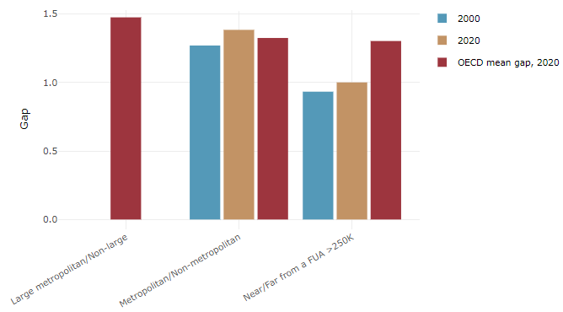

**Note**: Far from a FUA>250K includes regions near/with a small FUA and remote regions. OECD mean gap based on 1 586 TL3 regions in 27 countries with available data (no TL3 data for Australia, Canada, Chile, Colombia, Costa Rica, Iceland, Ireland, Israel, Mexico, Luxembourg and Switzerland).

**Source**: OECD Regional Database (2022).

In Slovenia, the gap between the upper and the lower half of regions in terms of labour productivity decreased between 2001 and 2019. Over this period labour productivity in the upper half of regions grew roughly by 31%, 12 percentage points less than in the lower half of regions. During 2020, the gap widened again. Nevertheless, more years of data are necessary to determine the long-term impact of the COVID-19 pandemic on labour productivity gaps in regions.

**Figure 3. Evolution of labour productivity, TL3 OECD regions**

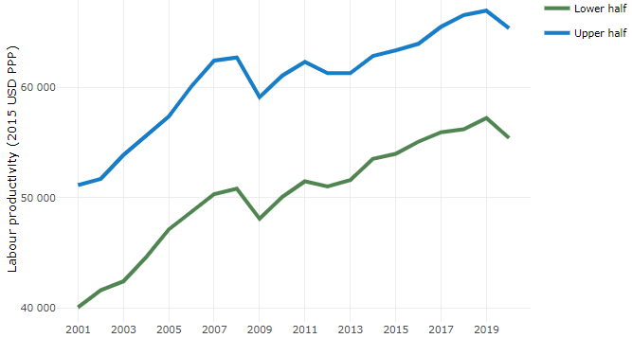

**Note**: A region is in the “upper half” if labour productivity was above the country median in the first year with available data and “lower half” if productivity was below the country median. Labour productivity in each group is equal to the sum of Gross Value Added, expressed in USD at constant prices and PPP (base year 2015) within the group, divided by the sum of total employment in regions within the group. Regions are small (TL3) regions, except for Australia, Canada, Chile, Colombia, Ireland, Mexico, Norway, Switzerland, Türkiye and the United States where they are large (TL2) regions due to data availability.

**Source**: OECD Regional Database (2022).

Regions where the economic activity shifts towards tradable activities, such as industry and tradable services, tend to grow faster in terms of labour productivity. In Slovenia, between 2001 and 2020, the share of workers in the industrial sector went down in all regions but more so in regions that used to be in the upper half of the labour productivity distribution. At the same time, the share of workers in the tradable services sector went up in all regions but more so in regions that were already in the upper half of the labour productivity distribution. Hence, the evolution of employment shares in the tradable services sector widened the labour productivity gap between regions while the opposite was true for the industrial sector.

**Figure 4. Share of workers in most productive (tradable) sectors, TL3 OECD regions**

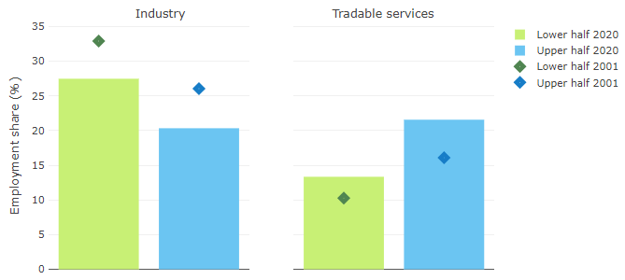

**Note**: A region is in the “upper half” if labour productivity was above the country median in the first year with available data and “lower half” if productivity was below the country median. The share of workers in a given sector for a group of regions is defined as the sum of employment in that sector within the group divided by the sum of total employment within the group. Regions are small (TL3) regions, except for Australia, Canada, Chile, Ireland, Mexico, Norway, Switzerland, Türkiye and the United States where they are large (TL2) regions due to data availability. Industry includes the following tradable goods sectors: Mining and quarrying (B), Manufacturing (C), Electricity, gas, steam and air conditioning supply (D) and Water supply; sewerage; waste management and remediation activities (E) NACE macro sectors. Tradable services include Information and communication (J), Financial and insurance activities (K), Real estate activities (L), Professional, scientific and technical activities (M), Administrative and support service activities (N).

**Source**: OECD Regional Database (2022).

## Recent policy developments

* The implementation of the Government Programme for Border Areas with specific features. The renovation of the programme is envisaged. The main objective is to involve more actively other ministries to contribute with their own development policies.
* Promoting measures for strengthening productivity, mainly on less developed areas and measures for the green transformation development policy.
* The Regional development field (Regional development Directorate) has been integrated in 2023 into a new Ministry for Cohesion and Regional Development.
* The process of preparing a new generation of Regional Development Agreements will start soon.