# SPAIN

The [OECD Regional Outlook](https://www.oecd-ilibrary.org/urban-rural-and-regional-development/oecd-regional-outlook_2dafc8cf-en) reviews recent trends, policy developments, and prospects across OECD regions, including the underlying causes driving regional inequalities in performance and well-being. The report offers evidence, guidance and policy recommendations on how to improve competitiveness and productivity, promote inclusive growth, accelerate the net-zero transition and raise well-being standards through effective regional development policy and multi-level governance.

## Territorial definitions

The data in this note reflect different sub-national geographic levels in OECD countries. In particular, **regions** are classified on two territorial levels reflecting the administrative organisation of countries: large regions (TL2) and small regions (TL3). In Canada, TL2 corresponds to the provinces and territories.

Small regions are classified according to their access to metropolitan areas (Fadic et al. 2019). The typology classifies small (TL3) regions into metropolitan and non-metropolitan regions according to the following criteria:

* **Metropolitan regions**, if more than half of the population live in a FUA. Metropolitan regions are further classified into **metropolitan large**, if more than half of the population live in a (large) FUA of at least 1.5 million inhabitants; and **metropolitan midsize**, if more than half of the population live in a (midsize) FUA of at 250 000 to 1.5 million inhabitants.
* **Non-metropolitan regions**, if less than half of the population live in a midsize/large FUA. These regions are further classified according to their level of access to FUAs of different sizes: **near a midsize/large FUA** if more than half of the population live within a 60-minute drive from a midsize/large FUA (of more than 250 000 inhabitants) or if the TL3 region contains more than 80% of the area of a midsize/large FUA; **near a small FUA** if the region does not have access to a midsize/large FUA and at least half of its population have access to a small FUA (i.e. between 50 000 and 250 000 inhabitants) within a 60-minute drive, or contains 80% of the area of a small FUA; and **remote**, otherwise.

Disclaimer: <https://oecdcode.org/disclaimers/territories.html>

Overview

|  |  |
| --- | --- |
| Population *(specify date)* and territory | 48.345.223 million (July 2023), 505 940 km2 (2018) |
| Administrative structure *(unitary/federal)* | Quasi-federal |
| Regional or state-level governments *(number)* | 17 regions plus 2 autonomous cities |
| Intermediate-level governments *(number)* | 50 provinces |
| Municipal-level governments *(number)* | 8.131 municipalities (July 2023) |
| Share of subnational government in total expenditure/revenues (2021) | 49.6% of total expenditure  57.9% of total revenues  [Source: [Subnational governments in OECD countries: key data, 2023 edition](https://stats.oecd.org/Index.aspx?DataSetCode=SNGF)] |
| Key regional development challenges | Spanish population continues to grow, while it tends to concentrate in large urban areas, resulting in a deeper territorial imbalance. As a result, around 90% of the population is spread over 30% of the land. Also, as Eurostat data shows, the population density in Spain in 2019 stood at 93.8 people per square kilometer, below the EU average of 109 inhab./km2 . Moreover, based on municipal organization data, municipalities with 5,000 or fewer inhabitants represent (as of January 1, 2021) 83.9% of the total, although they host about 5.69 million people, or 12% of the total Spanish population. At the same time, a significant number of municipalities with between 5,001 and 20,000 inhabitants also present worrying patterns of depopulation and ageing population. Specifically, on January 1, 2021, from the 899 municipalities between 5,001 and 20,000 inhabitants, 36% have lost population in the period 2016-2021 and in more than a third of these locations (35%), at least 20% of the population is over 65 years old.  Spain has the longest life expectancy in the EU, with 20% of the population aged 65+ and 1/3 of this share is 80+.  In rural areas and intermediate cities, the proportion of older people is higher (38-48% for rural areas, and 31% of the total population for intermediate regions). Also, the effect of tourism increases the disparities, due to the floating population effect and large seasonal population increases, mostly concentrated in highly densely populated coastal areas where land use pressure and cost is intensified.  In addition, depopulated areas suffer from higher masculization ratios, young brain drain loss, salary and digital gaps, smaller sized companies which, among other factors, typically result in lower productivity and innovation rates compared to urban areas. |
| Objectives of regional policy | Giving the above described situation, the Ministry of Ecological Transition and Demographic created in October 2020 the General Secretariat of Demographic Challenge, with the following duties (approved by Royal Decree 500/2020):   * The preparation, in collaboration with other ministerial departments and territorial administrations, and the proposal and promotion, within the scope of the General State Administration, of the general objectives, strategies and plans and priority actions regarding the demographic challenge. * The coordination of other ministerial departments and territorial public administrations in matters of the demographic challenge, as well as the promotion of public-private collaboration for the achievement of the objectives related to the demographic challenge. * The functions that the Law for the Sustainable Development of the Rural Environment of 2007 attributes to the General State Administration. * The promotion, without prejudice to the competencies of other ministerial departments, of equal opportunities and non-discrimination based on residence and age, as well as the promotion and safeguarding, in collaboration with other ministerial departments and territorial public administrations, of the appropriate provision of basic services to the entire population, under conditions of equity, with special attention to children, youth and the elderly. * The promotion, without prejudice to the competences of other ministerial departments, of the role of women in rural areas, as well as the social and labor inclusion of immigrants in areas at demographic risk. * The coordination of policies aimed at promoting the reconciliation of family and professional life, co-responsibility, child rearing and the development of family projects, especially in the areas most affected by demographic risks. * The coordination of public policies, within the scope of the General State Administration, aimed at promoting awareness, knowledge and training, from childhood and youth, and throughout life, which enhance the value of the territory, especially in rural areas, and promote the knowledge and revitalization of existing opportunities in areas affected by depopulation. * The promotion, without prejudice to the competencies of other ministerial departments, of investment, employment opportunities, diversification and economic development, with the aim of strengthening the socioeconomic fabric in areas affected by depopulation. * The promotion and encouragement, in collaboration with the other ministerial departments and the territorial public administrations, of the adequate dimensioning of the infrastructures and equipment necessary to face the demographic challenge. * The promotion and encouragement, in collaboration with other ministerial departments and territorial public administrations, of policies aimed at addressing the progressive aging and the effects of the floating population. * Participation in representation of the Ministry in international organizations and monitoring of international agreements on the demographic challenge.   Participation in representation of the General State Administration in Councils of the European Union in matters of demographic challenge and other international organizations. |
| Legal/institutional framework for regional policy | Treaty on the Functioning of the European Union, Article 174.  2030 National Strategy for Demographic Challenge: It establishes the objectives and strategic lines of action to advance in territorial cohesion and fight against depopulation. |
| Budget allocated to regional development (i.e., amount) and fiscal equalisation mechanisms between jurisdictions (if any) | The General Secretariat was created on January 29, 20203 as a result of the integration of the competences on demography and its problems in the Ministry of Ecological Transition.  For the exercise of its functions, the General Secretariat was endowed with a management body, the General Directorate for Policies against Depopulation, and a Technical Office to assist the Secretary General. In 2022, the body's budget practically tripled due to the creation, among other initiatives, of the State Territorial Cohesion Fund, initially endowed with 29 million euros, among other tasks. In 2023 the consolidation of its mandate was quite visible in its 71M euros budget. |
| National regional development policy framework | The Partnership Agreement 2021-2027 for Spain covers the national ERDF programme under objective 5.2 for the General Secretariat for Demographic Challenge.  Approval of the national Recovery, Transformation and Resilience Plan (RTRP). It is an opportunity to address reforms and investments through ten lever policies that will build the urban and rural agenda. |
| Urban policy framework | Target 5.2 of the ERDF, i.e. in urban-rural areas, the promotion of integrated local social, economic and environmental development, culture and natural heritage, sustainable tourism and safety.  Approval of the national Recovery, Transformation and Resilience Plan (RTRP). It is an opportunity to address reforms and investments through ten lever policies that will build the urban and rural agenda. |
| Rural policy framework | CAP Strategic Plan 2023-2027 (Ministry of Agriculture, Fisheries and Food)  <https://www.mapa.gob.es/es/pac/post-2020/default.aspx>  Approval of the national Recovery, Transformation and Resilience Plan (RTRP). It is an opportunity to address reforms and investments through ten lever policies that will build the urban and rural agenda. |
| Major regional policy tools (e.g., funds, plans, policy initiatives, institutional agreements, etc.) | 130 Measures Plan to face the Demographic Challenge. Action plan that allows, through the implementation of actions, to align the strategic objectives of the National Strategy with the lever policies of the Recovery, Transformation and Resilience Plan.  Digital Rural Challenge Plan, approved to train at least 384,868 people by 2025 and narrow the digital skills gap.  Designing, tendering and awarding of yearly national subsidies for territorial transformation projects. 2022-ongoing  Implementation of Territorial and Transformation Cohesion Fund, an instrument to meet the needs of areas at risk of territorial vulnerability, which allows financing all kinds of initiatives that generate benefits for territorial cohesion and opportunities for economic and social development.  Creation of Innovative Centers to foster added-value based in tech employment in vulnerable areas.  Cross-border Development Strategy with Portugal  Constitution of Territorial Cohesion Forum: Space for Civil Society Participation; and Governance Mechanisms.  Promotion of youth employment and local talent. Creation of Rural Campus Program to carry out training practices in rural environments. Upcoming edition with cross-border internships in Portugal.  Planning of pilot projects financed by ERDF structural funding. |
| Policy co-ordination tools at national level | DELEGATE COMMISSION FOR THE DEMOGRAPHIC CHALLENGE for the Coordination within the Government - General State Administration. |
| Multi-level governance mechanisms between national and subnational levels (e.g., institutional agreements, Committees, etc.) | SECTORAL CONFERENCE FOR THE DEMOGRAPHIC CHALLENGE for the coordination between the State, Autonomous Communities and Spanish Federation of Municipalities and Provinces (SFMP)  TERRITORIAL COHESION FORUM, a space for Civil Society Participation, with biannual encounters. |
| Policy co-ordination tools at regional level | SECTORAL CONFERENCE FOR THE DEMOGRAPHIC CHALLENGE for the coordination between the State, Autonomous Communities and Spanish Federation of Municipalities and Provinces (SFMP) |
| Evaluation and monitoring tools | SIDAMUN is a tool that makes available to experts, administrations and citizens detailed information on the state of the situation of the territory.  It allows the user to access municipal information and its provincial, regional and national visualization, as well as make personalized queries through search filters. It is structured through six thematic blocks: demographic, geographical, economic, related to available services, housing and home and environmental. |
| Future orientations of regional policy | 2023, Consolidation and extension of public policy by:  Completion and evaluation of the Plan 130 measures with a significant increase in the overall budget of the Plan, reaching a budget of more than 12,000 million €. Beginning of the elaboration of a new Plan by the Delegate Commission for the new legislature.  Consolidation of the Cohesion and Territorial Transformation Fund as the tool for territorial cohesion with an increase of 35% by 2023.  New impetus for innovation policy with the Network of Territorial Innovation Centers. In addition to the 5 CITs already agreed in 2022: Cuenca, Soria, Teruel, Comarcas Pirenaicas, León, another 5 will be added in 2023: Asturias, Jaén, Huelva, Castellón with a central node "Ciuden" in Ponferrada.  Consolidation of the aid policy aimed at local entities, non-profit organizations and entrepreneurs, increasing from 29.2 M€ to 33 M€.  Launching of the Digital Rural Challenge with the objective of digital training in rural areas (Investment of component 19 PRTR) with the objective of training 384,868 people before the end of 2025 and an investment of 90 M €.  Investing 76 million for projects that develop sustainable forest management.  For the first time, there will be a specific allocation for policies to combat depopulation in the programming of the ERDF Multiregional Program, within the specific political objective 5.2 Spain will be the pioneer country in obtaining this type of financing in the EU.  The Rural Campus program for university internships in rural areas will increase from 400 participants and 37 universities in 2022 to 1,000 participants and 47 universities in 2023. |

## Regional Inequality Trends

Spain experienced a decline in the Theil index of GDP per capita over 2000-2020. Inequality reached its maximum in 2001. The figures are normalized, with values in the year 2000 set to 1.

The Top 20%/Mean ratio was 0.031 higher in 2020 compared to 2000, indicating increased polarisation. The Bottom 20%/Mean ratio was 0.053 higher in the same period, indicating bottom convergence.

**Figure 1. Trends in GDP per capita inequality indicators, TL3 OECD regions**

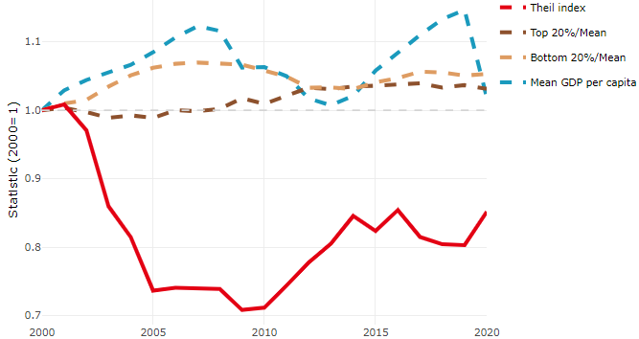

**Note**: Top/bottom calculated as population equivalent (top/bottom regions with at least 20% of the population). The interpretation of top/bottom 20% GDP per capita is that 20% of the population in the country holds 20% of the value. Top 20%/Mean calculated as mean GDP per capita in top 20% regions over mean TL3 GDP per capita in a given year. Bottom 20%/Mean calculated as mean TL3 GDP per capita in bottom 20% regions over mean TL3 GDP per capita in a given year. To improve data consistency, input series are aggregated when TL3 regions are part of the same FUA. To improve time series, TL3 missing values have been estimated based on the evolution at higher geographic level.

**Source**: OECD Regional Database (2022).

In 2020, the gap in GDP per capita between large metropolitan and non-large metropolitan regions was 1.178. For reference, the same value for OECD was 1.475. This gap increased by 0.03 percentage points between 2000 and 2020.

Meanwhile, in 2020, the gap in GDP per capita between metropolitan and non-metropolitan regions was 1.095. For reference, the same value for OECD was 1.325. This gap increased by 0.016 percentage points since 2000.

In turn, the gap in GDP per capita between regions near and far a Functional Urban Area (FUA) of more than 250 thousand inhabitants was 1.113 in 2020 and increased by 0.028 percentage points since 2000.

**Figure 2. GDP per capita gap by type of region compared to the OECD average**

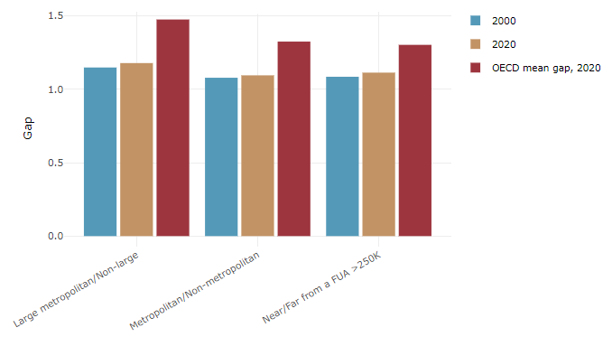

**Note**: Far from a FUA>250K includes regions near/with a small FUA and remote regions. OECD mean gap based on 1 586 TL3 regions in 27 countries with available data (no TL3 data for Australia, Canada, Chile, Colombia, Costa Rica, Iceland, Ireland, Israel, Mexico, Luxembourg and Switzerland).

**Source**: OECD Regional Database (2022).

In Spain, the gap between the upper and the lower half of regions in terms of labour productivity remained stable between 2001 and 2019. Over this period labour productivity grew roughly by 11% in both groups of regions. During 2020, the gap narrowed down. Nevertheless, more years of data are necessary to determine the long-term impact of the COVID-19 pandemic on labour productivity gaps in regions.

**Figure 3. Evolution of labour productivity, TL3 OECD regions**

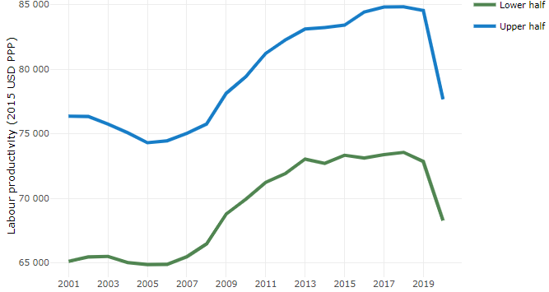

**Note**: A region is in the “upper half” if labour productivity was above the country median in the first year with available data and “lower half” if productivity was below the country median. Labour productivity in each group is equal to the sum of Gross Value Added, expressed in USD at constant prices and PPP (base year 2015) within the group, divided by the sum of total employment in regions within the group. Regions are small (TL3) regions, except for Australia, Canada, Chile, Colombia, Ireland, Mexico, Norway, Switzerland, Türkiye and the United States where they are large (TL2) regions due to data availability.

**Source**: OECD Regional Database (2022).

Regions where the economic activity shifts towards tradable activities, such as industry and tradable services, tend to grow faster in terms of labour productivity. In Spain, between 2001 and 2020, the share of workers in the industrial sector went down in all regions but more so in regions that used to be in the upper half of the labour productivity distribution. Hence, the evolution of employment shares in the industrial sector reduced the labour productivity gap between regions. At the same time, the share of workers in the tradable services sector went up in all regions, approximately by the same amount.

**Figure 4. Share of workers in most productive (tradable) sectors, TL3 OECD regions**

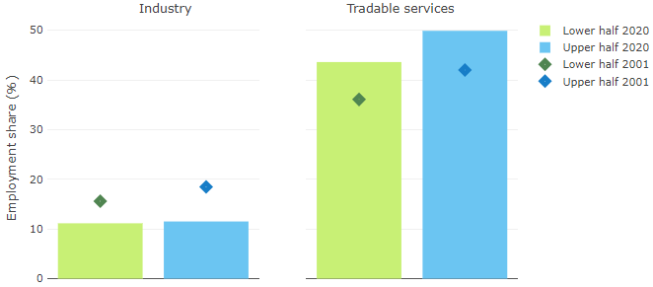

**Note**: A region is in the “upper half” if labour productivity was above the country median in the first year with available data and “lower half” if productivity was below the country median. The share of workers in a given sector for a group of regions is defined as the sum of employment in that sector within the group divided by the sum of total employment within the group. Regions are small (TL3) regions, except for Australia, Canada, Chile, Ireland, Mexico, Norway, Switzerland, Türkiye and the United States where they are large (TL2) regions due to data availability. Industry includes the following tradable goods sectors: Mining and quarrying (B), Manufacturing (C), Electricity, gas, steam and air conditioning supply (D) and Water supply; sewerage; waste management and remediation activities (E) NACE macro sectors. Tradable services include Information and communication (J), Financial and insurance activities (K), Real estate activities (L), Professional, scientific and technical activities (M), Administrative and support service activities (N).

**Source**: OECD Regional Database (2022).

## Recent policy developments

From the creation of the General Secretariat of Demographic Challenge, the following results have been achieved:

* 130 Measures Plan to face Demographic Challenge: more than 13 000 million EUR, with 85% of the measures active (early 2023). Main axis of action to foster cohesion: digital transition and full territorial connectivity; development and innovation in the territory; equal rights and opportunities for women and youth; strengthening public services and promoting decentralization; social welfare and care economy.
* Territorial Governance Mechanisms put in place: Government Delegate Commission for Demographic Challenge for the approval and coordination of national plans; and Demographic Challenge Sectoral Conferences, with regional representatives, for the coordination and identification of competence framework and agreement on distribution criteria and territorialization of resources.
* First Calls for innovative projects awarded in 2022 (267 projects aimed at reducing urban-rural inequalities and fight against depopulation for local authorities, non-profit entities and private companies, with special emphasis on young people and women).
* Distribution of credit to promote bioeconomy, green entrepreneurship and sustainable forest management (2022) and digital training actions (2023).
* Creation of 5 innovation centres spread over the territory in vulnerable areas to combat depopulation (job creation, knowledge transfer, creating networks).
* First edition of Rural Campus Program completed (400 internships carried out in rural areas).
* Yearly approval of Territorial Cohesion Fund to distribute financial resources among the regions, based on cohesion convergence criteria.
* Generation of Knowledge: integrated municipal data system (SIDAMUN).