# SWEDEN

The [OECD Regional Outlook](https://www.oecd-ilibrary.org/urban-rural-and-regional-development/oecd-regional-outlook_2dafc8cf-en) reviews recent trends, policy developments, and prospects across OECD regions, including the underlying causes driving regional inequalities in performance and well-being. The report offers evidence, guidance and policy recommendations on how to improve competitiveness and productivity, promote inclusive growth, accelerate the net-zero transition and raise well-being standards through effective regional development policy and multi-level governance.

## Territorial definitions

The data in this note reflect different sub-national geographic levels in OECD countries. In particular, **regions** are classified on two territorial levels reflecting the administrative organisation of countries: large regions (TL2) and small regions (TL3). In Canada, TL2 corresponds to the provinces and territories.

Small regions are classified according to their access to metropolitan areas (Fadic et al. 2019). The typology classifies small (TL3) regions into metropolitan and non-metropolitan regions according to the following criteria:

* **Metropolitan regions**, if more than half of the population live in a FUA. Metropolitan regions are further classified into **metropolitan large**, if more than half of the population live in a (large) FUA of at least 1.5 million inhabitants; and **metropolitan midsize**, if more than half of the population live in a (midsize) FUA of at 250 000 to 1.5 million inhabitants.
* **Non-metropolitan regions**, if less than half of the population live in a midsize/large FUA. These regions are further classified according to their level of access to FUAs of different sizes: **near a midsize/large FUA** if more than half of the population live within a 60-minute drive from a midsize/large FUA (of more than 250 000 inhabitants) or if the TL3 region contains more than 80% of the area of a midsize/large FUA; **near a small FUA** if the region does not have access to a midsize/large FUA and at least half of its population have access to a small FUA (i.e. between 50 000 and 250 000 inhabitants) within a 60-minute drive, or contains 80% of the area of a small FUA; and **remote**, otherwise.

Disclaimer: <https://oecdcode.org/disclaimers/territories.html>

Overview

|  |  |
| --- | --- |
| Population *(specify date)* and territory | 10,5 millions (nov 2022), 410 000 km2 |
| Administrative structure *(unitary/federal)* | Unitary |
| Regional or state-level governments *(number)* | 20 Regions and the municipality of Gotland with the responsibilities of both a region and a municipality.  21 county boards, government authorities at regional level. |
| Intermediate-level governments *(number)* | --- |
| Municipal-level governments *(number)* | 290 Municipalities (*kommuner*) |
| Share of subnational government in total expenditure/revenues (2021 | 49.5% of total expenditure  50.7% of total revenues  [Source: [Subnational governments in OECD countries: key data, 2023 edition](https://stats.oecd.org/Index.aspx?DataSetCode=SNGF)] |
| Key regional development challenges | * In the national strategy for sustainable regional development 2022–2030 five megatrends were defined: demographic change, globalisation, environment and climate, socio-economic challenges and cohesion, and finally technical development. * In the 2023 budget bill, the government also pointed out welfare and skills supply. * More recently, rising inflationary pressures and rising prices of energy. |
| Objectives of regional policy | Development power with strengthened local and regional competitiveness for sustainable development in all parts of the country. |
| Legal/institutional framework for regional policy | * Regional Development Responsibility Law (Lag 2010:630 om regionalt utvecklingsansvar) * Regulation 2017:583 on Regional growth work (*Förordning 2017:583 om regionalt tillväxtarbete*) * The Constitution, the Instrument of Government: Chapter 1, section 1, Self governance of municipalities and regions * Treaty on the Functioning of the European Union, Article 174. |
| Budget allocated to regional development (i.e., amount) and fiscal equalisation mechanisms between jurisdictions (if any) | * Regional policy approximately 2021–2027 includes ERDF, JTF and national budget (regional development and transport grant) €2,7 billions 2021–2027. * Economic equalisation for regional and local governments (municipalities) and equalisation of municipal costs for support and service (total 2023: SEK billion 152, 71 percent targeting municipalities, governmental grants approx. 90% of total.) |
| National regional development policy framework | * National strategy for sustainable regional development throughout Sweden 2021–2030 * Partnership Agreement 2021–2027 for Sweden which covers the strategic direction of European Regional Development Fund, Just Transition Fund, European Maritime and Fisheries Fund, European Social Fund+ |
| Urban policy framework | * Strategy for liveable cities – Policy for sustainable urban development. (Skr. 2017/18:230) |
| Rural policy framework | * Sweden has a national rural policy defined by the Coherent Rural Policy Bill 2018. Its main goal is to have viable rural areas with equal opportunities for enterprise, work, housing and welfare that lead to long-term sustainable development throughout the country. The policy specifies objectives, policy areas and measures for rural development. * Common agricultural policy 2023–2027 (LEADER) |
| Major regional policy tools (e.g., funds, plans, policy initiatives, institutional agreements, etc.) | * National grants for regional development (*Anslag 1:1 Regionala utvecklingsåtgärder inom utgiftsområde 19 Regional utveckling*) * European Regional Development Funds * Just Transition Fund * Regulation on regional transport grants (to companies in the four most northern counties of Sweden) (*Förordning 2000:281 om regionalt transportbidrag*) * Regulation on regional investment aids (Förordning 2015:211 om statligt stöd till regionala investeringar) * Regulation on aid to commercial services (grocery stores, petrol stations in rural areas) *(Förordning 2000:284 om stöd till kommersiell servic*e) * Regulation on grants for project activities within the regional growth policy (*Förordningen 2003 :596 om bidrag för projektverksamhet inom den regionala tillväxtpolitiken*) * Operating grants to the civil society * State grants for lagging municipalities (*Statsbidrag för socioekonomiskt eftersatta kommuner*) |
| Policy co-ordination tools at national level | * Ministry of Rural Affairs and Infrastructure * Co-ordination mechanism within the Swedish government offices and government and Collective decision-making in the government. * Agency of Economic and Regional Growth * Network of national agencies to improve co-ordination of policies and governance between national and regional level * Network for territorial analysis of national agencies |
| Multi-level governance mechanisms between national and subnational levels (e.g., institutional agreements, Committees, etc.) | * Forum for sustainable regional development 2022-2030, with politicians and civil servants * Network of national agencies to improve co-ordination of policies and governance between national and regional level * ERDF-monitoring committees * JTF-monitoring committe |
| Policy co-ordination tools at regional level | * Regional Development Strategies (*Regionals utvecklingsstrategier, RUS*) * 8 regional ERDF programmes * Service programmes (for developing commercial services * Reglab (a regional forum for regional capacity building) |
| Evaluation and monitoring tools | Regional development policy and Cohesion policy:   * The National Audit office’s policy reviews i.e.on the outcomes of national regional development policy, RiR 2022:8 * Evaluation plan for ERDF and JTF and diverse EU-COMM requirements of monitoring * National monitoring system (Agency for Economic and Regional Growth) for National regional grants (1.1 anslag) used in regions and at the National Agency for Economic and Regional Growth. Includes both quantitative and qualitative measurements. Results are presented in the government’s annual Budget bill. * Result indicators on regional development policy presented in Government´s annual Budget bill. * Advanced program evaluations by the National Agency for Growth Analysis and others * Region’s mandatory monitoring and evaluation activities (regulation 2017:583). Incl. indicators (economic, socio-economic and wellbeing) related to region’s development strategies * Furthermore, in Sweden, stakeholders at the national and regional level have developed a system of indicators for assessing the quality of life and sustainability of development at the regional and local level – the so called “GDP+” tool.   Rural policy:   * The rural development policy is accompanied by a monitoring and evaluation system based on indicators and qualitative methods for assessing the implementation and outcome of rural policy. Furthermore, the Rural development policy is reported as part of the governments process for yearly budgets. * The rural development program (of the CAP) is accompanied by a monitoring and evaluation plan and evaluations governed by the regulation of the programme (Board of Agriculture). |
| Future orientations of regional policy | In the 2023 Budget Bill, the government identified three development areas for the implementation of the National strategy for sustainable regional development throughout Sweden 2021–2030 on national level:  1. transition to sustainable regional development,  2. the importance of a territorial perspective where the whole country is given increased opportunity to develop and  3. a coordinated implementation where responsibilities and tasks are clear. |

## Regional Inequality Trends

Sweden experienced an increase in the Theil index of GDP per capita over 2000-2020. Inequality reached its maximum in 2020. The figures are normalized, with values in the year 2000 set to 1.

The Top 20%/Mean ratio was 0.011 higher in 2020 compared to 2000, indicating increased polarisation. The Bottom 20%/Mean ratio was 0.036 lower in the same period, indicating bottom divergence.

**Figure 1. Trends in GDP per capita inequality indicators, TL3 OECD regions**

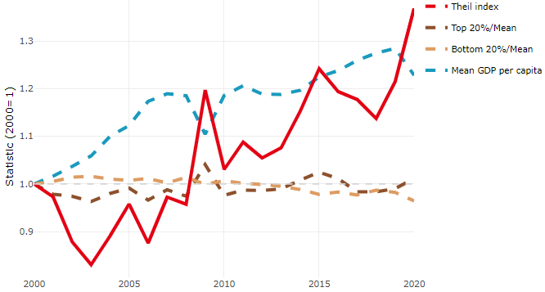

**Note**: Top/bottom calculated as population equivalent (top/bottom regions with at least 20% of the population). The interpretation of top/bottom 20% GDP per capita is that 20% of the population in the country holds 20% of the value. Top 20%/Mean calculated as mean GDP per capita in top 20% regions over mean TL3 GDP per capita in a given year. Bottom 20%/Mean calculated as mean TL3 GDP per capita in bottom 20% regions over mean TL3 GDP per capita in a given year. To improve data consistency, input series are aggregated when TL3 regions are part of the same FUA. To improve time series, TL3 missing values have been estimated based on the evolution at higher geographic level.

**Source**: OECD Regional Database (2022).

In 2020, the gap in GDP per capita between large metropolitan and non-large metropolitan regions was 1.684. For reference, the same value for OECD was 1.475. This gap increased by 0.028 percentage points between 2000 and 2020.

Meanwhile, in 2020, the gap in GDP per capita between metropolitan and non-metropolitan regions was 1.263. For reference, the same value for OECD was 1.325. This gap increased by 0.014 percentage points since 2000.

In turn, the gap in GDP per capita between regions near and far a Functional Urban Area (FUA) of more than 250 thousand inhabitants was 1.263 in 2020 and increased by 0.014 percentage points since 2000.

**Figure 2. GDP per capita gap by type of region compared to the OECD average**

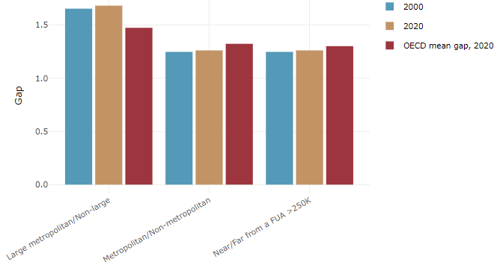

**Note**: Far from a FUA>250K includes regions near/with a small FUA and remote regions. OECD mean gap based on 1 586 TL3 regions in 27 countries with available data (no TL3 data for Australia, Canada, Chile, Colombia, Costa Rica, Iceland, Ireland, Israel, Mexico, Luxembourg and Switzerland).

**Source**: OECD Regional Database (2022).

In Sweden, the gap between the upper and the lower half of regions in terms of labour productivity remained stable between 2001 and 2019. Over this period labour productivity grew roughly by 27% in both groups of regions. During 2020, the gap remained stable. Nevertheless, more years of data are necessary to determine the long-term impact of the COVID-19 pandemic on labour productivity gaps in regions.

**Figure 3. Evolution of labour productivity, TL3 OECD regions**

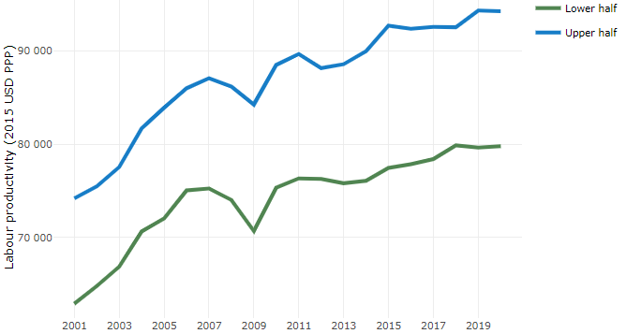

**Note**: A region is in the “upper half” if labour productivity was above the country median in the first year with available data and “lower half” if productivity was below the country median. Labour productivity in each group is equal to the sum of Gross Value Added, expressed in USD at constant prices and PPP (base year 2015) within the group, divided by the sum of total employment in regions within the group. Regions are small (TL3) regions, except for Australia, Canada, Chile, Colombia, Ireland, Mexico, Norway, Switzerland, Türkiye and the United States where they are large (TL2) regions due to data availability.

**Source**: OECD Regional Database (2022).

Regions where the economic activity shifts towards tradable activities, such as industry and tradable services, tend to grow faster in terms of labour productivity. In Sweden, between 2001 and 2020, the share of workers in the industrial sector went down in all regions but more so in regions that were already in the lower half of the labour productivity distribution. At the same time, the share of workers in the tradable services sector went up in all regions but more so in regions that were already in the upper half of the labour productivity distribution. Hence, the evolution of employment shares both in the industrial and in the tradable services sectors widened the labour productivity gap between regions.

**Figure 4. Share of workers in most productive (tradable) sectors, TL3 OECD regions**

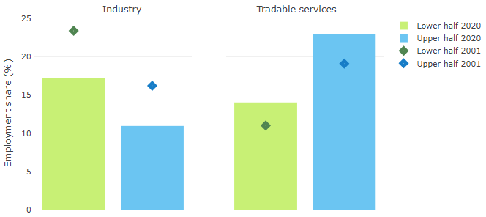

**Note**: A region is in the “upper half” if labour productivity was above the country median in the first year with available data and “lower half” if productivity was below the country median. The share of workers in a given sector for a group of regions is defined as the sum of employment in that sector within the group divided by the sum of total employment within the group. Regions are small (TL3) regions, except for Australia, Canada, Chile, Ireland, Mexico, Norway, Switzerland, Türkiye and the United States where they are large (TL2) regions due to data availability. Industry includes the following tradable goods sectors: Mining and quarrying (B), Manufacturing (C), Electricity, gas, steam and air conditioning supply (D) and Water supply; sewerage; waste management and remediation activities (E) NACE macro sectors. Tradable services include Information and communication (J), Financial and insurance activities (K), Real estate activities (L), Professional, scientific and technical activities (M), Administrative and support service activities (N).

**Source**: OECD Regional Database (2022).

## Recent policy developments

The National strategy for sustainable regional development throughout Sweden 2021–2030 is the framework for the regional development policy until 2030. The national strategy was submitted by the previous government in March 2021 in the form of a letter (*skr. 2020/21:133*) to the Parliament (Riksdag). The Riksdag approved it in June 2022 in accordance with the proposal of the Committee on Industry and Trade. The strategy highlights three basic prerequisites for effective implementation:

* capacity for regional and local development work
* regional consideration and cooperation between state agencies, regions and other actors, as well as
* learning through analysis, follow-up, evaluation and research.

In the strategy, there are four strategic areas that will form the basis for the implementation of the regional development policy 2021–2030. The strategy with its strategic areas and priorities is indicative for the regional development strategies of the regions.

* equal opportunities for housing, work and welfare throughout the country
* competence supply and competence development throughout the country
* innovation and renewal as well as entrepreneurship and business development throughout the country
* accessibility throughout the country through digital communication and the transport system.

The commission approved the Swedish partnership agreement in May 2022. The Partnership Agreement sets out the strategic orientation for the European Regional Development Fund (ERDF), the Just Transition Fund (JTF), the European Social Fund+ (ESF+) and the European Maritime, Fisheries and Aquaculture Fund (EMFAF).

All ERDF-programs, including all Interreg programs in which Sweden participates, were approved in 2022. The national program and the eight regional programmes comprise a total of approximately EUR 2,1 billion, including Swedish co-financing during the program period. In addition, the national envelope from ERDF regarding cross-border and transnational cooperation is EUR 358 million. The implementation of the ERDF-programs means that important investments in entrepreneurship, innovations, energy efficiency, climate change, circular economy and cross-regional cooperation can be made around the country.