# SWITZERLAND

The [OECD Regional Outlook](https://www.oecd-ilibrary.org/urban-rural-and-regional-development/oecd-regional-outlook_2dafc8cf-en) reviews recent trends, policy developments, and prospects across OECD regions, including the underlying causes driving regional inequalities in performance and well-being. The report offers evidence, guidance and policy recommendations on how to improve competitiveness and productivity, promote inclusive growth, accelerate the net-zero transition and raise well-being standards through effective regional development policy and multi-level governance.

## Territorial definitions

The data in this note reflect different sub-national geographic levels in OECD countries. In particular, **regions** are classified on two territorial levels reflecting the administrative organisation of countries: large regions (TL2) and small regions (TL3). In Canada, TL2 corresponds to the provinces and territories.

Small regions are classified according to their access to metropolitan areas (Fadic et al. 2019). The typology classifies small (TL3) regions into metropolitan and non-metropolitan regions according to the following criteria:

* **Metropolitan regions**, if more than half of the population live in a FUA. Metropolitan regions are further classified into **metropolitan large**, if more than half of the population live in a (large) FUA of at least 1.5 million inhabitants; and **metropolitan midsize**, if more than half of the population live in a (midsize) FUA of at 250 000 to 1.5 million inhabitants.
* **Non-metropolitan regions**, if less than half of the population live in a midsize/large FUA. These regions are further classified according to their level of access to FUAs of different sizes: **near a midsize/large FUA** if more than half of the population live within a 60-minute drive from a midsize/large FUA (of more than 250 000 inhabitants) or if the TL3 region contains more than 80% of the area of a midsize/large FUA; **near a small FUA** if the region does not have access to a midsize/large FUA and at least half of its population have access to a small FUA (i.e. between 50 000 and 250 000 inhabitants) within a 60-minute drive, or contains 80% of the area of a small FUA; and **remote**, otherwise.

Disclaimer: <https://oecdcode.org/disclaimers/territories.html>

Overview

|  |  |
| --- | --- |
| Population *(specify date)* and territory | 8 812 700 (as of January 1, 2022), 41 291 km2 |
| Administrative structure *(unitary/federal)* | federal |
| Regional or state-level governments *(number)* | 26 cantons |
| Intermediate-level governments *(number)* | N/A |
| Municipal-level governments *(number)* | 2148 (as of January 1, 2022) |
| Share of subnational government in total expenditure/revenues (2021) | 60.1% of total expenditure  61.4% of total revenues  [Source: [Subnational governments in OECD countries: key data, 2023 edition](https://stats.oecd.org/Index.aspx?DataSetCode=SNGF)] |
| Key regional development challenges | * The rural exodus and its corollary, the strong ageing of the remaining population, pose problems for the peripheral regions of the Alpine region and their economic development. * Demographic change and with it, the industrialization of agriculture that leads to a multiplication of constructions outside of the building zone, which reinforces the sprawl and degrades the landscapes in a more visible way. * The lack of an adequate local workforce * Sustainable use of (esp. water) resources in mountain areas and rural areas to ensure security of supply, especially with energy. * Complex Swiss ecosystem (decentralized country) |
| Objectives of regional policy | The federal government and the cantons created the Swiss regional policy to support Switzerland's mountain regions, other rural regions, and border regions in dealing with their structural changes. This economic development program promotes projects, initiatives, and programs that improve the economic framework conditions for entrepreneurial activities and sustainably enhance innovation capacity, value creation, and, thus, competitiveness. In this way, the Swiss regional policy contributes to creating and preserving jobs in the regions concerned. Indirectly, it contributes to the decentralized use of the territory and the reduction of regional disparities. |
| Legal/institutional framework for regional policy | 700 / Federal act on Spatial Planning  700.1 / Ordinance on Spatial Planning  709.17 / Ordinance on coordination and cooperation in spatially relevant federal tasks  901.0 / Federal Law on Regional Policy  901.021 / Ordinance on Regional Policy  910.1 / Federal Act on Agriculture  19.016 / Message on economic promotion for the years 2020 – 2023 |
| Budget allocated to regional development (i.e., amount) and fiscal equalisation mechanisms between jurisdictions (if any) | Approximately CHF 320 million are available to regional development for the years 2016 to 2023. On the fiscal equalization mechanisms, we possess the National fiscal equalization. Federalism is one of Switzerland’s fundamental principles. The 26 cantons and 2,148 communes have extensive powers. Fiscal equalization is thus also important for the unity of the country. It is based on the principle of solidarity: the economically strong cantons and the Confederation help out the economically weaker cantons. |
| National regional development policy framework | Broader Sense: Swiss Umbrella strategy on “coherent spatial development” which aims at aligning spatial effects of sectoral and regional policies in urban and rural areas and their interlinkages  Narrow Sense: The New Regional Policy (NRP) is the Swiss national regional development policy framework based on the Federal Law on Regional Policy.  Regional innovation system  Interreg programs A / B & C |
| Urban policy framework | Through the agglomeration policy (AggloPol), the federal government supports Switzerland's agglomerations with their cities and municipalities in further sustainable development. Several specific measures are available for the implementation of the policy. These complement the measures of various sectoral policies, such as transport or social policies. As a cross-cutting policy, AggloPol also provides a framework of objectives and actions for implementing and coordinating the various sectoral policies in urban areas. |
| Rural policy framework | PERM - Policy for rural areas and mountain regions  The New Regional Policy (NRP)  The agricultural policy |
| Major regional policy tools (e.g., funds, plans, policy initiatives, institutional agreements, etc.) | 26 Cantonal development policies are active and work with the government to enhance each region and answer their particular needs. |
| Policy co-ordination at national level | State Secretariat for Economic Affairs, Regional and spatial planning policy |
| Multi-level governance mechanisms between national and subnational levels (e.g., institutional agreements, Committees, etc.) | Conference of Cantonal Services |
| Policy co-ordination tools at regional level |  |
| Evaluation and monitoring tools | Regional systems of evaluation and monitoring  Regular extern assessments  Governmental Indicators (outcomes / output) from defined objectives |
| Future orientations of regional policy | Broader Sense: Strategy on coherent spatial development undergoes an actualization.  Narrow Sense: With the program 2024-2017, the future orientations of the NRP will enter its third eight-year period (2024-2031). The former priority themes of "Industry / Innovation" and "Tourism" will be maintained. Smaller infrastructures can now be supported under certain conditions with non-repayable contributions. In addition to "local economy," which complements the export-oriented approach of NPR, sustainability, and digitalization will be particularly important cross-cutting themes. |

## Regional Inequality Trends

Switzerland experienced an increase in the Theil index of GDP per capita over 2000-2020. Inequality reached its maximum in 2018. The figures are normalized, with values in the year 2008 set to 1.

The Top 20%/Mean ratio was 0.028 lower in 2020 compared to 2000, indicating decreased polarisation. The Bottom 20%/Mean ratio was 0.018 lower in the same period, indicating bottom divergence.

**Figure 1. Trends in GDP per capita inequality indicators, TL2 OECD regions**

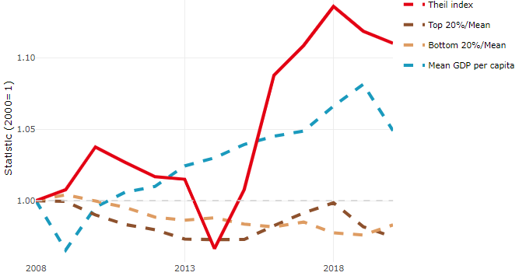

**Note**: Top/bottom calculated as population equivalent (top/bottom regions with at least 20% of the population). The interpretation of top/bottom 20% GDP per capita is that 20% of the population in the country holds 20% of the value. Top 20%/Mean calculated as mean GDP per capita in top 20% regions over mean TL3 GDP per capita in a given year. Bottom 20%/Mean calculated as mean TL3 GDP per capita in bottom 20% regions over mean TL3 GDP per capita in a given year. To improve data consistency, input series are aggregated when TL3 regions are part of the same FUA. To improve time series, TL3 missing values have been estimated based on the evolution at higher geographic level.

**Source**: OECD Regional Database (2022).

There is no data for the gap in GDP per capita between large metropolitan and non-large metropolitan regions for 2000 and 2020.

Meanwhile, in 2020, the gap in GDP per capita between metropolitan and non-metropolitan regions was 1.11. For reference, the same value for OECD was 1.325. This gap decreased by 0.057 percentage points since 2000.

In turn, the gap in GDP per capita between regions near and far a Functional Urban Area (FUA) of more than 250 thousand inhabitants was 1.183 in 2020 and decreased by 0.077 percentage points since 2000.

**Figure 2. GDP per capita gap by type of region compared to the OECD average**

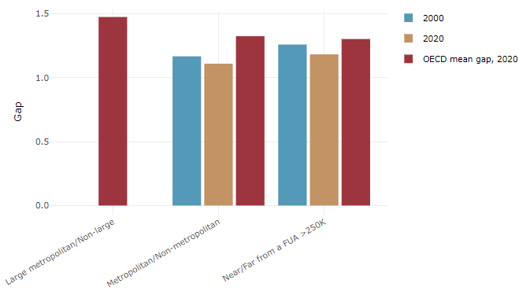

**Note**: Far from a FUA>250K includes regions near/with a small FUA and remote regions. OECD mean gap based on 1 586 TL3 regions in 27 countries with available data (no TL3 data for Australia, Canada, Chile, Colombia, Costa Rica, Iceland, Ireland, Israel, Mexico, Luxembourg and Switzerland).

**Source**: OECD Regional Database (2022).

In Switzerland, the gap between the upper and the lower half of regions in terms of labour productivity remained stable between 2011 and 2019. Over this period labour productivity grew roughly by 6% in both groups of regions. During 2020, the gap narrowed down. Nevertheless, more years of data are necessary to determine the long-term impact of the COVID-19 pandemic on labour productivity gaps in regions.

**Figure 3. Evolution of labour productivity, TL2 OECD regions**

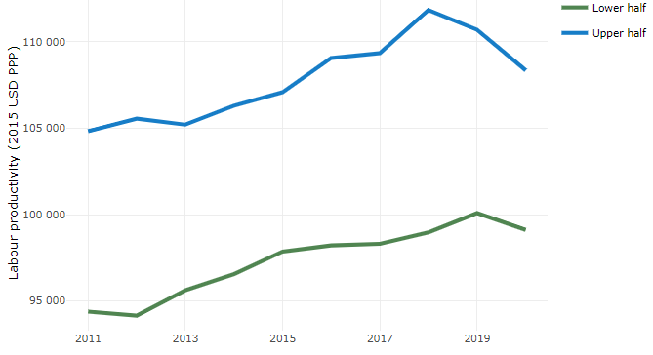

**Note**: A region is in the “upper half” if labour productivity was above the country median in the first year with available data and “lower half” if productivity was below the country median. Labour productivity in each group is equal to the sum of Gross Value Added, expressed in USD at constant prices and PPP (base year 2015) within the group, divided by the sum of total employment in regions within the group. Regions are small (TL3) regions, except for Australia, Canada, Chile, Colombia, Ireland, Mexico, Norway, Switzerland, Türkiye and the United States where they are large (TL2) regions due to data availability.

**Source**: OECD Regional Database (2022).

Regions where the economic activity shifts towards tradable activities, such as industry and tradable services, tend to grow faster in terms of labour productivity. In Switzerland, between 2011 and 2020, the share of workers in the industrial sector went down in all regions, approximately by the same amount. At the same time, the share of workers in the tradable services sector went up in all regions, approximately by the same amount.

**Figure 4. Share of workers in most productive (tradable) sectors, TL2 OECD regions**

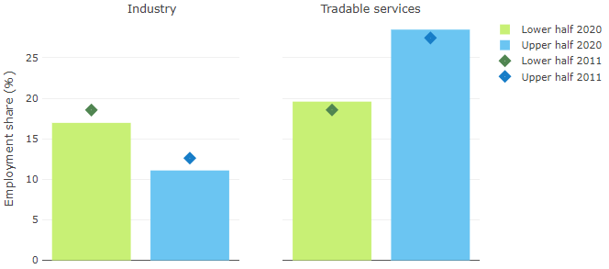

**Note**: A region is in the “upper half” if labour productivity was above the country median in the first year with available data and “lower half” if productivity was below the country median. The share of workers in a given sector for a group of regions is defined as the sum of employment in that sector within the group divided by the sum of total employment within the group. Regions are small (TL3) regions, except for Australia, Canada, Chile, Ireland, Mexico, Norway, Switzerland, Türkiye and the United States where they are large (TL2) regions due to data availability. Industry includes the following tradable goods sectors: Mining and quarrying (B), Manufacturing (C), Electricity, gas, steam and air conditioning supply (D) and Water supply; sewerage; waste management and remediation activities (E) NACE macro sectors. Tradable services include Information and communication (J), Financial and insurance activities (K), Real estate activities (L), Professional, scientific and technical activities (M), Administrative and support service activities (N).

**Source**: OECD Regional Database (2022).

## Recent policy developments

The Confederation's multi-year program 2024-2027 defines the following priorities:

Industry: Innovative products and companies are an important factor in Switzerland's prosperity. The NPR supports innovation in SMEs at the business-to-business level in rural areas, mountain regions, and border regions. This support is provided mainly through the six "Regional innovation systems" (RIS), which promote competitiveness and innovation capacity, help for access to technological innovation and innovation that goes beyond technological innovation, offer support and coordinated services in the areas of information, advice, networking, infrastructure, and financing.

Tourism: Tourism is vital to the regional economy, especially in mountain regions. The NPR encourages the development of new tourism offers and innovative products in this field. It also promotes collaborative projects between destinations and participates in financing tourism infrastructures that increase value creation in the region.

Digitalisation: Digitalisation affects all areas of the economy. NPR supports and promotes digitalisation projects within its scope of impact. It also invests in awareness-raising and networking measures to prevent regions from being left behind in the digital age.

In addition to these priorities mentioned above, for the period 2024-2027, sustainability and social innovation will become central. As a result, projects in these areas will be fostered.