ICELAND

Overview

|  |  |
| --- | --- |
| Population *(specify date)* and territory | 376.248 (as of January 1, 2022), 103.000 km2 |
| Administrative structure *(unitary/federal)* | Unitary country. |
| Regional or state-level governments *(number)* | Iceland has two administrative levels of government: the State and the municipalities (64). Article 78 of the Icelandic constitution refers to the municipalities.  „The municipalities shall manage their affairs independently as laid down by law. The income sources of the municipalities, and the right of the municipalities to decide whether and how to use their sources of income, shall be regulated by law.” |
| Intermediate-level governments *(number)* | 8 regional associations of local authorities |
| Municipal-level governments *(number)* | 64 |
| Share of subnational government in total expenditure/revenues (2021) | 29.0% of total expenditure  32.2% of total revenues  [Source: [Subnational governments in OECD countries: key data, 2023 edition](https://stats.oecd.org/Index.aspx?DataSetCode=SNGF)] |
| Key regional development challenges | The following five key priority areas that are addressed in the parliamentary resolution on a strategic regional plan for the period 2022–2036 to meet the impending challenges in the field of regional development:  1. Demographic development and basic services.  2. Diverse economic activities.  3. Infrastructure.  4. Environmental and climate change issues.  5. International competitiveness and sustainability of communities.  Strengthening the local government level and gender-equality perspective shall be incorporated while resolving these challenges. |
| Objectives of regional policy | The government’s regional development objectives pursuant to the Act on Regional Planning and Initiatives are to:  A. Equalise access to services,  B. Equalise employment opportunities,  C. Promote sustainable development of communities throughout the country. |
| Legal/institutional framework for regional policy | The parliament (Alþingi) resolves to task the government with implementing the following 15-year regional development policy and five-year action plan (The Act on Strategic Regional Plan and Regional Plans of Action [Act 69 of July 9 2015](https://www.althingi.is/lagas/nuna/2015069.html)) and to take this implementation into account when drawing up the annual general budget and in the five-year fiscal plan.  The Icelandic Regional Development Institute (*Byggðastofnun*) was founded in 1985 and falls under [Act. No 106 of December 27 1999](https://www.byggdastofnun.is/static/files/Log_og_reglugerd/byggdastofnun-log-106-1999-enska-2014.pdf) and [Regulation No 347 of May 16 2000](https://www.byggdastofnun.is/static/files/Log_og_reglugerd/byggdastofnun-reglugerd-347-2000-enska-2014.pdf). It is an independent state-owned institute and heres under the ultimate authority of the Minister of Infrastructure. The function of Byggðastofnun is to promote rural settlement and economic activity, with special emphasis on the creation of equal opportunities for all inhabitants to employment and habitation. In accordance with its function Byggðastofnun prepares, organizes and funds projects and provides loans with the aim of bolstering regional settlement, boosting employment and encouraging innovation in business and industry.  Byggðastofnun organizes and contributes to consultancy services in co-operation with economic development agencies, local authorities, and other interested parties.  Regional plans of action (RPA) are a joint project of national and local authorities. The Act on Strategic Regional Plan and Regional Plans of Action [Act 69 of July 9 2015](https://www.althingi.is/lagas/nuna/2015069.html)(in Icelandic) established the procedures and ethos of RPA. The aim of the legislation is to support regional development and increase consultation in regional affairs between ministries, within each region and between administrative levels. The responsibility of local authorities in regional and community development would also be increased.  The eight regional associations of local authorities are responsible for implementing the initiatives of regional plans of Actions through five-year contracts with the government. The country is divided into eight regions.  The government’s steering group for regional development as defined in law supports the regional associations of local authorities in developing and executing regional initiatives. The role of the steering group includes increasing coordination within the government in matters pertaining to regional development and ensuring active consultation with the municipal level. The steering group has representatives from all government ministries and the Icelandic Association of Local Authorities, as well as observers from the Icelandic Regional Development Institute and the regional associations of local authorities. The Minister responsible for regional matters appoints members to the group and the Minister’s representative chairs the group. |
| Budget allocated to regional development (i.e., amount) and fiscal equalisation mechanisms between jurisdictions (if any) | |  |  |  | | --- | --- | --- | | **Breakdown of the 2022–2026 fiscal framework for regional development.** | **2022** | **2023** | | ***Regional development total*** | ***2078*** | ***1969*** | | Strategic Regional plan | 923 | 875 | | *Proportion of allocated to the action plan* | *647* | *661* | | Regional plans of action | 569 | 569 | | The Regional Development Institute | 213 | 211 | | Employment consultants in regional Iceland | 206 | 204 | | Transport cost equalization | 167 | 167 | | ***Other equalization measures*** | **55.600** | **72.600** | | Local Authorities' Equalization Fund | 55.000 | 72.000 | | Loftbrú - Lower airfares for residents in rural areas | 600 | 600 |   * Adjusted to 2022 fiscal plan price levels In ISK million |
| National regional development policy framework | The objective of the act on Strategic Regional Plan and Regional Plans of Action Act 69 of July 9 2015, continues to strengthen regional development and increase consultation between ministries in the field of regional affairs, within each part of the country and between levels of government, and to transfer to local authorities greater responsibility in the field of regional and community development. Regional development matters are governed by the Ministry of Infrastructure, but inherently involve most policy areas, thus touching all ministries. |
| Urban policy framework | A NUP has not been formed in Iceland to the current point. One of the action in current regional development plan for the period 2022–2036, is the National Urban policy (C.4), The objective of the action is to strengthen the largest urban areas, Reykjavík and Akureyri, and strengthen their competitiveness and role in regional development. Policies will be formulated that, on the one hand, define the role of Reykjavik as the capital city and contribute to increased international competitiveness of the capital region and, on the other hand, the role and development of Akureyri as a regional city that can offer greater diversity in services, culture and job opportunities. This effort shall be based on the OECD principles on the development and content of national urban policy, as applicable. |
| Rural policy framework | Parliamentary resolution on Strategic Regional Plan (SRP) for the period 2022–2036 |
| Major regional policy tools (e.g., funds, plans, policy initiatives, institutional agreements, etc.) | The parliament (Alþingi) resolves that work shall be carried out in accordance with a five-year action plan with 44 actions to ensure progress towards the objectives set out in the regional development plan 2022-2036.  Individual ministries shall finance actions as applicable. Funds allocated under the regional development plan shall be used for financing individual actions, either co-financing along with the responsible and implementing parties or fully, as dictated by the budget allocations.  Institute of Regional Development organizes and works on consultancy with rural industries in collaboration with business development associations, municipalities, and others. |
| Policy co-ordination tools at national level | The government’s steering group for regional development supports the regional associations of local authorities in developing and executing regional initiatives. The role of the steering group includes increasing coordination within the government in matters pertaining to regional development and ensuring active consultation with the municipal level. The steering group has representatives from all government ministries and the Icelandic Association of Local Authorities, as well as observers from the Icelandic Regional Development Institute and the regional associations of local authorities. The Minister responsible for regional matters appoints members to the group and the Minister’s representative chairs the group. |
| Multi-level governance mechanisms between national and subnational levels (e.g., institutional agreements, Committees, etc.) | Regional plans of action (RPA) are an innovation in public administration and a joint project of national and local authorities. The Act on Strategic Regional Plan and Regional Plans of Action from 2015 established the procedures and ethos of RPA. The aim of the legislation is to support regional development and increase consultation in regional affairs between ministries, within each region and between administrative levels. The responsibility of local authorities in regional and community development would also be increased. |
| Policy co-ordination tools at regional level | Each region has a consultation forum that is directly involved in formulating and carrying out the initiative. Such forums include representatives from:   * Municipalities Public institutions in the region * The business sector * The cultural sector * The academic community * Non-governmental organizations |
| Evaluation and monitoring tools | The SRP has three metrics to evaluate each of its three main objectives:  A. Equalize access to services,  1. Discrepancies in household heating costs.  2. Percentage of those living within 30 kilometers of healthcare centers, preschools, primary schools, secondary schools, and general grocery shops.  3. Proportional school attendance at the secondary school and university levels, in the age groups of 16–24 years and 24 years and older, respectively.  B. Equalize employment opportunities,  1. Participation in employment and average employment incomes.  2. Ratio of government jobs to population/total number of full-time equivalents.  3. Educational level (25–64 years)  C. Promote sustainable development of communities throughout the country.  1. Dependency ratio.  2. Demographic vulnerabilities.  3. Municipal climate policies: cf. the metrics provided by the Icelandic climate action plan.  Most of these metrics can be monitored on a dashboard that is under development on the homepage of the Icelandic Regional Development Institute. |
| Future orientations of regional policy | Flourishing communities and robust population centers should be found in all parts of the country, in which improved living standards and freedom of residence are promoted, through equal access to basic services, housing and diverse employment opportunities.   * Basic services should be provided to inhabitants in their immediate community as far as possible. * The Reykjavík metropolitan area shall be a center of public administration and central services to which all people in the country have good access to. * Regional affairs shall be integrated with other functions as applicable. Public sector strategy and planning shall be guided by climate change issues and sustainable development and impacts on the development of individual communities and habitation should be examined and assessed. |

Recent policy developments

The Strategic Regional Plan (SRP) of Iceland 2022-2036 is an integrated social and economic development plan that provides a framework for regional support. Its main goals are to address depopulation in individual regions; address the lack of economic and industrial diversity; support technological changes and the development and adaption of individual industries; outline necessary adaption measures to counter the impacts of climate change; ensure smooth communications and access to services and respond to increasing competition for people and companies.

The following points are examples of challenges and opportunities that are addressed in a novel or more decisive way than in previous SRP’s

* Existing knowledge on the effects of climate change, risk assessments and impacts on biological diversity are to be considered in all policy making, planning and decisions concerning the development of communities, land use and planning on land, sea and in coastal areas. In this regard a special action in the SRP has the objective … “to formulate a comprehensive approach to the adaptation of municipalities to the effects impacts of climate change.” This is in line with the emphasis of the Nordic Council of Ministers
* Following a steep increase in number of immigrants an emphasis is on facilitating social diversity and demographic factors, such as gender, age and origin and the opportunities inherent in the human resources of each rural community are to be fully utilised. In that regard a special action will be implemented with the objective to increase awareness of the importance of equality and diversity within local governments by supporting their efforts to reflect the diversity of human society so that their decision making serves the needs and benefits the entire population while being in compliance with their gender equality plans.
* In effort to boost the international competitiveness of the country for investments and human capital along with equalizing the access to jobs and services for the whole population a special focus is on the urban – rural linkage. For that purpose, a designated action is on the SRP with the aim to define the role of the two largest urban areas in the overall regional development of the country. The work will be executed in the OECD NUP framework as applicable.
* The contemporary digital revolution has already weakened the ties between subsistence and residence in many occupations and that opens opportunities for more freedom of residence which is the aim of one the 44 actions of the SRP by increasing the number of location independent jobs to increase the variety of jobs in rural areas. The prospects of communities may thus increasingly be determined by factors such as natural amenities, spatial planning, the provision of services to children and the elderly, cultural and recreational opportunities, and beyond anything else a good and enjoyable social life.

***Labour income per capita by regions***

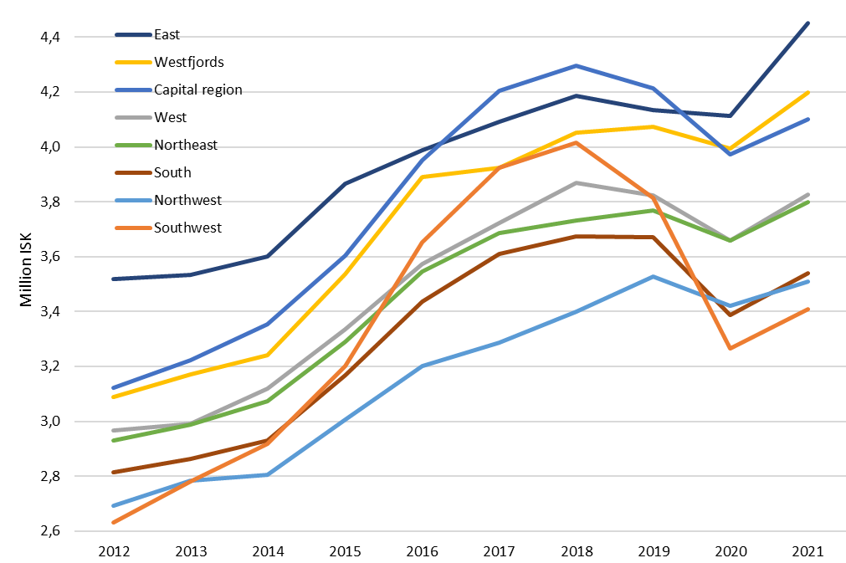

***Share of industries in total taxable wages by regions***

