Site Plan

# Site Purpose

OE Design exists to showcase the creative and technical capabilities of a modern front-end developer. The website serves  
 as a professional portfolio for Elujoba Oluwaseyi Ebenezer, highlighting his work in web design and development. It  
 offers potential clients and collaborators a clear view of his skills, services, and design philosophy. OE Design  
 focuses on creating visually appealing, responsive, and user-centered websites that solve real-world problems. The site  
 also aims to build trust, attract freelance opportunities, and eventually grow into a full-service digital design brand.

# Scenerios

Potential Client Browsing for a Web Designer:  
 Scenario: A small business owner wants a clean, user-friendly website for their brand and searches online for freelance  
 web designers.  
 How OE Design Helps:  
   
 The portfolio showcases examples of past projects.  
   
 The “Services” page outlines affordable packages.  
   
 Contact form allows direct outreach for a quote.

Recruiter Looking for Front-End Talent:  
 Scenario: A tech recruiter is scouting for junior front-end developers with a strong eye for design and coding.  
 How OE Design Helps:  
   
 Clear display of skills (HTML, CSS, JavaScript, React).  
   
 Project case studies show problem-solving and implementation.  
   
 Resume and LinkedIn links are available.

Student or Beginner Developer Seeking Inspiration  
 Scenario: A new developer visits OE Design to see how others structure and present their web dev work.  
 How OE Design Helps:  
   
 Clear layout of projects, tools used, and code snippets.  
   
 Blog or tips section (if available) gives advice on design principles or tech stack choices.  
   
 Shows what a polished beginner-to-intermediate portfolio looks like.

# Color Schema

Headings: #2E1435

Paragraphs: #EAE8E7

Paragraphs1: #C7C5C4

Background_Colors: #F9F9F9

Background_colors1: #1F0D26

Accents: #0DCCCA

# Typography

Inter

# Wireframe

1. Wide Screen

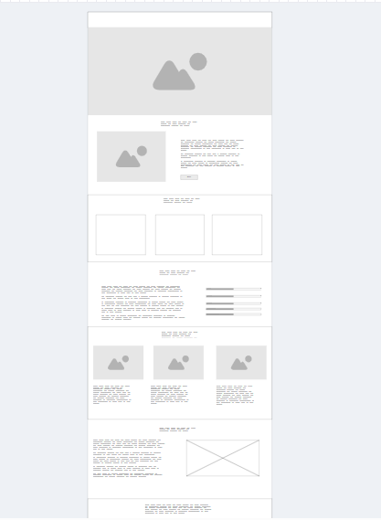

1. Mobile Screen

