Trivadis Markdown Doc Template

A template for markdown based documentation

Stefan Oehrli

Table of Contents

# Formatting Examples

## Basic Syntax

These are the elements outlined in John Gruber’s original design document. All Markdown applications support these elements.

### Heading

Headings are created with a #. Where the number of # corresponds to the level of the heading.

# This is an <h1> tag  
## This is an <h2> tag  
### This is an <h3> tag

### Emphasis

*This text will be italic*  
_This will also be italic_  
  
**This text will be bold**  
__This will also be bold__  
  
_You **can** combine them_

*This text will be italic* *This will also be italic*

**This text will be bold** **This will also be bold**

*You* ***can*** *combine them*

### Blockquote

> blockquote

blockquote

### Ordered List

1. First item
2. Second item
3. Third item

### Unordered List

* First item
* Second item
* Third item

### Code

code

### Horizontal Rule

### Link

[title](https://www.example.com)

### Image

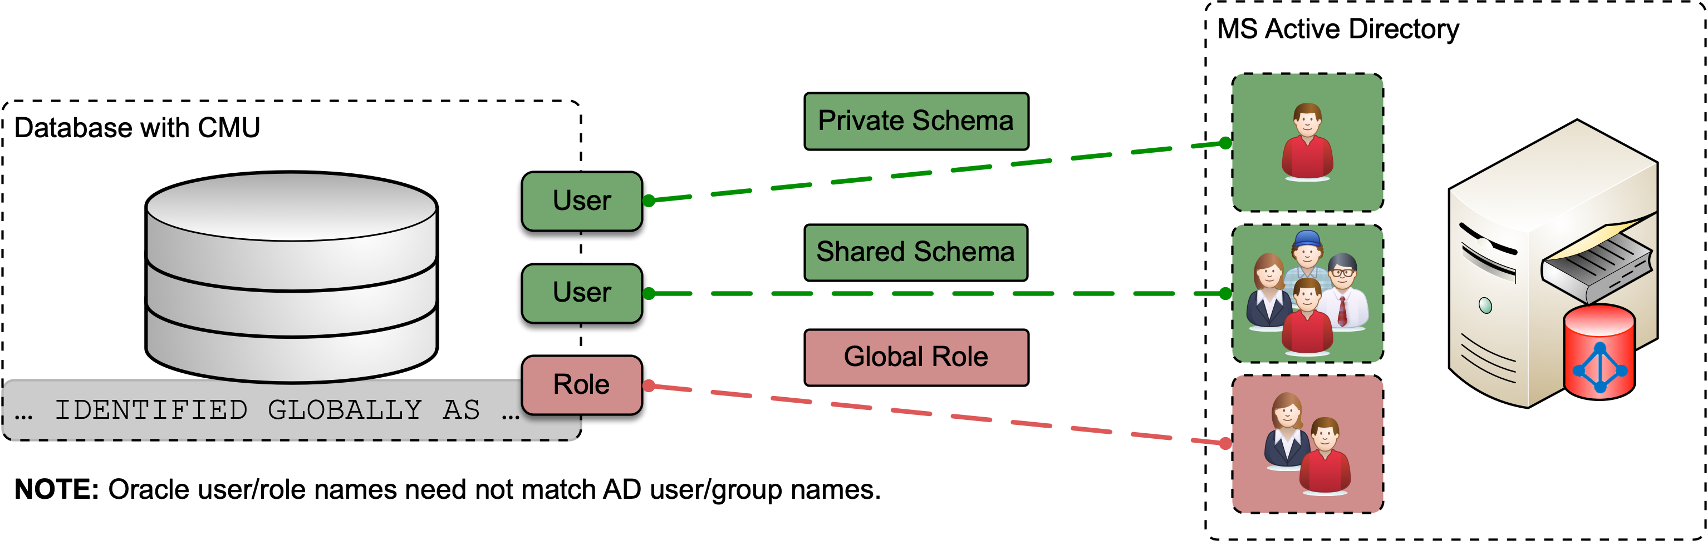

“Oracle Centrally Managed Users Overview”

## Extended Syntax

These elements extend the basic syntax by adding additional features. Not all Markdown applications support these elements.

### Table

| Syntax | Description |
| --- | --- |
| Header | Title |
| Paragraph | Text |

### Fenced Code Block

{  
 "firstName": "John",  
 "lastName": "Smith",  
 "age": 25  
}

### Footnote

Here’s a sentence with a footnote. [1]

### Heading ID

### My Great Heading

### Definition List

term

definition For a list of all available boxes and options visit theFor a list of all available boxes and options visit theFor a list of all available boxes and options visit the

### Strikethrough

~~The world is flat.~~

### Task List

* ☒ Write the press release
* ☐ Update the website
* ☐ Contact the media

## Box Types

For a list of all available boxes and options visit the [awesomebox documentation](https://ctan.org/pkg/awesomebox).

::: note  
**Note** Lorem ipsum dolor ...  
:::

Lorem ipsum dolor sit amet, consectetur adipiscing elit. Nam aliquet libero quis lectus elementum fermentum.

Fusce aliquet augue sapien, non efficitur mi ornare sed. Morbi at dictum felis. Pellentesque tortor lacus, semper et neque vitae, egestas commodo nisl.

::: tip  
**Tip** Lorem ipsum dolor ...  
:::

**Tip** Lorem ipsum dolor sit amet, consectetur adipiscing elit. Nam aliquet libero quis lectus elementum fermentum.

Fusce aliquet augue sapien, non efficitur mi ornare sed. Morbi at dictum felis. Pellentesque tortor lacus, semper et neque vitae, egestas commodo nisl.

::: warning  
**Warning** Lorem ipsum dolor ...  
:::

**Warning** Lorem ipsum dolor sit amet, consectetur adipiscing elit. Nam aliquet libero quis lectus elementum fermentum.

Fusce aliquet augue sapien, non efficitur mi ornare sed. Morbi at dictum felis. Pellentesque tortor lacus, semper et neque vitae, egestas commodo nisl.

::: warning  
**Caution** Lorem ipsum dolor ...  
:::

**Caution** Lorem ipsum dolor sit amet, consectetur adipiscing elit. Nam aliquet libero quis lectus elementum fermentum.

Fusce aliquet augue sapien, non efficitur mi ornare sed. Morbi at dictum felis. Pellentesque tortor lacus, semper et neque vitae, egestas commodo nisl.

::: important  
**Important** Lorem ipsum dolor ...  
:::

**Important** Lorem ipsum dolor sit amet, consectetur adipiscing elit. Nam aliquet libero quis lectus elementum fermentum.

Fusce aliquet augue sapien, non efficitur mi ornare sed. Morbi at dictum felis. Pellentesque tortor lacus, semper et neque vitae, egestas commodo nisl.

Markdown formatting inside the environments is supported.

**Lorem ipsum dolor** sit amet, consectetur adipiscing elit.

if(args.length < 2) {  
 System.out.println("Lorem ipsum dolor sit amet");  
}

*Nam aliquet libero quis lectus elementum fermentum.*

**Trivadis** Lorem ipsum dolor sit amet, consectetur adipiscing elit. Nam aliquet libero quis lectus elementum fermentum.

Fusce aliquet augue sapien, non efficitur mi ornare sed. Morbi at dictum felis. Pellentesque tortor lacus, semper et neque vitae, egestas commodo nisl.

**Trivadis** Lorem ipsum dolor sit amet, consectetur adipiscing elit. Nam aliquet libero quis lectus elementum fermentum.

Fusce aliquet augue sapien, non efficitur mi ornare sed. Morbi at dictum felis. Pellentesque tortor lacus, semper et neque vitae, egestas commodo nisl.

1. This is the footnote.