

by Lev Kiwi, PhD

Whitepaper BI

BI with a future –

exact predictions of your business development

How to look to the future   
with your existing BI solution

Business intelligence helps companies draw conclusions from the past. Using an intelligent algorithm, BI solutions can also be enabled to make predictions about future developments.

Data analysis with business intelligence solutions is like looking into the rear-view mirror. The course followed can be traced junction by junction, turn by turn, and each section of the journey up to now can be examined in detail. This allows conclusions to be drawn about how to adapt the driving style in order to be even more efficient on the road in the future. However, you can’t deduce what the next stage will look like from this.

Just because the winding mountain pass is behind you and you had to take your foot off the   
accelerator doesn’t mean that the road can’t lead to the motorway. For a company, this means:   
from this, but does not have a sufficient basis for creating meaningful predictions for the future.

**No additional tools required**

An innovative approach from Trivadis now makes such predictions possible within the existing   
BI solution. Machine learning allows past data to be used to predict future events. Continuous data analysis enables predictions to be created and queried or filtered in the existing BI environment. By using standard tools (Python & relational databases), this solution can be implemented in practically any company using the existing infrastructure – and without additional technologies.

Data analysis with business intelligence solutions is like looking into the rear view mirror. The course followed can be traced junction by junction, turn by turn, and each section of the journey up to now can be examined in detail. This allows conclusions to be drawn about how to adapt the driving style in order to be even more efficient on the road in the future. However, you can’t deduce what the next stage will look like from this.

Untertitel

Just because the winding mountain pass is behind you and you had to take your foot off the   
accelerator doesn’t mean that the road can’t lead to the motorway. For a company, this means:   
Anyone who has a BI solution can gain telling insights into the past business performance   
from this, but does not have a sufficient basis for creating meaningful predictions for the future.

No additional tools required

An innovative approach from Trivadis now makes such predictions possible within the existing   
BI solution. Machine learning allows past data to be used to predict future events. Continuous data analysis enables predictions to be created and queried or filtered in the existing BI environment. By using standard tools (Python & relational databases), this solution can be implemented in practically any company using the existing infrastructure – and without additional technologies.

**Beispiele für Mehrfach-Lizenzen**

|  |  |
| --- | --- |
| Anzahl db* Backup Lizenzen | Mengenrabatt VP |
| 5 | 20% |
| 10 | 35% |
| 50 | 50% |
| 100 | 55% |

**No additional tools required**

* An innovative approach from Trivadis now makes such predictions possible within the existing   
  BI solution.
* Machine learning allows past data to be used to predict future events.
* Continuous data analysis enables predictions to be created and queried or filtered in the existing BI environment.

No additional tools required

An innovative approach from Trivadis now makes such predictions possible within the existing   
BI solution. Machine learning allows past data to be used to predict future events. Continuous data analysis enables predictions to be created and queried or filtered in the existing BI environment. By using standard tools (Python & relational databases), this solution can be implemented in practically any company using the existing infrastructure – and without additional technologies.

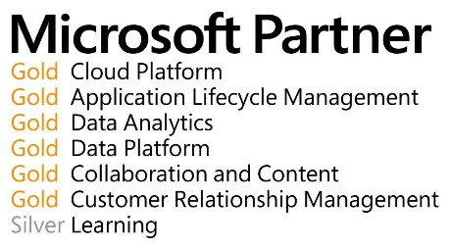

UNSERE PARTNERSCHAFTEN UND ZERTIFIZIERUNGEN

**Dein Ansprechpartner**

Sebastian Bloch

Trivadis Services AG

Badenerstrasse 13

CH-5200 Brugg

Telefon: +41 58 459 50 29

[E-Mail: sebastian.bloch@trivadis.com](E-Mail:%20sebastian.bloch@trivadis.com)

