Model : 2c2d2000

train/val/test accuracy : 80/79/80

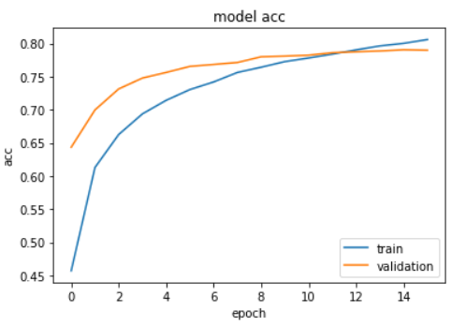

Model : 2c2d5000

train/val/test accuracy : 82/83/83

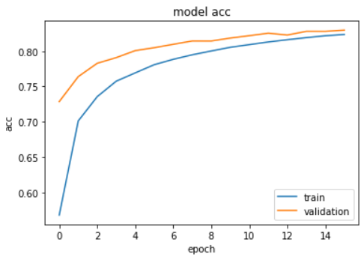

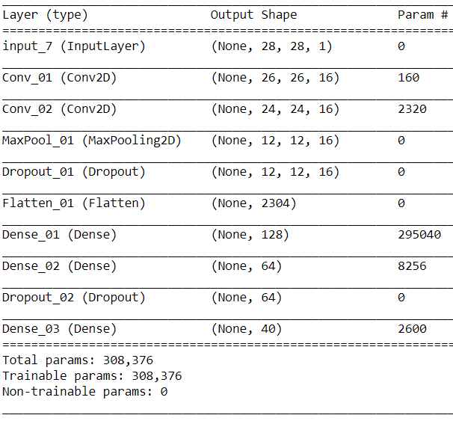

Model : 3c1d2000

train/val/test accuracy : 81/82/82

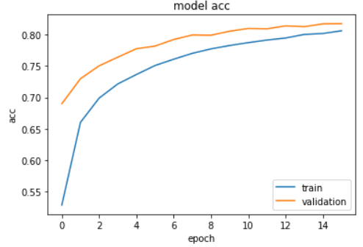

Model : 3c1d5000

train/val/test accuracy : 83/85/85

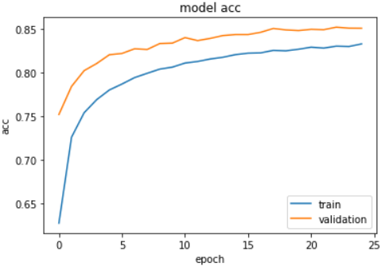

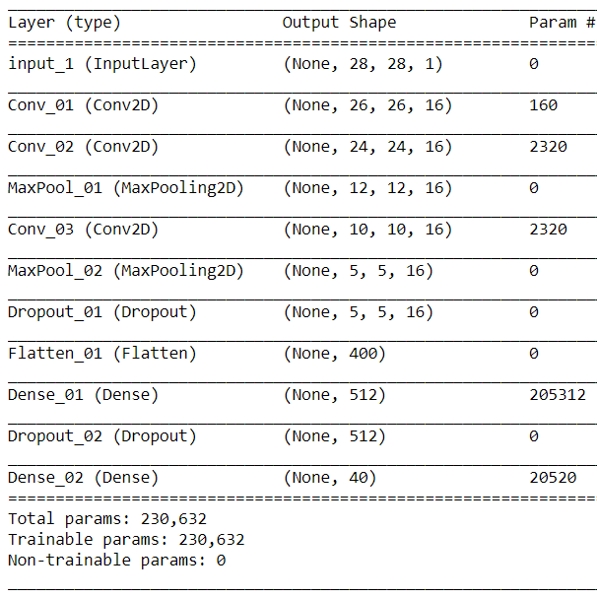

Results seem to show : Deeper model and more data get to higher classification accuracy for quickdraw set; but has lower ability to recognise drawings of similar objects outside quickdraw dataset

2c2d2000

Processed Input predicted class: light bulb

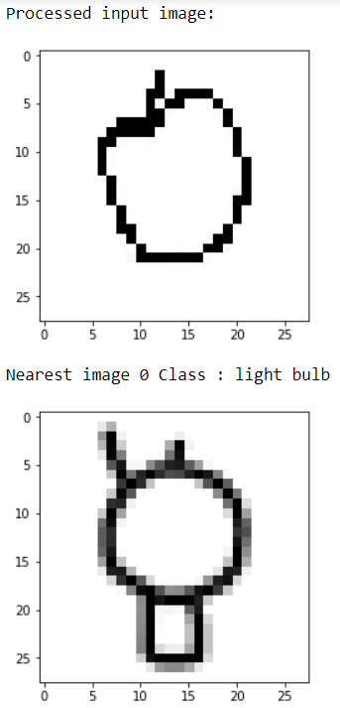

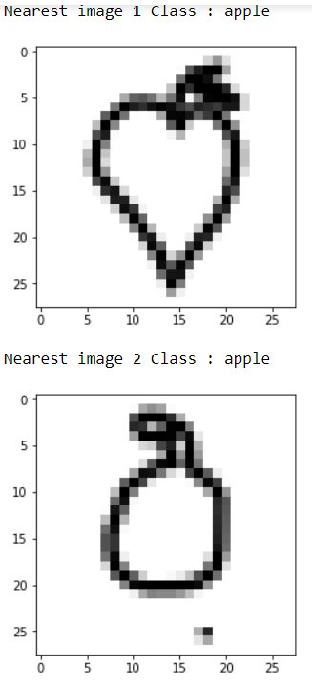2c2d5000

Processed Input predicted class: light bulb

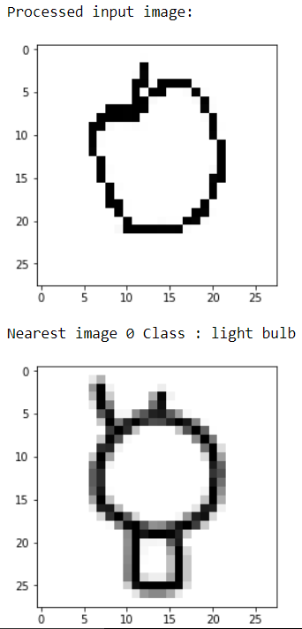

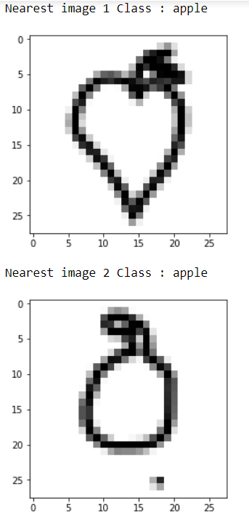3c1d2000

Processed Input predicted class: light bulb

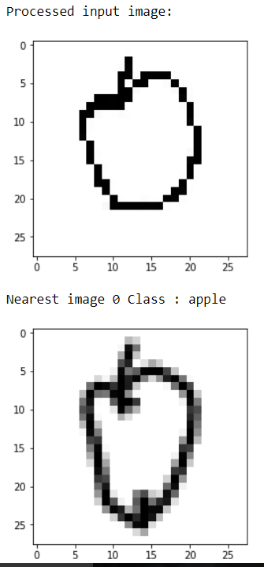

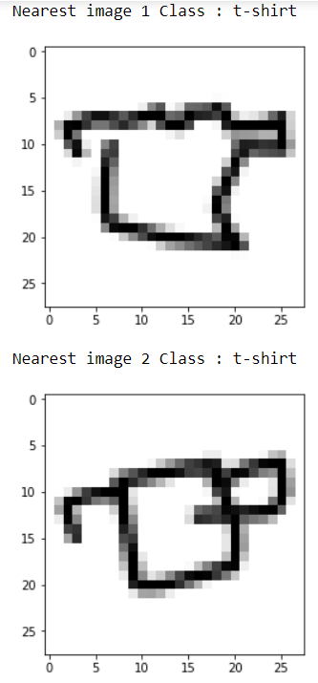

3c1d5000

Processed Input predicted class: hedge hog

