**WHO KNOWS THE WHO IN THE NIGERIAN FEMALE HIP HOP WORLD?**

Over the past few years, much has been said about the overwhelming dominance of the male folks over the female in the Nigerian hip hop music industry. This article is not just another controversial write up about the male versus the female in the Nigerian hip hop world but a means of appreciating the reigning heroines in the industry.

Truly, unlike what we have in Europe or America today, it is usually very difficult to list five or ten genuinely hottest female hip hop artistes (as at this year) in Nigeria or Africa at large. Do you want to give it a try? Ok, no problem, start counting…bla bla bla… are you there yet?

So, were you able to find up to ten? I mean ten female hip hop artistes with 5 hit singles or 2 hot albums they have made recently (within the past few years). Are you still there?

Let’s briefly examine these five Divas whose seat in the Nigerian female hip hop world can still be considered as a model for the upcoming female artistes:

**TIWA SAVAGE**



This lady has got some striking record in the international music industry. Unlike many artistes who walk into stardom by chance, **Tiwa** graduated from Berklee College of Music in 2007 and has since then been working with music producers in the industry. Till date, she is one of the Nigerian artistes with the highest number of international features. **Tiwa** Savage had done remarkable backups for **George Michael, Mary J. Blige, Destiny's Child, Chaka Khan, Spice Girl, Emma Bunton, Kelly Clarkson, Andreas Bocelli, Sting, 50 Cent, The Black Eyed Peas, Eminem, Robbie Williams** etc. She is currently the only female artiste in Mavin Records.

**Tiwa** is not only a musical artiste; she is a TV presenter and also had been an avid songwriter since the age of 15. She owes these *hits* to her songwriting record: **Jaicko's** *"Oh Yeah,"* which features **Snoop Dogg**, **Kat Deluna's** *"Push Push"* featuring **Akon** and with production by **David Guetta**, and **Fantasia's** *"Collard Greens & Cornbread,"* from the album *Back to Me.*

**OMAWUNMI MEGBELE**



Once upon a year, sometime in 2007, the whole Nigerians stood still to celebrate the musical icon **Omawunmi Megbele**, the beautiful artiste who dazzled and literarily set the stage ablaze with her captivating performance in the popular musical reality TV show, Idols West Africa. No doubt, shortly after being selected as the 1st Runner – Up in the musical competition, **Omawunmi** practically showed her fans that she is up to the task of being an African Idol in the international music scene.

Apart from being an articulate and stylish singer, **Omawunmi** is also a bona fide Law graduate of Ambrose Alli university, Edo state. She later proceeded to study French at Alliance Francaise. This legendary effort from her disproves the wrong notion among the upcoming artistes that effective formal /professional education is not a yardstick for success in the music career. **Omawunmi** has performed on stage with top class Nigerian artistes such as **D’Banj, 2face, P-Square** and International acts like **Chaka Demus** and **Pliers**. She won the Best Female Vocal Performance and Next Rated Artiste at the 2009 Hip Hop World Awards. She is one of the Hottest Young Sisters in the Nigerian music industry….flowing with vibes, energy & FIRE! Judging by her last hit single, I know you cannot but conclude that **Omawumi** is here to stay! Enemies…*go wee we*!

**GOLDIE HARVEY**

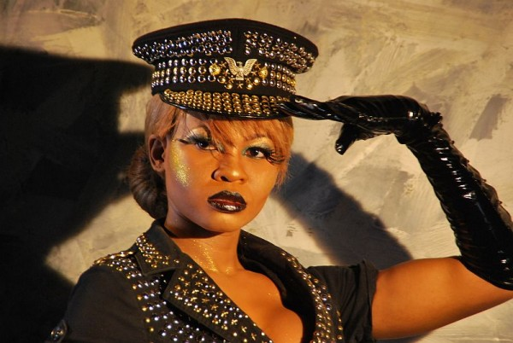

Just check her out! Sexy, expensive, ambitious, godly, bold, mysterious, multitalented, extremely intelligent, flamboyant; are some of the words often used to describe the Nigerian female hip hop singer and songwriter **SUSAN OLUWABIMPE HARVEY**. The elusive diva famously known as ‘’GOLDIE’’ graces the Nigerian music scene with her unconventional ‘pop’ genre. There is practically none of her kind in the Nigerian music industry.

Goldie graduated from the University of Sunderland with a Bachelor of Arts in Business Management. She has bagged several award nominations to her records owing to her ground breaking videos such as ‘’Komole’’ ‘’Spin Me’’ ‘’Shift’’ and ‘’Nothing has Changed’’ all from her 2007 limited edition album *Spin Me*. ‘Through the turbulence, drudgery and seeming imperviousness of the music industry, Goldie held her own, talent for talent, and creativity for creativity. After a tentative management deal in 2009, Goldie was signed on to Nigeria’s foremost music label, Kennis Music in 2010’.

Goldie has so far in the past year nabbed a total of ten (10 awards) including Exquisite Lady of the year (ELOY) Best Female Artiste award and City People Best Female Artiste of the year... She has also been inducted as a Federal Celebrity Special Marshal alongside other notable Nigerian Celebrities. She has also been conferred a United Nations Youth Ambassador for Peace by the Federal Government.

**WAJE (*Words Aren’t Just Enough!*)**



**WAJE** is an incredible artiste whose vocal range covers three octaves. She was discovered singing in church as an industrious young lady whose love for humanity led her to study SOCIAL WORKS in the university of Nigeria Nsuka (UNN). In the year 2005 **WAJE** decided to take a bold step into stardom as she fully launched her music career; still a student at the time she paid her dues by doing a lot of free shows and gigs, singing at every given opportunity she got. The first major spot light she got was her being featured in the hit single by **PSQUARE** titled *DO ME*, a massive hit track across Africa and some parts of Europe. This helped boost her career a little further, after which she participated in ADVANCED WARNING a reality TV show(which featured artistes that are upward and on the verge of a breakthrough),the reality show was organized by MTV base south Africa and ZAIN Nigeria, where she emerged first runner up.

**WAJE** has shared the stage with various international artistes, she performed with the phenomenal **Wyclef Jean** on stage in south Africa, she also opened **for Kerry Hilson** during a show organized in Calabar, Nigeria. She has also worked with a lot of artistes making good music and smash hit singles like *ONE NAIRA* (**MI** featuring **WAJE**),*SAME GUY* (**Omawumi** featuring **WAJE**),*DO ME* (**Psquare** featuring **WAJE**)and a whole lot more. She proud to have bagged the following awards: BEST RHYTHM AND BLUES SINGER 2011 CITY PEOPLE ENTERTAINMENT AWARDS, BEST FEMALE VOCALIST 2011 NIGERIAN ENTERTAINMENT AWARDS, BEST FEMALE VOCALIST 2011 HIPHOP WORLD AWARDS (HEADIES), BEST AFRICAN ART 2011 DEAFA AFR0-EUROPE AWARDS, BEST VOCAL PEFORMANCE 2010 SOUTH SOUTH AWARDS, and several other award nominations.

**SASHA**

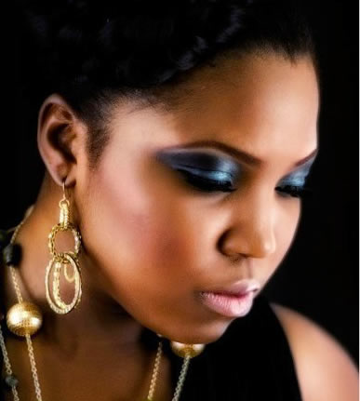

**SASHA**, also known as **Yetunde Alabi**, the “First Lady" of Nigerian Hip Hop has remained the most visible female artiste in Nigeria for over 7 years, with the success of her debut album "First Lady" and support from her record label STORM, she has continued to increase her dedicated fan base and has been nominated for various awards at home and abroad. **SASHA** won the "Best female artiste" award at the women in entertainment awards held in England (February,2009) for her first single titled *"Adara"* ,and was nominated in two categories ( Best female video and Best cinematography) by the prestigious Sound City Video Music Awards for her second single *"Only One"* which was held on the first of August 2009.

**SASHA** has earned the respect of her peers from her dedication, hard work and stellar performances, some of which include her being the first ever Nigerian female artiste to perform at the 20th anniversary of the World Music Awards in October 2008, she had shared stages with a host of International and National acts which include **Boys 2 men**, **Dru Hill**, **Rihanna,** **Shakira**, **P Diddy**, **John Legend** and **R Kelly** In Suncity, South Africa on his most recent African tour (June, 2009) to name a few. As a designer of her own clothing label (Eclectic by Sasha) and the National Ambassador of the Nigerian Mobile phone company Anabel, then Samsung (in 2012), she remains arguably one of the busiest female artistes in Nigeria. She owes the following awards to her record: Most Entertaining 2008 (Faculty of Law Unilag), Most Promising Female Artiste 2005 (Amen Award), Most Promising artiste, West Africa 2004 (Kora Award), and several award nominations.

**Now, the BIG question is, ‘who is your hottest who on the list?’ Turn in your comments and say what you know about the artiste of your choice. We can learn from you…besides, this may be a channel to let these wonderful ladies know how much we feel their presence and budding influence in the challenging terrain of the Nigerian hip hop kingdom. Go Ladies!**

Kindly follow PLAYMYJAMZ on twitter **@playmyjamz**

info@playmyjamz.com

Author: Akinyele Kurlarday **@kurlarday**

kurlarday@playmyjamz.com

……………………………………………………………………………………………………………..

**SASHA**

**SASHA**, also known as **Yetunde Alabi**, the “First Lady" of Nigerian Hip Hop has remained the most visible female artiste in Nigeria for over 7 years, with the success of her debut album "First Lady" and support from her record label STORM, she has continued to increase her dedicated fan base and has been nominated for various awards at home and abroad. **SASHA** won the "Best female artiste" award at the women in entertainment awards held in England (February,2009) for her first single titled *"Adara"* ,and was nominated in two categories ( Best female video and Best cinematography) by the prestigious Sound City Video Music Awards for her second single *"Only One"* which was held on the first of August 2009.

**SASHA** has earned the respect of her peers from her dedication, hard work and stellar performances, some of which include her being the first ever Nigerian female artiste to perform at the 20th anniversary of the World Music Awards in October 2008, she had shared stages with a host of International and National acts which include **Boys 2 men**, **Dru Hill**, **Rihanna,** **Shakira**, **P Diddy**, **John Legend** and **R Kelly** In Suncity, South Africa on his most recent African tour (June, 2009) to name a few. As a designer of her own clothing label (Eclectic by Sasha) and the National Ambassador of the Nigerian Mobile phone company Anabel, then Samsung (in 2012), she remains arguably one of the busiest female artistes in Nigeria. She owes the following awards to her record: Most Entertaining 2008 (Faculty of Law Unilag), Most Promising Female Artiste 2005 (Amen Award), Most Promising artiste, West Africa 2004 (Kora Award), and several award nominations.