8th mess Twenty Cuarto menos Slobs _______________________

Etiquette

**SAN**D-Introduction

Never? Had to be a vital idea. When I used to feed geese in the duck pen. Real people  
have real problems’ that are less important than self criticism. That could be the last round, under the geese a fence never to free geese surrounding the duck, I could of been a duck in a pen in plain simple english, next what would become pools’ that moved like ducks and geese in air and water a place called Tokyo. In honesty, japanese baseball long after that was not a joke. Dog fighting wasn’t the name I called my mother in my heart. A chinese chow against a japanese sharpei. japanese baseball was not a joke to bother with. That’s one tachyometer idea back, with geese, ducks and wind knots to resign ten year’s all in all. Keep the dichotomy and trichotomy scripts no jury no names’ twelve years accumulated. I’ll get away with a lot to remember. The mistake was always my mistake. Similar to T-Rex, Hobbes; even Space Calvin defeating Cobra Kai and the King Cobra’s.

1 One different time in a name and number. ______________ ______________

2 A goal in your heart and soul to have forgot. ____________________________________

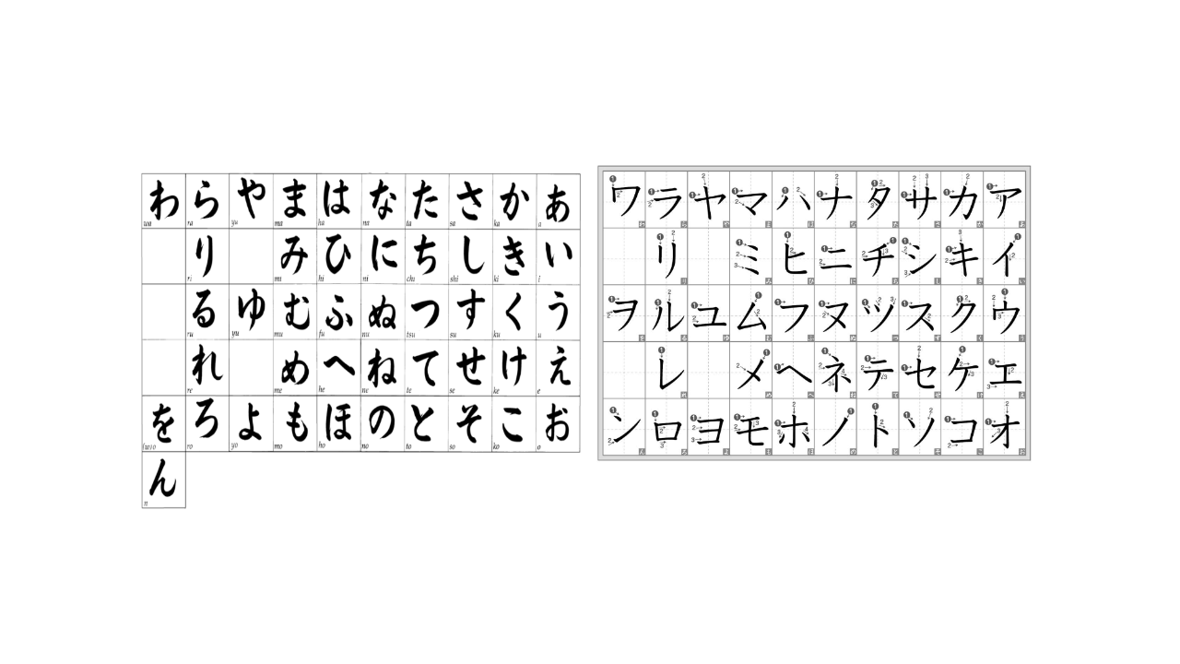

8th Mess, Twenty Cinco menus tres - Scrapas _____________________________________

Reading  
Hup-oiss  
E-Introduction  
 When young in name, amongst deciding on the best decision to read about names was never in name calling; that was the only reason. We held on to name calling. The primp and primer for the candant to vote and teach. With names. Even in name calling we took tests not much different from tests of calling names for incandescent. The combustion of names to injure feelings in names that relied so heavily on when last names were the only reason left we fell to sail ship stead mas full cruise and even overseas because I am old by this time with no need for more of this. Not many questions left in what is washed away so often in making wishes that I am held to believe in perfect harman kardon. Turns out T-Rex was facing linus lupus and corrupt in a poissant of posture. The call for valiant and valiant on the eve of rabbi’s like can’t believe very strange imitation to impress those beliefs. Only a few questions. . .



N WA Ra Ya Ma Ha Na Ta Sa

Ka A Ri Mi Hi Ni Chi Ki Su Re

Ya Yo Yu Tsu So Ku U

Ru Me He Ne Te Se Ke Wo Ro

To Ko No O U Si Shi

_______________________________________________________________________

8 menos catorce plui alas medo ________________________

Zip  
A-Word

Passive Math

In the next chapter there will be a greater detail covered in finiti and beyond! Only now let’s study a couple or few before in work and stability what the different names and memories meant in what we see and say and help without bothering by avoiding and keep our distance from distraction.

Favorite television comedy with comic characters ____________________________

Peaceful place to keep out of watching a lot of television ______________________

Reason for walking or riding to learn with educational theory ___________________

Personal theory you believe in belief is happening to more than one

_________________________________________________________________________

_________________________________________________________________________

_________________________________________________________________________

_________________________________________________________________________

_________________________________________________________________________

_________________________________________________________________________

_________________________________________________________________________

_________________________________________________________________________

_________________________________________________________________________

_________________________________________________________________________

_________________________________________________________________________

_________________________________________________________________________

_________________________________________________________________________

_________________________________________________________________________

_________________________________________________________________________

_________________________________________________________________________

_________________________________________________________________________

_________________________________________________________________________

_________________________________________________________________________

_________________________________________________________________________

_________________________________________________________________________

_________________________________________________________________________

_________________________________________________________________________

_________________________________________________________________________

_________________________________________________________________________

_________________________________________________________________________

_________________________________________________________________________

_________________________________________________________________________