RUMBLE MUSEUM 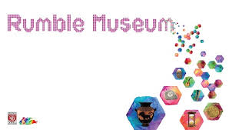

Handling Session Worksheet

| **Group** |  |
| --- | --- |
| **Accession number**  *What is the number the museum uses to identify the object?* |  |
| **Title**  *How would you describe this object in a few words?* |  |
| **Dimensions**  *What is the height? Width?* |  |
| **Material**  *What is it made of?* |  |
| **Type**  *What kind of object is it?* |  |
| **Condition**  *Is the object complete? Has it been damaged or repaired?* |  |
| **Date**  *When was the object made? How can you find out this information?* |  |
| **Observations**  *What do you find interesting about the object? What was it for? Why did someone make it? Who might have owned it? Does it tell you anything about the owner’s wealth or status? Is it like any object that you might find at home?* |  |

**Now record your objects with your phone camera. What do you need to make a useful record shot? Think about the angle of the photo, the background and indicating the scale of the object.**