## horizontal line



WAP-Design Document

08.03.2020

**─**

Onur Ereren (3449173)

Omer Faruk Gokbak (3782174)

# 

**Introduction** **2**

**Viewports** **3**

Main View: 3

Login View: 6

Register View: 8

# 

# 

# Introduction

Posttit is a social news aggregation, an online community, a discussion website, a collection of forums, where people can share news and content or comment on other people’s posts. Users can submit links, photos and text posts to the website. Posts are able to be voted up or down. Submissions with more up-votes appear towards the top of the list. Users can not add or vote any post unless they sign in.

# Viewports

##### **Main View**

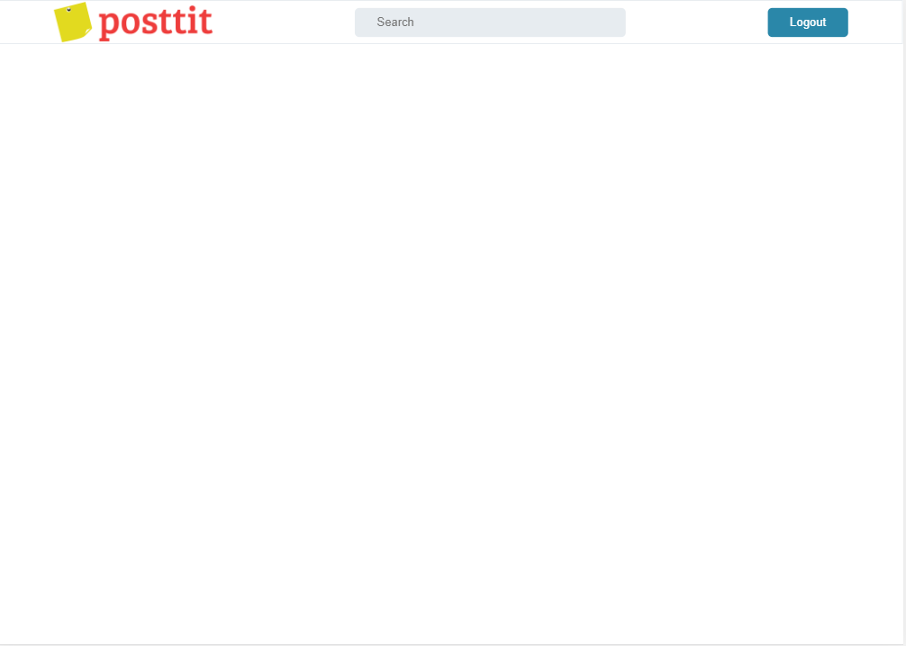

This is the computer view of the main page.



This is the mobile view of the main page.

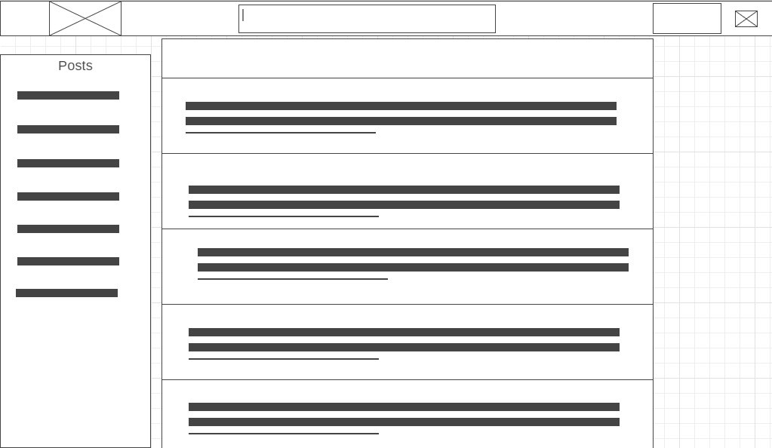

This design will be similar to our final design (main page)

##### 

##### **Login View**

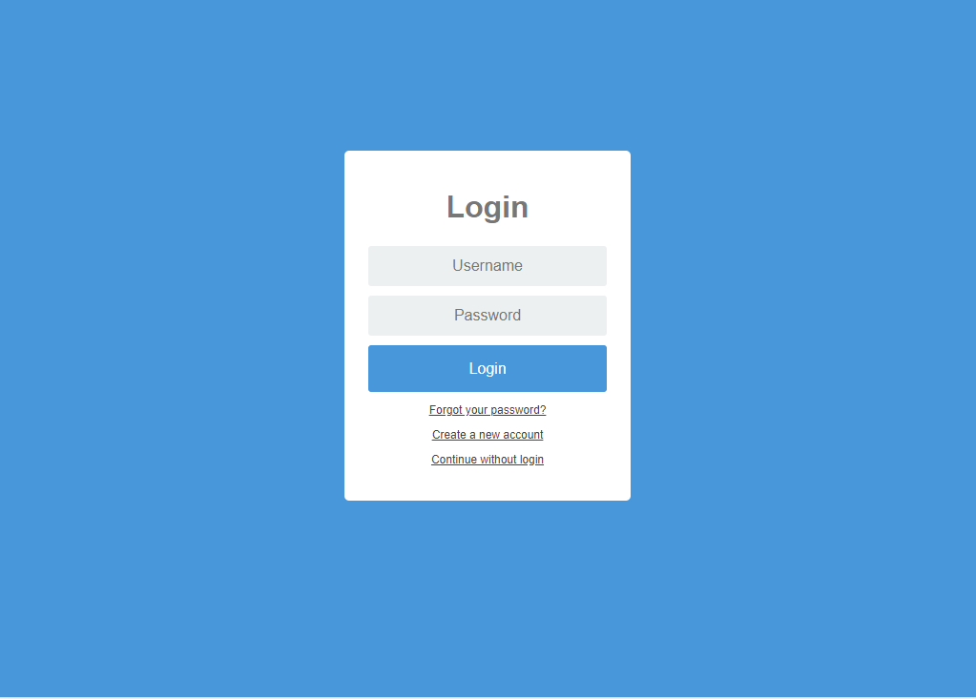

This is the computer view of the login page

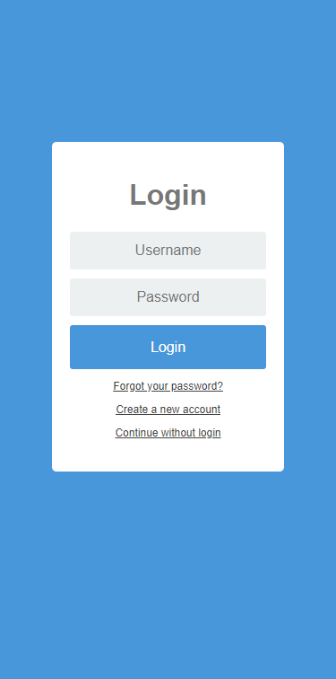

This is the mobile view of the login page

##### **Register View**

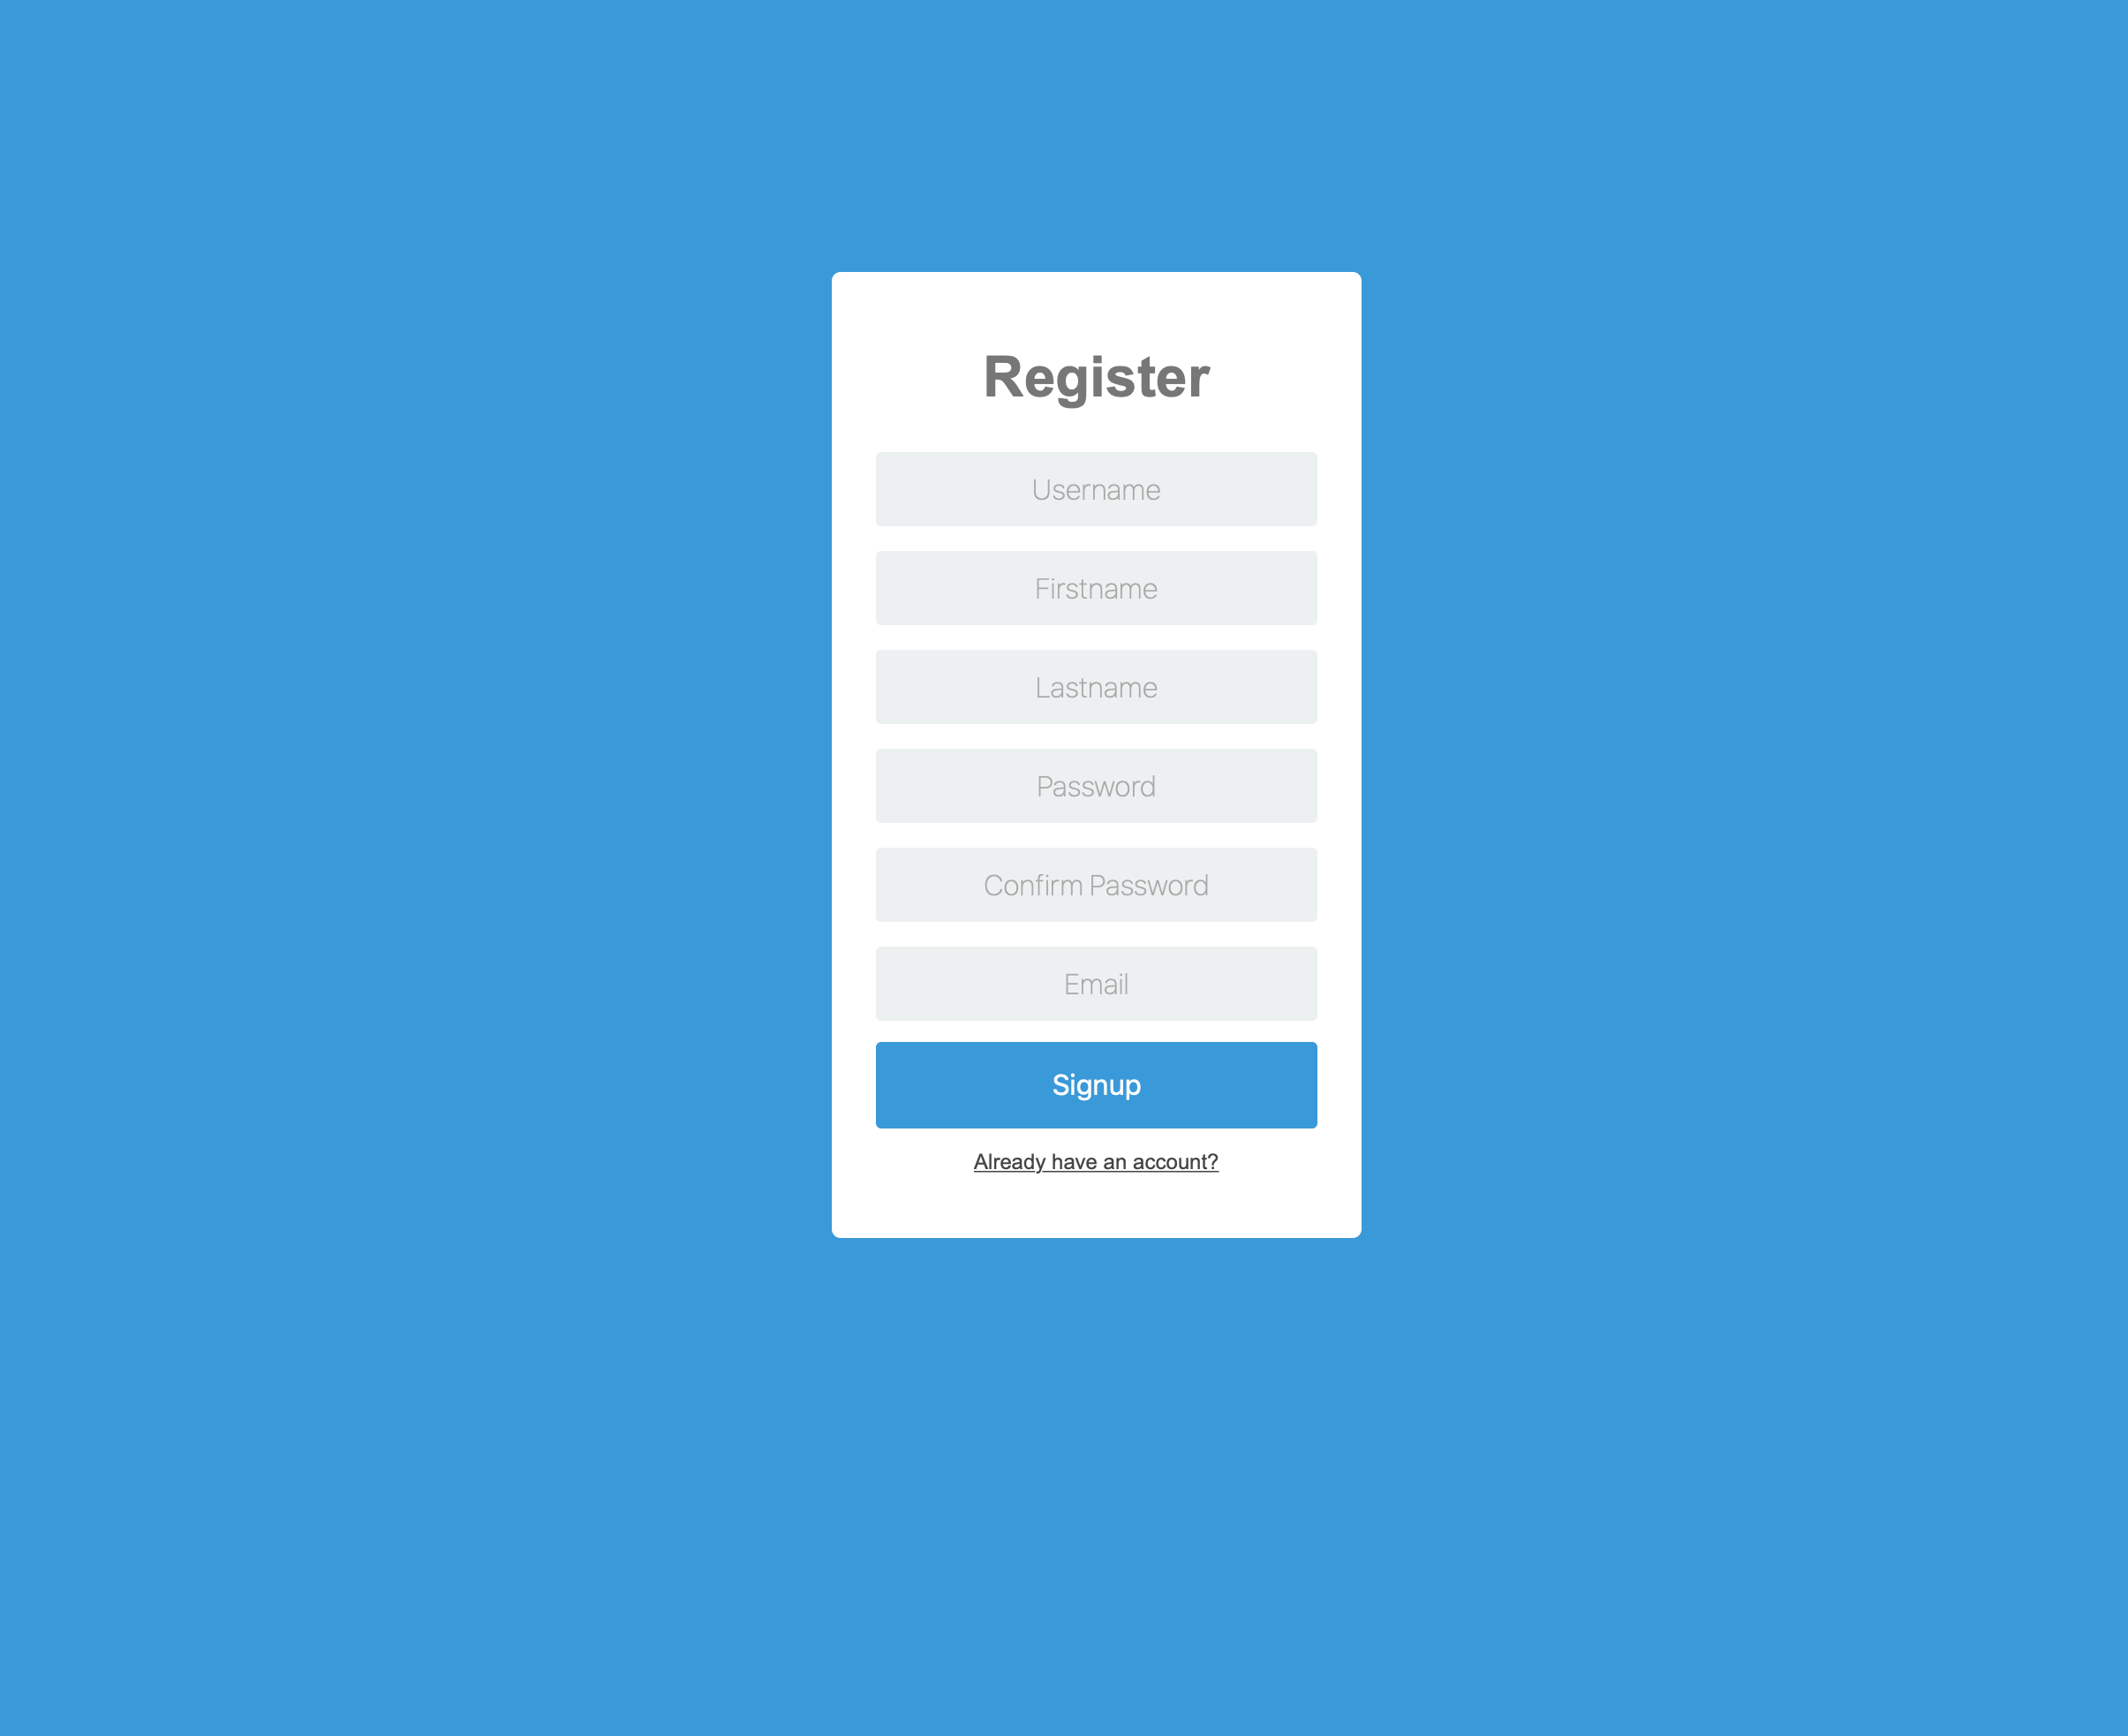

This is the computer view of the register page

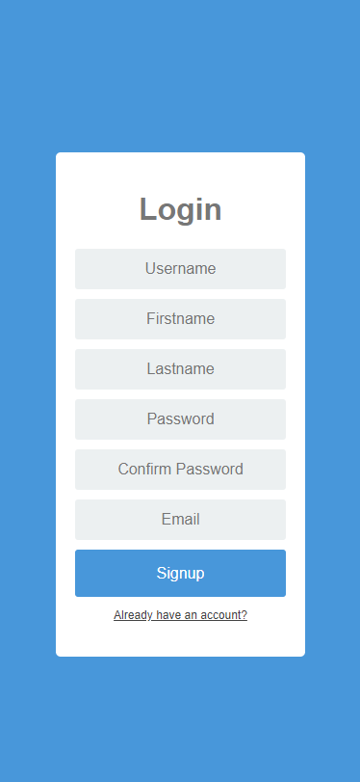

This is the mobile view of the register page