MemeClassroom: An Open Platform for Meme-Based Pedagogy and Critical Media Literacy
[Author Name(s)]
[Affiliation / Institution], [City, Country]​
[author.email@institution.edu]
Abstract. Memes are among the most familiar multimodal artefacts in students' daily lives, yet classrooms rarely draw on them either as a teaching resource or as an object of critical analysis. MemeClassroom is an open, web-based platform that lets teachers and students create, curate, and discuss educational memes while building media-literacy skills. Built with React, Tailwind CSS, and Firebase, it combines a multi-format meme editor (image, GIF, video, audio), a peer-rated meme library organised by subject and grade, an 18-question, six-dimension meme-literacy assessment with a five-level progression badge, an open resources hub, and a teacher community (“Staffroom”). The intended users are secondary and higher-education teachers, students, and teacher-educators. At T4E 2026 we will run a hands-on, browser-only demonstration in which attendees create a meme, take a short literacy-test segment, and browse curated classroom resources.
Keywords: meme pedagogy, media/meme literacy, open educational resources (OER), universal design for learning (UDL).
1 Introduction and Context
Students already spend a large share of their daily communication in memes — a dense, multimodal blend of image, text, and cultural reference. Classrooms, however, treat this fluency as unrelated to formal learning: teachers who want to use memes to make abstract concepts concrete have no trusted, curated, classroom-appropriate space to find or create them, and students receive almost no structured practice decoding the bias, framing, and satire embedded in the meme content they consume every day. This gap spans subjects and grade levels, from upper-secondary through higher and informal education, wherever a class has internet access.
Generic meme-generator tools produce content but offer no pedagogical scaffolding, peer curation, or literacy assessment; general OER repositories, in turn, are not built around the meme format at all. MemeClassroom is purpose-built to close this gap by combining meme creation, peer-rated curation, a structured media-literacy assessment, and a teacher reflection community in a single open, no-cost platform.
2 Objectives / Rationale
MemeClassroom is designed to help teachers turn memes into a deliberate teaching resource — reinforcing concept recall through student-created memes — and to help both teachers and students decode the bias, rhetoric, and intent embedded in the memes they already encounter online. It primarily serves secondary and higher-education teachers and students, with a secondary audience of teacher-educators and subject-matter experts who curate the Resources hub and review content through role-based moderation.
- Level of education: upper-secondary through higher/informal education (roughly ages 13+), subject-agnostic, with grade-band tagging (e.g., 10–12, 13–15, 16–18, university) built into the meme metadata.
- T4E alignment: a free, browser-based, no-installation tool that lowers the barrier to “technology for education” adoption; a no-login literacy-test entry point and mobile-first, accessibility-oriented design support equitable access in low-resource and BYOD classrooms.
3 Description of Proposal
The platform is organised around five core spaces plus an administrative layer:
Meme Lab. A browser-based, multi-format editor for images, GIFs (with an in-editor Giphy search), video, and audio, supporting text overlays, cropping, stickers, and template remixing. Before publishing, users tag a meme by subject, grade, format, and language, which powers discovery in the Library.
Meme Library. A peer-rated repository of published memes, organised by subject and grade, with multi-dimensional community ratings and an Expert-comment channel from verified subject specialists — helping teachers quickly identify pedagogically sound, classroom-ready content rather than relying on a simple like count.
Meme Literacy Test. An 18-question assessment spanning six critical-literacy dimensions (e.g., decoding bias, distinguishing satire from misinformation), awarding a five-level progression badge (Spectator → Decoder → Analyst → Critic → Scholar). It requires no account, making it usable as a standalone outreach or icebreaker activity.
Resources and Staffroom. The Resources hub hosts a beginner course, real classroom use cases, and peer-contributed OER articles and activity packs that ground meme use in pedagogy; the Staffroom is a threaded community where teachers post honest, real-world outcomes tied to a specific meme, closing the feedback loop between creation and classroom practice.
Admin HQ. A role-based console for content moderation, Expert-application review, and platform analytics, so content quality can scale beyond manual review by the founding team.
Technically, the platform is a React 19 single-page application built with Vite and styled with Tailwind CSS (including a light/dark theme), backed by Firebase (Firestore, Cloud Storage, and Hosting), with continuous deployment via GitHub Actions on every merge and automatic preview deployments for pull requests.
Pedagogically, the design follows Universal Design for Learning (UDL) principles — an in-app accessibility widget, a text-to-speech reader, and a readability indicator provide multiple means of representation and engagement — and a design-based meme-pedagogy framework (Fig. 1) that moves from traditional teaching, through meme creation, curation, and peer collaboration, to pedagogically scaffolded, meaningful classroom integration.
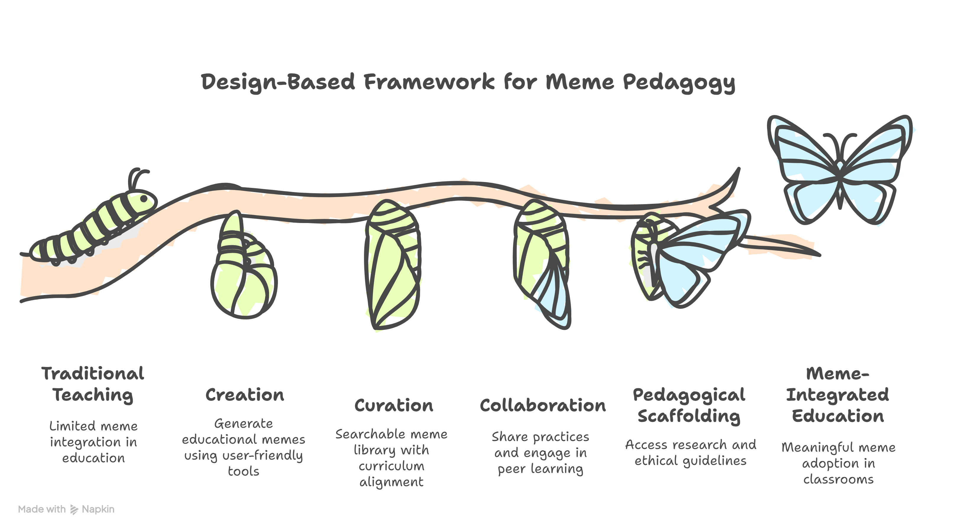
Fig. 1. The design-based meme-pedagogy framework underlying MemeClassroom's feature set.
In a typical usage scenario, a teacher asks students to create a meme explaining a concept in the Meme Lab, publishes selected memes to the Library for peer rating, and then leads a Staffroom discussion reflecting on which memes best supported comprehension — closing the loop from creation to classroom evidence.
4 Implementation / Session Plan
The demo is a live, hands-on walkthrough of the deployed platform, not a research talk, run over a 20-minute slot:
- 0–3 min: Frame the problem (the classroom meme-literacy gap) and the platform's objectives.
- 3–10 min: Live demo — create and remix a meme in the Meme Lab and publish it to the Library.
- 10–15 min: Participant interaction — attendees take a short segment of the Meme Literacy Test on their own device and see their badge result instantly.
- 15–18 min: Guided tour of the Resources hub and a sample Staffroom discussion thread.
- 18–20 min: Q&A and discussion.
Attendees need only a browser on a laptop or phone; the Literacy Test segment requires no account. A pre-seeded demo teacher account is used for the Meme Lab, Library, and Staffroom walkthrough.
5 Audience / Applicability
The primary stakeholders are secondary and higher-education teachers and students, along with teacher-educators, OER curators, and ed-tech researchers interested in multimodal and media-literacy pedagogy. The platform is subject-agnostic (used for biology, physics, mathematics, history, geography, and other subjects) and spans grade bands from upper-secondary through university and informal learning, as reflected in the Meme Lab's grade-tagging system.
Its mobile-first, responsive design and no-login literacy-test entry point make it usable in low-resource, single-device or BYOD classrooms as well as well-equipped 1:1 device labs and fully online courses. Built-in UDL features (text-to-speech, adjustable readability, an accessibility widget) support learners with diverse needs, and multilingual content tagging (currently English, Hindi, Malayalam, and Tamil) supports regional-language classrooms.
6 Resources / Logistics
- One presenter laptop with a modern browser, connected to a projector/display for the live walkthrough.
- Attendee devices (BYOD laptops or phones) with a browser and internet access to try the Literacy Test and Meme Lab directly — no software installation required.
- Stable Wi-Fi/internet connectivity for the room.
- A pre-seeded demo teacher account (credentials provided to session organisers on request) for the Meme Lab/Library/Staffroom segment.
- A one-page handout with a QR code linking to the live platform and the Literacy Test.
7 Prior Experience / Evidence
MemeClassroom is a functional, actively developed web platform rather than a mock-up: all core spaces described above (Home, Meme Lab, Library, Resources, Staffroom, Literacy Test, Admin HQ, and user Profile) are implemented in the codebase and deploy automatically to Firebase Hosting on every merge via GitHub Actions, with separate preview deployments for pull requests. Development has proceeded iteratively — for example, the Resources page navigation was recently redesigned from a tab bar to a tile-based landing view following usability heuristics drawn from progressive-disclosure and card-based navigation patterns.
The platform has not yet been piloted in a live classroom; this T4E demo is intended as a first step toward recruiting early-adopter teachers for a structured classroom pilot. [Add team experience / prior edtech projects here.]
8 Conclusion
MemeClassroom turns a multimodal literacy that students already bring into the classroom into a deliberate teaching and critical-thinking resource, pairing meme creation and peer-curated content with a structured literacy assessment and a teacher feedback community, on a free, accessible, open-source stack. Its modular React/Firebase architecture, no-login entry points, and subject-agnostic design make it inexpensive to pilot and straightforward to scale to new subjects, languages, and grade bands — making it directly relevant to T4E's focus on accessible, equitable technology for education.
References
1. MemeClassroom source repository. GitHub (2026)
2. [Add supporting citation on meme pedagogy / multimodal learning.]
3. [Add supporting citation on Universal Design for Learning (UDL).]
4. [Add supporting citation on media/critical literacy assessment.]
Acknowledgments. [Add funding / support acknowledgments, if any.]
Disclosure of Interests. The authors have no competing interests to declare that are relevant to the content of this article.

