ICC104 Report
Student Name: Vireakboth Oeung
Student ID: A00181743

Introduction
Cloud computing has become a fundamental technology in modern information systems, enabling organizations and individuals to access computing resources over the internet without relying on traditional physical infrastructure. Instead of maintaining on premises hardware, cloud platforms provide scalable, on-demand services that improve efficiency, flexibility, and cost management (Erl & Barcelo, 2023; Dubey, Tiwari, & Raja, 2023).
This assessment focuses on the practical and theoretical application of cloud computing using Amazon Web Services (AWS). In the practical component, an Amazon Elastic Compute Cloud (EC2) instance was created to act as a virtual machine, alongside an Amazon Simple Storage Service (S3) bucket used for cloud-based storage. The interaction between these services demonstrates how cloud computing integrates compute and storage resources within a unified environment.
The implementation in this task primarily reflects the Infrastructure as a Service (IaaS) model, where users are provided with virtualized computing resources such as virtual machines and storage without needing to manage the underlying physical hardware (Marinescu, 2018). AWS operates under a public cloud deployment model, where services are delivered over the internet and shared among multiple users while maintaining logical isolation.
Several key characteristics of cloud computing are demonstrated in this implementation. These include on-demand self-service, allowing users to create and manage resources as needed; scalability, enabling resources to expand based on demand; and resource pooling, where cloud providers allocate shared resources efficiently across multiple users (Mell & Grance, 2011). Additionally, broad network access allows services such as EC2 and S3 to be accessed from anywhere via the internet.
Overall, this assessment demonstrates how cloud computing technologies can be applied in a practical environment, highlighting the advantages of virtualization, scalability, and service integration in modern IT systems.

Part 1
Amazon Simple Storage Service (S3) is a cloud-based object storage service provided by AWS that allows users to store and retrieve data over the internet. Unlike traditional storage systems that rely on physical hardware, S3 provides highly scalable, durable, and flexible storage by distributing data across multiple data centers (Erl & Barcelo, 2023). This makes it suitable for a wide range of applications, including data backup, file storage, and web hosting.
Compared to traditional IT infrastructure, S3 offers several advantages, including reduced hardware costs and improved scalability (Lawal, 2023). Firstly, it eliminates the need for organizations to invest in and maintain physical storage hardware, reducing operational and capital costs. Secondly, S3 provides virtually unlimited scalability, allowing users to store large amounts of data without worrying about storage limits. Additionally, S3 ensures high availability and durability, as data is replicated across multiple locations to prevent data loss (Marinescu, 2018). These benefits highlight the efficiency and reliability of cloud-based storage solutions compared to on-premises systems.
In this implementation, an S3 bucket was created using the AWS Management Console. The bucket, named “assessment3-s3bucket,” acts as a container for storing data objects. Within the S3 dashboard, the “Buckets” section was used to create and manage the storage resource, while the “Objects” section was used to upload and view stored files. 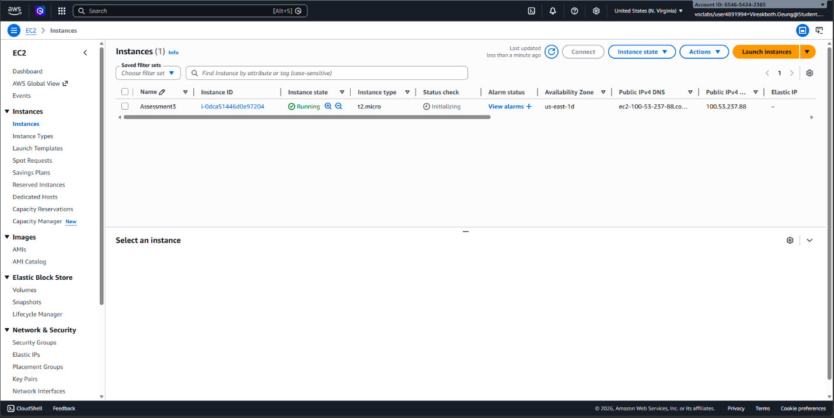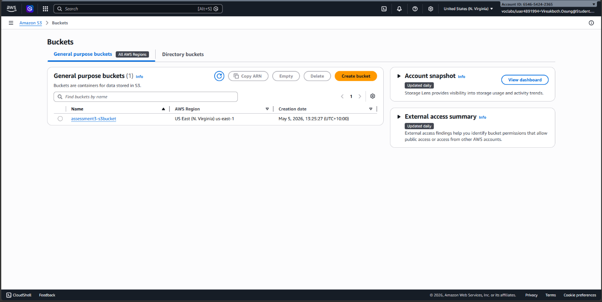
To demonstrate the interaction between compute and storage services, AWS CloudShell was used to execute AWS CLI commands. A file was first created using a simple command, and then uploaded to the S3 bucket using the “AWS s3 cp” command. The successful upload was verified by listing the contents of the bucket and confirming the presence of the file within the S3 console. This process demonstrates how cloud-based computer environments can interact with storage services efficiently.
Due to restrictions within the AWS Academy lab environment, IAM role creation and direct mounting of the S3 bucket were not permitted. However, the use of AWS CLI through CloudShell provided an effective alternative for establishing communication between the EC2 environment and S3 storage. This approach still demonstrates the core concept of integration between cloud services, which is a fundamental feature of cloud computing systems. 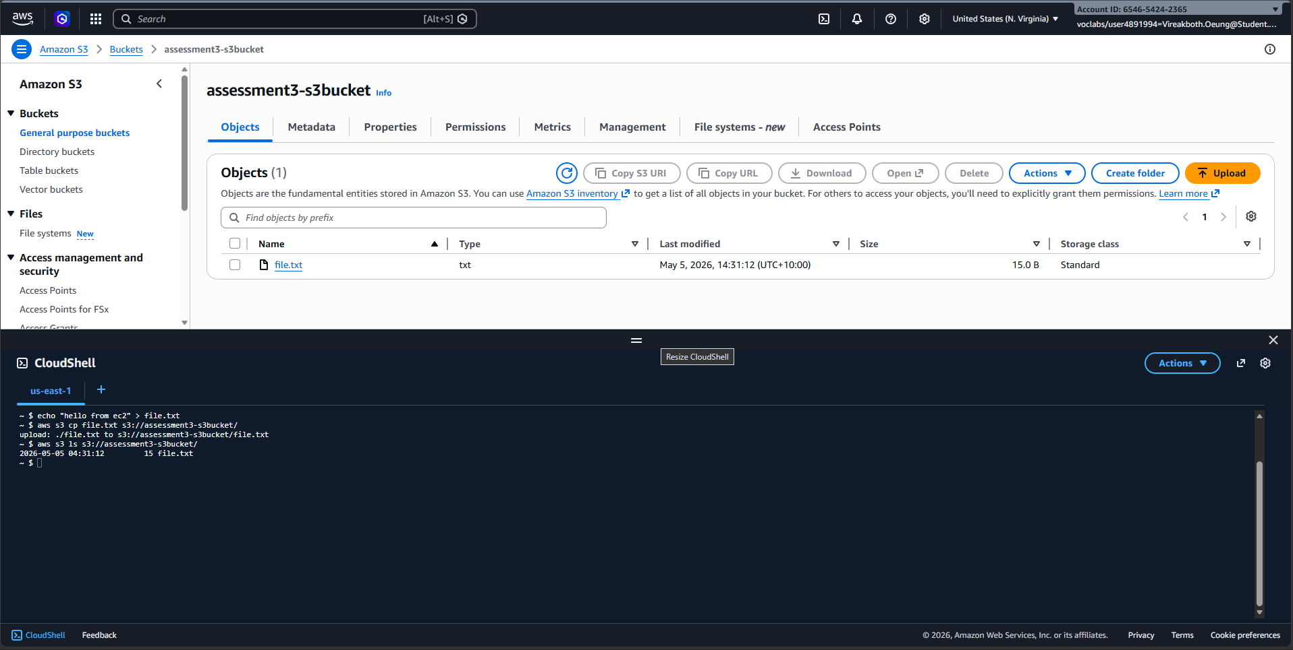
Overall, the implementation highlights how AWS S3 can be used as a reliable and scalable storage solution, while also demonstrating the practical interaction between cloud computing resources.

Part 2
In this section, Amazon Web Services (AWS) is compared with Microsoft Azure, two of the leading cloud service providers widely adopted across industries. Both platforms offer a comprehensive range of services and support various cloud computing models, making them suitable for different organizational needs.
Both AWS and Azure provide Infrastructure as a Service (IaaS), Platform as a Service (PaaS), and Software as a Service (SaaS). AWS delivers services such as EC2 for virtual machines and S3 for storage, while Azure provides equivalent services through Azure Virtual Machines and Azure Blob Storage. Although the functionalities are similar, AWS is often recognized for its extensive range of services and flexibility, while Azure is preferred for its strong integration with Microsoft-based environments (Buyya, Vecchiola, & Selvi, 2013).
In terms of performance and scalability, both platforms are highly efficient and supported by globally distributed data centers. They allow users to dynamically allocate resources based on demand, ensuring optimal performance for various workloads. This scalability is a key advantage of cloud computing, enabling organizations to respond quickly to changing requirements (Armbrust, et al., 2010).
Cost is another critical factor when comparing cloud providers. Both AWS and Azure use a pay-as-you-go pricing model, where users are charged based on resource consumption. However, pricing structures can differ depending on the type of service, usage patterns, and geographic regions. Azure may provide cost advantages for organizations already using Microsoft licensing, while AWS offers a wider variety of pricing options and services (Rittinghouse & Ransome, 2010).
A fundamental concept underlying both platforms is virtualization. Virtualization enables multiple virtual machines to operate on a single physical server, improving resource utilization and efficiency. In AWS, this is implemented through EC2 instances, while Azure uses Virtual Machines. This abstraction allows users to deploy computing environments without managing physical infrastructure directly (Hwang, Fox, & Dongarra, 2012).
Another key concept is resource pooling, where cloud providers allocate shared computing resources across multiple users. This approach ensures efficient utilization of hardware while maintaining isolation between users. Resource pooling allows cloud systems to deliver scalable and reliable services, which is a defining characteristic of cloud computing environments (Zhang, Cheng, & Boutaba, 2010; Mell & Grance, 2011).
Overall, both AWS and Azure demonstrate the core principles of cloud computing, including scalability, flexibility, and efficient resource management. While they offer similar capabilities, their differences in ecosystem integration, pricing models, and service design provide users with options depending on their specific requirements.

In conclusion
This assessment demonstrated both the practical implementation and theoretical understanding of cloud computing using Amazon Web Services. An EC2 instance was successfully created to represent a virtual machine, while an S3 bucket was used to provide scalable cloud storage. The interaction between these services, achieved through AWS CloudShell and command-line tools, highlighted how compute and storage resources are integrated within a cloud environment.
The report also explored the advantages of cloud storage compared to traditional infrastructure, including scalability, cost efficiency, and high availability. Furthermore, a comparison between AWS and Microsoft Azure showed that both platforms offer similar core services while differing in integration, flexibility, and pricing models. Key concepts such as virtualization and resource pooling were discussed, demonstrating how cloud providers efficiently manage shared resources.
Overall, cloud computing provides a flexible and efficient solution for modern IT systems, enabling organizations to adapt quickly to changing technological demands.

References
Armbrust, M., Fox, A., Griffith, R., Joseph, A. D., Katz, R., Konwinski, A., . . . Zaharia, M. (2010). A View of Cloud Computing. Association for Computing Machinery. Communications of the ACM.
Buyya, R., Vecchiola, C., & Selvi, S. T. (2013). Mastering cloud computing : foundations and applications programming. Waltham: Morgan Kaufmann. Retrieved from http://www.books24x7.com/marc.asp?bookid=54003
Dubey, P., Tiwari, A. K., & Raja, R. (2023). Amazon Web Services : the definitive guide for beginners and advanced users. Singpore: Bentham Science Publishers. Retrieved from https://search.ebscohost.com/login.aspx?direct=true&scope=site&db=nlebk&db=nlabk&AN=3712396
Erl, T., & Barcelo, E. (2023). Cloud computing : concepts, technology, security & architecture. New York: Pearson. Retrieved from https://www.oreilly.com/library/view/-/9780138052287/
Hwang, K., Fox, G. C., & Dongarra, J. J. (2012). Distributed and cloud computing: from parallel processing to the internet of things. Boston : Morgan Kaufmann, an imprint of Elsevier. Retrieved from http://site.ebrary.com/id/10908181
Lawal, A. B. (2023). Cloud Computing Fundamentals. La Vergne : Ojula Technology Innovations. Retrieved from https://www.vlebooks.com/vleweb/product/openreader?id=none&isbn=9789334616835
Marinescu, D. C. (2018). Cloud computing : theory and practice (Second edition). Cambridge: MA : Morgan Kaufmann. Retrieved from https://search.ebscohost.com/login.aspx?direct=true&scope=site&db=nlebk&db=nlabk&AN=3631002
Mell, P., & Grance, T. (2011). The NIST Definition of Cloud Computing. National Institue of Standards and Technology.
Rittinghouse, J. W., & Ransome, J. F. (2010). Cloud computing : implementation, management, and security. Boca Raton,: CRC Press. Retrieved from http://www.books24x7.com/marc.asp?bookid=32102
Zhang, Q., Cheng, L., & Boutaba, R. (2010). Cloud computing: state-of-the-art and research challenges. doi:https://doi.org/10.1007/s13174-010-0007-6

