headers

oevkaya

7/4/2021

Table of Contents

# 1 Summary

Summary statistics of iris

data(iris)  
summary(iris)

## Sepal.Length Sepal.Width Petal.Length Petal.Width   
## Min. :4.300 Min. :2.000 Min. :1.000 Min. :0.100   
## 1st Qu.:5.100 1st Qu.:2.800 1st Qu.:1.600 1st Qu.:0.300   
## Median :5.800 Median :3.000 Median :4.350 Median :1.300   
## Mean :5.843 Mean :3.057 Mean :3.758 Mean :1.199   
## 3rd Qu.:6.400 3rd Qu.:3.300 3rd Qu.:5.100 3rd Qu.:1.800   
## Max. :7.900 Max. :4.400 Max. :6.900 Max. :2.500   
## Species   
## setosa :50   
## versicolor:50   
## virginica :50   
##   
##   
##

## 1.1 Summary for only Petal.Length

data(iris)  
summary(iris$Petal.Length)

## Min. 1st Qu. Median Mean 3rd Qu. Max.   
## 1.000 1.600 4.350 3.758 5.100 6.900

## 1.2 Summary for only Sepal.Length

data(iris)  
summary(iris$Sepal.Length)

## Min. 1st Qu. Median Mean 3rd Qu. Max.   
## 4.300 5.100 5.800 5.843 6.400 7.900

### 1.2.1 Scatter plot of Sepal.Length and Sepal.Width

With customization

plot(iris$Sepal.Length, iris$Sepal.Width)

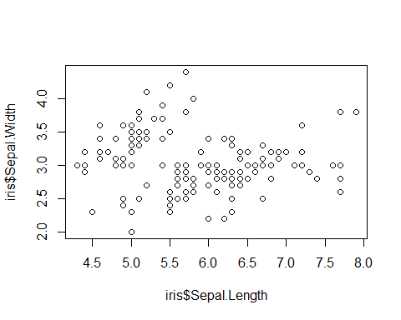

Scatter plot

plot(iris$Sepal.Length, iris$Sepal.Width)

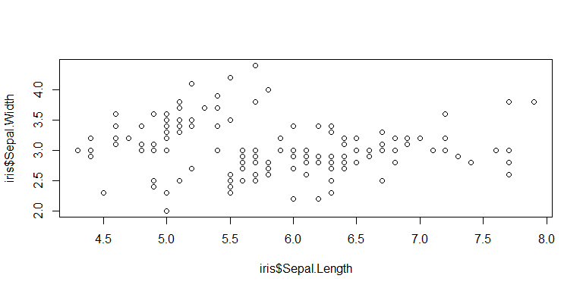

plot(iris$Sepal.Length, iris$Sepal.Width)



meansl <- mean(iris$Sepal.Length)  
meanpl <- mean(iris$Petal.Length)  
meansl

## [1] 5.843333

meanpl

## [1] 3.758

The mean difference for Sepal Lenght and Petal Length is 2.0853333