officedown template

Your Name

2024-12-24

## Table of content

## List of figures

## List of tables

## Sections

Lorem ipsum dolor sit amet, consectetur adipiscing elit. Nulla eu pulvinar arcu, quis aliquam dui. In at cursus ante. Vestibulum non sagittis lacus. Duis vitae iaculis dui. Vivamus tempor, nibh ut pretium tempus, enim lorem dignissim quam, at euismod massa magna at magna.

Lorem ipsum dolor sit amet, consectetur adipiscing elit. Nulla eu pulvinar arcu, quis aliquam dui. In at cursus ante. Vestibulum non sagittis lacus. Duis vitae iaculis dui. Vivamus tempor, nibh ut pretium tempus, enim lorem dignissim quam, at euismod massa magna at magna. Sed facilisis dapibus diam nec volutpat. Maecenas facilisis dapibus egestas. Curabitur dignissim pharetra pulvinar. Nunc bibendum elit sed cursus congue. Curabitur ligula quam, iaculis faucibus orci quis, vestibulum lobortis lectus. Suspendisse fringilla nisl pulvinar, laoreet tellus sed, sollicitudin tortor. Donec consequat congue erat in iaculis. Curabitur luctus tellus ut turpis iaculis, nec laoreet ligula scelerisque.

### Landscape section

Lorem ipsum dolor sit amet, consectetur adipiscing elit. Nulla eu pulvinar arcu, quis aliquam dui. In at cursus ante. Vestibulum non sagittis lacus. Duis vitae iaculis dui. Vivamus tempor, nibh ut pretium tempus, enim lorem dignissim quam, at euismod massa magna at magna. Sed facilisis dapibus diam nec volutpat.

**Şekil****:** Sütun Grafiği

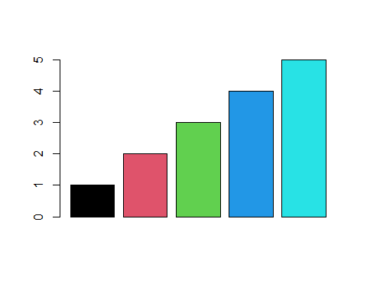

Yukarıda verilen sütun grafiğinde (Şekil ) gösterildiği üzere, …

### Regresyon Analizi

##   
## Call:  
## lm(formula = mpg ~ wt + hp, data = mtcars)  
##   
## Residuals:  
## Min 1Q Median 3Q Max   
## -3.941 -1.600 -0.182 1.050 5.854   
##   
## Coefficients:  
## Estimate Std. Error t value Pr(>|t|)   
## (Intercept) 37.22727 1.59879 23.285 < 2e-16 ***  
## wt -3.87783 0.63273 -6.129 1.12e-06 ***  
## hp -0.03177 0.00903 -3.519 0.00145 **   
## ---  
## Signif. codes: 0 '***' 0.001 '**' 0.01 '*' 0.05 '.' 0.1 ' ' 1  
##   
## Residual standard error: 2.593 on 29 degrees of freedom  
## Multiple R-squared: 0.8268, Adjusted R-squared: 0.8148   
## F-statistic: 69.21 on 2 and 29 DF, p-value: 9.109e-12

| r.squared | adj.r.squared | sigma | statistic | p.value | df | logLik | AIC | BIC | deviance | df.residual | nobs |
| --- | --- | --- | --- | --- | --- | --- | --- | --- | --- | --- | --- |
| 0.8267855 | 0.8148396 | 2.593412 | 69.21121 | 9.109054e-12 | 2 | -74.32617 | 156.6523 | 162.5153 | 195.0478 | 29 | 32 |

Model Performans ozeti

| r.squared | adj.r.squared | sigma | statistic | p.value | df | logLik | AIC | BIC | deviance | df.residual | nobs |
| --- | --- | --- | --- | --- | --- | --- | --- | --- | --- | --- | --- |
| 0.8267855 | 0.8148396 | 2.593412 | 69.21121 | 0 | 2 | -74.32617 | 156.6523 | 162.5153 | 195.0478 | 29 | 32 |

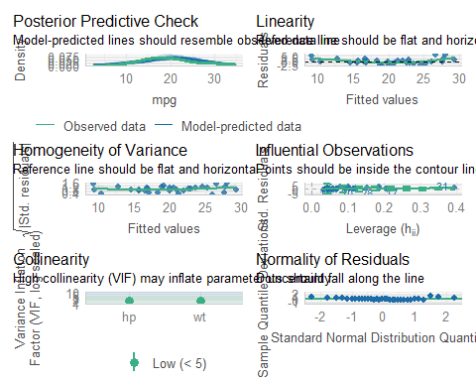

| AIC | AICc | BIC | R2 | R2_adjusted | RMSE | Sigma |
| --- | --- | --- | --- | --- | --- | --- |
| 156.6523 | 158.1338 | 162.5153 | 0.8267855 | 0.8148396 | 2.468854 | 2.593412 |

## The data contains 32 observations of the following 11 variables:  
##   
## - mpg: n = 32, Mean = 20.09, SD = 6.03, Median = 19.20, MAD = 5.41, range:  
## [10.40, 33.90], Skewness = 0.67, Kurtosis = -0.02, 0 missing  
## - cyl: n = 32, Mean = 6.19, SD = 1.79, Median = 6.00, MAD = 2.97, range: [4,  
## 8], Skewness = -0.19, Kurtosis = -1.76, 0 missing  
## - disp: n = 32, Mean = 230.72, SD = 123.94, Median = 196.30, MAD = 140.48,  
## range: [71.10, 472], Skewness = 0.42, Kurtosis = -1.07, 0 missing  
## - hp: n = 32, Mean = 146.69, SD = 68.56, Median = 123.00, MAD = 77.10, range:  
## [52, 335], Skewness = 0.80, Kurtosis = 0.28, 0 missing  
## - drat: n = 32, Mean = 3.60, SD = 0.53, Median = 3.70, MAD = 0.70, range:  
## [2.76, 4.93], Skewness = 0.29, Kurtosis = -0.45, 0 missing  
## - wt: n = 32, Mean = 3.22, SD = 0.98, Median = 3.33, MAD = 0.77, range: [1.51,  
## 5.42], Skewness = 0.47, Kurtosis = 0.42, 0 missing  
## - qsec: n = 32, Mean = 17.85, SD = 1.79, Median = 17.71, MAD = 1.42, range:  
## [14.50, 22.90], Skewness = 0.41, Kurtosis = 0.86, 0 missing  
## - vs: n = 32, Mean = 0.44, SD = 0.50, Median = 0.00, MAD = 0.00, range: [0, 1],  
## Skewness = 0.26, Kurtosis = -2.06, 0 missing  
## - am: n = 32, Mean = 0.41, SD = 0.50, Median = 0.00, MAD = 0.00, range: [0, 1],  
## Skewness = 0.40, Kurtosis = -1.97, 0 missing  
## - gear: n = 32, Mean = 3.69, SD = 0.74, Median = 4.00, MAD = 1.48, range: [3,  
## 5], Skewness = 0.58, Kurtosis = -0.90, 0 missing  
## - carb: n = 32, Mean = 2.81, SD = 1.62, Median = 2.00, MAD = 1.48, range: [1,  
## 8], Skewness = 1.16, Kurtosis = 2.02, 0 missing

## We fitted a linear model (estimated using OLS) to predict mpg with wt and hp  
## (formula: mpg ~ wt + hp). The model explains a statistically significant and  
## substantial proportion of variance (R2 = 0.83, F(2, 29) = 69.21, p < .001, adj.  
## R2 = 0.81). The model's intercept, corresponding to wt = 0 and hp = 0, is at  
## 37.23 (95% CI [33.96, 40.50], t(29) = 23.28, p < .001). Within this model:  
##   
## - The effect of wt is statistically significant and negative (beta = -3.88, 95%  
## CI [-5.17, -2.58], t(29) = -6.13, p < .001; Std. beta = -0.63, 95% CI [-0.84,  
## -0.42])  
## - The effect of hp is statistically significant and negative (beta = -0.03, 95%  
## CI [-0.05, -0.01], t(29) = -3.52, p = 0.001; Std. beta = -0.36, 95% CI [-0.57,  
## -0.15])  
##   
## Standardized parameters were obtained by fitting the model on a standardized  
## version of the dataset. 95% Confidence Intervals (CIs) and p-values were  
## computed using a Wald t-distribution approximation.

## Tables

### Table 1

**Tablo** **:** mtcars verisinin ilk 6 satırı

| mpg | cyl | disp | hp | drat | wt | qsec | vs | am | gear | carb |
| --- | --- | --- | --- | --- | --- | --- | --- | --- | --- | --- |
| 21.0 | 6 | 160 | 110 | 3.90 | 2.620 | 16.46 | 0 | 1 | 4 | 4 |
| 21.0 | 6 | 160 | 110 | 3.90 | 2.875 | 17.02 | 0 | 1 | 4 | 4 |
| 22.8 | 4 | 108 | 93 | 3.85 | 2.320 | 18.61 | 1 | 1 | 4 | 1 |
| 21.4 | 6 | 258 | 110 | 3.08 | 3.215 | 19.44 | 1 | 0 | 3 | 1 |
| 18.7 | 8 | 360 | 175 | 3.15 | 3.440 | 17.02 | 0 | 0 | 3 | 2 |
| 18.1 | 6 | 225 | 105 | 2.76 | 3.460 | 20.22 | 1 | 0 | 3 | 1 |

### Table 2

**Tablo :** iris

| Sepal.Length | Sepal.Width | Petal.Length | Petal.Width | Species |
| --- | --- | --- | --- | --- |
| 5.1 | 3.5 | 1.4 | 0.2 | setosa |
| 4.9 | 3.0 | 1.4 | 0.2 | setosa |
| 4.7 | 3.2 | 1.3 | 0.2 | setosa |
| 4.6 | 3.1 | 1.5 | 0.2 | setosa |
| 5.0 | 3.6 | 1.4 | 0.2 | setosa |
| 5.4 | 3.9 | 1.7 | 0.4 | setosa |

### Table 3

**Tablo** **:** cars

| speed | dist |
| --- | --- |
| 4 | 2 |
| 4 | 10 |
| 7 | 4 |
| 7 | 22 |
| 8 | 16 |
| 9 | 10 |

Tab.Verinin ilk birkac gozlemiVerinin ilk birkaç gözlemi

’de özetlendiği gibi, belirli aracların özellikleri birbirinden farklı görünmektedir.

Yukarıda tabloda altı cızılen **arac sahıplerine** ….

## figures

### A boxplot

**Şekil****:** A boxplot

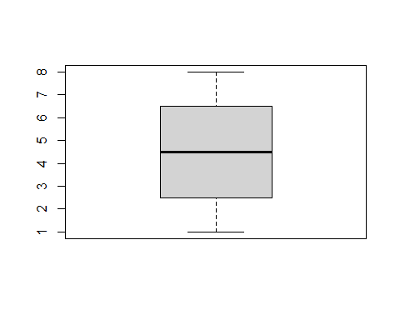

### A barplot

**Şekil****:** What a barplot

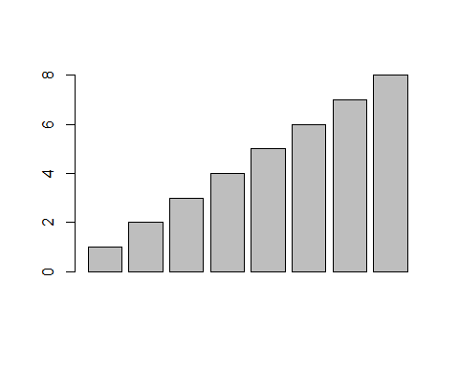

## Lists

Amet nunc eros curabitur tellus massa, eros maximus porttitor sociosqu, pellentesque.

* Erat mauris egestas finibus tincidunt sed in rhoncus a tellus etiam.
  + A adipiscing per ultricies justo tellus lorem.
    - Imperdiet ut dui primis, sed gravida, at sed nulla.
    - Sem posuere lacus consequat inceptos dapibus duis malesuada finibus.
  + Urna sed dui, ornare, eu turpis mus pellentesque amet amet bibendum.
* Himenaeos tincidunt, auctor dapibus scelerisque, montes nunc faucibus sodales malesuada ridiculus sed cubilia ligula.

1. Erat mauris egestas finibus tincidunt sed in rhoncus a tellus etiam.
   1. A adipiscing per ultricies justo tellus lorem.
      1. Imperdiet ut dui primis, sed gravida, at sed nulla.
      2. Sem posuere lacus consequat inceptos dapibus duis malesuada finibus.
   2. Urna sed dui, ornare, eu turpis mus pellentesque amet amet bibendum.
2. Himenaeos tincidunt, auctor dapibus scelerisque, montes nunc faucibus sodales malesuada ridiculus sed cubilia ligula.

Lorem dolor interdum orci eros pellentesque semper tristique, sodales, et sed ut! Porta mattis natoque et. Ac facilisi ipsum viverra elementum vestibulum ligula amet enim magnis luctus ullamcorper. Rhoncus rhoncus elit in at nisl. Tincidunt habitant sit.

* Aptent conubia quam montes id sagittis.
  + Mattis nisi nascetur, aliquam duis ex, tristique.
    - Imperdiet ut dui primis, sed gravida, at sed nulla.
    - Donec ligula nulla ac. Nisl ac at accumsan sagittis eros felis lobortis amet nec phasellus urna bibendum sapien.
  + Eu dui ac id, dictum proin consectetur convallis.
* Facilisi eu lectus mauris lorem. Et sed sapien pellentesque sed etiam vehicula.
* In porttitor id lorem eu efficitur, nisl dis!

See figure and table !

All examples are created using certain packages belong to (R Core Team 2019) language.

# References

R Core Team. 2019. *R: A Language and Environment for Statistical Computing*. Vienna, Austria: R Foundation for Statistical Computing. <https://www.R-project.org>.