This web project allows you to select some dishes from ingredients that you have.

Goal of the project - to deep knowledge and experience in ASP. NET MVC.

Technologies that I’ve used:

* ASP. NET MVC 5
* Frameworks: Ninject, Entity Framework, Knockout JS, jQuery.

1. The main page:

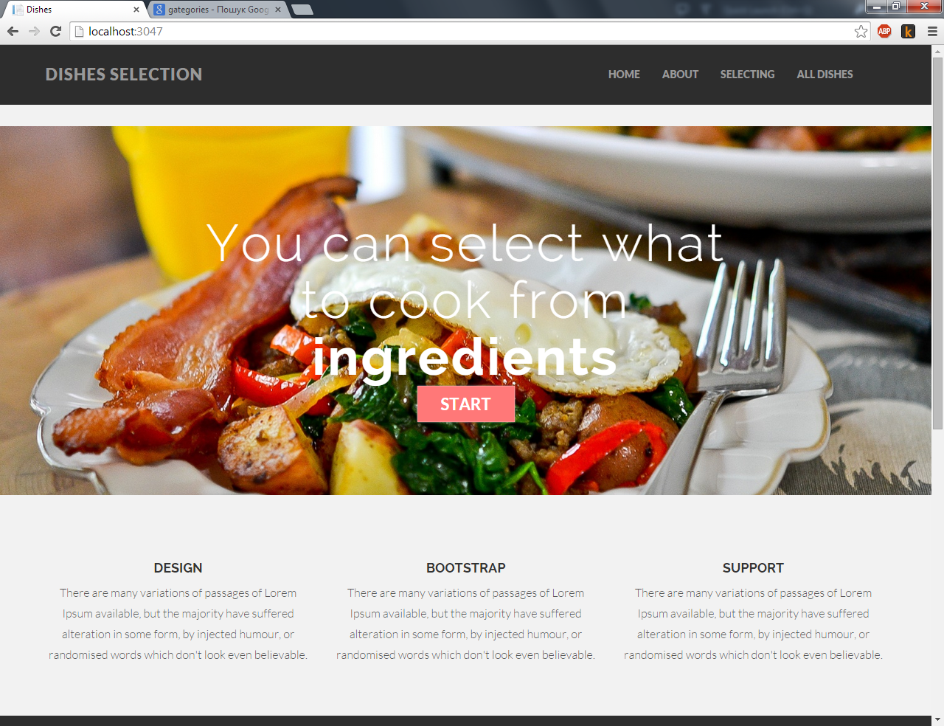

1. 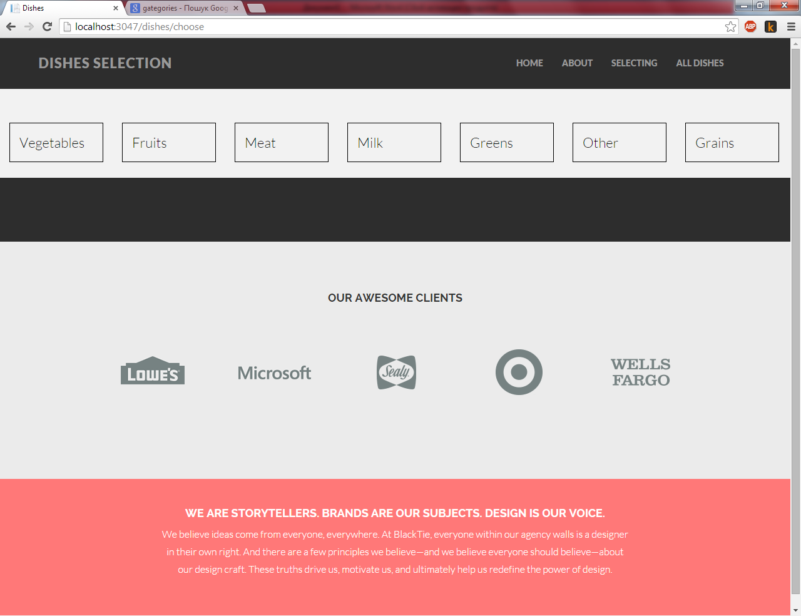To start selecting dishes you need to click “Start”. And now you are on the page where you see categories of ingredients:
2. 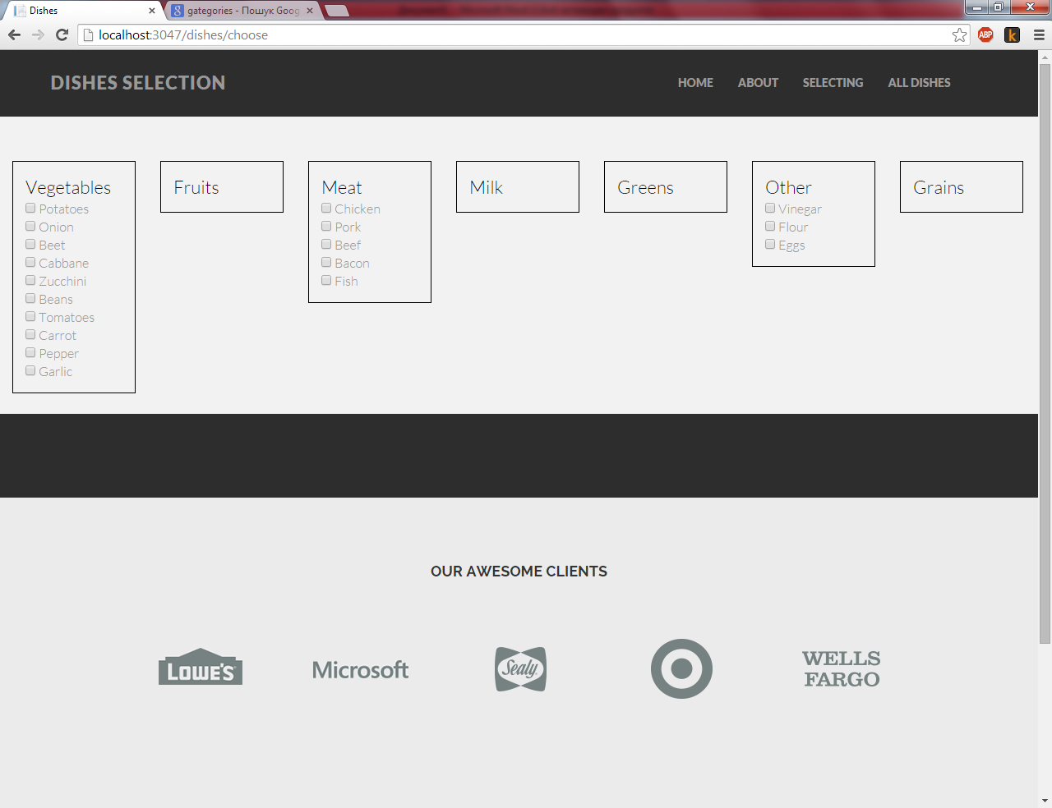To open each category you should click on it:
3. Than you can choose ingredients that you have at home. And if your selection enough to cook some dish – this will appear.

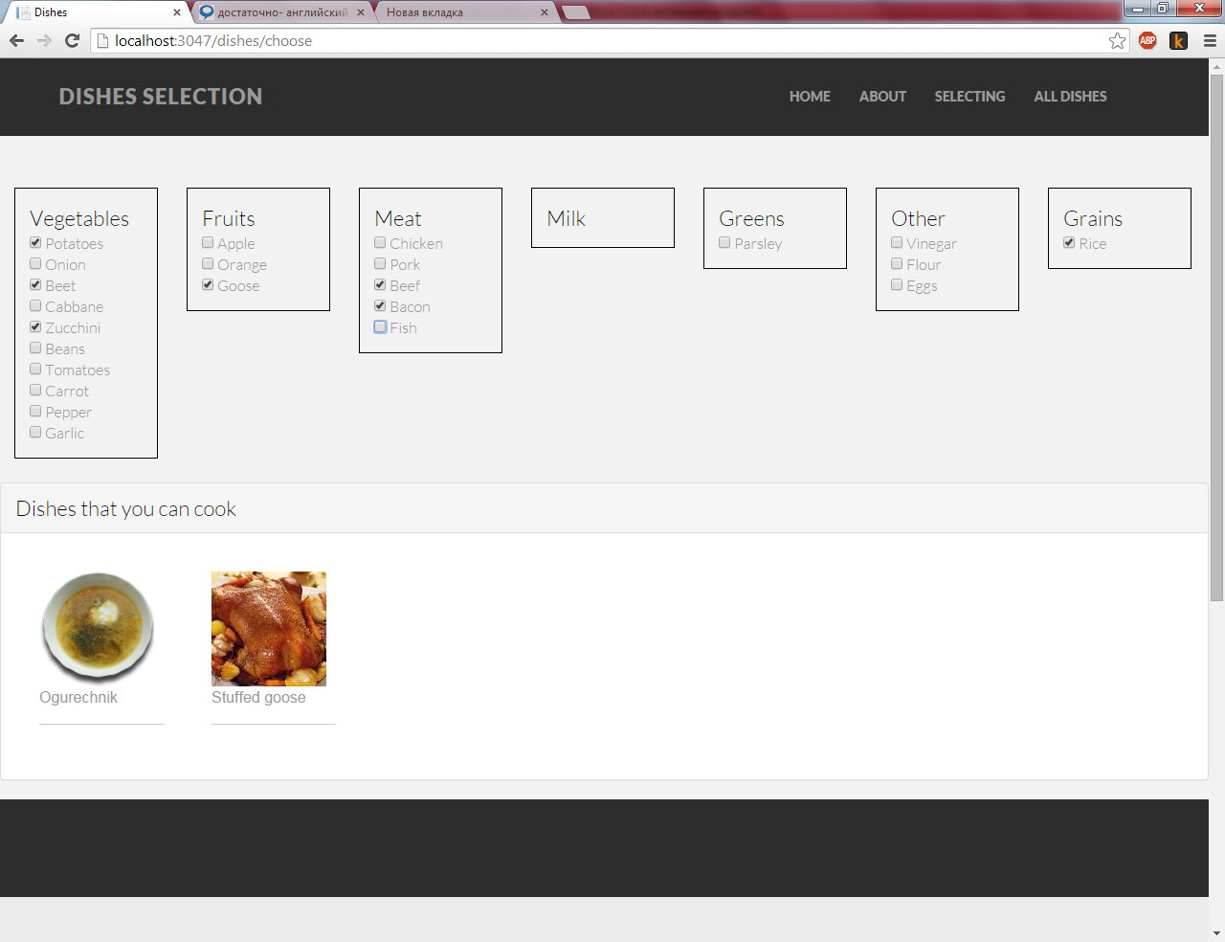

1. 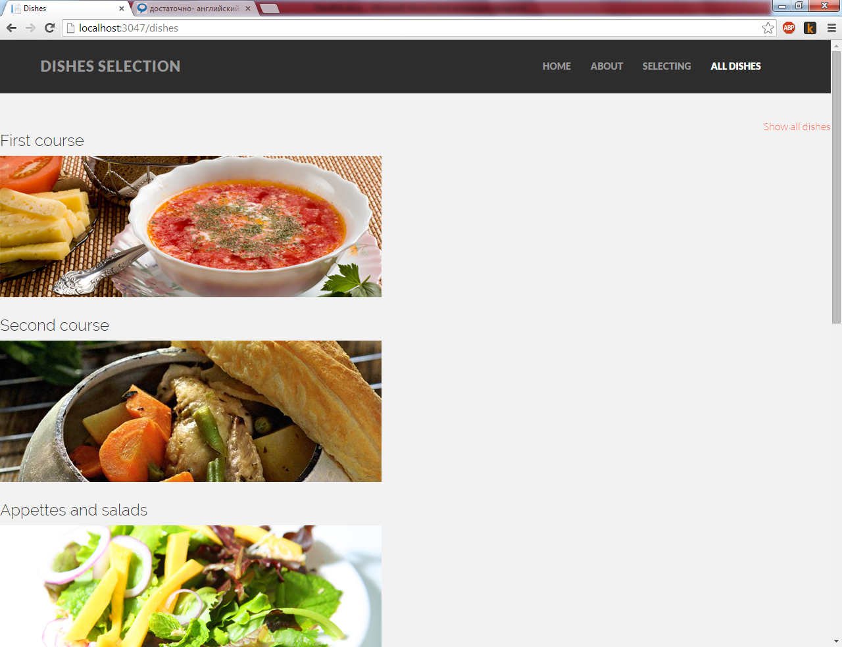Any dish has a category. You can see all dish categories by link “All dishes”
2. 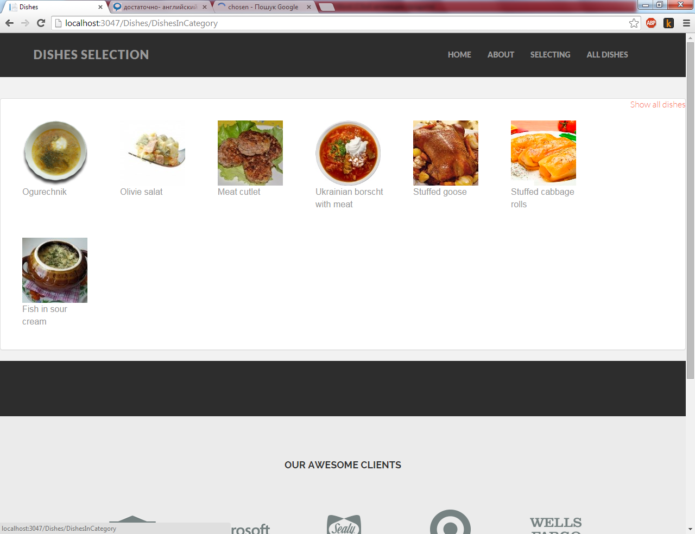You can see all dishes from chosen category or you can click on link “Show all dishes” to see whole the dishes on the project (There are few dishes for testing the project).