**中国科学技术大学计算机学院**

**《数字电路实验》报告**



实验题目：贪吃蛇游戏

学生姓名：Ouedraogo Ezekiel B.

学生学号：PL19215001

完成日期：1/12/2021

计算机实验教学中心制

2020年10月

【实验环境】

Vivado

FPGA板子

【实验过程】

首先设计游戏的背景

**module** cel_color**(**

**input** VGA_clk**,**

**input** displayArea**,**

**input** **[**10**:**0**]** xCount**,** yCount**,**

**output** **reg** cel**,** in_space**,** cel_border**,** out_space

**);**

**parameter** CEL_SIZE **=** 32**;**

**parameter** OUT_SPACE **=** 1**;**

**parameter** IN_SPACE **=** 2**;**

**parameter** BORDER **=** 2**;**

**wire** **[**10**:**0**]** q_x **=** xCount**/(**CEL_SIZE**);**

**wire** **[**10**:**0**]** q_y **=** yCount**/(**CEL_SIZE**);**

**wire** **[**7**:**0**]** cel_x **=** xCount **-** q_x**\***CEL_SIZE**;**

**wire** **[**7**:**0**]** cel_y **=** yCount **-** q_y**\***CEL_SIZE**;**

**integer** i **=** IN_SPACE **+** BORDER **+** OUT_SPACE**;**

**integer** j **=** BORDER **+** OUT_SPACE**;**

**integer** k **=** OUT_SPACE**;**

**always@(posedge** VGA_clk**)**

**begin**

**if(**displayArea**)**

**begin**

cel **<=** **(**cel_x **>=** i**)** **&&** **(**cel_y **>=** i**)** **&&** **(**cel_x **<** CEL_SIZE **-** i**)** **&&** **(**cel_y **<** CEL_SIZE **-** i**)** **?** 1 **:** 0**;**

**if(**cel**)**

**begin**

in_space **<=** 0**;**

cel_border **<=** 0**;**

out_space **<=** 0**;**

**end**

**else**

**begin**

in_space **=** **(**cel_x **>=** j**)** **&&** **(**cel_y **>=** j**)** **&&** **(**cel_x **<** CEL_SIZE **-** j**)** **&&** **(**cel_y **<** CEL_SIZE **-** j**)** **?** 1 **:** 0**;**

**if(**in_space**)**

**begin**

cel_border **<=** 0**;**

out_space **<=** 0**;**

**end**

**else**

**begin**

cel_border **=** **(**cel_x **>=** k**)** **&&** **(**cel_y **>=** k**)** **&&** **(**cel_x **<** CEL_SIZE **-** k**)** **&&** **(**cel_y **<** CEL_SIZE **-** k**)** **?** 1 **:** 0**;**

**if(**cel_border**)**

out_space **<=** 0**;**

**else**

out_space **=** 1**;**

**end**

**end**

**end**

**end**

**endmodule**

结果

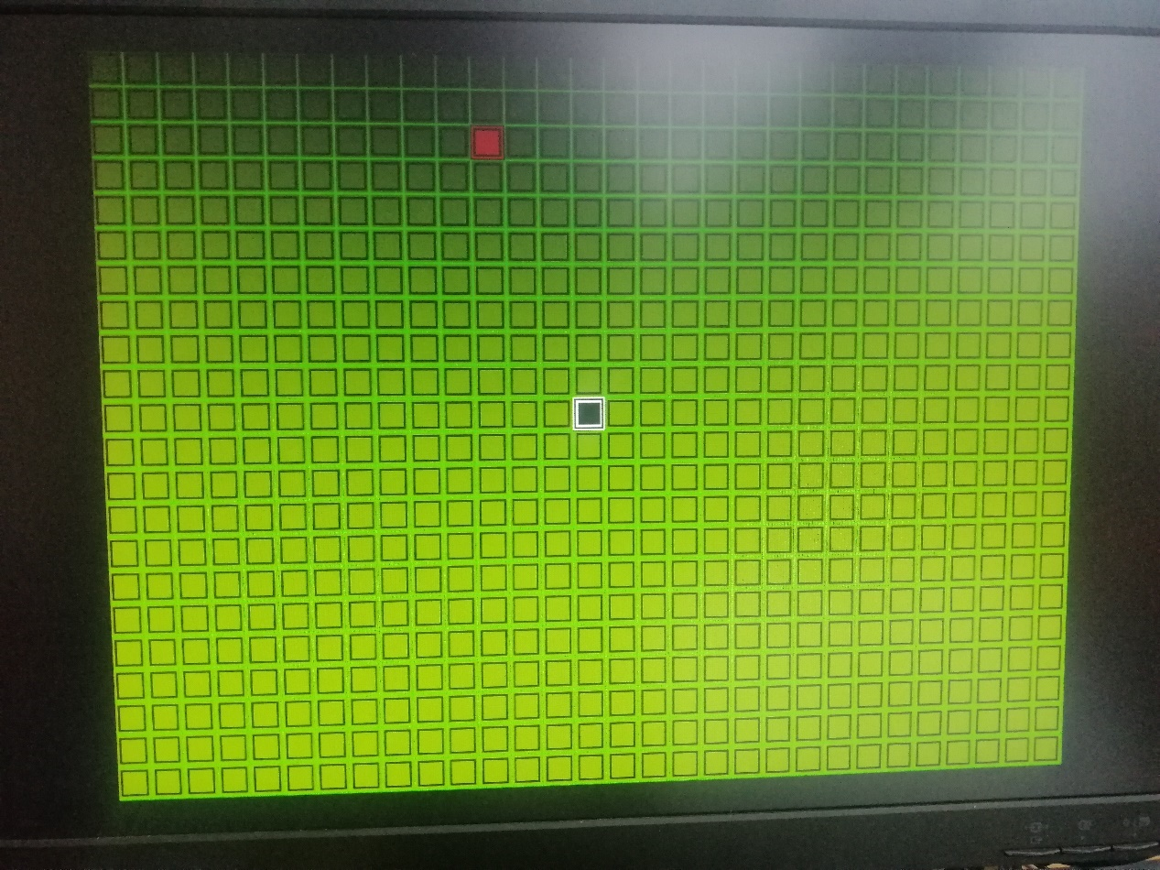

分析：输入信号为VGA_clk，displayArea，xCount，yCount。其中displayArea = 1时，表示在显示区域。 xCount和yCount表示位置。

看结果图可以发现背景时很多小正方形组成的。每个正方形含四部分，如下图:

cel

in_space

out_space

cel_border

到每个变量指的部分，其输出变量为1否则为0。四部分都可以设置自己的颜色。所以用模块就可以显示背景，蛇，目标和墙， 只需要到每个背景，蛇，目标或墙时候换颜色。

其次给目标设计一个输出随机位置的模块

**module** randomGrid**(**

**input** VGA_clk**,**

**input** **[**10**:**0**]** max_X**,** min_X**,**

**input** **[**10**:**0**]** max_Y**,** min_Y**,**

**output** **reg** **[**10**:**0**]** rand_X**,**

**output** **reg** **[**10**:**0**]** rand_Y

**);**

**always** **@(posedge** VGA_clk**)**

**begin**

rand_X **<=** **((**rand_X **+** 3**)** **%** **(**max_X**-**min_X**))** **+** min_X**;**

rand_Y **<=** **((**rand_Y **+** 5**)** **%** max_Y**-**min_Y**)** **+** min_Y**;**

**end**

**endmodule**

在设计一个VGA控制模块

**module** VGA_gen**(**

**input** CLK**,** RESET**,** //clk=65MHzz

**output** displayArea**,**

**output** **reg** **[**10**:**0**]** xCount**,**yCount**,** //x,y pixel

**output** **reg** VGA_HS**,**VGA_VS

**);**

**parameter** H_CNT **=** 11'd1343**;** //136+160+1024+24=1344-1

**parameter** V_CNT **=** 11'd805**;** //6+29+768+3=806-1

**reg** h_de**,** v_de**;** //data enable

**reg** **[**10**:**0**]** h_cnt**,**v_cnt**;**

**always@(posedge** CLK**)**

**begin**

**if(**RESET**)**

h_cnt **<=** 11'd0**;**

**else** **if(**h_cnt**>=**H_CNT**)**

h_cnt **<=** 11'd0**;**

**else**

h_cnt **<=** h_cnt **+** 11'd1**;**

**end**

**always@(posedge** CLK**)**

**begin**

**if(**RESET**)**

v_cnt **<=** 11'd0**;**

**else** **if(**h_cnt**==**H_CNT**)**

**begin**

**if(**v_cnt**>=**V_CNT**)**

v_cnt **<=** 11'd0**;**

**else**

v_cnt **<=** v_cnt **+** 11'd1**;**

**end**

**end**

**always@(posedge** CLK**)**

**begin**

**if(**RESET**)**

h_de **<=** 1'b0**;**

**else** **if((**h_cnt**>=**296**)&&(**h_cnt**<=**1319**))**

h_de **<=** 1'b1**;**

**else**

h_de **<=** 1'b0**;**

**end**

**always@(posedge** CLK**)**

**begin**

**if(**RESET**)**

v_de **<=** 1'b0**;**

**else** **if((**v_cnt**>=**35**)&&(**v_cnt**<=**802**))**

v_de **<=** 1'b1**;**

**else**

v_de **<=** 1'b0**;**

**end**

**always@(posedge** CLK**)**

**begin**

**if(**RESET**)**

VGA_HS **<=** 1'b1**;**

**else** **if(**h_cnt**<=**11'd135**)**

VGA_HS **<=** 1'b0**;**

**else**

VGA_HS **<=** 1'b1**;**

**end**

**always@(posedge** CLK**)**

**begin**

**if(**RESET**)**

VGA_VS **<=** 1'b1**;**

**else** **if(**v_cnt**<=**11'd5**)**

VGA_VS **<=** 1'b0**;**

**else**

VGA_VS **<=** 1'b1**;**

**end**

**always@(posedge** CLK**)**

**begin**

**if(**h_de **==** 1'h0**)**

xCount **<=** 11'h0**;**

**else**

xCount **<=** xCount **+** 11'h1**;**

**end**

**always@(negedge** h_de**)**

**begin**

**if(**v_de **==** 1'h0**)**

yCount **<=** 11'h0**;**

**else**

yCount **<=** yCount **+** 11'h1**;**

**end**

**assign** displayArea **=** **(**v_de**==**1 **&&** h_de**==**1**);**

**endmodule**

最后设计游戏的基本功能

**module** Play**(**

**input** CLK**,** RESET**,**

**input** UP**,** LEFT**,** DOWN**,** RIGHT**,**

**output** **reg** **[**3**:**0**]** VGA_R**,** VGA_G**,** VGA_B**,**

**output** VGA_HS**,** VGA_VS

**);**

**parameter** SCREEN_H **=** 1024**;**

**parameter** SCREEN_V **=** 768**;**

**parameter** UNIT **=** 32**;**

**parameter** SNAKE_MAX_SIZE **=** 20**;**

**wire** VGA_clk**,** locked**;** //65 MHz

**wire** displayArea**;**

**wire** **[**10**:**0**]** xCount**,** yCount**;** //x ,y pixel

**reg** **[**3**:**0**]** direction**;**

**reg** **[**10**:**0**]** snakeX**[**0**:**SNAKE_MAX_SIZE**];**

**reg** **[**10**:**0**]** snakeY**[**0**:**SNAKE_MAX_SIZE**];**

**reg** **[**SNAKE_MAX_SIZE**:**0**]** snakeBody**;**

**reg** **[**7**:**0**]** snake_size**;**

**reg** game_over**;**

**reg** apple**,** border**;**

**reg** **[**10**:**0**]** appleX **=** 64**;**

**reg** **[**10**:**0**]** appleY **=** 64**;**

**wire** **[**10**:**0**]**rand_X**;**

**wire** **[**10**:**0**]**rand_Y**;**

**reg** update**;**

**wire** cel**;**

**wire** in_space**;**

**wire** cel_border**;**

**wire** out_space**;**

**reg** **[**27**:**0**]** count**,** max_count**;**

// generate VGA clock (65 MHz) from input clock (100 MHz)

clk_wiz_0 clk_wiz_0**(**

**.**clk_in1 **(**CLK**),**

**.**reset **(**RESET**),**

**.**clk_out1 **(**VGA_clk**),**

**.**locked **(**locked**)**

**);**

//VGA controller

VGA_gen VGA_gen**(**

**.**CLK**(**VGA_clk**),** **.**RESET**(~**locked**),**

**.**displayArea**(**displayArea**),**

**.**xCount**(**xCount**),.**yCount**(**yCount**),**

**.**VGA_HS**(**VGA_HS**),.**VGA_VS**(**VGA_VS**)**

**);**

//get random number to place the apple

randomGrid randomGrid**(**

**.**VGA_clk**(**VGA_clk**),**

**.**max_X**(**SCREEN_H**-**UNIT**),** **.**min_X**(**UNIT**),**

**.**max_Y**(**SCREEN_V**-**UNIT**),** **.**min_Y**(**UNIT**),**

**.**rand_X**(**rand_X**),**

**.**rand_Y**(**rand_Y**)**

**);**

//color cels

cel_color cel_color**(**

**.**VGA_clk**(**VGA_clk**),**

**.**displayArea**(**displayArea**),**

**.**xCount**(**xCount**),** **.**yCount**(**yCount**),**

**.**cel**(**cel**),** **.**in_space**(**in_space**),** **.**cel_border**(**cel_border**),** **.**out_space**(**out_space**)**

**);**

**integer** i**,**j**;**

**always@(posedge** VGA_clk **or** **posedge** RESET**)**

**begin**

**if(**RESET**)**

**begin**

// place the snake head at display center

i **=** SCREEN_H**/**2 **-** UNIT**/**2**;**

j **=** SCREEN_V**/**2 **-** UNIT**/**2**;**

snakeX**[**0**]** **<=** **(**i **-** i**%**UNIT**);**

snakeY**[**0**]** **<=** **(**j **-** j**%**UNIT**);**

// place apple

i **=** rand_X**;**

j **=** rand_Y**;**

appleX **<=** **(**i **-** i**%**UNIT**);**

appleY **<=** **(**j **-** j**%**UNIT**);**

**for(**i **=** 1**;** i **<** SNAKE_MAX_SIZE**;** i **=** i **+** 1**)**

**begin**

// place the invisible snake parts outside the scanning area

snakeX**[**i**]** **<=** SCREEN_H**;**

snakeY**[**i**]** **<=** SCREEN_V**;**

**end**

max_count **<=** 28'd65_000_000**;**

snake_size **<=** 1**;**

game_over **<=** 0**;**

**end**

**else** **if(~**game_over**)**

**begin**

**if(**update**)**

**begin**

**for(**i **=** 1**;** i **<** snake_size**;** i **=** i **+** 1**)**

**begin**

snakeX**[**i**]** **<=** snakeX**[**i **-** 1**];**

snakeY**[**i**]** **<=** snakeY**[**i **-** 1**];**

**end**

**case(**direction**)**

4'b1**:** snakeY**[**0**]** **<=** **(**snakeY**[**0**]** **-** UNIT**);**

4'b10**:** snakeX**[**0**]** **<=** **(**snakeX**[**0**]** **-** UNIT**);**

4'b100**:** snakeY**[**0**]** **<=** **(**snakeY**[**0**]** **+** UNIT**);**

4'b1000**:** snakeX**[**0**]** **<=** **(**snakeX**[**0**]** **+** UNIT**);**

**endcase**

**end**

**else**

**begin**

// Detect if snake head hit the apple

**if** **(**apple **&&** snakeBody**[**0**])**

**begin**

i **=** rand_X**;**

j **=** rand_Y**;**

appleX **<=** **(**i **-** i**%**UNIT**);**

appleY **<=** **(**j **-** j**%**UNIT**);**

**if(**snake_size **<** SNAKE_MAX_SIZE **)**

snake_size **<=** snake_size **+** 1**;**

**end**

// Detect if snake head hit border

**else** **if** **(**border **&&** snakeBody**[**0**])**

game_over **<=** 1'b1**;**

// Detect if snake head hit the snake body

**else** **if** **(|**snakeBody**[**SNAKE_MAX_SIZE **-** 1 **:**1**]** **&&** snakeBody**[**0**])**

game_over **<=** 1'b1**;**

**end**

**end**

**end**

//check update

**always@(posedge** VGA_clk **or** **posedge** RESET**)**

**begin**

**if(**RESET**)**

**begin**

count **<=** 28'd0**;**

update **<=** 0**;**

**end**

**else** **if(**count **>=** max_count**)**

**begin**

count **<=** 28'd0**;**

update **<=** 1**;**

**end**

**else**

**begin**

count **<=** count **+** 28'd1**;**

update **<=** 0**;**

**end**

**end**

//color cel

**always@(posedge** VGA_clk**)**

**begin**

**if(**displayArea**)**

**begin**

**if(**border**)**

**begin**

**if(**cel**)** **{**VGA_R**,** VGA_G**,** VGA_B**}** **<=** 12'h3**;**

**else** **if(**in_space**)** **{**VGA_R**,** VGA_G**,** VGA_B**}** **<=** 12'h0**;**

**else** **if(**cel_border**)** **{**VGA_R**,** VGA_G**,** VGA_B**}** **<=** 12'h3**;**

**else** **if(**out_space**)** **{**VGA_R**,** VGA_G**,** VGA_B**}** **<=** 12'h0**;**

**else** **{**VGA_R**,** VGA_G**,** VGA_B**}** **<=** 12'h0**;**

**end**

**else** **if(|**snakeBody**)**

**begin**

**if(**cel**)** **{**VGA_R**,** VGA_G**,** VGA_B**}** **<=** 12'h0**;**

**else** **if(**in_space**)** **{**VGA_R**,** VGA_G**,** VGA_B**}** **<=** 12'hfff**;**

**else** **if(**cel_border**)** **{**VGA_R**,** VGA_G**,** VGA_B**}** **<=** 12'h0**;**

**else** **if(**out_space**)** **{**VGA_R**,** VGA_G**,** VGA_B**}** **<=** 12'hfff**;**

**else** **{**VGA_R**,** VGA_G**,** VGA_B**}** **<=** 12'h0**;**

**end**

**else** **if(**apple**)**

**begin**

**if(**cel**)** **{**VGA_R**,** VGA_G**,** VGA_B**}** **<=** 12'h700**;**

**else** **if(**in_space**)** **{**VGA_R**,** VGA_G**,** VGA_B**}** **<=** 12'h0**;**

**else** **if(**cel_border**)** **{**VGA_R**,** VGA_G**,** VGA_B**}** **<=** 12'h700**;**

**else** **if(**out_space**)** **{**VGA_R**,** VGA_G**,** VGA_B**}** **<=** 12'h0**;**

**else** **{**VGA_R**,** VGA_G**,** VGA_B**}** **<=** 12'h0**;**

**end**

**else**

**begin**

**if(**cel**)** **{**VGA_R**,** VGA_G**,** VGA_B**}** **<=** 12'h340**;**

**else** **if(**in_space**)** **{**VGA_R**,** VGA_G**,** VGA_B**}** **<=** 12'h3**;**

**else** **if(**cel_border**)** **{**VGA_R**,** VGA_G**,** VGA_B**}** **<=** 12'h340**;**

**else** **if(**out_space**)** **{**VGA_R**,** VGA_G**,** VGA_B**}** **<=** 12'h70**;**

**else** **{**VGA_R**,** VGA_G**,** VGA_B**}** **<=** 12'h0**;**

**end**

**end**

**end**

//init direction

**always@(posedge** CLK**)**

**begin**

**if(**RESET**)**

direction **<=** 4'b0**;**

**else** **if(**UP**)**

direction **<=** 4'b1**;**

**else** **if(**LEFT**)**

direction **<=** 4'b10**;**

**else** **if(**DOWN**)**

direction **<=** 4'b100**;**

**else** **if(**RIGHT**)**

direction **<=** 4'b1000**;**

**else**

direction **<=** direction**;**

**end**

// Detect if the VGA scanning is hitting the border

**always** **@(posedge** VGA_clk**)**

**begin**

border **<=** **((**xCount **<=** UNIT**)** **||** **(**xCount **>** SCREEN_H **-** UNIT**)** **||** **(**yCount **<=** UNIT**)** **||** **(**yCount **>** **(**SCREEN_V **-** UNIT**)));**

**end**

// Detect if the VGA scanning is hitting the apple

**always** **@(posedge** VGA_clk**)**

**begin**

apple **<=** **((**xCount **>=** appleX**)** **&** **(**yCount **>=** appleY**)** **&** **(**xCount **<** appleX **+** UNIT**)** **&** **(**yCount **<** appleY **+** UNIT**));**

**end**

// Detect if the VGA scanning is hitting the snake head or snake body

**always@(posedge** VGA_clk**)**

**begin**

**for(**i **=** 0**;** i **<** SNAKE_MAX_SIZE**;** i **=** i **+** 1**)**

snakeBody**[**i**]** **<=** **((**xCount **>=** snakeX**[**i**])** **&** **(**yCount **>=** snakeY**[**i**])** **&** **(**xCount **<** snakeX**[**i**]** **+** UNIT**)** **&** **(**yCount **<** snakeY**[**i**]** **+** UNIT**));**

**end**

**endmodule**

结果

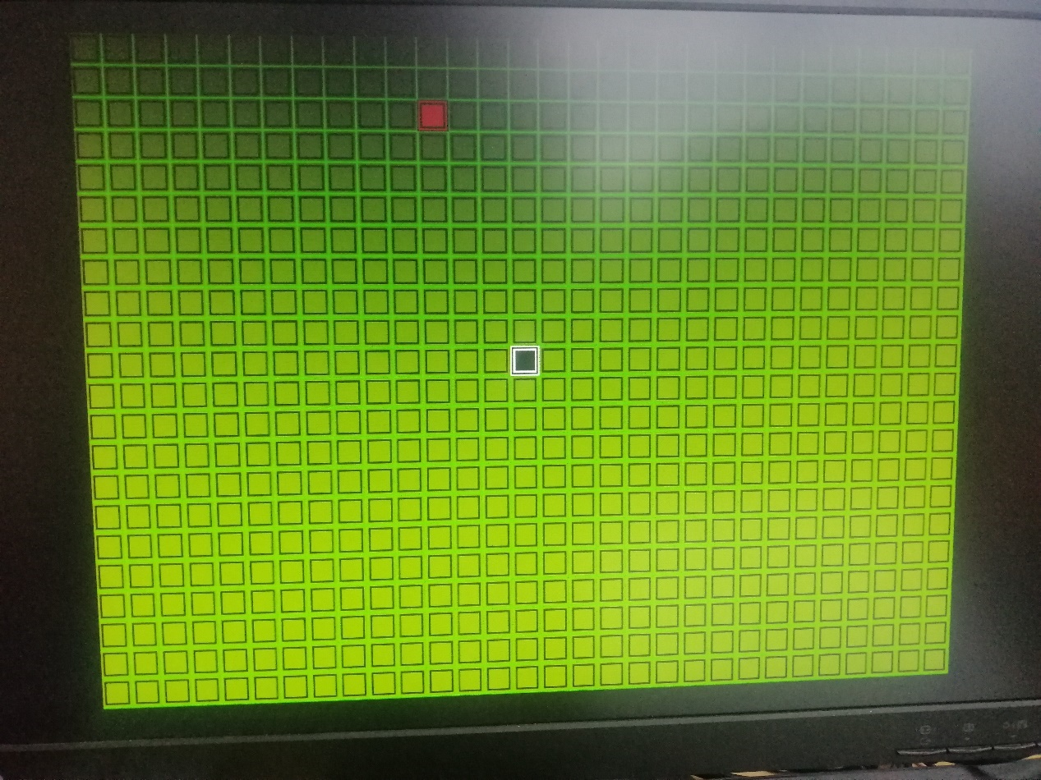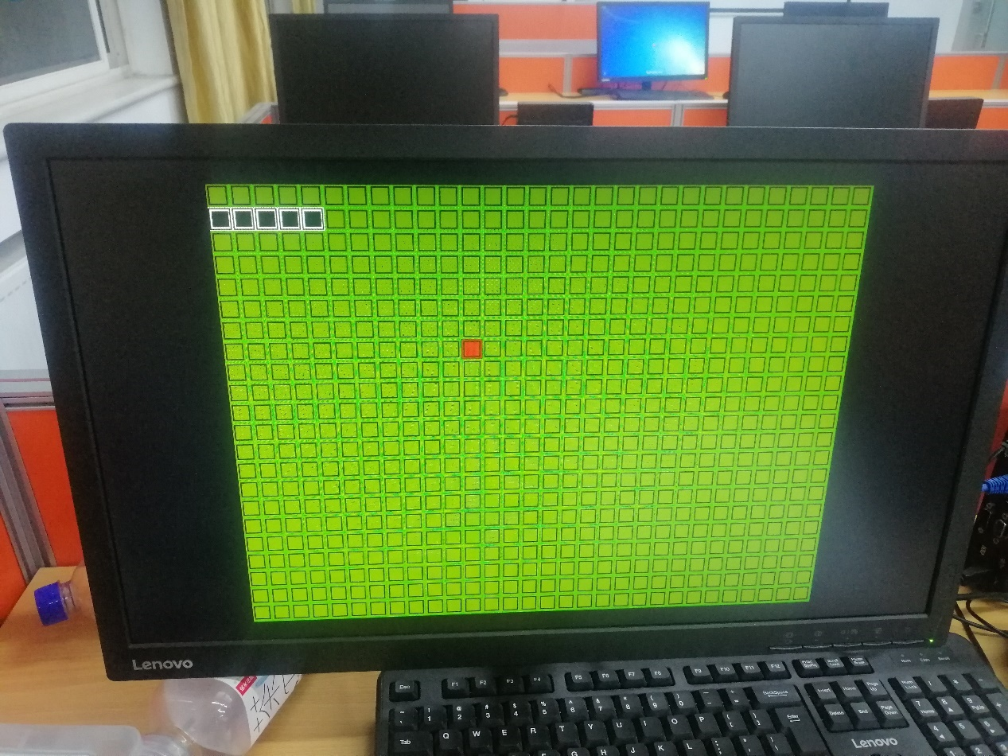

XDC文件

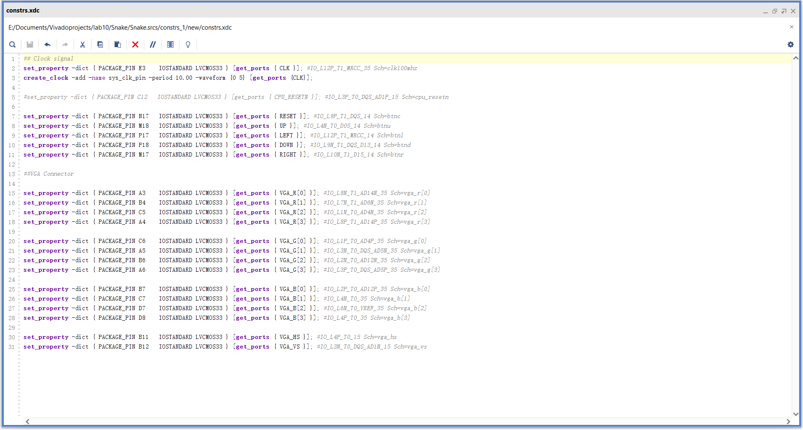

FPGA的上下左右按键用来控制蛇的行动。

【总结与思考】

该实验花的大部分时间在了设计完美的图像，所以有些的功能只是做出了最基础的比如蛇吃一个目标后增长，撞到墙游戏暂停，等。