Table of Contents
Dragino LPS8 setup 2
The Thing Network (TTN) setup 3
Create your TTN Account 3
Register your TTN gateway 3
Create a new TTN application 5

Dragino LPS8 setup

After connecting LPS8 gateway ethernet RJ45 to your network, you’ll be able to connect to the embedded webserver on port 8080.

http://<ip of LPS8>:8000 to access configuration

- Lora basic configuration

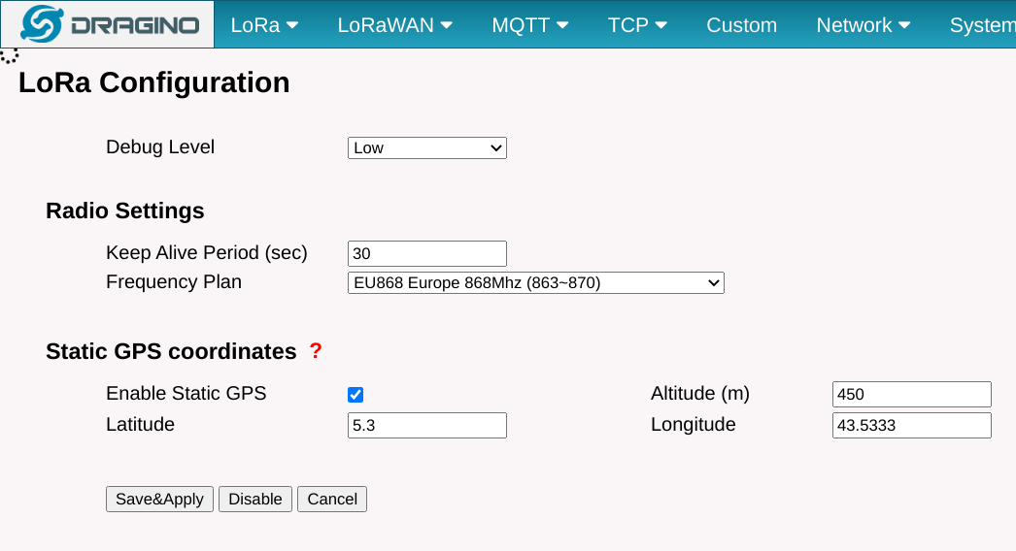

The Thing Network (TTN) setup

This chapter will describe the steps to configure all TTN elements :

- Create account
- enroll your Dragino gateway
- Create a new Lorawan Application
- Declare a Lorawan node in the application
- Create a payload decoder
- Configure a HTTP Post payload plugin

Create your TTN Account

Go to https://account.thethingsnetwork.org/register and create a new account.

Register your TTN gateway

Log in TTN, and go to console (https://console.thethingsnetwork.org/)

Select Gateways :
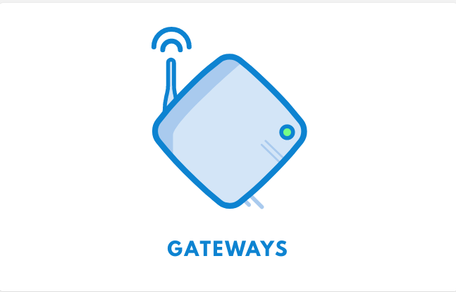

Click «Register gateway »

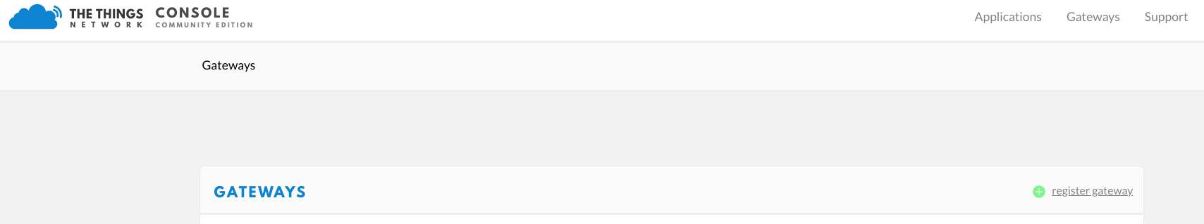

Fill all the informations in the form, and don’t forget to select « I’m using legacy packet forwarder »
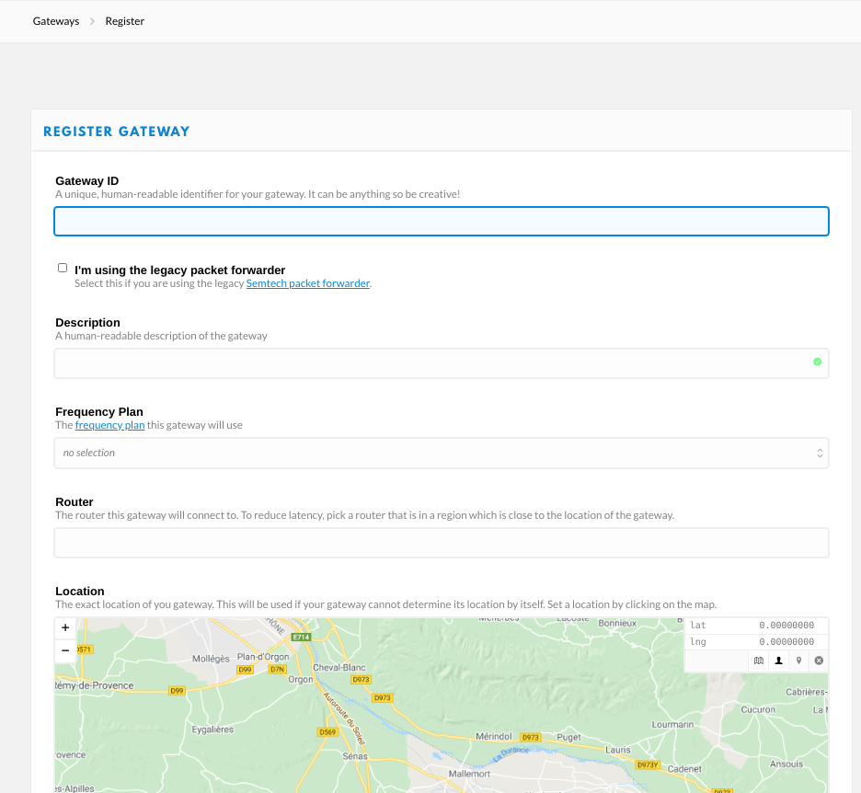

Create a new TTN application

- Select « add Application »
