**CPCZurich2019 Tutorials – METACOGNITION Installation Guide**

***PART 1: Main toolbox download***

1. Make sure you install Matlab and that you can open and run it before installing this Toolbox
2. Then go to the github page of the HMeta-d Toolbox and download the ‘master’ folder (found here: <https://github.com/metacoglab/HMeta-d>).

You will be provided with 2 possibilities to download the toolbox:

1. Downloading the Toolbox via .zip File.
2. Cloning the Toolbox. This allows you to keep up-to date with future changes in the Toolbox but is only possible if you have a git account.

For the purposes and if you do not have a git account we advise you to use the first possibility and only download the .zip File.

1. Un-zip the file and put it in a folder/directory which you will use for the practical tutorial (e.g. Desktop/CPC2019/MetacognitionTutorial).

**Make sure you do not have any spaces in the titles of your folders!**

1. Open Matlab and in Matlab navigate to the folder/directory you prepared (e.g. “MetacognitionTutorial”). Then right-click on the directory and “Add to Path”, “Selected Folders and Subfolders”.

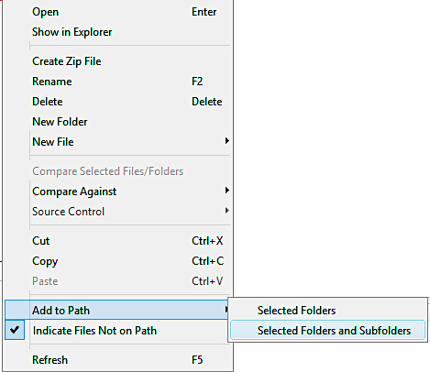

1. Now you need to install JAGS (an MCMC language similar to BUGS) on your machine, which can be found here: <http://mcmc-jags.sourceforge.net>

**Note that there are re compatibility issues between matjags and JAGS 4.X.** To run the MATLAB code you will need to install JAGS 3.4.0 rather than the latest version.

1. Feel free to try the toolbox by following the tutorial instructions that can be found on the wiki: <https://github.com/smfleming/HMM/wiki/HMeta-d-tutorial>.

To get started try running exampleFit or exampleFit_group. **Note: This is a great way to test that the version of JAGS you installed runs ☺.**

If you have trouble getting to this point before the Practical Tutorial Session please contact Ines Borges Pereira ([inesb@student.ethz.ch](mailto:inesb@student.ethz.ch)), she will be able to help you out at dedicated times during the CPC, which we will announce at the CPC.

***PART 2: Tutorial-specific files***

Once the tutorial slides and instructions have been finalised, they will be emailed to all individuals who have signed up to the tutorial.

When these files have been received, they will need to be added to the folder you created above (e.g. Desktop/CPC2019/MetacognitionTutorial).

***FINAL NOTE:***

Remember to check that the folder you created containing the HMeta-d Toolbox and tutorial-specific files (e.g. Desktop/CPC2019/MetacognitionTutorial) is added to your matlab path (folders and subfolders) when you open your matlab terminal for the tutorial ☺.