Community of practice reading group

Table of Contents

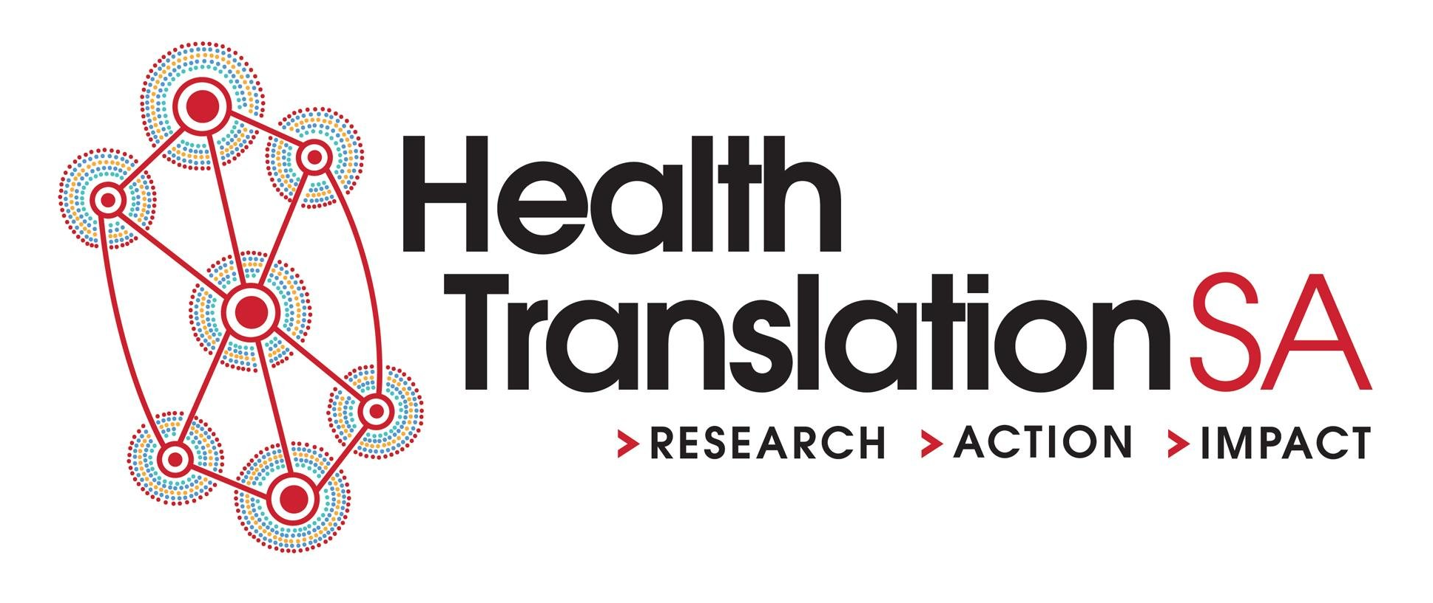

# Quantitative thinking

What we read would be a reflection of the aims and the capacity of the group. Professor Mark Mackay has suggested that this be a vehicle to immerse people who are not currently experts in a more quantitative way of thinking. This would be in keeping with the NHM book club.

# Provisional reading list

Hence, books that could be read could include:

|  |  |
| --- | --- |
| Book | Author |
| Calling Bullshit: The Art of Skepticism in a Data-Driven World | Carl T. Bergstrom Jevin D. West |
| How To Make the World Add Up | Tim Hartford |
| The Ostrich Paradox Why We Underprepare for Disasters | Robert Meyer and Howard Kunreuther |
| The Art of Statistics: Learning from Data | David Spiegelhalter |
| The Art of Logic in an Illogical World | Eugenia Cheng |
| Merchants of Doubt: How a Handful of Scientists Obscured the Truth on Issues from Tobacco Smoke to Global Warming | Naomi Oreskes, Erik M. Conway |
| The Signal and the Noise: The Art and Science of Prediction | Nate Silver |
| Standards: Recipes for Reality | Lawrence Busch |
| The Sum of the People: How the Census Has Shaped Nations, from the Ancient World to the Modern Age | Andrew Whitby |
| The Design Thinking Playbook: Mindful Digital Transformation of Teams, Products, Services, Businesses and Ecosystems | Michael Lewrick |
| Factfulness: Ten Reasons We're Wrong About the World and Why Things Are Better Than You Think | Hans Rosling, Ola Rosling, Anna Rosling Rönnlund |