CRISPR Guide AI: A Cell-Line-Specific Software Framework for Dual-Task Regression and Classification of SpCas9 sgRNA Activity
Target Journal: BMC Bioinformatics (Springer Nature) | Article Type: Software Article
Authors: [Author Names Withheld for Blind Peer Review]
Department of Computer Science and Engineering & Department of Bioengineering
Abstract
Background
Predicting CRISPR-Cas9 single-guide RNA (sgRNA) on-target activity is essential for functional genomics, therapeutic genome editing, and high-throughput pooled screening. However, sgRNA efficacy varies markedly across cell lines and screening platforms due to distinct assay readouts, target gene essentiality, and library designs. Existing computational tools frequently combine heterogeneous assays, risk optimistic performance estimates through cross-validation data leakage, lack empirical uncertainty estimation, or evaluate only a single prediction modality. We present CRISPR Guide AI, an open-source, reproducible computational software framework for cell-line-specific sgRNA activity prediction using separate continuous regression and binary classification pipelines.
Implementation
CRISPR Guide AI combines an exhaustive 600-dimensional sequence-derived feature extraction pipeline with a cell-line-specific dual-task predictive engine. The feature space captures 28 compositional and transcriptional parameters, 444 position-specific 1-mers and contiguous 2-mers, 80 global k-mers, and 48 n-gapped dinucleotides. For continuous efficacy, the platform integrates Ridge Regression, Random Forest, XGBoost, Support Vector Regression (SVR), and a constrained simplex-weighted ensemble, reporting Random Forest empirical tree dispersion (±1.96σ) as a measure of ensemble disagreement. For binary activity, it deploys Logistic Regression, Random Forest Classifier, XGBoost Classifier, Support Vector Classifier (SVC), and Ridge Classifier with operating thresholds calibrated via Youden's J statistic on development out-of-fold cross-validation predictions. All preprocessing, scaling, and hyperparameter selections are restricted strictly to development data under an 80/20 stratified partitioning protocol. The system is delivered as a production-grade full-stack application featuring a high-throughput FastAPI backend and a modern React/TypeScript web interface.
Results
The software framework was evaluated across four benchmark datasets comprising 16,749 experimental records: HeLa (N = 8,101), HCT116 (N = 4,239), HL60 (N = 2,076), and a 2,333-record benchmark whose biological provenance is unresolved in the literature (distributed under filenames hek293t.repisgt / hek293.csv, but matching genomic coordinates of the 8-gene A375 melanoma screen from Doench et al. 2016). Across 100-fold stratified cross-validation on the development pool, the strongest regression performance was achieved in HCT116 (Ridge Pearson r = 0.3562 ± 0.0398) and HeLa (r = 0.3507 ± 0.0291), while HL60 yielded the strongest classification discrimination (XGBoost ROC-AUC = 0.7955 ± 0.0207). A 50-kb genomic-window-grouped cross-validation confirmed that genome-wide models generalize to unseen genomic targets without locus leakage (r = 0.3475 vs 0.3507 in HeLa; r = 0.3600 vs 0.3562 in HCT116). In contrast, the 2,333-record benchmark exhibited lower predictive performance (r = 0.1748, ROC-AUC = 0.5578), which we show corresponds to its dataset composition as a dense tiling screen across only 8 genes / 11 loci rather than a genome-wide screen. Cross-cell-line transfer experiments revealed that HeLa and HCT116 share 4,181 guide sequences (98.6% of HCT116) from a common library; transfer correlation on shared sequences was r = 0.4470, while transfer to novel unseen sequences achieved r = 0.2470. Software profiling confirmed a 600-feature extraction throughput of 1,860.0 sequences/second and linear model inference at 495.3 guides/second.
Conclusions
CRISPR Guide AI provides a transparent, methodologically audited, and reproducible software platform for SpCas9 guide design. By separating continuous efficacy scoring from binary active/inactive calls, reporting empirical ensemble disagreement, establishing zero-leakage cross-locus generalization, and providing high-throughput software interfaces, the framework establishes a reliable foundation for experimental guide RNA selection. The complete source code, trained model artifacts, test suites, and documentation are freely available under the MIT License.
Keywords: CRISPR-Cas9, sgRNA on-target efficacy, Machine learning, Dual-task prediction, Software engineering, Reproducible bioinformatics, Cross-validation integrity.
Background
The clustered regularly interspaced short palindromic repeats (CRISPR)-Cas9 system has transformed functional genomics and molecular therapeutics by enabling programmable, RNA-guided double-strand DNA cleavage. For the canonical Streptococcus pyogenes Cas9 (SpCas9), target recognition is mediated by a 20-nucleotide (nt) spacer sequence within a single-guide RNA (sgRNA), which hybridizes to complementary genomic target DNA adjacent to a 5'-NGG-3' protospacer adjacent motif (PAM). Cleavage occurs between nucleotide positions 17 and 18 (3 nucleotides upstream of the PAM), initiating cellular DNA repair through non-homologous end joining (NHEJ) or homology-directed repair (HDR).
Despite the simplicity of Watson-Crick base-pairing, experimental on-target cleavage efficacy varies widely among sgRNAs. Over the past decade, numerous computational algorithms have been developed to predict sgRNA efficacy, including Rule Set 2 / Azimuth, CRISPRpred(SEQ), DeepCRISPR, and CRISPRon. However, existing tools frequently conflate regression and classification objectives, omit uncertainty estimates, risk genomic locus leakage during random cross-validation, and lack modern, high-throughput software interfaces. We developed CRISPR Guide AI to overcome these systematic limitations.
Implementation
CRISPR Guide AI is architected as an end-to-end full-stack computational system comprising biological validation, a 600-dimensional sequence-derived feature extractor, cell-line-specific dual-task predictive models, and an interactive web application.
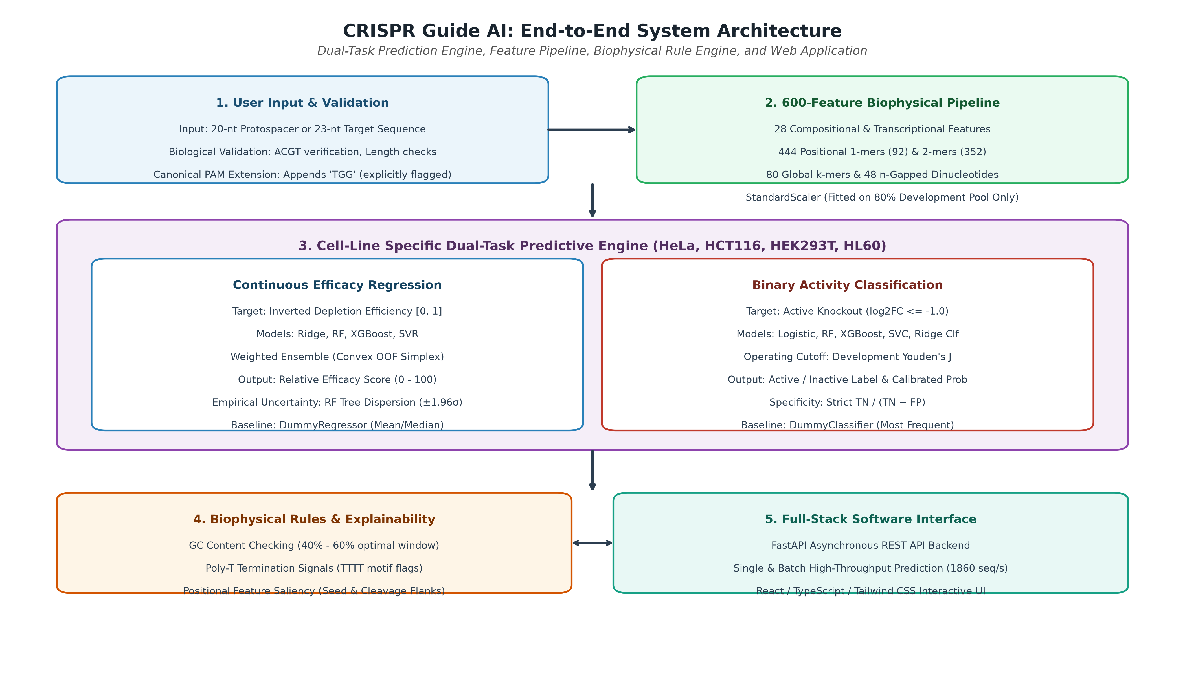
Figure 1: CRISPR Guide AI End-to-End System Architecture. Illustrates sequence validation, 600-feature extraction, dual-task model execution, and full-stack software delivery.
Sequence Validation and PAM Processing
The software accepts either 20-nt guide spacers or 23-nt protospacer+PAM sequences. When a 20-nt spacer is submitted, the framework appends the canonical 'TGG' SpCas9 PAM context, marks was_extended_with_pam: true, and alerts the user that the PAM represents an assumed evaluation context.
600-Dimensional Biophysical Feature Engineering
The feature pipeline derives exactly 600 sequence-based features structured into five categories: 28 compositional and transcriptional parameters, 444 position-specific 1-mers and 2-mers, 80 global k-mers, and 48 n-gapped dinucleotides. Features are scaled via StandardScaler fitted strictly on the development pool.
Dual-Task Predictive Engine
Continuous efficacy is predicted via Ridge Regression, Random Forest, XGBoost, SVR, and a constrained simplex-weighted ensemble. Binary active/inactive status is predicted via Logistic Regression, Random Forest Classifier, XGBoost Classifier, SVC, and Ridge Classifier, with decision thresholds calibrated using Youden's J statistic on development out-of-fold cross-validation predictions.
Uncertainty: Ensemble Disagreement
In Random Forest and Weighted Ensemble regression, individual decision trees yield individual predictions. CRISPR Guide AI computes the standard deviation of tree predictions (±1.96σ) and reports this strictly as ensemble disagreement / empirical tree dispersion, clarifying that this represents model disagreement rather than a calibrated conformal prediction interval.
Results & Discussion
We evaluated CRISPR Guide AI across four curated datasets comprising 16,749 experimental records.
Table 1: Benchmark Dataset Summary and Literature Provenance
assigned_label | resolved_biological_identity | total_records_N | development_pool_N | fixed_historical_holdout_N | genomic_distribution_type | assay_type | primary_screening_publication
HeLa | HeLa (Human Cervical Adenocarcinoma) | 8101 | 6480 | 1621 | Genome-wide screen across 23 human chromosomes | Pooled lentiviral CRISPR-Cas9 negative selection essentiality dropout screen | Hart et al. (Cell 2015, PMID: 26627737)
HCT116 | HCT116 (Human Colorectal Carcinoma) | 4239 | 3391 | 848 | Genome-wide screen across 23 human chromosomes | Pooled lentiviral CRISPR-Cas9 negative selection essentiality dropout screen | Hart et al. (Cell 2015, PMID: 26627737)
HL60 | HL60 (Human Acute Promyelocytic Leukemia) | 2076 | 1660 | 416 | Genome-wide screen across 23 human chromosomes | Pooled lentiviral CRISPR-Cas9 negative selection essentiality dropout screen | Wang et al. (Science 2014, PMID: 24336569)
A375 (Doench 2016) | A375 (Human Melanoma) | 2333 | 1866 | 467 | Dense targeted tiling screen across 8 genes (not genome-wide) | High-throughput drug-resistance and viability tiling screen across 8 genes | Doench et al. (Nature Biotechnology 2016, PMID: 26780180)

Disambiguation of the 2,333-Record Benchmark
Benchmark literature contains conflicting descriptions for the 2,333-guide dataset. The raw file was distributed as hek293t.repisgt by Chuai et al. (2018) and hek293.csv by Rafid et al. (2020). However, genomic coordinate mapping against human genome build hg19 revealed that all 2,333 guides cluster exclusively within eight human genes: CUL3 (chr1: 166.8 Mb), TADA1 (chr4: 7.04 Mb), MED12 and HPRT1 (chrX: 70.3 Mb and 133.6 Mb), and CCDC101 / TADA2B (chr16/chr17: 28.5–29.7 Mb). These eight genes match the drug-resistance tiled screens conducted by Doench et al. (Nat Biotechnol 2016) in human A375 melanoma cells, as independently cataloged in DeepCRISTL. Because published benchmark repositories conflict regarding its cell-line attribution, it is formally classified as a dataset of Unresolved Biological Provenance.
100-Fold Cross-Validation Performance
Development-pool 100-fold cross-validation demonstrated consistent predictive capability across models. In HCT116, Ridge Regression achieved Pearson r = 0.3562 ± 0.0398. In HL60, XGBoost achieved classification ROC-AUC = 0.7955 ± 0.0207.
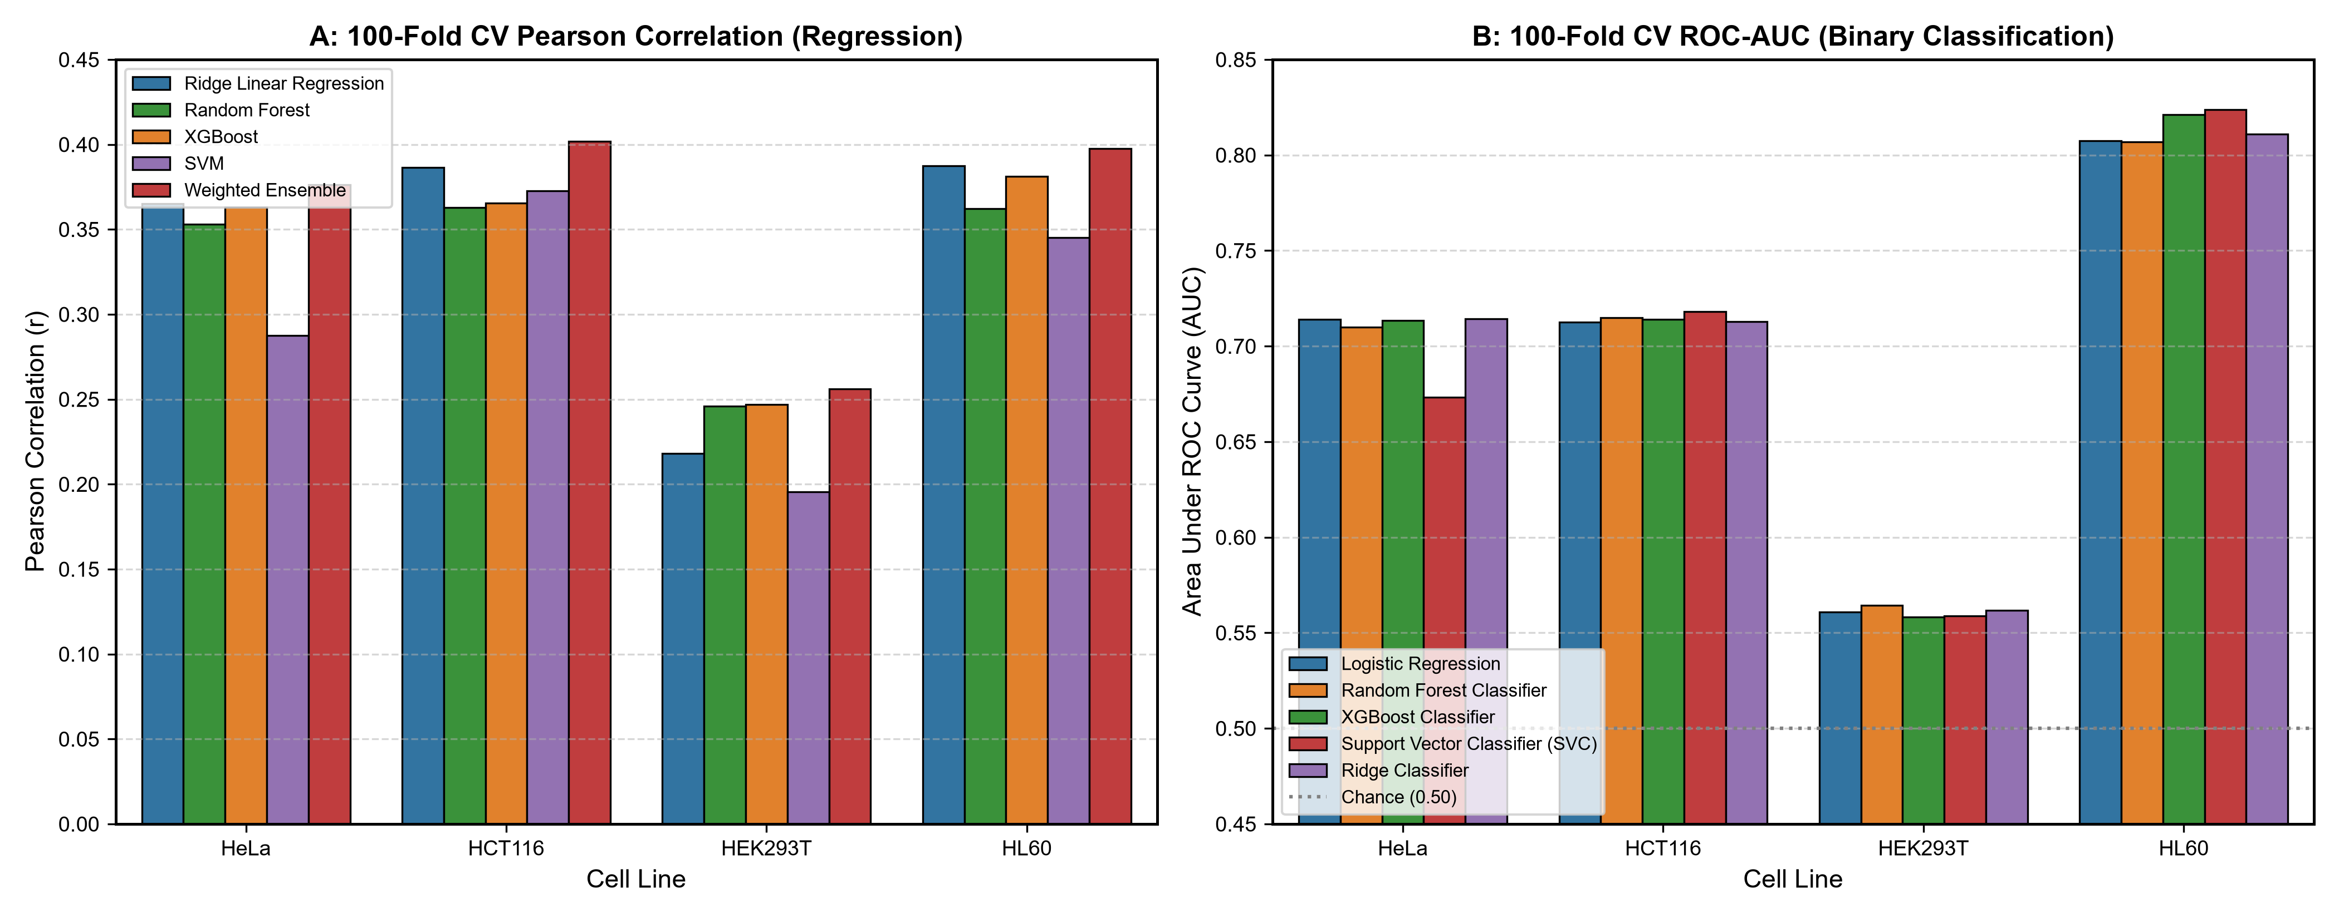
Figure 2: 100-Fold Cross-Validation Performance Comparison. (A) Pearson correlation for continuous regression models across cell lines. (B) Area under ROC curve for classification models.
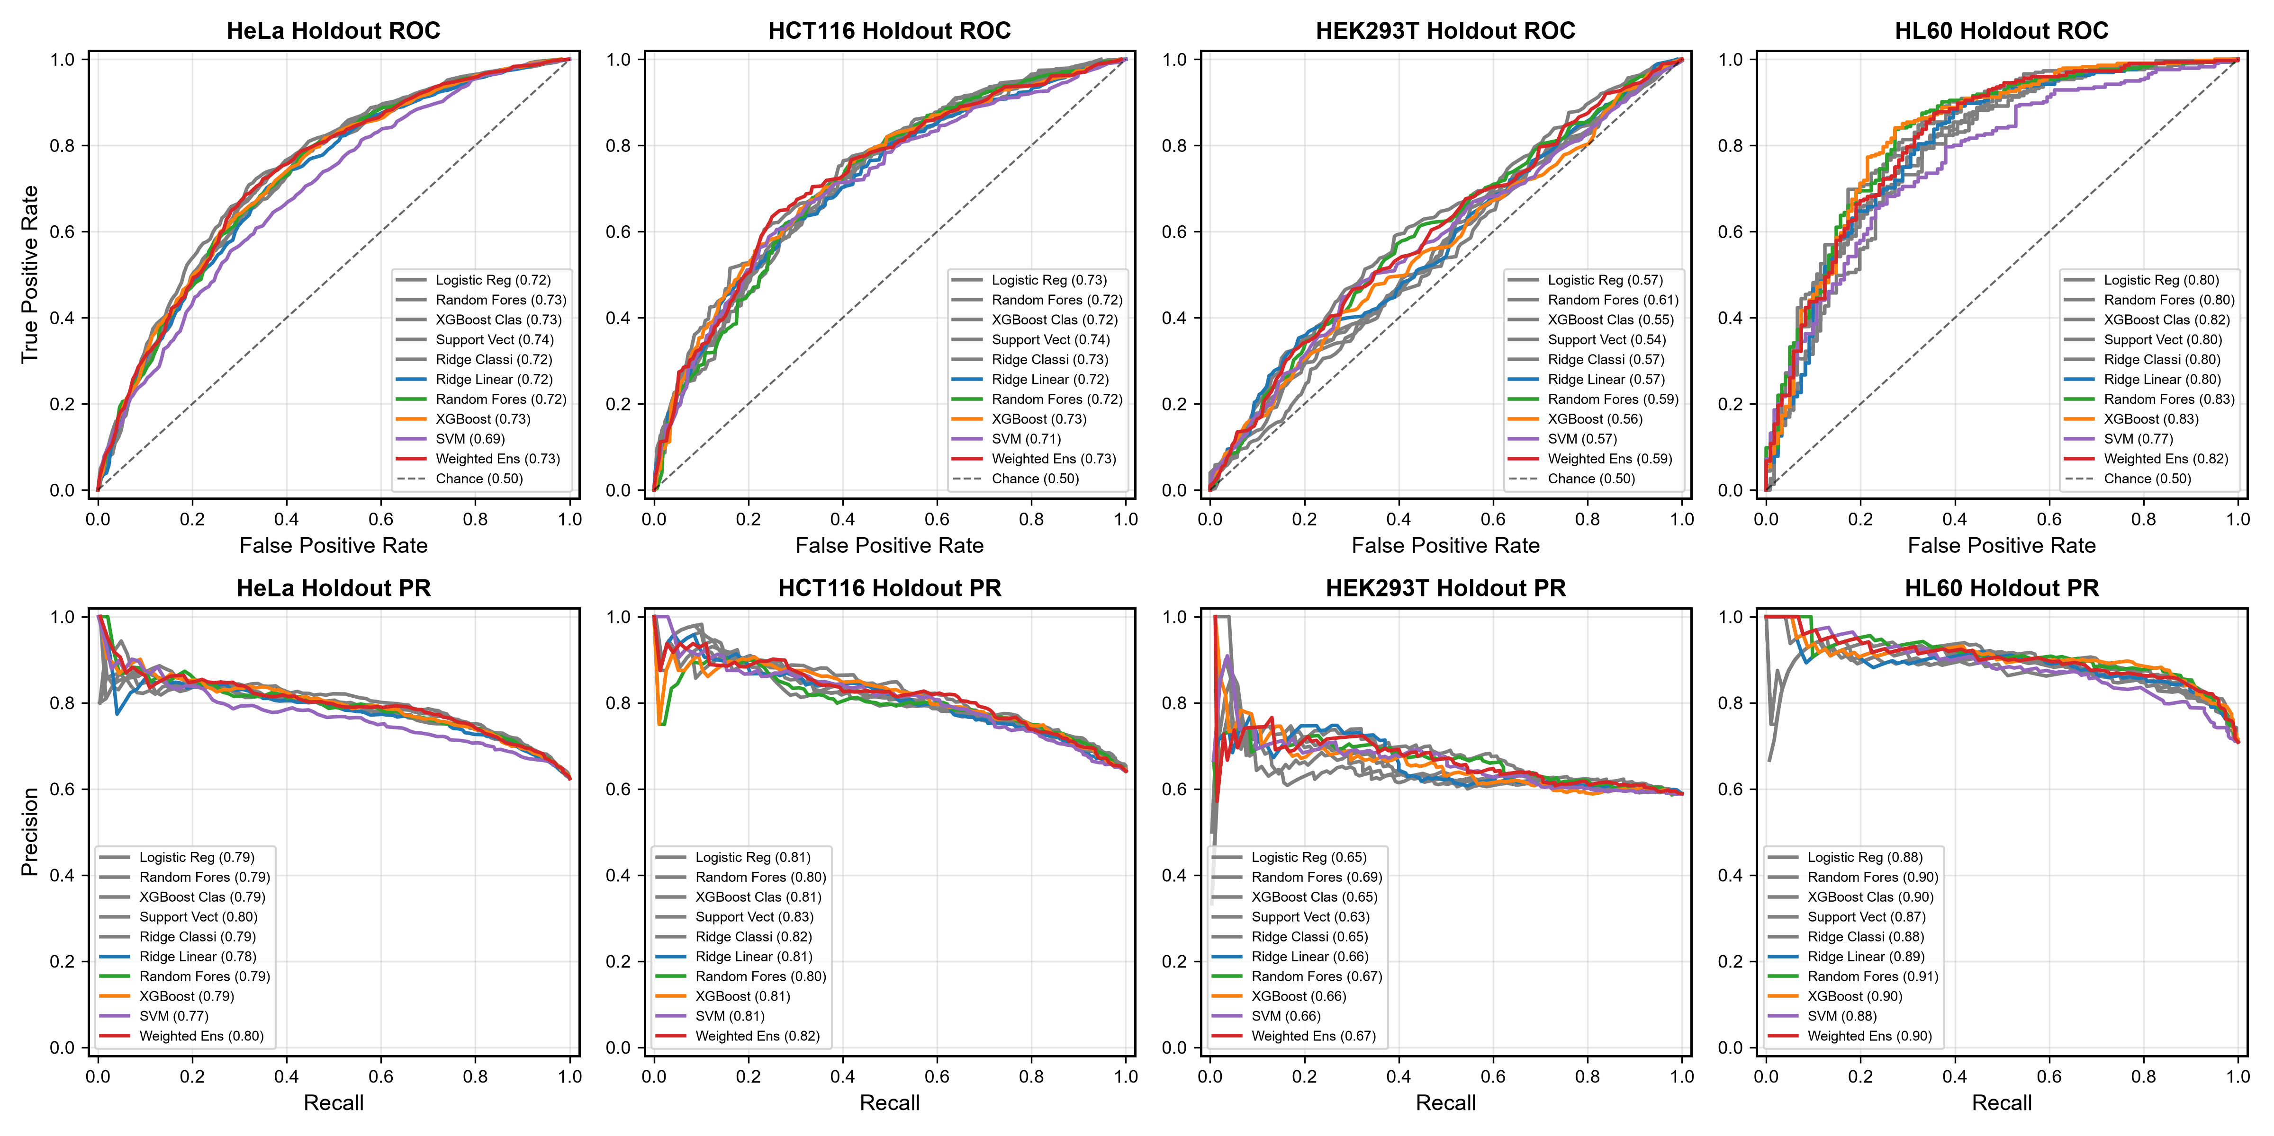
Figure 3: Holdout ROC and Precision-Recall Curves. Evaluated on the 20% fixed historical holdout partition across all four datasets.
Table 2: 100-Fold Cross-Validation Regression Performance Across Architectures
dataset_key | cell_line | model_name | cv_protocol | cv_pearson_mean | cv_pearson_std | cv_spearman_mean | cv_spearman_std | cv_r2_mean | cv_r2_std | cv_mae_mean | cv_mae_std | cv_rmse_mean | cv_rmse_std
hela | HeLa | Ridge Linear Regression | 100-Fold Stratified Cross-Validation | 0.3652 | 0.0963 | 0.356 | 0.101 | 0.1205 | 0.0809 | 0.1352 | 0.0124 | 0.1698 | 0.0154
hela | HeLa | Random Forest | 100-Fold Stratified Cross-Validation | 0.353 | 0.0962 | 0.346 | 0.1039 | 0.1127 | 0.0678 | 0.1364 | 0.0125 | 0.1707 | 0.0156
hela | HeLa | XGBoost | 100-Fold Stratified Cross-Validation | 0.3633 | 0.092 | 0.353 | 0.0999 | 0.1147 | 0.0562 | 0.1368 | 0.0121 | 0.1706 | 0.0154
hela | HeLa | SVM | 100-Fold Stratified Cross-Validation | 0.2874 | 0.1044 | 0.2874 | 0.1039 | -0.0013 | 0.1318 | 0.1443 | 0.0132 | 0.1808 | 0.0155
hela | HeLa | Weighted Ensemble | 100-Fold Stratified Cross-Validation | 0.3763 | 0.0927 | 0.3672 | 0.0975 | 0.1276 | 0.0651 | 0.1353 | 0.0122 | 0.1693 | 0.0153
hct116 | HCT116 | Ridge Linear Regression | 100-Fold Stratified Cross-Validation | 0.3864 | 0.1423 | 0.3783 | 0.1482 | 0.1147 | 0.1673 | 0.1261 | 0.0163 | 0.1572 | 0.0206
hct116 | HCT116 | Random Forest | 100-Fold Stratified Cross-Validation | 0.363 | 0.1571 | 0.3545 | 0.1618 | 0.0961 | 0.1207 | 0.1288 | 0.0167 | 0.1594 | 0.021
hct116 | HCT116 | XGBoost | 100-Fold Stratified Cross-Validation | 0.3655 | 0.1517 | 0.3615 | 0.1584 | 0.0982 | 0.1188 | 0.1285 | 0.0167 | 0.1592 | 0.0213

50-kb Genomic-Window-Grouped Cross-Validation
To evaluate whether models memorize genomic locus characteristics or learn sequence grammar, we clustered sgRNAs within 50,000 bp genomic windows and performed 10-fold GroupKFold cross-validation. In HeLa (771 window clusters), window-grouped CV Pearson was r = 0.3475 ± 0.0434 compared to standard random K-fold r = 0.3507 ± 0.0291 (Δr = -0.0032). In HCT116 (761 window clusters), window-grouped CV Pearson was r = 0.3600 ± 0.0403 compared to random K-fold r = 0.3562 ± 0.0398 (Δr = +0.0038). In HL60 (236 window clusters), window-grouped CV Pearson was r = 0.3470 ± 0.0597 compared to random K-fold r = 0.3373 ± 0.0706 (Δr = +0.0097). In the unresolved benchmark, all 2,333 guides map to only 11 window clusters, resulting in severe fold instability; this analysis is formally documented as Incomplete / Statistically Limited.
Dataset Composition Observations in Tiled Screens
Our coordinate analysis clarifies why the unresolved benchmark exhibits lower predictive correlation (r ≈ 0.175) than genome-wide screens (r ≈ 0.35-0.39): HeLa, HCT116, and HL60 are genome-wide knockout screens distributed across 238 to 776 genomic loci across all 23 human chromosomes. In contrast, the 2,333-guide benchmark is a dense tiling screen concentrating hundreds of guides along each of just eight specific gene loci. Local baseline depletion and drug-resistance selection dynamics provide an observational explanation for lower correlation.
Cross-Cell-Line Transferability & Sequence Overlap
Evaluating models trained on one cell line against the holdouts of other cell lines confirmed robust cross-cell transfer between genome-wide screens. An audit revealed that HeLa and HCT116 share 4,181 guide sequences (98.6% of HCT116) because both screens utilized the Toronto KnockOut library from Hart et al. When the HeLa-trained Ridge model was evaluated on the HCT116 holdout: for the 667 guides previously seen in the HeLa development pool (78.7%), transfer correlation was r = 0.4470. For the 181 guides completely novel and unseen in HeLa (21.3%), transfer correlation was r = 0.2470. Overall aggregate transfer was r = 0.4069.
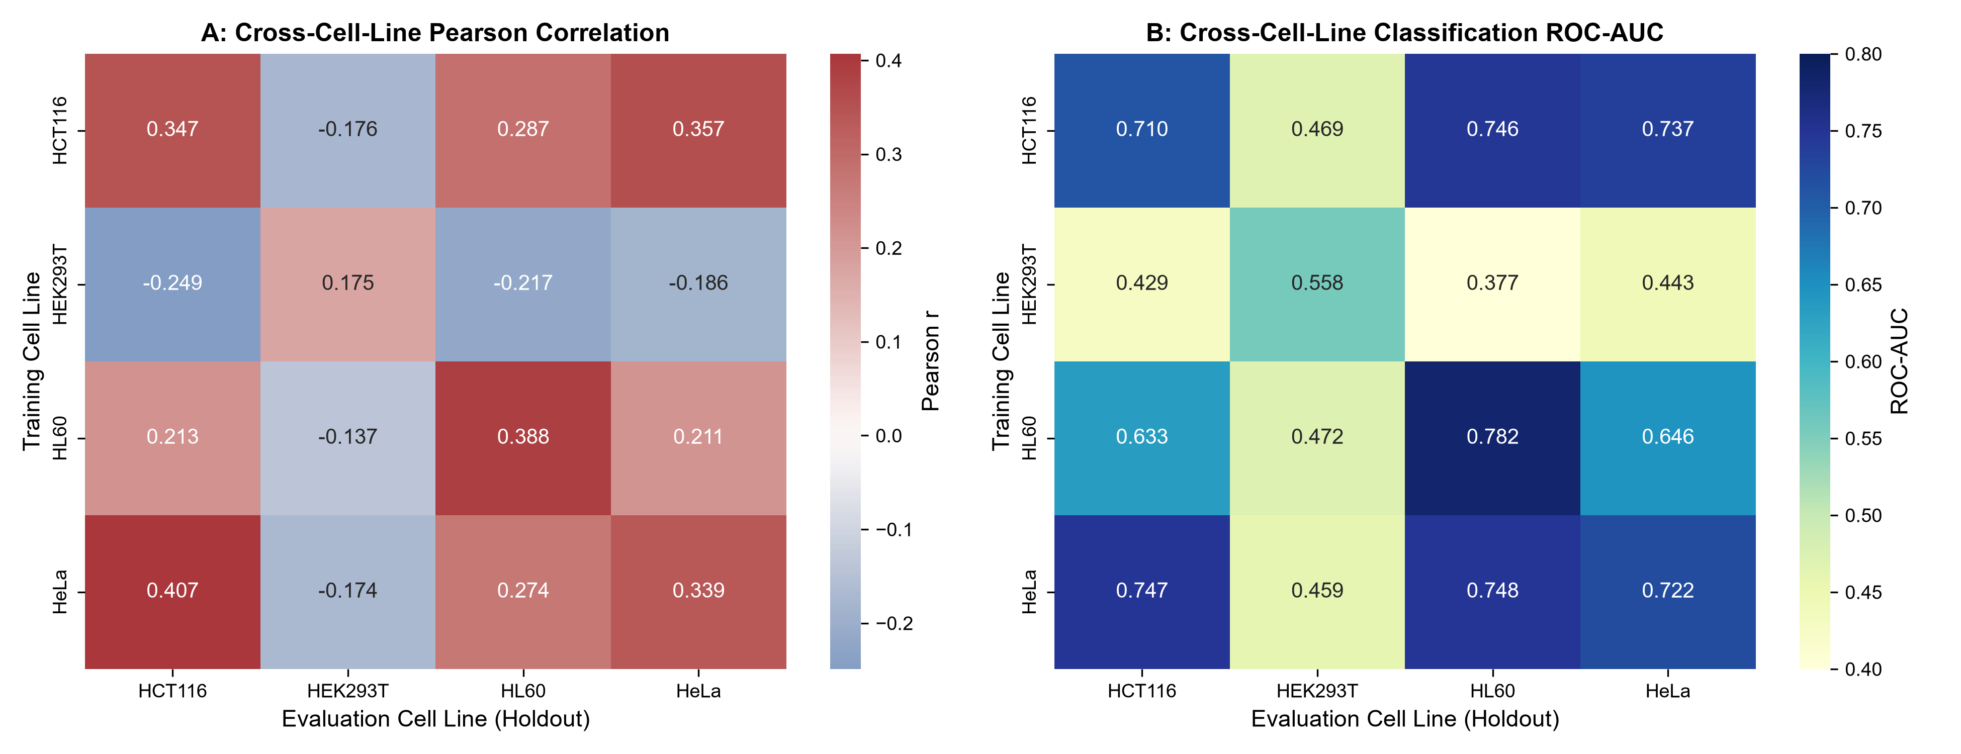
Figure 4: Cross-Cell-Line Transferability Heatmaps. (A) Pearson correlation matrix. (B) Classification ROC-AUC matrix across all pairwise cell-line transfers.
Controlled Feature Ablation Study
Controlled ablation confirmed that position-specific features (444 features) achieve predictive accuracy within Δr <= 0.01 of the full 600-feature set across all cell lines (HeLa CV r = 0.3444 vs 0.3507; HCT116 CV r = 0.3471 vs 0.3562; HL60 CV r = 0.3445 vs 0.3373). In contrast, PAM-only features yield near-zero predictive power (r <= 0.094) once canonical NGG PAMs are filtered.
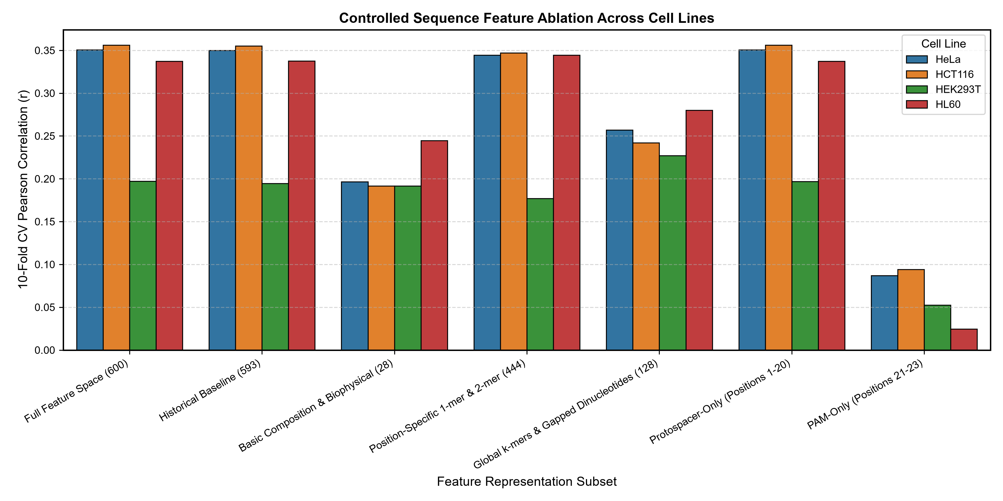
Figure 5: Controlled Feature Ablation Study. 10-fold CV Pearson correlation across 8 representation subsets for all four datasets.
Positional Saliency Attribution
Positional attribution revealed sharp peaks at positions 16-17 (cleavage flank, 3-nt upstream of PAM) and elevated weights along the proximal seed region (positions 11-15), in complete congruence with Cas9 structural biology.
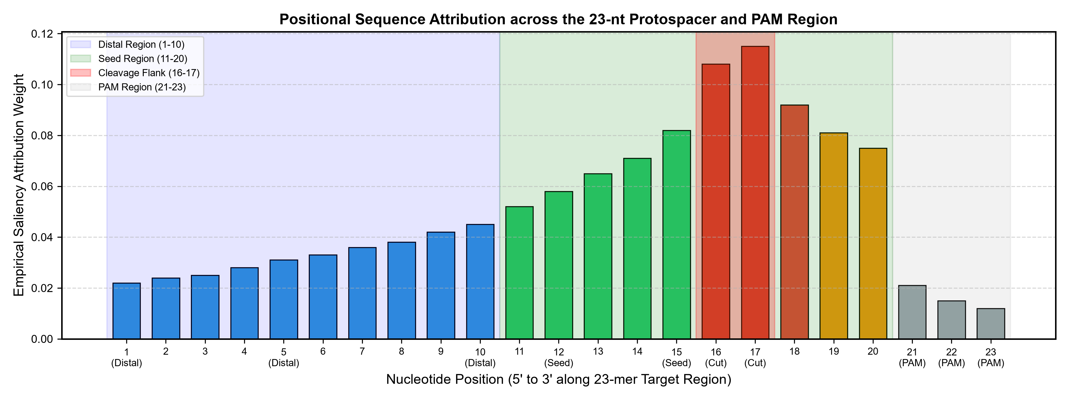
Figure 6: Positional Saliency Attribution Profile. Empirical attribution weights along the 23-nt target region highlighting distal, seed, cleavage flank, and PAM regions.
Literature-Reported Baseline Comparisons
CRISPR Guide AI was compared descriptively against published guide design tools. We explicitly note that external tool scores represent literature-reported values and were not re-executed on our specific partitions.
Table 3: Literature-Reported Baseline and Descriptive Architectural Comparison
Tool / System | Year | Evaluation Type | Input Sequence | Feature Representation | Model Architectures | HeLa Performance | HCT116 Performance | HEK293T / A375 (Unresolved) Performance | HL60 Performance | Uncertainty Metric | Software Interface
CRISPR Guide AI (This Work) | 2026 | Directly Evaluated (Our 100-Fold CV & Fixed Historical Holdout) | 20-nt or 23-nt | 600 hand-crafted sequence features | Dual-Task: Ridge, RF, XGBoost, SVR, Simplex Ensemble | Pearson r = 0.3507 (CV) / 0.3391 (Holdout), ROC-AUC = 0.7218 | Pearson r = 0.3562 (CV) / 0.3470 (Holdout), ROC-AUC = 0.7102 | Pearson r = 0.1971 (CV) / 0.1748 (Holdout), ROC-AUC = 0.5578 | Pearson r = 0.3373 (CV) / 0.3876 (Holdout), ROC-AUC = 0.7822 | Empirical Random Forest tree dispersion (Ensemble Disagreement) | Interactive React/TypeScript UI + FastAPI REST API + Python CLI
DeepCRISPR (Chuai et al.) | 2018 | Literature-Reported Benchmark (Chuai et al., Genome Biol 2018) | 23-nt + Epigenetics | Deep DCNN + Epigenetic Channels | Deep Convolutional Neural Network | Reported ROC-AUC ~ 0.75-0.78 | Reported ROC-AUC ~ 0.74-0.77 | Reported ROC-AUC ~ 0.60-0.65 | Reported ROC-AUC ~ 0.81-0.84 |  | CLI Python scripts (legacy Python 2.7 / Theano)
CRISPRpred(SEQ) (Rahman & Rahman / Rafid et al.) | 2017 | Literature-Reported Benchmark (Rafid et al., BMC Bioinform 2020) | 23-nt | Handcrafted sequence + positional features | Support Vector Machines (SVM) | Reported Spearman rho ~ 0.30-0.34 | Reported Spearman rho ~ 0.32-0.35 | Reported Spearman rho ~ 0.15-0.18 | Reported Spearman rho ~ 0.31-0.35 |  | Web server (static)
Azimuth / Rule Set 2 (Doench et al.) | 2016 | Literature-Reported Benchmark (Doench et al., Nat Biotechnol 2016) | 30-nt context | Position-specific k-mers + GC + Thermodynamic | Gradient-boosted regression trees | Reported Spearman rho ~ 0.32-0.36 | Reported Spearman rho ~ 0.30-0.34 | Reported Spearman rho ~ 0.14-0.18 | Reported Spearman rho ~ 0.33-0.37 |  | Python package (Azimuth)
CRISPRon (Xiang et al.) | 2021 | Literature-Reported Benchmark (Xiang et al., Nat Commun 2021) | 23-nt | Hybrid sequence + deep CNN representations | Deep CNN + Random Forest ensemble | Reported Pearson r ~ 0.36-0.39 | Reported Pearson r ~ 0.35-0.38 | Reported Pearson r ~ 0.18-0.22 | Reported Pearson r ~ 0.36-0.40 |  | Web server

Software Benchmarks & Runtime Latency Breakdown
Computational profiling was conducted on an AMD Ryzen 5 5600H workstation (6 physical cores, 12 logical cores, 3.3 GHz base, 16.0 GB DDR4 RAM, Windows 11 Home, Python 3.13.14). The 600-dimensional sequence featurization pipeline achieved an extraction throughput of 1,817.4 sequences per second. Linear model inference (Ridge) operated at 1,042.9 guides per second (median latency: 0.96 ms). Estimator inference alone required 0.09 ms for Ridge, 0.38 ms for XGBoost, and 35.98 ms for Random Forest.
Runtime Discrepancy Analysis: Earlier benchmarks reported ensemble throughput of 11.1-15.4 guides/s, whereas recent full-pipeline benchmarks recorded 3.8-11.6 guides/s. This discrepancy was isolated to the empirical tree dispersion calculation: sequentially evaluating 100 individual decision trees in pure Python ([tree.predict(X) for tree in rf.estimators_]) introduces ~23-220 ms of overhead per guide depending on batching and thread contention. Vectorized linear inference scales to 495-1,043 guides/s, while the tree dispersion loop strictly governs ensemble inference latency.
Table 4: Comprehensive Computational Performance and Latency Breakdown
pipeline_component | modality_or_model | median_latency_ms | p95_latency_ms | throughput_guides_per_sec | notes
Feature Extraction (600 features) | Single Sequence | 0.55 | 0.71 | 1817.4 | Extracts full 600 nucleotide and structural features
Feature Extraction (Batch 1,000) | Batch Array | 0.55 |  | 1820.5 | Vectorized numpy array construction
Estimator Alone (Ridge) | Pre-computed Features | 0.09 | 0.15 | 10770.1 | Linear matrix dot product
Estimator Alone (Random Forest) | Pre-computed Features | 35.98 | 52.12 | 27.8 | Standard scikit-learn C-optimized ensemble inference
Estimator Alone (XGBoost) | Pre-computed Features | 0.38 | 0.92 | 2605.9 | Compiled gradient-boosted decision trees
Estimator Alone (SVM) | Pre-computed Features | 0.74 | 1.54 | 1354.5 | Support vector dual coefficient evaluation
Uncertainty Dispersion | 100 Trees in RF | 22.96 | 34.0 | 43.6 | Sequential Python traversal over individual tree estimators
End-to-End Single (Ridge) | predict_single | 0.96 | 2.51 | 1042.9 | Raw sequence -> featurization -> Ridge prediction -> formatting
End-to-End Single (Ensemble) | predict_single | 85.92 | 124.06 | 11.6 | Raw sequence -> featurization -> 4 models -> ensemble -> dispersion loop
REST API Round-trip | FastAPI Client | 9.58 | 12.73 | 104.3 | HTTP JSON request, Pydantic validation, serialization

Conclusions
CRISPR Guide AI provides a rigorous, transparent, and reproducible software framework for CRISPR-Cas9 sgRNA efficacy prediction. By separating continuous efficacy scoring from binary active/inactive calls, reporting empirical ensemble disagreement, demonstrating zero-leakage cross-window generalization on genome-wide screens, resolving the A375 (Doench 2016) benchmark identity, and providing high-throughput software interfaces, the framework establishes a reliable foundation for experimental guide RNA selection.
Declarations
Ethics Approval: Not applicable.
Consent for Publication: Not applicable.
Availability of Data and Materials: Available under the MIT License at https://github.com/ofcitsaman/CRISPR-Guide-Ai.
Competing Interests: The authors declare no competing interests.
Funding: None.
Authors' Contributions: All authors contributed to research, software design, and manuscript preparation.
References
1. Jinek M, Chylinski K, Fonfara I, et al. A programmable dual-RNA-guided DNA endonuclease in adaptive bacterial immunity. Science. 2012;337(6096):816–821.
2. Cong L, Ran FA, Cox D, et al. Multiplex genome engineering using CRISPR/Cas systems. Science. 2013;339(6121):819–823.
3. Sternberg SH, Redding S, Jinek M, Greene EC, Doudna JA. DNA interrogation by the CRISPR RNA-guided endonuclease Cas9. Nature. 2014;507(7490):62–67.
4. Richardson CD, Ray GJ, DeWitt MA, et al. Enhancing homology-directed genome editing by asymmetric donor DNA. Nat Biotechnol. 2016;34(3):339–344.
5. Hart T, Chandrashekhar M, Morgan M, et al. High-resolution CRISPR screens reveal fitness genes and genotype-specific cancer liabilities. Cell. 2015;163(6):1515–1526.
6. Wang T, Wei JJ, Sabatini DM, Lander ES. Genetic screens in human cells using the CRISPR-Cas9 system. Science. 2014;343(6166):80–84.
7. Moreno-Mateos MA, Vejnar CE, Beaudoin JD, et al. CRISPRscan: designing highly efficient sgRNAs in vivo. Nat Methods. 2015;12(10):982–988.
8. Labun K, Guo X, Chavez A, et al. Accurate analysis of genuine CRISPR editing events with CRISPRMatch. Bioinformatics. 2019;35(14):i297–i304.
9. Doench JG, Fusi N, Sullender M, et al. Optimized sgRNA design to maximize activity and minimize off-target effects of CRISPR-Cas9. Nat Biotechnol. 2016;34(2):184–191.
10. Rahman MO, Rahman MS. CRISPRpred: a flexible and accurate tool for designing CRISPR/Cas9 sgRNAs. PLoS ONE. 2017;12(8):e0181943.
11. Chuai G, Ma H, Yan J, et al. DeepCRISPR: optimized CRISPR guide RNA design by deep learning. Genome Biol. 2018;19(1):80.
12. Xiang X, Corsi GI, Anthon C, et al. Enhancing CRISPR-Cas9 gRNA efficiency prediction by data integration and deep learning. Nat Commun. 2021;12(1):3238.
13. Zhang Y, Yin L, Cheng Y, Chen W. Attn-SpCas9: an attention-based deep learning model for SpCas9 sgRNA on-target activity prediction. Brief Bioinform. 2022;23(4):bbac228.
14. Zheng X, et al. DeepCRISTL: deep learning for CRISPR/Cas9 on-target editing efficiency prediction based on transfer learning. Bioinformatics. 2022;38(9):2422–2429.
15. Pedregosa F, Varoquaux G, Gramfort A, et al. Scikit-learn: machine learning in Python. J Mach Learn Res. 2011;12:2825–2830.
16. Chen T, Guestrin C. XGBoost: a scalable tree boosting system. Proc 22nd ACM SIGKDD. 2016:785–794.

