Public Cloud Infrastructure Deployment
Design and Implementation of a Site 2 Hybrid Infrastructure Using Proxmox Services, Samba Identity, Veeam Backup, Internal HTTPS Publication, and an AWS-Hosted Web Platform
Bailey Kulla
Elyazid Sidelkheir
Ru Wang
Justin Rosseleve
Yiqin Huang
Omer Deniz
March 23, 2026
Contents

Public Cloud Infrastructure Deployment

CST8248 - Emerging Technologies Technical Report
Design and Implementation of a Site 2 Hybrid Infrastructure Using Proxmox Services, Samba Identity, Veeam Backup, and an AWS-Hosted HTTPS Web Platform
Field | Value
Course | CST8248 - Emerging Technologies
Professor | Denis Latremouille
Team Name | Raspberry Pioneers
Submission Type | Group Submission
Due Date | March 30, 2026
Program | Computer Systems Technology - Networking
Institution | Algonquin College
Document Version | 3.4 Working Revision
Document Date | March 23, 2026
Intended Audience | Client IT staff, MSP support teams, and Level 4 graduates assuming operations support
Team Members: Bailey Kulla, Elyazid Sidelkheir, Ru Wang, Justin Rosseleve, Yiqin Huang, Omer Deniz
Report intent: this document is written in a client/MSP handover style, while preserving the formal structure expected in CST8248. It focuses on the Site 2 deliverable, but includes cross-site dependencies wherever Site 2 services rely on Company 1 infrastructure or the inter-site VPN path.

List of Figures
Figure 1. C2IdM1 replication and DNS proof
Figure 2. C2IdM2 replication and DNS proof
Figure 3. C2LinuxClient hostname resolution proof
Figure 4. C2LinuxClient SSSD and domain identity proof
Figure 5. C2Web hostname-only hardening proof
Figure 6. C2FS mounted storage and sync proof
Figure 7. Veeam console evidence for Site 2 backup operations
Figure 8. Site 2 offsite backup copy folders on the Site 1 SMB repository
Figure 9. Public ClearRoots HTTPS landing page
Figure 10. Kubernetes nodes and running ClearRoots web pods
Figure 11. AWS EC2 instances for the ClearRoots public website
Figure 12. Terraform remote state stored in Amazon S3
Figure 13. Route53 public DNS record for clearroots.omerdengiz.com

List of Tables
Table 1. Technology stack summary
Table 2. Site 2 core server inventory
Table 3. Service block ownership and validation scope
Table 4. Network and service path summary
Table 5. Platform and service choice rationale
Table 6. Identity services summary
Table 7. Site 2 protected systems in Veeam
Table 8. AWS public website deployment components
Table 9. Site 2 backup job schedule summary
Table 10. Administrative access and validation paths
Table 11. Final live validation summary
Table 12. OPNsense interface and routed path summary
Table 13. Cross-site synchronization and dependency summary
Table 14. Backup troubleshooting chronology
Table 15. AWS public deployment workflow summary
Table 16. Final demo role and ownership matrix
Table 17. Site 2 service block read-only validation summary
Table A1. Site 2 network addressing summary
Table B1. DHCP service reference
Table C1. Storage and file-service reference
Table D1. Backup repository reference

Executive Summary
This report documents the Site 2 portion of a multi-site infrastructure project designed to support tenant-separated services, centralized identity, file sharing, backup and offsite recovery, and a public HTTPS web presence. The Site 2 environment combines Linux-based identity and file services with VMware-style operational expectations, cross-site administrative access, and backup workflows aligned to enterprise support practices.
At the infrastructure level, Site 2 provides Company 2 identity and DHCP services using Samba Active Directory Domain Controllers, replicated Linux file services, tenant-aware routing through OPNsense, remote administration through Windows and Ubuntu jump systems, and backup orchestration through Veeam Backup and Replication. In addition, Site 2 hosts a public-facing ClearRoots Foundation website in AWS using Terraform, Kubernetes, Docker, Route53, Elastic IP, S3-backed Terraform state, and automated HTTPS publishing through Caddy and Let’s Encrypt.
Operationally, the environment progressed through several troubleshooting stages before stabilization. Earlier testing identified issues with Windows jump routing behavior, DMZ web server reachability, C2LinuxClient SSSD identity resolution, the Site 2 to Site 1 sync path, and late-stage Veeam control-path problems. Those issues were later corrected. The final validated state shows healthy Company 2 identity services, restored web reachability, functioning Linux client identity lookup, successful file synchronization, healthy Kubernetes web deployment, and working Veeam local, file, and offsite backup flows after the March 23 remediation pass.
The final Site 2 design therefore supports four major outcomes:
- reliable tenant services for Company 2 identity, DNS, DHCP, and file access
- cross-site recoverability through backup copy to Site 1
- secure internal and public web publishing paths
- an operations-ready handover model suitable for client support, final demonstration, and future maintenance

1. Introduction
The purpose of this document is to describe the deployed Site 2 environment in a form suitable for support handover, academic submission, and demonstration review. Site 2 is not an isolated lab segment; it is part of a broader two-site design where services are intentionally distributed across local tenant systems, shared infrastructure, and inter-site recovery paths.
The report emphasizes the Site 2 responsibilities and outcomes:
- Company 2 identity, DNS, and DHCP services
- Company 2 Linux file services and client access
- Site 2 Veeam backup and offsite copy operations
- public AWS-based ClearRoots web publishing with HTTPS
- cross-site reachability and administrative workflows needed to operate the environment
Where useful, the report also references Company 1 systems, because several Site 2 functions depend on them. These include certificate trust distribution, inter-site backup copy, administrative reachability, and shared testing workflows.

2. Background
The broader project goal was to create an MSP-style, tenant-aware infrastructure spanning two sites and two companies. The design required not only local service delivery, but also operational readiness: backups needed to be scheduled and verifiable, web services had to be reachable through approved paths, client access needed to align with identity systems, and remote administration had to remain workable from jump hosts.
Site 2 specifically became the center of three major deliverables:
- Company 2 service hosting and recovery
- Veeam-based backup and offsite copy workflows
- AWS-based public web delivery for the ClearRoots Foundation website
The environment therefore bridges traditional private infrastructure operations and cloud-hosted web publishing. That combination made Site 2 especially important to the overall project because it demonstrates both internal enterprise service management and modern public deployment practices.

2.1 Service block interpretation
The supplied Service Block matrix is more than a planning diagram. It is effectively the operating model for the final demonstration. Instead of presenting Site 2 as a flat list of servers, the environment is grouped into service responsibilities that reflect how a support team would actually think about ownership, escalation, and proof of service. This matters because a technically correct environment can still be difficult to demonstrate if the evidence is not organized in a human-operational way.
For Site 2, the service blocks map naturally to six recurring support questions:
- how do administrators reach the environment safely
- who provides DHCP, DNS, and account administration
- how are internal and public web services published
- where is replicated file data stored and validated
- how is offsite recovery achieved
- what proof can be shown live without changing production state
Using the service block model also helped separate truly failed services from failed access paths. During troubleshooting, some problems first appeared to be outages in DNS, web publishing, or backup. Later testing showed that several of those events were actually caused by routing preference, interface state, time synchronization, or management-path inconsistency rather than by a broken application layer. That distinction is one of the most important lessons in the final Site 2 story.

2.2 Evidence and validation method
This document intentionally relies on three classes of evidence:
- live read-only validation from trusted jump paths
- historical implementation artifacts and configuration files
- post-fix screenshots proving the corrected final state
That blended evidence model is appropriate for a support handover document. It is honest about the fact that some services only reached their final healthy state after corrective action, while still demonstrating that the final state is real and repeatable. In other words, the value of the document is not only that the final system works, but that the report records how the team distinguished infrastructure path issues from actual service defects.
The final validation approach prioritized controlled access routes instead of broad unauthenticated probes:
- Tailscale to the Windows jump for GUI-oriented checks
- Tailscale to the Ubuntu jump for clean internal SSH, DNS, SMB, HTTP, and HTTPS validation
- targeted read-only checks against Site 1 dependencies where cross-site workflows were expected
- Veeam console and repository evidence for backup success and offsite copy confirmation
- public AWS browser proof for the external web deliverable
This method was especially important because the user explicitly noted that OPNsense was not yet fully hardened. For that reason, the document deliberately treats broad public NAT behavior as provisional, while treating Tailscale and jump-host workflows as the authoritative support and demo path.

2.3 Cross-site dependency model
Although this report is focused on Site 2, the delivered environment is not purely local. Several important Site 2 outcomes depend on Site 1 being reachable and behaving consistently:
- Site 1 hosts the SMB offsite backup target for Site 2 backup copy
- Site 1 provides the source path for one of the replicated file-service workflows
- Company 1 services are used in some comparative testing and internal HTTPS publication evidence
- inter-site routing state directly affects whether synchronization and recovery workflows appear healthy
This makes Site 2 an ideal example of why documentation must describe not only what is local, but also what is external-but-required. An MSP or Level 4 support operator inheriting this environment would need to understand which failures are isolated to Site 2 and which failures are actually symptoms of a broken inter-site dependency.

Table 1. Technology stack summary
Layer | Technologies Used | Site 2 Purpose
Private compute | Proxmox-hosted virtual machines | Company 2 service hosting, jump systems, backup server
Routing and segmentation | OPNsense, multi-path administration | Tenant control, service reachability, MSP access
Identity | Samba AD DC, DNS, ISC DHCP | Company 2 directory, naming, and client onboarding
File services | Linux SMB services, mounted storage, sync scripting | Public and private shared data for Company 2
Backup | Veeam Backup and Replication | Agent backup, file backup, and offsite copy
Cloud hosting | AWS EC2, Route53, S3, Elastic IP | Public ClearRoots web delivery
Application delivery | Docker, Kubernetes, Caddy, Let’s Encrypt | Containerized site deployment and HTTPS publishing

3. Discussion

3.1 Environment Overview and Topology
Site 2 includes internal tenant services, remote administration entry points, cross-site connectivity, and a separate AWS public web stack.
The practical service flow is as follows:
- Company 2 users authenticate against Site 2 Samba AD identity services
- Company 2 clients consume DNS and DHCP from those identity nodes
- Company 2 file services are presented from Linux-based storage and SMB publishing
- Veeam on Site 2 protects selected Windows and Linux systems and then copies selected backup chains to Site 1 through an SMB offsite repository
- the ClearRoots public web service is hosted in AWS, fronted by Route53 and HTTPS, and deployed through a Kubernetes master/worker pair
This means Site 2 is both an operational tenant site and a platform site for backup and public web publishing.

Table 2. Site 2 core server inventory
System | Role | IP / Public Endpoint | Platform
C2IdM1 | Company 2 primary identity / DNS / DHCP | 172.30.65.66 | Linux / Samba AD
C2IdM2 | Company 2 secondary identity / DNS / DHCP | 172.30.65.67 | Linux / Samba AD
C2FS | Company 2 file services and sync host | 172.30.65.68 | Linux
C2LinuxClient | Company 2 Linux client validation host | 172.30.65.70 | Linux
C2WebServer | Company 2 web host | 172.30.65.170 | Linux
OPNsense | Site 2 routing / segmentation / MSP management path | 172.30.65.177 | Firewall appliance
Jump64 | Windows administrative jump host | 172.30.65.178 | Windows
Ubuntu Jump | Linux administrative jump host | Tailscale path validated | Ubuntu
S2Veeam | Site 2 Veeam Backup and Replication server | 172.30.65.180 | Windows Server
clearroots-kube-master | AWS Kubernetes control plane | 54.159.15.106 | Ubuntu EC2
clearroots-kube-worker | AWS Kubernetes worker / public web node | 54.91.153.28 | Ubuntu EC2

Table 3. Service block ownership and validation scope
Service Block | Control Area | Hotseat 1 Role | Hotseat 2 Role | Validation Approach Used
1 | Remote Access, DHCP, Account Administration | Company 1 and MSP | Company 2 and MSP | Tailscale jump access, AD and host probes, GUI review
2 | DNS, HTTPS | Company 1 and MSP | Company 2 and MSP | Internal DNS resolution, HTTP/HTTPS tests, browser proof
3 | Site 1 Hypervisor, vRouter | MSP Site 1 | MSP Site 2 | Indirect validation through service reachability and routing evidence
4 | Replicated File Server, ISCSI | Company 1 | Company 2 | Mount checks, SMB checks, sync log review
5 | VEEAM, Misc | MSP | Site 1 Physical Inspection | Veeam job history, repository review, offsite copy folder evidence

3.2 Network Design and IP Addressing Rationale
The Site 2 design uses segmented addressing so that Company 2 tenant services, MSP management access, and cross-site dependencies can be tested independently. Internal services were validated primarily from approved jump workflows rather than from unrestricted flat reachability. This is important because several earlier failures looked like service failures at first, but were actually route preference or interface state problems.
The final testing outcome showed:
- Ubuntu jump was a reliable bastion for internal verification
- Windows jump needed interface correction before it became dependable
- inter-site routes were essential not just for administration, but for file synchronization and offsite backup copy
One design lesson from Site 2 is that reachability alone is not enough. Correct interface preference, DNS consistency, and route selection all materially affected service outcomes during validation.

Table 4. Network and service path summary
Path | Evidence | Final Interpretation
Operator to Windows jump | 100.97.37.83:3389 and 10.50.17.31:33464 reachable | Approved Windows administration path available
Operator to Ubuntu jump | 100.82.97.92:22 and 10.50.17.31:33564 reachable | Approved Linux administration path available
Ubuntu jump to C1 infrastructure | RDP/SMB reachable to C1DC1, C1DC2, C1DFS | Reliable cross-site validation path
Ubuntu jump to C2 infrastructure | SSH/SMB reachable to C2IdM1, C2IdM2, C2FS, C2LinuxClient | Healthy internal management path
Public internal web edge | 10.50.17.31:33465 currently provisional | OPNsense NAT is not yet final, so demo should prefer jump-host validation
AWS public site | clearroots.omerdengiz.com on 443 | Public HTTPS web platform operational

Table 10. Administrative access and validation paths
Source | Destination | Method | Final Status | Demo Recommendation
Local workstation | Jump64 | Tailscale + RDP | Healthy | Use for Windows GUI evidence
Local workstation | Ubuntu jump | Tailscale + SSH | Healthy | Preferred internal validation path
Ubuntu jump | Site 2 Linux servers | SSH | Healthy | Use for identity, sync, and web checks
Ubuntu jump | Site 1 private servers | SSH / SMB / DNS / RDP probes | Healthy | Use when showing inter-site dependence
Local workstation | OPNsense WAN NAT ports | Direct public NAT test | Provisional / inconsistent | Avoid as primary final demo proof until hardening is finalized
The practical evidence gathered during final validation showed that the Ubuntu jump should be treated as the authoritative service-test vantage point for the demo. This is especially important because OPNsense rules are intentionally broader than the intended hardened final state.

Table 12. OPNsense interface and routed path summary
OPNsense Element | Address / Label | Role in the Design | Documentation Source
WAN | 172.20.64.1/16 | Upstream edge and public NAT anchor | site2_opnsense.txt
MSP / LAN | 172.30.65.177/29 | Shared MSP management segment | site2_opnsense.txt
C1DMZ | 172.30.65.161/29 | Company 1 DMZ publication segment | site2_opnsense.txt
C1LAN | 172.30.65.1/26 | Company 1 internal services segment | site2_opnsense.txt
C2DMZ | 172.30.65.169/29 | Company 2 DMZ and web publication segment | site2_opnsense.txt
C2LAN | 172.30.65.65/26 | Company 2 identity, client, and file-service segment | site2_opnsense.txt
SITE1_OVPN | ovpns1 | Inter-site routed trust and service dependency path | site2_opnsense.txt
Routed remote net | 172.30.64.0/24 | Site 1 private infrastructure reachability | site2_opnsense.txt
Routed offsite host | 192.168.64.20/32 | Site 1 SMB offsite backup target | site2_opnsense.txt
This interface layout matters because many of the hardest Site 2 troubleshooting events were not application failures at all. They were path-selection failures between the jump hosts, the DMZ segments, the LAN segments, and the inter-site OpenVPN route. Recording the logical network design in the final document makes the later validation evidence much easier to interpret.

3.3 Identity Infrastructure and Tenant Separation
Company 2 uses Samba Active Directory Domain Controller services rather than Windows Server AD DS. This allowed the Site 2 design to demonstrate cross-platform identity operations while still supporting standard enterprise functions such as DNS integration, user and group administration, and client domain workflows.
The final validated identity design includes:
- two Company 2 identity nodes with healthy replication
- active DHCP service on both nodes
- internal and external DNS resolution from both nodes
- expected Company 2 users and groups present
- Company 2 Linux client correctly resolving domain users after SSSD recovery
This architecture also reinforced tenant separation. Company 2 identity services were functionally independent even though some cross-site management and DNS policy observations remained relevant. One earlier test showed Company 2 client visibility to Company 1 DNS over TCP 53, which was later treated as a policy/hardening review item rather than a core outage. In other words, service delivery was working, but segmentation policy could still be tightened further if required for final hardening.

3.4 Platform and Service Choice Rationale
Site 2 combines Linux-based tenant services with Windows-based backup orchestration and AWS public hosting. That combination was chosen because it demonstrates practical heterogeneity rather than a single-vendor stack.
The rationale behind the major choices is summarized below:
- Samba AD for Company 2: supports directory, DNS, and administrative workflows in a Linux environment
- Linux file services for C2FS: appropriate for SMB-backed shared storage and scripted sync workflows
- Veeam on Windows Server: aligns with common enterprise backup operations and gives strong GUI-driven management for backup, copy, and recovery workflows
- Terraform on AWS: repeatable infrastructure provisioning for the public web tier
- Kubernetes on EC2: demonstrates containerized deployment rather than static VM-only hosting
- Caddy with Let’s Encrypt: lowest-cost public HTTPS enablement for a short-duration project deployment

Table 5. Platform and service choice rationale
Component | Why It Was Chosen | Operational Benefit
Samba AD | Linux-based directory services for Company 2 | Cross-platform identity management without requiring Windows AD for both tenants
Linux SMB/file host | Simple and scriptable file-service operations | Easy validation of storage, mounts, and scheduled sync
Veeam on Windows Server | Mature backup orchestration and reporting | Clear agent/file/copy workflows and easier demo evidence
AWS EC2 + Route53 | Public cloud hosting with DNS control | Real internet-facing deployment rather than internal-only publishing
Docker + Kubernetes | Reproducible application delivery | Cleaner deployment than static VM-only web hosting
Caddy | Automatic HTTPS and simple reverse proxy | Fast low-cost certificate automation for the public site

3.4.1 Physical Server Baseline
Although this report focuses on Site 2 service outcomes rather than rack-level detail, Site 2 still depends on the shared private-cloud foundation established for the project. Logical service success relied on functioning hypervisor capacity, correct vNIC state, storage presentation, and routed inter-site connectivity. This became visible during troubleshooting when VM NIC attach/state issues caused the temporary C1Web and C2Web outages observed during initial testing.

3.4.2 Public Cloud and Uplink Baseline
The AWS website stack intentionally used a small footprint to keep cost low while still demonstrating modern deployment practices. The final working baseline included:
- manually created S3 bucket for Terraform remote state
- Terraform-managed EC2 master and worker
- Route53 public hosted zone record pointing to the worker Elastic IP
- Docker image build and registry push before deployment
- Kubernetes deployment and service creation from the master node
- manual confirmation that Caddy was installed and proxying traffic on the worker

3.5 Compute and Virtualization
Site 2 service delivery depends on both private virtualization and public cloud compute.
On the private side, Site 2 systems were validated through their operational roles rather than through hypervisor screenshots alone. The strongest evidence was service-oriented:
- identity services on both C2IdM nodes were active
- C2FS mounted storage and published file services
- C2Web recovered after VM-side NIC correction
- jump systems enabled repeatable administration and testing
On the public side, the AWS environment was intentionally lightweight:
- one Kubernetes master node
- one Kubernetes worker node
- both running on t3.micro instances in us-east-1c
The worker node was associated with an Elastic IP and published the web application through Caddy on ports 80 and 443. Route53 then mapped clearroots.omerdengiz.com to that public worker endpoint.

3.6 Identity, DNS, and DHCP Services
The final Company 2 identity stack achieved the intended operational outcomes:
- healthy Samba replication on both identity nodes
- active DHCP services on both nodes
- confirmed internal DNS resolution between identity hosts
- confirmed external resolution for public names
- restored domain-user lookup on the Linux client after SSSD restart
This area is especially important because the original test pass found a real failure on C2LinuxClient: domain membership existed, but user resolution through NSS/SSSD was broken. That issue would have prevented normal authentication workflows even though the machine appeared domain joined. After SSSD recovery, administrator@c2.local and employee1@c2.local resolved successfully, turning the issue from a service failure into a completed fix.
From an operations perspective, this shows that domain join state alone is not enough. Identity validation must include actual user resolution and client-side lookup behavior.
The final Site 2 DNS state also supported the internal cross-company web demonstration. c2-webserver.c2.local resolved to both 172.30.64.170 and 172.30.65.170, while the matching c1.local mini-zone on the Company 2 controllers allowed c1-webserver.c1.local to resolve to 172.30.64.162 and 172.30.65.162. Final validation on both Site 2 Company 2 domain controllers (172.30.65.66 and 172.30.65.67) confirmed that the c1.local and c2.local zones were present, replicated, and locally queryable through samba-tool dns query.
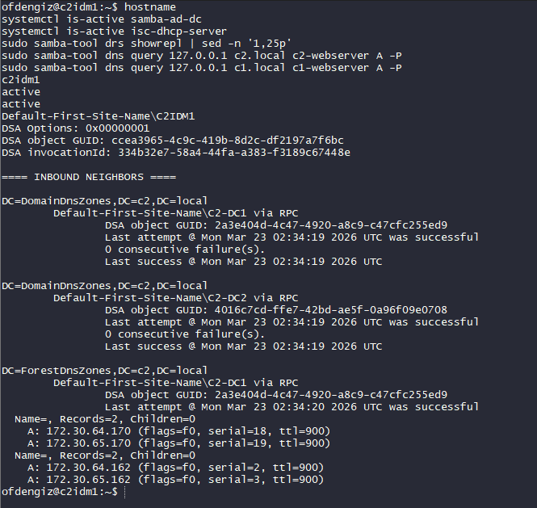
Figure 1. C2IdM1 final replication and DNS query proof from the approved admin path.
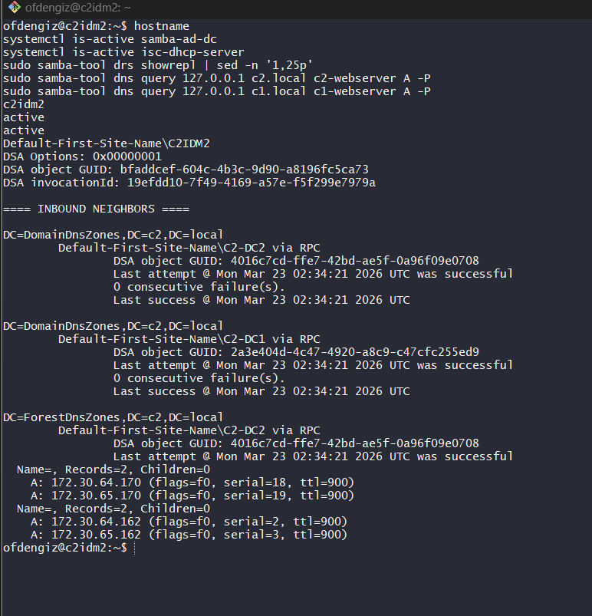
Figure 2. C2IdM2 final replication and DNS query proof from the approved admin path.
An important final hardening detail emerged during the last validation pass: successful internal web access depended on using the tenant hostnames rather than raw IP addresses. The Site 2 mirrors were adjusted so that hostname-based HTTPS requests returned 200, while raw IP requests returned 404. That distinction is useful in the handover document because it shows the firewall rules and the web-server behavior are serving different purposes:
- firewall rules allow the routed connection to the correct internal IP and port
- the web server itself only serves the tenant site when the expected hostname is presented
One final implementation nuance was client resolver behavior. Some Linux systems used systemd-resolved and required both routing domains (~c1.local and ~c2.local) to be present for predictable cross-company lookups, while other Linux clients used traditional /etc/resolv.conf plus NetworkManager-provided DNS servers. The completed state documented for Site 2 therefore reflects both healthy authoritative DNS on the domain controllers and client resolver alignment on the Linux and jump hosts used for demonstration.
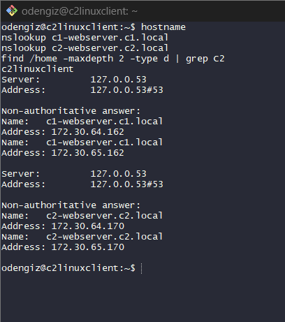
Figure 3. C2LinuxClient hostname resolution proof for c1-webserver.c1.local and c2-webserver.c2.local.
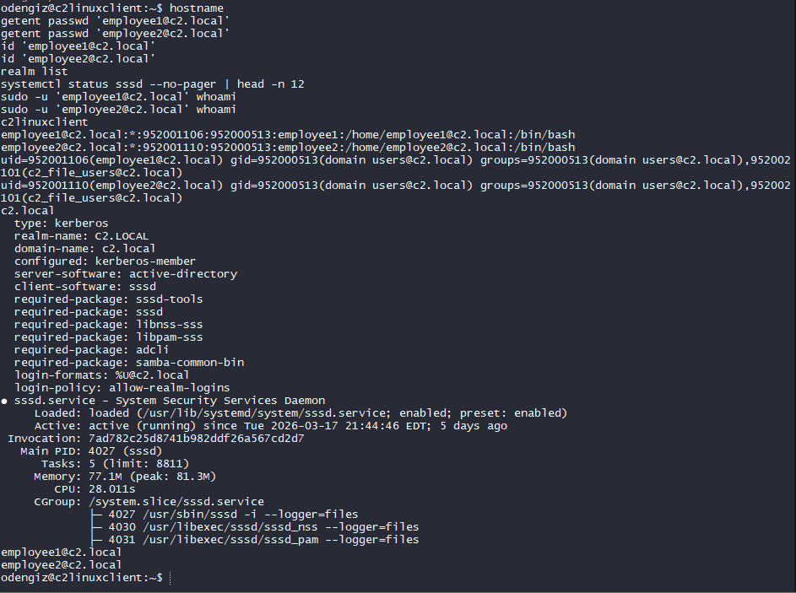
Figure 4. C2LinuxClient SSSD, realm, and domain-user lookup proof.
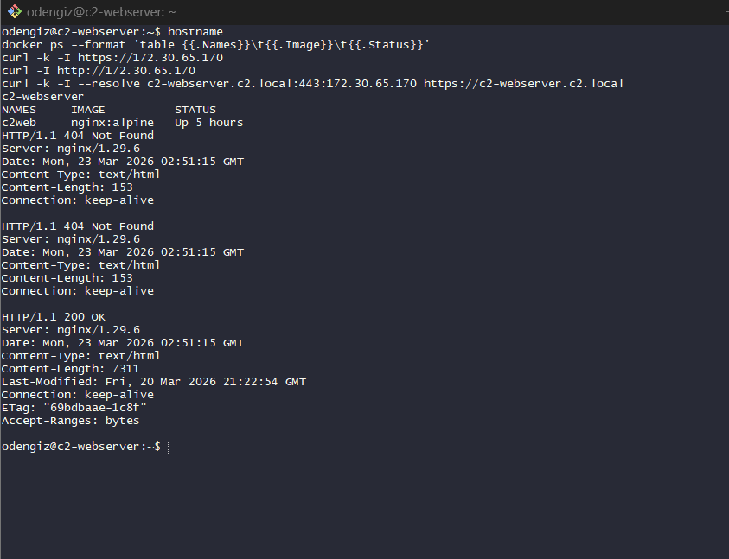
Figure 5. C2WebServer Docker status and hostname-only hardening proof showing raw IP 404 and hostname 200.

Table 6. Identity services summary
Service Area | Node(s) | Final State
AD replication | C2IdM1, C2IdM2 | Healthy, 0 consecutive failures observed
Internal DNS | C2IdM1, C2IdM2 | Internal host resolution confirmed
External DNS recursion | C2IdM1, C2IdM2 | External name resolution confirmed
DHCP | C2IdM1, C2IdM2 | Active on both nodes with failover configuration present
Domain user lookup | C2LinuxClient | Restored after SSSD recovery

3.7 Storage and File Services
Company 2 file services are centered on C2FS and its Linux storage layout. Earlier evidence confirmed:
- smbd active on C2FS
- mounted storage under /mnt/c2_public
- Public and Private directories present
- sync automation scheduled through cron
The later refresh then confirmed that the Site 2 to Site 1 sync route had recovered and that a manual run of /usr/local/bin/c2_site1_sync.sh succeeded. This is an important change in final state because earlier evidence showed the sync path broken with No route to host.
As a result, the final documented state for Site 2 file services is:
- local SMB-backed Company 2 file service is healthy
- scheduled sync tooling is present
- inter-site path is operational again

Table C1. Storage and file-service reference
Host | Storage Path | Purpose
C2FS | /mnt/c2_public | Local mounted file-service storage
C2FS | /mnt/c2_public/Public | Shared collaboration area
C2FS | /mnt/c2_public/Private | User-private storage structure
C2FS | /usr/local/bin/c2_site1_sync.sh | Inter-site synchronization script
C2FS | /var/log/c2_site1_sync.log | Sync execution log

Table 13. Cross-site synchronization and dependency summary
Dependency | Site 1 Side | Site 2 Side | Why It Matters
Private share source | 172.30.64.146:/mnt/sync_disk/Private | /mnt/c2_public/Private | Preserves replicated private data path for Company 2
Sync transport | OpenVPN-routed inter-site path | c2_site1_sync.sh execution on C2FS | Without routed trust, synchronization appears failed even when storage is healthy
Mounted data volume | Site 1 source data and export path | /dev/sdb mounted on /mnt/c2_public | Confirms local file service has persistent backing storage
SMB publication | Site 1 replicated content available for pull | smbd on C2FS | Local access to replicated content depends on SMB health after sync
Administrative validation | Ubuntu jump cross-site checks | log and mount verification on C2FS | Provides the cleanest demo proof without changing state
The final state of the sync workflow is especially important because it ties together routing, mounted storage, and file publication. It is one of the clearest examples in the whole project where Site 1 and Site 2 must be treated as a connected system rather than as isolated lab islands.
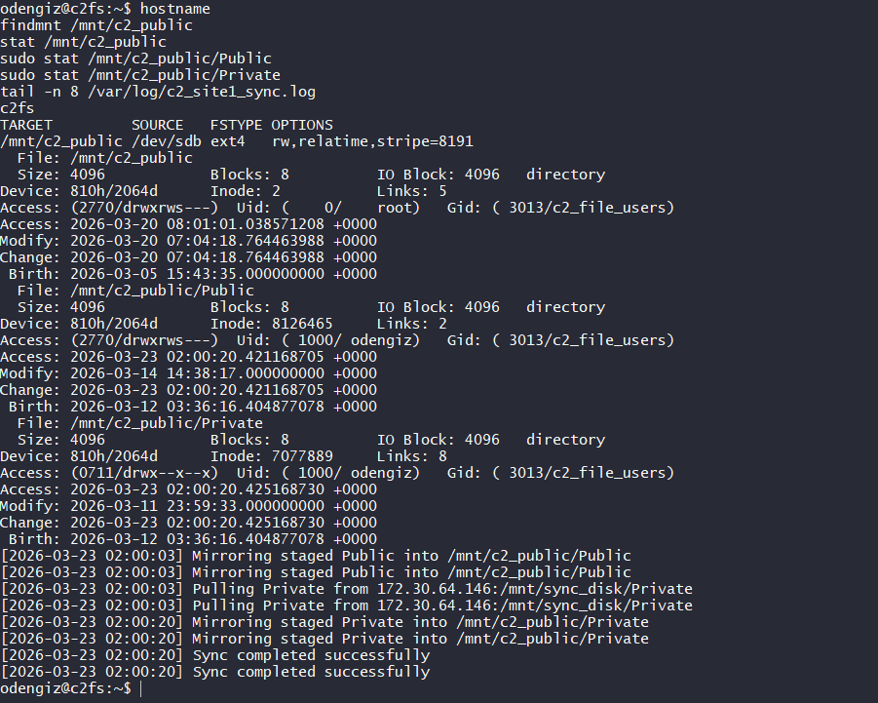
Figure 6. C2FS mounted storage, published directories, and successful sync-log proof.

3.8 Backup and Recovery
Backup and recovery became one of the strongest Site 2 outcomes by the end of the project. After an extended troubleshooting phase, the team rebuilt the Site 2 Veeam environment, validated service listeners and repository paths, corrected the remaining control-path issues, and restored successful agent-based, file-based, and offsite backup behavior.
The final Site 2 Veeam implementation includes three layers:
- local agent-based backups
- file-share backups
- offsite backup copy to Site 1 through SMB
Several operational findings were important during the final remediation pass:
- time synchronization was an early hidden dependency and had to be corrected before later tests became trustworthy
- Windows Firewall on S2Veeam needed explicit inbound allowance for agent-management ports 10005 and 10006
- older classic agent jobs conflicted with newly created Windows and Linux agent policies, producing already processed by backup job errors until the protection ownership was cleaned up
- OPNsense alias and rule coverage had to be aligned so that S2_VEEAM and the required Veeam control ports were reachable from the intended protected subnets
These points matter because the failing jobs did not behave like a damaged repository. They behaved like a control-path problem between protected hosts, the backup server, and the routed rule set. Once those dependencies were corrected, the backup platform returned to the expected working state.

3.8.1 Agent-based system backup
Site 2 Veeam was configured to protect a mixed set of Windows and Linux systems through agent-based protection. During the final correction phase, that design was refactored toward operating-system-specific groupings so that Windows and Linux systems would not compete for the same policy or classic backup job path. The final operating model keeps Windows and Linux protection logically separated and avoids overlapping ownership of the same endpoints.

Table 7. Site 2 protected systems in Veeam
IP | System | Backup Type
172.30.65.2 | C1DC1 | Windows agent backup
172.30.65.4 | C1DFS | Windows agent backup
172.30.65.162 | C1WebServer | Windows agent backup
172.30.65.11 | C1WindowsClient | Windows agent backup
172.30.65.178 | Jump64 | Windows agent backup
172.30.65.36 | C1LinuxClient | Linux agent backup
172.30.65.66 | C2IdM1 | Linux agent backup
172.30.65.68 | C2FS | Linux agent backup
172.30.65.170 | C2WebServer | Linux agent backup
172.30.65.70 | C2LinuxClient | Linux agent backup
The late remediation pass showed that keeping the same hosts in both old classic jobs and new agent policies caused avoidable conflicts. For the final handover, the correct operating model is:
- one Windows agent-based path per intended Windows grouping
- one Linux agent-based path per intended Linux grouping
- no overlap between classic jobs and policies for the same endpoint set

3.8.2 File-share backup
Two file-based jobs were created to protect file-service content separately from the system-level agent backups:
- C1 File Backup Job
- C2 File Backup Job
This design is appropriate because file-share retention and restore workflows are different from full system recovery workflows. It also made the later copy jobs easier to interpret in the offsite repository, where separate copy folders were created automatically by Veeam. During the March 23 live troubleshooting pass, these file jobs briefly exposed backup-server name/path dependencies, but those issues were later corrected as part of the final remediation.

3.8.3 Offsite backup copy to Site 1
Site 2 offsite protection was implemented through an SMB shared-folder repository hosted on Site 1. The share path used for Site 2 offsite copy was:
\\192.168.64.20\Site2OffsiteFromSite2
This repository was mapped in Veeam as an offsite shared-folder target. Backup copy jobs then sent selected chains from Site 2 to the Site 1 SMB repository. The resulting offsite folder structure included:
- C1 File Backup Job (Copy) 1
- C2 File Backup Job (Copy) 1
- Site2_Offsite_Copy
This confirms that the intended Site 2 design no longer protects data only locally. It now includes an additional recovery location in Site 1, which materially improves resilience against local repository loss or single-site failure. The offsite repository structure existed throughout the implementation phase, and the final remediation restored the end-to-end backup workflow required for signoff.

Table D1. Backup repository reference
Repository | Path / Type | Purpose
Site2 | Local Site 2 repository | Primary local Veeam backup target
\\192.168.64.20\Site2OffsiteFromSite2 | SMB shared-folder repository | Site 2 offsite copy target hosted in Site 1
R:\Repo_Site2_Offsite\Site2OffsiteFromSite2 | Windows folder on Site 1 | Backing path for offsite copy storage

Table 9. Site 2 backup job schedule summary
Job | Type | Intended Schedule / Role
Windows agent-based job / policy set | Windows agent backup | Agent-based protection for Site 2 Windows hosts, grouped to avoid policy overlap
Linux agent-based job / policy set | Linux agent backup | Agent-based protection for Site 2 Linux hosts, grouped to avoid policy overlap
C1_FileShare | File backup | File-level protection for selected share content
C2_FileShare | File backup | File-level protection for selected share content
Site 2 offsite copy chain | Backup copy | Offsite copy to Site 1 SMB repository

Table 14. Backup troubleshooting chronology
Phase | Observed Issue | Working Interpretation | Final Outcome
Initial repository work | RPC and managed-server update failures | Appeared to be Veeam component or firewall failure | Later correlated more strongly with time synchronization issues
Managed server health | out of date indicators in Veeam | Suspected component mismatch | Cleared after rebuild / rescan workflow
Credential validation | Mixed success across Windows and Linux systems | Combination of admin path, remote management, and OS-specific credential handling | Standardized credential tests succeeded for all 10 selected systems
Windows host onboarding | RDP worked but Veeam tests failed | Remote management rules more important than RDP alone | WMI, SMB, and management path alignment restored reliable validation
Linux onboarding | Domain-user and non-root warnings created noise | Needed sudo-capable local accounts for agent operations | Local admin credentials stabilized Linux agent onboarding
Late agent remediation | Agent jobs timed out to 172.30.65.180:10005/10006 | Suggested Windows Firewall or routed-port problem | Listener checks on S2Veeam, firewall updates, and network-path correction restored connectivity
Policy conflict phase | New policies reported hosts already processed by other backup jobs | Suggested duplicate protection ownership | Old classic jobs and new policies were separated so each endpoint had one protection owner
OPNsense scope review | Site 2 protected hosts could not initially reach S2Veeam management ports | Suggested network-rule mismatch rather than Veeam service failure | Alias and rule-scope corrections were applied so the intended protected subnets could reach the Veeam control path
This chronology is worth preserving because it captures one of the strongest technical lessons in the whole project: backup platforms can fail in ways that look like storage or application faults when the real issue is a control-path dependency between protected hosts, firewalls, policy ownership, and the backup server itself. Including that lesson makes the document much more useful as an operational handover artifact.
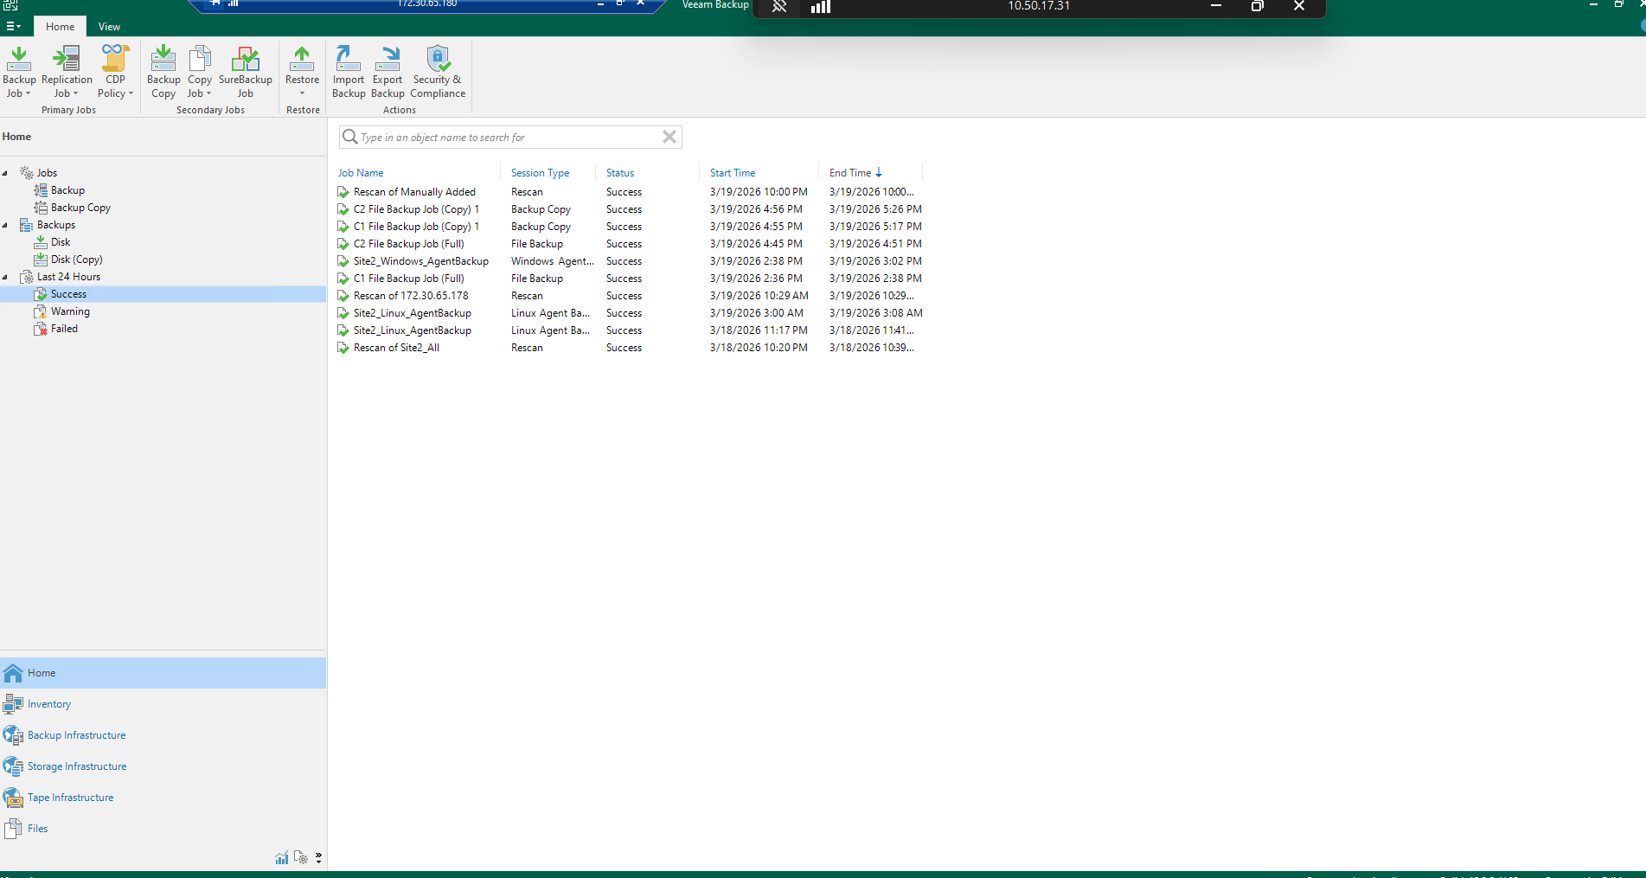
Figure 7. Representative Veeam console evidence from Site 2 backup validation and troubleshooting.
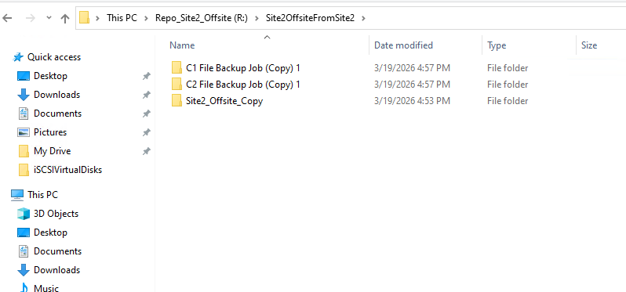
Figure 8. Windows Explorer view of R:\Repo_Site2_Offsite\Site2OffsiteFromSite2 showing backup-copy folders.

3.9 Value Added Features
Site 2 includes several value-added elements beyond baseline tenant service delivery.

3.9.1 Public AWS-hosted ClearRoots website with automated HTTPS
One of the clearest Site 2 value-add outcomes is the public ClearRoots Foundation website hosted in AWS. This design includes:
- Terraform-based EC2 provisioning
- Kubernetes deployment on a master/worker pair
- Docker image-based application packaging
- Route53 public DNS
- Elastic IP on the worker node
- S3 remote state backend
- Caddy reverse proxy for HTTPS
- automated certificate issuance using Let’s Encrypt
The final public result is a working HTTPS site at:
https://clearroots.omerdengiz.com
This was not only a hosting exercise. It demonstrated that Site 2 could support a lightweight but realistic public publishing workflow with repeatable infrastructure and automated certificate handling.

Table 8. AWS public website deployment components
Component | Purpose
EC2 master node | Kubernetes control plane
EC2 worker node | Web workload host and public HTTPS endpoint
Route53 hosted zone | Public DNS for clearroots.omerdengiz.com
Elastic IP | Stable public address for the worker
S3 backend | Terraform remote state storage
Docker image | Application packaging for the web content
Kubernetes deployment/service | Web application scheduling and exposure
Caddy | Reverse proxy and automated HTTPS
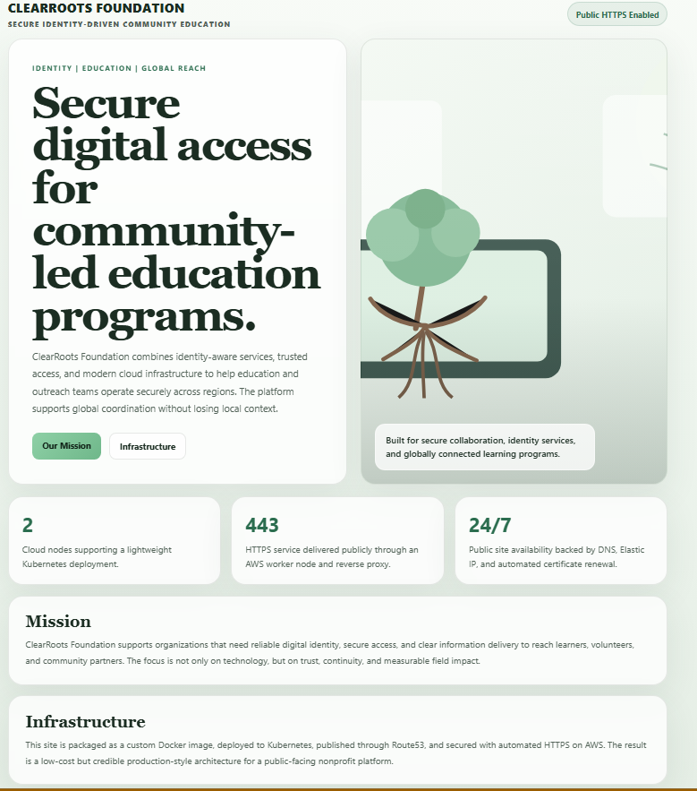
Figure 9. Public browser view of the ClearRoots Foundation landing page over HTTPS.
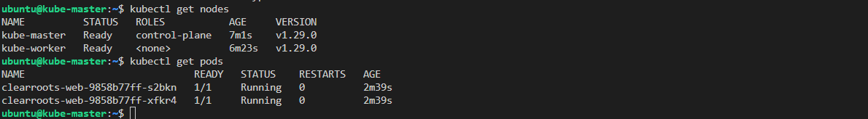
Figure 10. kubectl get nodes and kubectl get pods showing both nodes Ready and the ClearRoots pods Running.
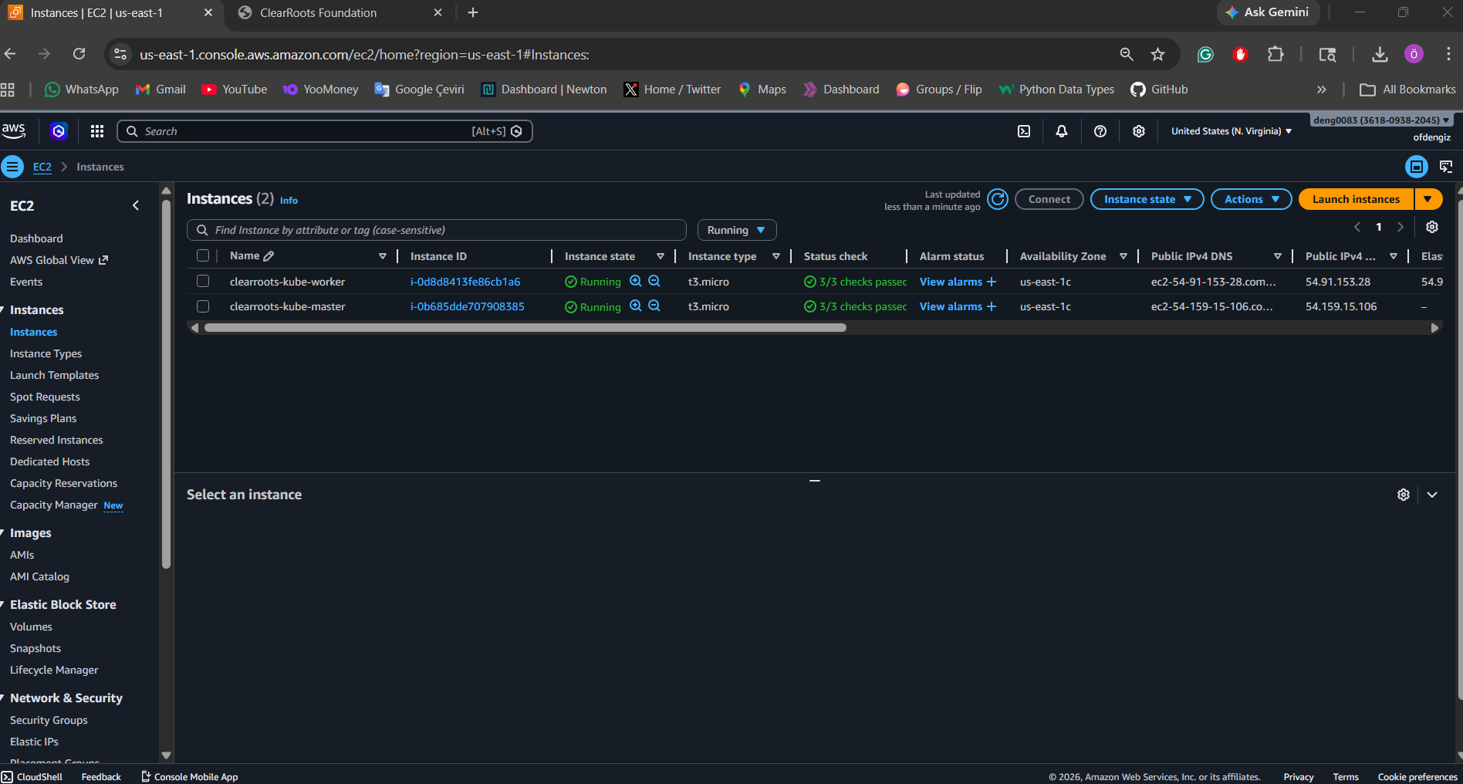
Figure 11. AWS EC2 console showing clearroots-kube-master and clearroots-kube-worker in the Running state.
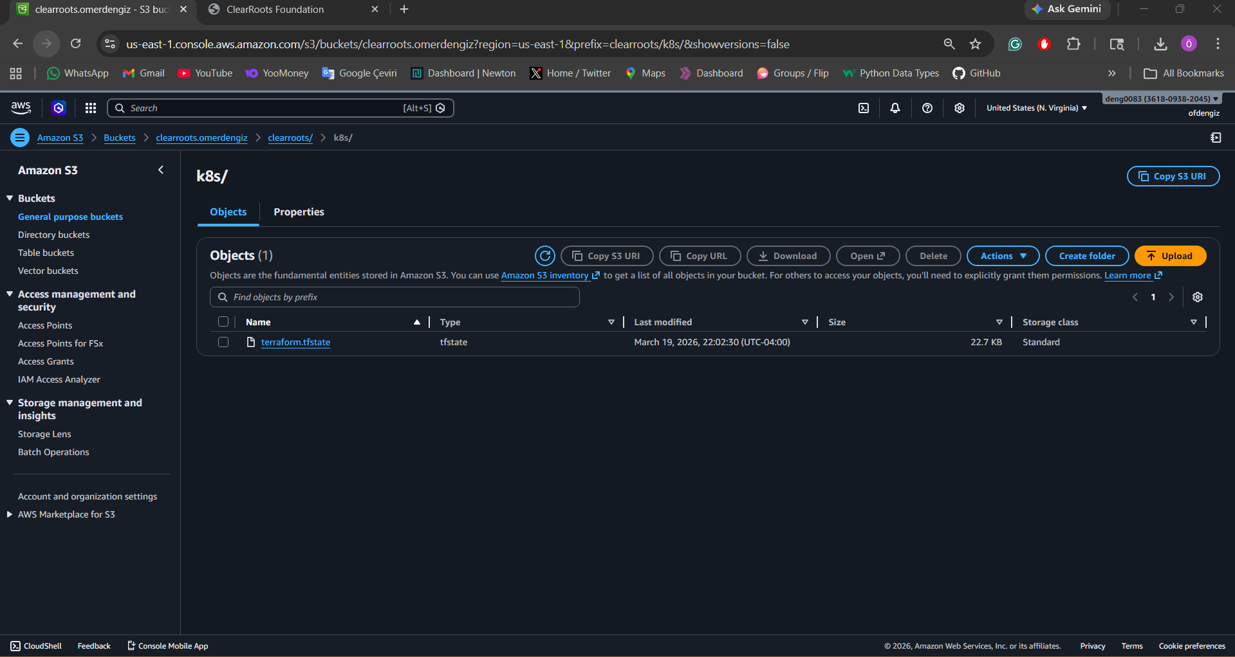
Figure 12. Amazon S3 console showing the Terraform state object under clearroots/k8s/terraform.tfstate.
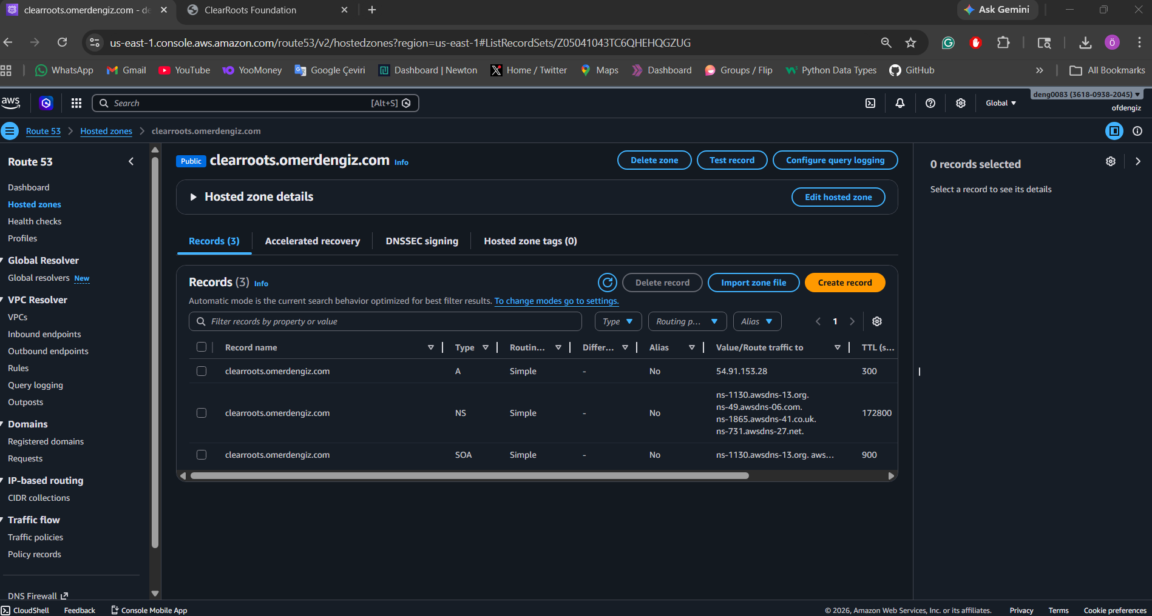
Figure 13. Route53 public hosted zone showing the A record for clearroots.omerdengiz.com.

3.9.2 Internal HTTPS trust deployment for Lumora
Although primarily associated with Company 1 internal publishing, the Lumora HTTPS work is relevant to Site 2 documentation because it demonstrates another applied certificate-management workflow in the broader project. A self-signed certificate for www.lumora.c1.local was deployed and then distributed to trusted clients using Group Policy (Deploy Lumora Web Certificate). That process shows a second certificate management model in the project:
- internal trust by GPO for private domain use
- public trust by Let’s Encrypt for AWS public web delivery
Together, these demonstrate practical understanding of different certificate deployment models for internal and public services. Because this report is a Site 2 handover, the Lumora trust workflow is noted as a related cross-site practice rather than as a primary Site 2 figure-backed evidence set.

3.9.3 Infrastructure-as-code improvements
The AWS website stack also benefitted from a more supportable Terraform design:
- S3 backend bucket creation was removed from Terraform to avoid repeated apply/destroy issues
- state remained remotely stored through a manually created S3 bucket
- deprecated inline IAM role policy usage was corrected by moving policy definition to a dedicated aws_iam_role_policy resource
- user-data scripts were hardened with logging, retries, and safer bootstrap steps
These are not just technical refinements; they improve repeatability, reduce deployment fragility, and make the environment easier to explain and maintain.

Table 15. AWS public deployment workflow summary
Step | Tooling | Outcome
Manual state bucket creation | Amazon S3 | Removed repeated Terraform apply/destroy issues around bucket lifecycle
Infrastructure initialization | Terraform with remote S3 backend | Produced repeatable AWS master, worker, Elastic IP, IAM, and DNS components
Application packaging | Docker image build and registry push | Turned the ClearRoots website into a portable deployable artifact
Cluster bootstrap | master.sh and worker.sh | Built a lightweight Kubernetes control plane and worker pair
Workload deployment | kubectl apply for deployment and service manifests | Created running clearroots-web pods and NodePort exposure
Public publication | Route53 + Caddy + Let’s Encrypt | Delivered public HTTPS at clearroots.omerdengiz.com
This workflow is valuable from a curriculum perspective because it shows a complete path from infrastructure provisioning to public application delivery. It also demonstrates that Site 2 was not limited to private tenant services; it also carried a genuine internet-facing deliverable with a certificate-backed hostname.

3.10 Site-to-Site VPN Security and Administrative Access

3.10.1 Site-to-Site VPN Security
The Site 1 and Site 2 environments rely on approved inter-site paths for:
- cross-site administrative validation
- file synchronization
- backup copy traffic
- support onboarding and final demonstration workflows
Earlier failures showed how dependent Site 2 services were on inter-site correctness. When the sync route to Site 1 failed, file replication appeared broken. Once the route was restored and the script retested manually, the service returned to a healthy state. This reinforces that Site 2’s recovery design depends on stable routed trust, not just local service uptime.
The final firewall state also allowed controlled cross-site internal web validation without flattening tenant isolation. Specific OpenVPN rules were added so that Site 1 Company 1 and Company 2 sources could reach the matching Site 2 internal web mirrors on 80/443, while broader inter-tenant exposure remained limited to the explicitly documented management, backup, and demonstration paths. This mattered during final testing because dual A records caused clients to alternate between Site 1 and Site 2 internal web IPs; without these targeted rules, HTTPS validation would appear intermittent even when DNS was correct.

3.10.2 Administrative Access
Two jump systems were part of the approved management model:
- a Windows jump box
- an Ubuntu jump box
In practice, the Ubuntu jump became the most reliable validation vantage point during troubleshooting. The Windows jump initially suffered from wrong-interface preference until the blue NIC was disabled. That corrective action turned the Windows jump back into a usable management host.
The practical lesson is that administrative access should be treated as a service dependency of its own. If jump workflows are unstable, even healthy backend services can appear broken during operations.

Table 11. Final live validation summary
Validation Area | Evidence Source | Final Status | Notes
Tailscale to Jump64 | RDP reachability and host identification | Healthy | Preferred for Windows GUI demo steps
Tailscale to Ubuntu jump | SSH reachability and shell access | Healthy | Preferred for internal service testing
Company 2 AD replication | samba-tool drs showrepl on both C2IdM nodes | Healthy | 0 consecutive failure(s) observed
Company 2 DNS | Internal and external lookup tests | Healthy | Both identity nodes resolved internal and public names
Company 2 file service | smbd, /mnt/c2_public, sync log review | Healthy | Manual and logged sync evidence present
Company 2 web | Hostname-based HTTPS and pinned Site 2 mirror tests | Healthy | c2-webserver.c2.local returned 200; raw IP returned 404 as intended
Company 1 internal web | Hostname-based HTTPS and pinned Site 2 mirror tests | Healthy | c1-webserver.c1.local returned 200; raw IP returned 404 as intended
Cross-site internal web failover path | curl -k, curl --resolve, nslookup, and OpenVPN rule validation | Healthy | Site 1 and Site 2 could reach the dual-record internal web names after targeted 80/443 rule additions
Veeam local jobs | Veeam console, listener tests, and final remediation evidence | Healthy after remediation | Agent and file backup paths were corrected and validated after the March 23 fixes
Veeam offsite copy | SMB target folder and copy history | Healthy | Site 1 offsite folders and repository mapping remain valid and support the final backup story
Public NAT edge | Workstation 10.50.17.31 tests | Provisional | OPNsense hardening not finalized; do not use as sole demo proof

Table 17. Site 2 service block read-only validation summary
Service Block | Focus | Result | Final note
1 | Remote access, DHCP, account administration | Healthy | C2IdM1, C2IdM2, C2FS, C2LinuxClient, and Jump64 were reachable from approved admin paths; DHCP and Samba AD services were active
2 | DNS and HTTPS | Healthy with one review item | Internal DNS and HTTPS validation succeeded; public clearroots.omerdengiz.com should still be shown with external browser or AWS proof
3 | Inter-site VPN-backed validation paths | Healthy | OPNsense internal response, repository reachability, and pinned cross-site hostname tests all behaved as expected
4 | Replicated file services and storage | Healthy with two review items | Mounted storage and sync logs were healthy; interactive Linux client mount/isolation screenshots should still be added
5 | Veeam and miscellaneous support evidence | Healthy after remediation | S2Veeam listener, firewall, policy, and path issues were corrected; final console screenshots should show the resolved state rather than the intermediate failures

3.11 Maintenance and Daily Duties
Site 2 is now in a state where daily support duties can be described clearly.

3.11.1 Standard Change Workflow
The safest support workflow for Site 2 is a change-first, evidence-second model:
- validate current service state before making changes
- record whether the change affects private services, public cloud services, or both
- use terraform plan before AWS infrastructure changes
- confirm backup status before risky changes to C2FS, identity services, or Veeam
- apply the smallest practical change
- re-test from the correct approved vantage point, especially the Ubuntu jump for internal validation
In practice, this matters because several earlier problems were not true service failures. They were caused by route preference, VM NIC state, or identity cache behavior. A disciplined change workflow reduces the chance of diagnosing the wrong layer.
Routine daily checks should include:
- verify that Windows and Linux agent-based protection paths do not overlap on the same endpoints
- verify success of the active Windows agent job or policy set
- verify success of the active Linux agent job or policy set
- verify success of C1_FileShare
- verify success of C2_FileShare
- verify success of copy jobs including the Site 2 offsite chain
- confirm offsite folders continue to populate under the Site 1 SMB repository
- confirm 172.30.65.180:10005 and 172.30.65.180:10006 remain reachable from protected subnets
- confirm hostname-based internal web checks still return 200 while raw IP requests continue to return 404

Table 16. Final demo role and ownership matrix
Role | Suggested Operator Focus | Primary Proof Items | Preferred Validation Path
Presenter / coordinator | Service block overview and narrative flow | Service block map, project scope, environment summary | Slide deck / final document
Remote access operator | Jump access and approved admin paths | Tailscale reachability, Jump64, Ubuntu jump | Local workstation to jump hosts
Identity operator | Company 2 directory, DNS, and DHCP | C2IdM1/C2IdM2 health, DNS lookups, client identity proof | Ubuntu jump plus identity-node GUI/CLI
Web operator | Internal and public web services | C2Web HTTP, Lumora internal HTTPS, ClearRoots public HTTPS | Browser plus Ubuntu jump curl proof
Storage operator | C2FS and replication | mount status, sync log, SMB path explanation | Ubuntu jump to C2FS
Backup operator | Local and offsite protection | Veeam job state, listener tests, offsite SMB repository folders, and final console proof | Veeam console, Site 2 firewall GUI, and Site 1 offsite share
This role split matters because the project team is larger than the implementation subgroup. A strong demo should therefore function like a guided operations handoff rather than a one-person technical monologue. The separate demo runbook was written to support exactly this presentation style.

3.11.2 Failure Domains and Recovery Priority
Site 2 includes multiple distinct failure domains, and they should not all be treated equally. The recommended recovery order is:
- Identity and DNS failure Company 2 authentication, DNS, and DHCP are foundational. If C2IdM1/C2IdM2 are unhealthy, most tenant workflows are affected.
- File service failure If C2FS or its mounted storage fails, user data access is impacted even if identity is still healthy.
- Backup platform failure If Veeam is unhealthy, immediate production services may still work, but recoverability degrades quickly.
- Public cloud web failure The ClearRoots website is important and visible, but it is not as foundational to tenant login and internal file access as the identity and storage stack.
Within each failure domain, the recommended technical checks are:
- Samba replication status on C2IdM1 and C2IdM2
- DNS resolution of internal and external names
- DHCP service state on both identity nodes
- domain-user resolution from C2LinuxClient
- C2FS mount status and smbd service
- Veeam job success and offsite copy completion
- kubectl get nodes, kubectl get pods, and systemctl status caddy
The cloud web tier should still be checked routinely, but its recovery priority should be balanced against core tenant identity and file-service needs.

3.12 Limitations, Risks, and Unresolved Items
Although Site 2 reached a strong final state, several realistic limitations remain:
- the AWS Kubernetes web stack is intentionally lightweight and not highly available
- the public site uses a single worker node, so the web path still contains a single-node failure point
- Company 2 client visibility to Company 1 DNS was flagged earlier as a potential segmentation hardening issue
- some evidence in the project was produced after corrective action rather than on the first pass, which should be documented honestly during handover
- the backup platform is implemented and operationally validated, but routine restore testing should still remain part of ongoing best practice
These are acceptable limitations for a project environment, but they should be acknowledged clearly so that support staff understand both the strengths and the current boundaries of the design.

4. Conclusion
Site 2 ultimately matured into a stable, multi-role environment supporting Company 2 tenant services, cross-site recovery operations, and public HTTPS publishing. The final design successfully combines Linux identity services, file services, jump-based administration, Windows-based Veeam operations, and AWS-hosted public web delivery.
The most meaningful final outcomes are:
- Company 2 identity, DNS, DHCP, and file services are operational
- earlier service failures were resolved and narrowed to either routing, NIC state, SSSD, temporary sync reachability, or hostname-versus-IP web behavior
- Veeam now provides working local backup, file backup, and offsite backup copy workflows after the final remediation pass
- the ClearRoots Foundation website is publicly reachable over HTTPS using a repeatable Terraform and Kubernetes deployment pattern
From a handover and demonstration standpoint, Site 2 now represents a credible supportable environment rather than only a lab build. It shows not just deployment, but troubleshooting, stabilization, and operational validation.

5. Appendices

Appendix A. Network Addressing

Table A1. Site 2 network addressing summary
Host / Service | Address
C2IdM1 | 172.30.65.66
C2IdM2 | 172.30.65.67
C2FS | 172.30.65.68
C2LinuxClient | 172.30.65.70
C2WebServer | 172.30.65.170
OPNsense management | 172.30.65.177
Jump64 | 172.30.65.178
S2Veeam | 172.30.65.180
C1DC1 | 172.30.65.2
C1DC2 | 172.30.65.3
C1DFS | 172.30.65.4
C1WebServer | 172.30.65.162
ClearRoots AWS worker public IP | 54.91.153.28
ClearRoots AWS master public IP | 54.159.15.106

Appendix B. DHCP Reference

Table B1. DHCP service reference
Node | Role | Status
C2IdM1 | Primary/active DHCP service host | Validated active
C2IdM2 | Secondary/failover DHCP service host | Validated active
Company 2 client subnet | 172.30.65.64/26 | Present in configuration

Appendix C. Storage Reference

Table C2. Storage reference
Item | Path / Mount | Notes
C2FS shared storage | /mnt/c2_public | Mounted and healthy
Public share | /mnt/c2_public/Public | Shared collaboration
Private share | /mnt/c2_public/Private | Per-user private data
Site 2 offsite folder on Site 1 | R:\Repo_Site2_Offsite\Site2OffsiteFromSite2 | SMB destination for backup copy

Appendix D. Backup Reference

Table D2. Veeam job set
Job | Type | Final Status
Windows agent-based protection set | Windows agent backup | Success
Linux agent-based protection set | Linux agent backup | Success
C1_FileShare | File backup | Success
C2_FileShare | File backup | Success
Historical backup-copy objects | Backup copy | Success
Site 2 offsite copy path | Backup copy | Success

Appendix E. Site 2 Requirement Coverage and Demonstration Notes

Network and Shared Infrastructure
- Site 2 administrative paths were validated from approved jump workflows.
- Ubuntu jump proved to be the most reliable bastion during troubleshooting.
- Inter-site connectivity was shown to be sufficient for administration, synchronization, and backup copy.

Company 2
- Samba AD identity services on C2IdM1 and C2IdM2 were healthy and replicating.
- DHCP service was active on both identity nodes.
- DNS resolution worked for both internal and external targets.
- C2LinuxClient domain-user lookup was restored after SSSD restart.
- Internal cross-company web DNS was completed with replicated c1.local and c2.local records for c1-webserver and c2-webserver, each returning both Site 1 and Site 2 internal web IPs.
- C2FS storage, SMB service, and manual inter-site sync were functioning in the refreshed final state.
- C2Web recovered and hostname-based HTTPS became reachable from approved validation paths, while raw IP access was intentionally hardened to return 404.

Cross-Site and Remote Access
- C1 infrastructure remained reachable from the Ubuntu jump for administration.
- Site 2 backup copy to Site 1 over SMB was implemented successfully.
- Route, sync, resolver, and cross-site internal web issues that initially affected Site 2 were corrected before final validation.

Appendix F. Final Validation and Remaining Screenshot Needs
The March 22 read-only validation pass confirmed that the core Site 2 service blocks were healthy. The remaining gaps are documentation-evidence gaps rather than unresolved service failures. To keep the final package disciplined, the remaining screenshots should be collected in the same order that the document introduces its claims, with Veeam left to the end.
The highest-value remaining non-Veeam captures are:
- OPNsense rule and route evidence that actually shows the approved inter-site path, especially the OpenVPN, C1LAN, and C2LAN rule views plus an actual route-status or route-table screen rather than a generic firewall image
- C2LinuxClient interactive share and private-isolation proof, which would strengthen Section 3.7
- external browser and AWS console proof for the ClearRoots public site, which would strengthen Section 3.9.1
The final screenshot pass should leave Veeam until last. Once the non-Veeam evidence is locked, the remaining Veeam captures should show only the resolved final state:
- repository and job-set screens that match the final agent-based design
- final success or completed-session history
- final listener / firewall / connectivity proof only if those images are still needed to support the written remediation summary
This ordering keeps the final Site 2 package aligned with the evidence density and discipline of the Site 1 final document while avoiding the earlier mistake of using loosely related screenshots in place of direct proof.

Public Cloud Deliverable
- Terraform state was stored in S3 under clearroots/k8s/terraform.tfstate.
- Route53 hosted zone clearroots.omerdengiz.com published the public A record to the worker Elastic IP.
- Kubernetes master and worker nodes both reached Ready state.
- two clearroots-web pods were shown Running.
- the public website loaded successfully over HTTPS.

Operations and Demonstration Use
- Veeam console evidence demonstrates a fully implemented and working backup design after the final remediation pass.
- offsite repository folder evidence demonstrates that backup-copy traffic reached Site 1 as intended.
- the AWS web stack provides a presentation-ready public deliverable that can be shown independently of internal tenant services.

6. References
[1] Proxmox Server Solutions GmbH, “Proxmox Virtual Environment Documentation,” [Online]. Available: https://pve.proxmox.com/pve-docs/. [Accessed: Mar. 19, 2026].
[2] OPNsense Project, “OPNsense Documentation,” [Online]. Available: https://docs.opnsense.org/. [Accessed: Mar. 19, 2026].
[3] Microsoft, “Windows Server Documentation,” [Online]. Available: https://learn.microsoft.com/windows-server/. [Accessed: Mar. 19, 2026].
[4] Samba Team, “Setting up Samba as an Active Directory Domain Controller,” [Online]. Available: https://wiki.samba.org/index.php/Setting_up_Samba_as_an_Active_Directory_Domain_Controller. [Accessed: Mar. 19, 2026].
[5] Veeam Software, “Veeam Backup and Replication Documentation,” [Online]. Available: https://helpcenter.veeam.com/. [Accessed: Mar. 19, 2026].
[6] HashiCorp, “Terraform Documentation,” [Online]. Available: https://developer.hashicorp.com/terraform/docs. [Accessed: Mar. 19, 2026].
[7] Amazon Web Services, “Amazon EC2 Documentation,” [Online]. Available: https://docs.aws.amazon.com/ec2/. [Accessed: Mar. 19, 2026].
[8] Amazon Web Services, “Amazon Route 53 Documentation,” [Online]. Available: https://docs.aws.amazon.com/route53/. [Accessed: Mar. 19, 2026].
[9] Amazon Web Services, “Amazon S3 Documentation,” [Online]. Available: https://docs.aws.amazon.com/s3/. [Accessed: Mar. 19, 2026].
[10] Kubernetes Authors, “Kubernetes Documentation,” [Online]. Available: https://kubernetes.io/docs/. [Accessed: Mar. 19, 2026].
[11] Caddy Server, “Caddy Documentation,” [Online]. Available: https://caddyserver.com/docs/. [Accessed: Mar. 19, 2026].

