ArenaX Architecture, ERD, and Delivery Roadmap
Project planning pack for the final full-stack course submission
Prepared for Ofek and Mevorach

1. Document Purpose
This document consolidates the architectural view, database design, and execution roadmap for ArenaX. It is intended to help the team align on implementation scope, ownership, and delivery order while ensuring compliance with the course requirements.

2. Solution Architecture
ArenaX is designed as a full-stack web application. The client is a React + TypeScript web app. All business logic, authentication, validation, file uploads, AI integration, and third-party communication are routed through a Node.js + Express backend. Data is stored in MongoDB. Lichess remains an external integration, while the AI feature is implemented as a backend-controlled service.
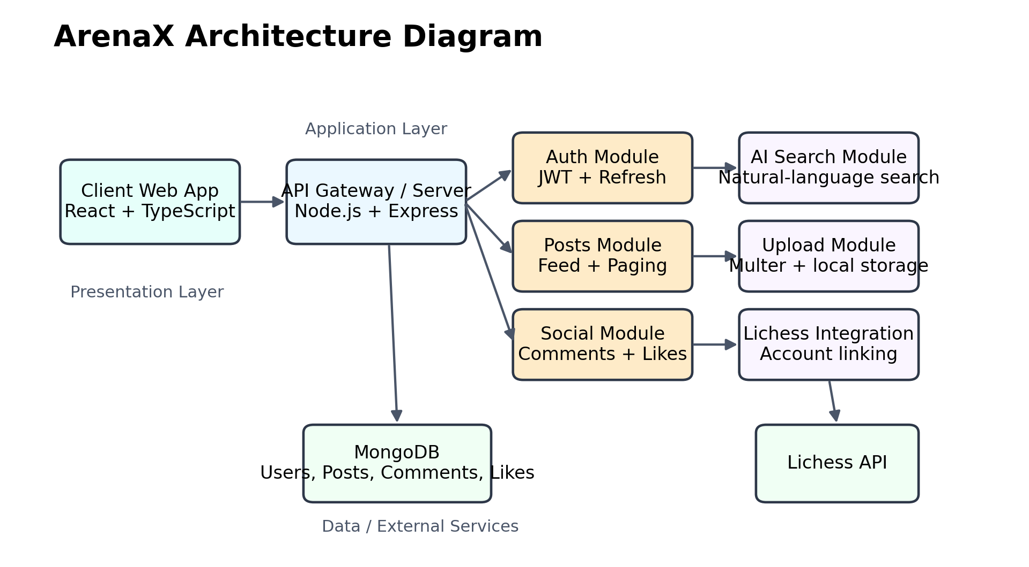
Figure 1. High-level ArenaX architecture.

Architecture Notes
- The frontend never communicates directly with Lichess or the AI provider. All external communication flows through the backend.
- Authentication is based on JWT access tokens and refresh tokens, with protected routes enforced by middleware.
- The upload module stores images on the server to satisfy the course requirement for local image storage.
- The AI feature should be domain-relevant, such as natural-language search across ArenaX posts.

3. Database Design
The database model is intentionally compact for the MVP while still supporting the required product flows: authentication, user profiles, posts, comments, likes, and future Lichess profile linking.
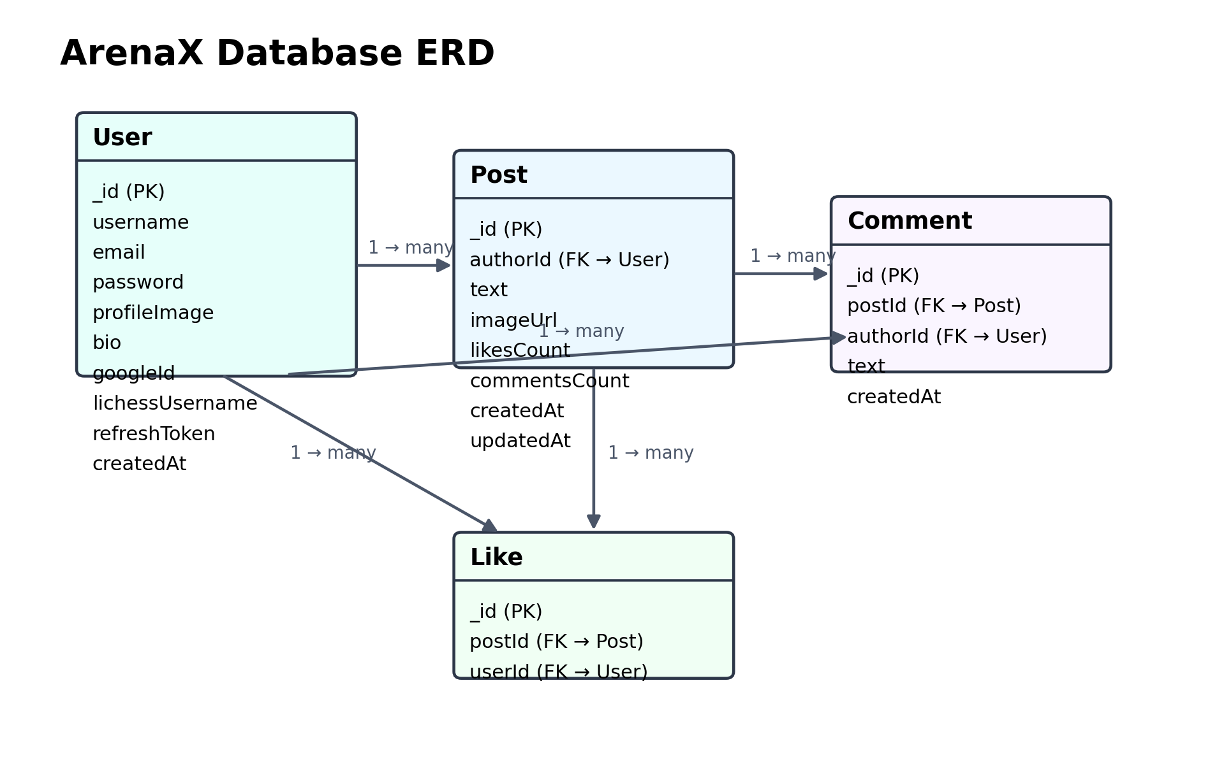
Figure 2. ArenaX database entity-relationship diagram.

Entity Summary
Entity | Main Fields | Purpose
User | username, email, password, profileImage, bio, googleId, lichessUsername, refreshToken | Stores identity, profile data, and authentication-related information.
Post | authorId, text, imageUrl, likesCount, commentsCount, createdAt | Represents a social post created by a user and displayed in the feed.
Comment | postId, authorId, text, createdAt | Stores comments displayed on the dedicated post details page.
Like | postId, userId | Tracks whether a user liked a specific post and supports like counters.

4. Delivery Roadmap
The recommended implementation sequence below is designed to reduce merge conflicts, support parallel work, and produce visible progress at the end of every stage.
- Phase 1 – Backend foundation: Complete backend authentication, Swagger, validation, token refresh flow, tests, and MongoDB integration.
- Phase 2 – Frontend authentication: Create the React app, routing, login/register pages, token persistence, and logout flow.
- Phase 3 – User profile: Implement profile page, edit profile form, profile image upload, and display of user posts.
- Phase 4 – Posts and feed: Implement create/edit/delete post APIs and UI, image upload, feed endpoint, and paging/infinite scroll.
- Phase 5 – Social interactions: Implement comments screen, comment counters, likes, and route protection for social actions.
- Phase 6 – AI feature: Add AI-powered natural-language search for posts and connect it to the frontend search experience.
- Phase 7 – Lichess connection: Allow users to store or connect a Lichess username and expose relevant profile data.
- Phase 8 – Deployment: Prepare production build, PM2 process management, HTTPS deployment, and server validation for final submission.

5. Detailed Task Roadmap
The following table breaks the work into concrete development tasks. Owners and branches are assigned to support a clean Git workflow using main, dev, and feature branches.
# | Task | Description | Owner | Branch
1 | Initialize frontend app | Create React + TypeScript client app structure and install base dependencies. | Mevorach | feature/client-setup
2 | Configure frontend routing | Add React Router and define the main public/private route layout. | Mevorach | feature/client-routing
3 | Build login page | Create login screen UI and connect form state handling. | Mevorach | feature/client-login
4 | Build register page | Create register screen UI and validation feedback. | Mevorach | feature/client-register
5 | Persist authentication | Store tokens safely and keep the user logged in across refreshes. | Mevorach | feature/client-auth-persist
6 | Create auth API client | Add Axios API wrapper for auth endpoints. | Mevorach | feature/client-auth-api
7 | Add Google login backend | Implement Google OAuth on the server to satisfy external-provider login requirement. | Ofek | feature/server-google-auth
8 | Add Google login frontend | Add Google login button and callback flow in the client. | Mevorach | feature/client-google-auth
9 | Create user profile API | Implement get/update profile endpoints on the backend. | Ofek | feature/server-profile
10 | Create profile page UI | Render profile details, bio, image, and linked Lichess username. | Mevorach | feature/client-profile
11 | Add profile image upload | Support uploading a profile image to the server and saving its path. | Ofek | feature/server-profile-upload
12 | Create edit profile UI | Implement editable form for username, bio, and profile image. | Mevorach | feature/client-profile-edit
13 | Design post model and routes | Implement backend model, validation, and routes for posts. | Ofek | feature/server-posts
14 | Create feed endpoint | Build feed API with pagination or infinite-scroll friendly response. | Ofek | feature/server-feed
15 | Create post editor UI | Create post form with text and image selection. | Mevorach | feature/client-post-create
16 | Render posts feed UI | Display paginated feed with author, text, image, counts, and actions. | Mevorach | feature/client-feed
17 | Enable edit/delete post | Allow post owners to update or remove their own posts. | Ofek | feature/server-post-controls
18 | Add edit/delete controls in UI | Expose edit and delete actions only for the post owner. | Mevorach | feature/client-post-controls
19 | Implement comments API | Create backend endpoints for creating and fetching comments by post. | Ofek | feature/server-comments
20 | Create comments page UI | Build the dedicated post details and comments screen. | Mevorach | feature/client-comments
21 | Implement likes API | Create like/unlike endpoints and efficient count updates. | Ofek | feature/server-likes
22 | Add likes UI | Render like button and optimistic count updates in the client. | Mevorach | feature/client-likes
23 | Add AI search endpoint | Implement natural-language search endpoint for ArenaX posts. | Ofek | feature/server-ai-search
24 | Add AI search UI | Create search bar and display AI-assisted results in the feed. | Mevorach | feature/client-ai-search
25 | Add Lichess account field | Store and expose Lichess username in the user profile. | Ofek | feature/server-lichess
26 | Add Lichess profile UI | Display linked Lichess username in the profile page. | Mevorach | feature/client-lichess
27 | Expand Swagger docs | Document all new endpoints, bodies, security rules, and responses. | Ofek | feature/server-swagger
28 | Expand automated tests | Add API tests for profile, posts, comments, likes, and AI search. | Ofek | feature/server-tests
29 | Protect client routes | Prevent unauthorized access to private pages. | Mevorach | feature/client-route-guards
30 | Polish error handling | Standardize frontend and backend error messages and validation display. | Ofek & Mevorach | feature/polish-errors
31 | Prepare production env | Separate development and production environment variables and settings. | Ofek | feature/server-production
32 | Prepare PM2 config | Create PM2 process configuration for deployment. | Ofek | feature/server-pm2
33 | Prepare HTTPS deployment | Document and configure HTTPS/domain setup on the college server. | Ofek | feature/server-https
34 | Final UI polish | Improve visual consistency, spacing, and submission readiness. | Mevorach | feature/client-polish
35 | Final QA pass | Execute end-to-end testing, bug fixes, README updates, and demo preparation. | Ofek & Mevorach | feature/final-qa

6. Git Workflow Rules
- main remains stable and submission-ready.
- dev is the integration branch for approved work.
- Every feature is developed in a dedicated feature/* branch.
- All pull requests should target dev first and then be merged into main only after validation.
- All code comments must be written in English.
- All commit messages must be written in simple English.

