ArenaX – System Specification

Project Overview
ArenaX is a social platform for chess players built around integration with Lichess. Users can create profiles, share posts with images, comment, like content, connect their Lichess accounts, and discover content using AI-powered search.

System Architecture
The system follows a modern full-stack architecture consisting of a React frontend, a Node.js/Express backend API, MongoDB database, and optional AI services.
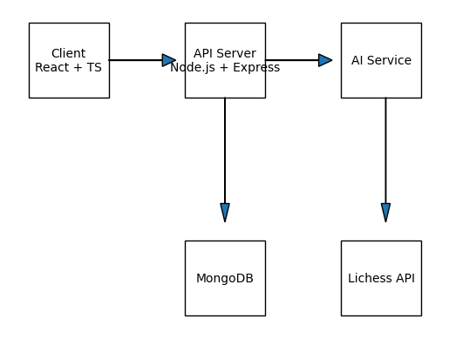

Technology Stack
Frontend: React + TypeScript
Backend: Node.js + Express + TypeScript
Database: MongoDB + Mongoose
Authentication: JWT + Refresh Tokens
Validation: Zod
Testing: Jest + Supertest
Documentation: Swagger
File Uploads: Multer

Core Features
• Authentication (Register, Login, Google Login, JWT, Refresh Token)
• User Profiles
• Post creation with image uploads
• Comments and likes
• Feed with pagination
• AI-powered content search
• Lichess account integration

Database Design
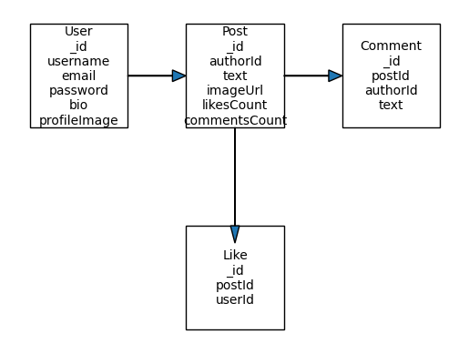

API Structure
/auth
/users
/posts
/comments
/likes
/ai

