שם: רימא שלאעטה

ת"ז: 208135475

פלאפון: 053-668-0666

אימייל: [Reema.shalata@gmail.com](mailto:Reema.shalata@gmail.com)

2. האפליקציה מציגה רשימת משחקי כדורגל כאשר במסך הראשי אפשר להכניס משחק כדורגל על בסיס הנתונים: עיר, תאריך, קבוצה א' וקבוצה ב'. את התאריך מכניסים על ידי datepicker. לאחר הכנסת הנתונים ניתן לשמור בSQLite את הנתונים. לאחר השמירה ניתן לעדכן ולמחוק את הנתונים. ניתן להוסיף נתונים חדשים ואת כל המשחקים רואים ברשימה בתחתית המסך הראשי.

במסך הראשי יש שני כפתורים נוספים לחיפוש משחקים. חיפוש משחק על בסיס קבוצה שולח לactivity חדש שבו ניתן להזין שם קבוצה ויוצגו כל המשחקים שהקבוצה משתתפת בהם. הכפתור השני הוא לחיפוש משחק על בסיס תאריך ויוצגו כל המשחקים עם התאריך שהוכנס.

3. האפליקציה יכולה לרוץ על כל מכשיר אנדרואיד והנתונים נשמרים על בסיס SQLite. ארכיטקטורת האפליקציה מכילה 3 מסכים סך הכל, ראשי ושני מסכי חיפוש. ישנם 4 מחלקות עזר:

א. מחלקת DatabaseHandler לניהול בסיס הנתונים, מכיל את כל הפונקציות של בסיס הנתונים (מחיקה, עדכון, הוספה, חיפוש ויצירה)

ב. מחלקת Game ליצירת משחק חדש המכיל את נתוני המשחק (עיר, תאריך, קבוצה א', קבוצה ב').

ג. מחלקת GameAdapter לניהול רשימת המשחקים במסך הראשי המכיל פונקציה לעריכת משחק בלחיצה עליו.

ד. מחלקת GameSearchAdapter לניהול רשימת המשחקים במסכי החיפוש אשר לא מאפשרים עריכה של המשחק בלחיצה עליו.

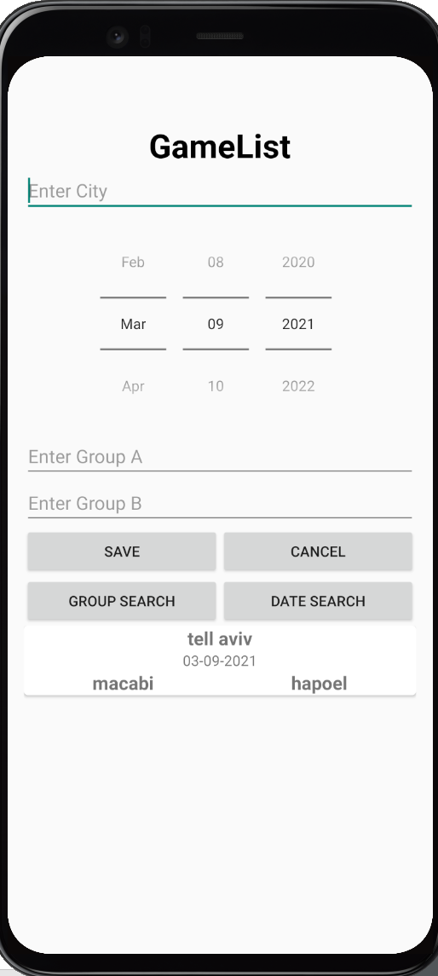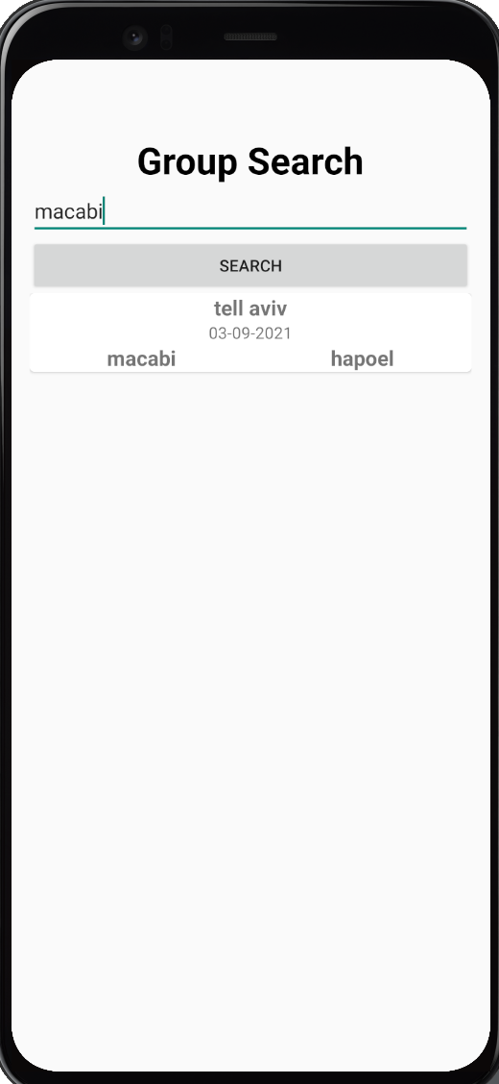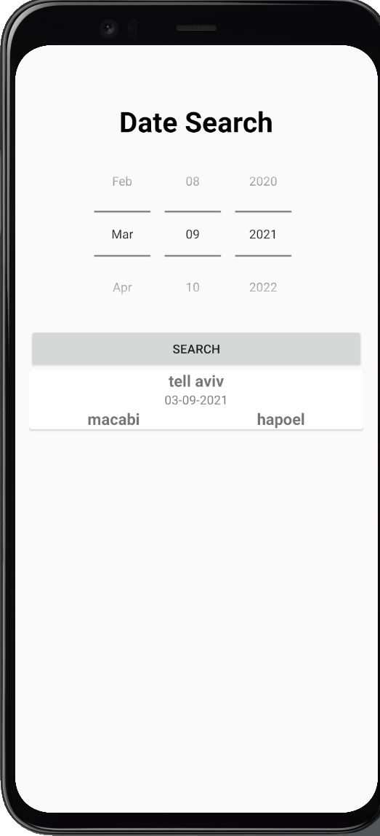

5. מודל מסד הנתונים הוא SQLite.

קוד:

DatabaseHandler

package com.example.project;  
  
import android.content.ContentValues;  
import android.content.Context;  
import android.database.Cursor;  
import android.database.sqlite.SQLiteDatabase;  
import android.database.sqlite.SQLiteOpenHelper;  
  
import java.util.ArrayList;  
  
public class DatabaseHandler extends SQLiteOpenHelper {  
  
 public static final int *DATABASE_VERSION*=1;  
 public static final String *DATABASE_NAME*="game_manager";  
 public static final String *TABLE_GAME*="game";  
 public static final String *COLUMN_ID*="id";  
 public static final String *COLUMN_CITY*="city";  
 public static final String *COLUMN_DATE*="date";  
 public static final String *COLUMN_GROUPA*="groupA";  
 public static final String *COLUMN_GROUPB*="groupB";  
   
  
 public static final String *CREATE_TABLE_GAME*="CREATE TABLE "+*TABLE_GAME*+" ("  
 +*COLUMN_ID*+" INTEGER PRIMARY KEY autoincrement, "  
 +*COLUMN_CITY*+" TEXT, "  
 +*COLUMN_DATE*+" TEXT, "  
 +*COLUMN_GROUPA*+" TEXT, "  
 +*COLUMN_GROUPB*+" TEXT)";  
  
 public static final String *DELETE_GAMES* =  
 "DROP TABLE IF EXISTS " + *TABLE_GAME*;  
 SQLiteDatabase db;  
   
 public DatabaseHandler(Context context) {  
 super(context, *DATABASE_NAME*, null, *DATABASE_VERSION*);  
 db=this.getWritableDatabase();  
 }  
  
 @Override  
 public void onCreate(SQLiteDatabase db) {  
 // *TODO Auto-generated method stub* db.execSQL(*CREATE_TABLE_GAME*);  
 }  
  
 @Override  
 public void onUpgrade(SQLiteDatabase db, int arg1, int arg2) {  
 // *TODO Auto-generated method stub* db.execSQL(*DELETE_GAMES*);  
 onCreate(db);  
 }  
   
   
 public long InsertGame(Game game)  
 {  
 ContentValues values=new ContentValues();  
 values.put(*COLUMN_CITY*, game.getCity());  
 values.put(*COLUMN_DATE*, game.getDate());  
 values.put(*COLUMN_GROUPA*, game.getGroupA());  
 values.put(*COLUMN_GROUPB*, game.getGroupB());  
 long id=db.insert(*TABLE_GAME*, null, values);  
 return id;  
 }  
   
 public int UpdateGame(int id, Game game)  
 {  
 ContentValues values=new ContentValues();  
 values.put(*COLUMN_CITY*, game.getCity());  
 values.put(*COLUMN_DATE*, game.getDate());  
 values.put(*COLUMN_GROUPA*, game.getGroupA());  
 values.put(*COLUMN_GROUPB*, game.getGroupB());  
 int count=db.update(*TABLE_GAME*, values, *COLUMN_ID*+" = ?", new String[]{String.*valueOf*(id)});  
 return count;  
 }  
  
 public int deleteGame(int id)  
 {  
 int count=db.delete(*TABLE_GAME*, *COLUMN_ID*+" = ?", new String[]{String.*valueOf*(id)});  
 return count;  
 }  
   
 public ArrayList<Game> SelectGameByDate(String date)  
 {  
 String[] projection={*COLUMN_ID*,*COLUMN_CITY*,*COLUMN_DATE*,*COLUMN_GROUPA*,*COLUMN_GROUPB*};  
 Cursor cursor = db.query(  
 *TABLE_GAME*,  
 projection,  
 *COLUMN_DATE*+ "=?",  
 new String[]{date},  
 null,  
 null,  
 null  
 );  
 ArrayList<Game> gameList =new ArrayList<Game>();  
 if(cursor.moveToFirst())  
 {  
 do{  
 gameList.add(cursorToGame(cursor));  
 }while(cursor.moveToNext());  
 }  
 return gameList;  
 }  
 public ArrayList<Game> SelectGameByGroup(String group)  
 {  
 String[] projection={*COLUMN_ID*,*COLUMN_CITY*,*COLUMN_DATE*,*COLUMN_GROUPA*,*COLUMN_GROUPB*};  
 Cursor cursor = db.query(  
 *TABLE_GAME*,  
 projection,  
 *COLUMN_GROUPA*+ "=?",  
 new String[]{group},  
 null,  
 null,  
 null  
 );  
 ArrayList<Game> gameList =new ArrayList<Game>();  
 if(cursor.moveToFirst())  
 {  
 do{  
 gameList.add(cursorToGame(cursor));  
 }while(cursor.moveToNext());  
 }  
 cursor = db.query(  
 *TABLE_GAME*,  
 projection,  
 *COLUMN_GROUPB*+ "=?",  
 new String[]{group},  
 null,  
 null,  
 null  
 );  
 if(cursor.moveToFirst())  
 {  
 do{  
 gameList.add(cursorToGame(cursor));  
 }while(cursor.moveToNext());  
 }  
 return gameList;  
 }  
   
 public ArrayList<Game> SelectAllGames()  
 {  
 String[] projection={*COLUMN_ID*,*COLUMN_CITY*,*COLUMN_DATE*,*COLUMN_GROUPA*,*COLUMN_GROUPB*};  
 Cursor cursor = db.query(  
 *TABLE_GAME*,  
 projection,  
 null,  
 null,  
 null,  
 null,  
 null  
 );  
 ArrayList<Game> gameList =new ArrayList<Game>();  
 if(cursor.moveToFirst())  
 {  
 do{  
 gameList.add(cursorToGame(cursor));  
 }while(cursor.moveToNext());  
 }  
 return gameList;  
 }  
  
 private Game cursorToGame(Cursor cursor) {  
 Game game =new Game();  
 game.setId((int)cursor.getLong( cursor.getColumnIndexOrThrow(*COLUMN_ID*)));  
 game.setCity(cursor.getString( cursor.getColumnIndexOrThrow(*COLUMN_CITY*)));  
 game.setDate(cursor.getString( cursor.getColumnIndexOrThrow(*COLUMN_DATE*)));  
 game.setGroupA(cursor.getString( cursor.getColumnIndexOrThrow(*COLUMN_GROUPA*)));  
 game.setGroupB(cursor.getString( cursor.getColumnIndexOrThrow(*COLUMN_GROUPB*)));  
 return game;  
 }  
}

Game:

package com.example.project;  
  
  
public class Game {  
  
 private int id;  
 private String city, date, groupA, groupB;  
  
 public Game(String city, String date, String groupA, String groupB) {  
 this.city=city;  
 this.date=date;  
 this.groupA=groupA;  
 this.groupB=groupB;  
 }  
  
 public Game() {  
  
 }  
  
 public int getId() {  
 return id;  
 }  
  
 public void setId(int id) {  
 this.id = id;  
 }  
  
 public String getCity() {  
 return city;  
 }  
  
 public void setCity(String city) {  
 this.city = city;  
 }  
  
 public String getDate() {  
 return date;  
 }  
  
 public void setDate(String date) {  
 this.date = date;  
 }  
  
 public String getGroupA() {  
 return groupA;  
 }  
  
 public void setGroupA(String groupA) {  
 this.groupA = groupA;  
 }  
  
 public String getGroupB() {  
 return groupB;  
 }  
  
 public void setGroupB(String groupB) {  
 this.groupB = groupB;  
 }  
}

GameAdapter

package com.example.project;  
  
import android.content.Context;  
import android.view.LayoutInflater;  
import android.view.View;  
import android.view.ViewGroup;  
import android.widget.ImageButton;  
import android.widget.TextView;  
  
import androidx.recyclerview.widget.RecyclerView;  
  
import java.util.ArrayList;  
  
public class GameAdapter extends RecyclerView.Adapter<GameAdapter.GameViewHolder> {  
  
 ArrayList<Game> gameArrayList;  
 MainActivity mainActivity;  
  
 public GameAdapter(ArrayList<Game> gameArrayList, Context context) {  
 this.gameArrayList = gameArrayList;  
 mainActivity=(MainActivity)context;  
 }  
  
 @Override  
 public GameViewHolder onCreateViewHolder(ViewGroup parent, int viewType) {  
 View view= LayoutInflater.*from*(parent.getContext()).inflate(R.layout.*row_item*,parent,false);  
 GameViewHolder viewHolder=new GameViewHolder(view);  
 return viewHolder;  
 }  
  
 @Override  
 public void onBindViewHolder(final GameViewHolder holder, int position) {  
 final Game game = gameArrayList.get(position);  
 holder.tvCity.setText(game.getCity());  
 holder.tvDate.setText(game.getDate());  
 holder.tvGroupA.setText(game.getGroupA());  
 holder.tvGroupB.setText(game.getGroupB());  
 holder.view.setOnClickListener(new View.OnClickListener() {  
 @Override  
 public void onClick(View view) {  
 mainActivity.setGameData(game);  
 }  
 });  
 }  
  
 @Override  
 public int getItemCount() {  
 return gameArrayList.size();  
 }  
  
 public class GameViewHolder extends RecyclerView.ViewHolder {  
 TextView tvCity, tvDate, tvGroupA, tvGroupB;  
 View view;  
  
 public GameViewHolder(View itemView) {  
 super(itemView);  
 view=itemView;  
 tvCity=(TextView)itemView.findViewById(R.id.*tvCity*);  
 tvDate=(TextView)itemView.findViewById(R.id.*tvDate*);  
 tvGroupA=(TextView)itemView.findViewById(R.id.*tvGroupA*);  
 tvGroupB=(TextView)itemView.findViewById(R.id.*tvGroupB*);  
 }  
 }  
}

GameSearchAdapter

package com.example.project;  
  
import android.content.Context;  
import android.view.LayoutInflater;  
import android.view.View;  
import android.view.ViewGroup;  
import android.widget.TextView;  
  
import androidx.recyclerview.widget.RecyclerView;  
  
import java.util.ArrayList;  
  
public class GameSearchAdapter extends RecyclerView.Adapter<GameSearchAdapter.GameViewHolder> {  
  
 ArrayList<Game> gameArrayList;  
 Context context;  
  
 public GameSearchAdapter(ArrayList<Game> gameArrayList, Context context) {  
 this.gameArrayList = gameArrayList;  
 this.context=context;  
 }  
  
 @Override  
 public GameViewHolder onCreateViewHolder(ViewGroup parent, int viewType) {  
 View view= LayoutInflater.from(parent.getContext()).inflate(R.layout.row_item,parent,false);  
 GameViewHolder viewHolder=new GameViewHolder(view);  
 return viewHolder;  
 }  
  
 @Override  
 public void onBindViewHolder(final GameViewHolder holder, int position) {  
 final Game game = gameArrayList.get(position);  
 holder.tvCity.setText(game.getCity());  
 holder.tvDate.setText(game.getDate());  
 holder.tvGroupA.setText(game.getGroupA());  
 holder.tvGroupB.setText(game.getGroupB());  
  
 }  
  
 @Override  
 public int getItemCount() {  
 return gameArrayList.size();  
 }  
  
 public class GameViewHolder extends RecyclerView.ViewHolder {  
 TextView tvCity, tvDate, tvGroupA, tvGroupB;  
 View view;  
  
 public GameViewHolder(View itemView) {  
 super(itemView);  
 view=itemView;  
 tvCity=(TextView)itemView.findViewById(R.id.tvCity);  
 tvDate=(TextView)itemView.findViewById(R.id.tvDate);  
 tvGroupA=(TextView)itemView.findViewById(R.id.tvGroupA);  
 tvGroupB=(TextView)itemView.findViewById(R.id.tvGroupB);  
 }  
 }  
}

MainActivity

package com.example.project;  
  
import android.Manifest;  
import android.content.Intent;  
import android.content.pm.PackageManager;  
import android.net.Uri;  
  
import android.os.Bundle;  
  
import android.view.View;  
import android.widget.Button;  
import android.widget.DatePicker;  
import android.widget.EditText;  
import android.widget.Toast;  
  
import androidx.annotation.NonNull;  
import androidx.appcompat.app.AppCompatActivity;  
import androidx.core.app.ActivityCompat;  
import androidx.recyclerview.widget.LinearLayoutManager;  
import androidx.recyclerview.widget.RecyclerView;  
  
import java.sql.Date;  
import java.text.SimpleDateFormat;  
import java.util.ArrayList;  
import java.util.Calendar;  
  
public class MainActivity extends AppCompatActivity {  
  
 EditText etCity, etGroupA, etGroupB;  
 DatePicker datePicker;  
 Button btnSave, btnDelete, btnCancel, btnGroupSearch, btnDateSearch;  
 RecyclerView recyclerView;  
 DatabaseHandler databaseHandler;  
 ArrayList<Game> gameArrayList;  
 Game game;  
  
 @Override  
 protected void onCreate(Bundle savedInstanceState) {  
 super.onCreate(savedInstanceState);  
 setContentView(R.layout.activity_main);  
  
 etCity = (EditText) findViewById(R.id.etCity);  
 datePicker = (DatePicker) findViewById(R.id.datePicker);  
 etGroupA = (EditText) findViewById(R.id.etGroupA);  
 etGroupB = (EditText) findViewById(R.id.etGroupB);  
  
 btnSave = (Button) findViewById(R.id.btnSave);  
 btnDelete = (Button) findViewById(R.id.btnDelete);  
 btnCancel = (Button) findViewById(R.id.btnCancel);  
 btnGroupSearch = (Button) findViewById(R.id.btnGroupSearch);  
 btnDateSearch = (Button) findViewById(R.id.btnDateSearch);  
  
 recyclerView = (RecyclerView) findViewById(R.id.recyclerview);  
 recyclerView.setLayoutManager(new LinearLayoutManager(this));  
  
 databaseHandler = new DatabaseHandler(getApplicationContext());  
 setGameAdapter();  
  
 btnSave.setOnClickListener(new View.OnClickListener() {  
 @Override  
 public void onClick(View view) {  
 String city = etCity.getText().toString();  
 int year = datePicker.getYear();  
 int month = datePicker.getMonth();  
 int day = datePicker.getDayOfMonth();  
 Calendar calendar = Calendar.getInstance();  
 calendar.set(year, month, day);  
 SimpleDateFormat format = new SimpleDateFormat("MM-dd-yyyy");  
 String date = format.format(calendar.getTime());  
 String groupA = etGroupA.getText().toString();  
 String groupB = etGroupB.getText().toString();  
 String command = btnSave.getText().toString();  
 if (command.equals("Save")) {  
 game = new Game(city, date, groupA, groupB);  
 insertGame(game);  
 } else if (game != null) {  
 game.setCity(city);  
 game.setDate(date);  
 game.setGroupA(groupA);  
 game.setGroupB(groupB);  
 updateGame(game);  
 }  
 }  
 });  
  
 btnDelete.setOnClickListener(view -> {  
 if (game != null) {  
 deleteGame(game);  
 }  
 });  
  
 btnCancel.setOnClickListener(view -> resetAllViews());  
 btnGroupSearch.setOnClickListener(view -> {  
 Intent intent = new Intent(MainActivity.this, SearchGroupActivity.class);  
 startActivity(intent);  
 });  
 btnDateSearch.setOnClickListener(view -> {  
 Intent intent = new Intent(MainActivity.this, SearchDateActivity.class);  
 startActivity(intent);  
 });  
 }  
  
 private void deleteGame(Game game) {  
 int count = databaseHandler.deleteGame(game.getId());  
 if (count > 0) {  
 Toast.makeText(MainActivity.this, "Deleted Successfully", Toast.LENGTH_SHORT).show();  
 resetAllViews();  
 setGameAdapter();  
 }  
 }  
  
 private void updateGame(Game game) {  
 int count = databaseHandler.UpdateGame(game.getId(), game);  
 if (count > 0) {  
 Toast.makeText(MainActivity.this, "Updated Successfully", Toast.LENGTH_SHORT).show();  
 resetAllViews();  
 setGameAdapter();  
 }  
 }  
  
 private void setGameAdapter() {  
 gameArrayList = databaseHandler.SelectAllGames();  
 GameAdapter adapter = new GameAdapter(gameArrayList, MainActivity.this);  
 recyclerView.setAdapter(adapter);  
 }  
  
 private void insertGame(Game game) {  
 long id = databaseHandler.InsertGame(game);  
 if (id > 0) {  
 Toast.makeText(MainActivity.this, "Saved Successfully", Toast.LENGTH_SHORT).show();  
 resetAllViews();  
 setGameAdapter();  
 }  
  
 }  
  
 private void resetAllViews() {  
 etCity.setText("");  
 etGroupA.setText("");  
 etGroupB.setText("");  
 etCity.requestFocus();  
 btnSave.setText("Save");  
 btnDelete.setVisibility(View.GONE);  
 game = null;  
 }  
  
 public void setGameData(Game game) {  
 this.game = game;  
 etCity.setText(game.getCity());  
 String date = game.getDate();  
 if(date!=null){  
 int year = Integer.parseInt(date.substring(6,10));  
 int month = Integer.parseInt(date.substring(0,2))-1;  
 int day = Integer.parseInt(date.substring(3,5));  
 datePicker.updateDate(year,month,day);  
 }  
 etGroupA.setText(game.getGroupA());  
 etGroupB.setText(game.getGroupB());  
 btnSave.setText("Update");  
 btnDelete.setVisibility(View.VISIBLE);  
 }  
}

SearchDateActivity

package com.example.project;  
  
import androidx.appcompat.app.AppCompatActivity;  
import androidx.recyclerview.widget.LinearLayoutManager;  
import androidx.recyclerview.widget.RecyclerView;  
  
import android.os.Bundle;  
import android.view.View;  
import android.widget.Button;  
import android.widget.DatePicker;  
import android.widget.EditText;  
import android.widget.Toast;  
  
import java.text.SimpleDateFormat;  
import java.util.ArrayList;  
import java.util.Calendar;  
  
public class SearchDateActivity extends AppCompatActivity {  
 DatePicker datePicker;  
 Button btnSearch;  
 RecyclerView recyclerView;  
 DatabaseHandler databaseHandler;  
 ArrayList<Game> gameArrayList;  
  
 @Override  
 protected void onCreate(Bundle savedInstanceState) {  
 super.onCreate(savedInstanceState);  
 setContentView(R.layout.activity_search_date);  
  
 datePicker = (DatePicker) findViewById(R.id.datePicker);  
  
 btnSearch = (Button) findViewById(R.id.btnSearch);  
  
 recyclerView = (RecyclerView) findViewById(R.id.recyclerview);  
 recyclerView.setLayoutManager(new LinearLayoutManager(this));  
  
 databaseHandler = new DatabaseHandler(getApplicationContext());  
  
 btnSearch.setOnClickListener(new View.OnClickListener() {  
 @Override  
 public void onClick(View view) {  
 int year = datePicker.getYear();  
 int month = datePicker.getMonth();  
 int day = datePicker.getDayOfMonth();  
 Calendar calendar = Calendar.getInstance();  
 calendar.set(year, month, day);  
 SimpleDateFormat format = new SimpleDateFormat("MM-dd-yyyy");  
 String date = format.format(calendar.getTime());  
 setGameAdapter(date);  
 //search  
 }  
 });  
 }  
  
 private void setGameAdapter(String date) {  
 gameArrayList = databaseHandler.SelectGameByDate(date);  
 GameSearchAdapter adapter = new GameSearchAdapter(gameArrayList, SearchDateActivity.this);  
 recyclerView.setAdapter(adapter);  
 }  
}

SearchGroupActivity

package com.example.project;  
  
import androidx.appcompat.app.AppCompatActivity;  
import androidx.recyclerview.widget.LinearLayoutManager;  
import androidx.recyclerview.widget.RecyclerView;  
  
import android.os.Bundle;  
import android.view.View;  
import android.widget.Button;  
import android.widget.DatePicker;  
import android.widget.EditText;  
import android.widget.Toast;  
  
import java.text.SimpleDateFormat;  
import java.util.ArrayList;  
import java.util.Calendar;  
  
public class SearchGroupActivity extends AppCompatActivity {  
 EditText etGroup;  
 Button btnSearch;  
 RecyclerView recyclerView;  
 DatabaseHandler databaseHandler;  
 ArrayList<Game> gameArrayList;  
  
 @Override  
 protected void onCreate(Bundle savedInstanceState) {  
 super.onCreate(savedInstanceState);  
 setContentView(R.layout.activity_search_group);  
  
 etGroup = (EditText) findViewById(R.id.etGroup);  
  
 btnSearch = (Button) findViewById(R.id.btnSearch);  
  
 recyclerView = (RecyclerView) findViewById(R.id.recyclerview);  
 recyclerView.setLayoutManager(new LinearLayoutManager(this));  
  
 databaseHandler = new DatabaseHandler(getApplicationContext());  
  
 btnSearch.setOnClickListener(view -> {  
 String group = etGroup.getText().toString();  
 setGameAdapter(group);  
 });  
 }  
  
 private void setGameAdapter(String group) {  
 gameArrayList = databaseHandler.SelectGameByGroup(group);  
 GameSearchAdapter adapter = new GameSearchAdapter(gameArrayList, SearchGroupActivity.this);  
 recyclerView.setAdapter(adapter);  
 }  
}