1. Copy Without Threading

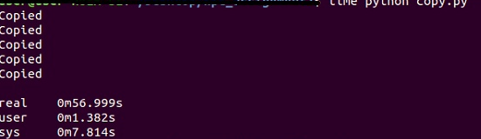

2. Copy Using Processes

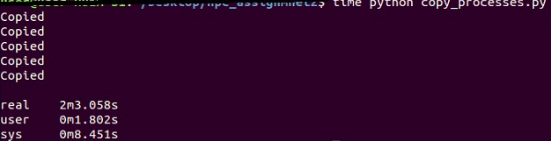

3. Copy Using Threads

