Z. K. L3 A
THE SIMPLE PENDULUM

- General Background: A mass m hanging from a string whose length is L and a pivot point on which this mass is fixed are what a simple pendulum (which was discovered during the 10th century by Ibn Yusuf) consists of. During the 17th century, it is developed by some physicist, especially by Galileo.

When the mass hanging from the string is released with an initial angle, it starts to move with a periodic motion. The motion can be approximated as a simple harmonic motion if the pendulum swings through a small angle (so sin (ө) can be approximated as ө). The frequency and period for the simple pendulum are the independent of the initial angle of the movement (initial position of the mass to the vertical reference line). In addition to the initial angle of the mass, the period doesn’t depend on the mass of the object. However, it is affected by the length of the string which the mass is hanged on and the acceleration of gravity.

The most widespread applications of the simple pendulum are for timekeeping,

gravimetry (the existence of the variable g in the period equation of simple pendulum -
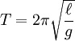
- means that the pendulum frequency is different at different places on

Earth), seismology, scholar tuning, and coupled pendula. It is also used for entertainment and religious practice.

- Aim: To determine the effects or contribution of the length of the string on the period for the simple pendulum and find out a mathematical relationship between the length and the period.

- Hypothesis: Since the length of the string which the mass is hanged on is shortened, the magnitude of the period for the simple pendulum gets increased. Different masses of the object hanging from the string have no effect on the period.

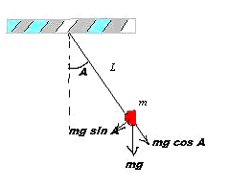
- Apparatus / Materials:

- A string used as a rigid rod
- A mass (pendulum)
- Table clamp
- A rod on which the mass is fixed
- Stopwatch
- Ruler

Figure 1: The Simple Pendulum

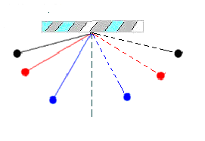

- Plan / Method:
- Take a rod on which you will hang a mass on it and fix it on a linear surface by using table clamps.
- Take an object which will be used as a mass for your pendulum and by using the top of the rod fixed on the table as a pivot point, hang the mass with a string (or rigid rod).
.

Figure 2: Effects of angle on the frequency
and the period of the pendulum
- Let the mass to start its periodic motion. Record the time taken by the motion of the pendulum to determine its period and repeat this step by taking the angle of the mass to the vertical reference line.
- Change the mass hanged from the pivot point (without changing the length of the string, gravitational acceleration and the angle of the mass to the vertical reference line) and see whether or not it affects the period of the pendulum. Repeat this procedure for different masses and use 3 trials for each one.
- Use the same masses and change the length of the string to observe either the mass of the length of the string (or both) affect the period of the movement. Repeat this procedure for different lengths of the string. Record your data on your data collection table.

p.c: Gravitational acceleration should be kept constant during the experiment.

  - Variables:

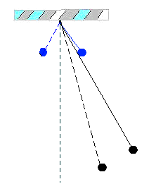
- Controlled & Independent Variables:
  - Angle that the pendulum is released and weight, during examining the effects of length.
  - Length and angle, during examining the effects of weight.
  - Weight and the length of the pendulum, during examining the effects of angle

- Dependent Variables:

- Period for the simple pendulum

Figure 3: Effect of the length of the string on
the period for the simple pendulum.
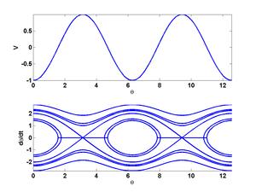
Potential energy and phase portrait of a simple pendulum. []

- Data Collection & Data Processing and Presentation:

Trials | Time measured  (±0.05s) | Number of turns | Length of the string  (±0.05cm)
1st | 1.86 | 3 | 10.00
1st | 1.90 | 3 | 10.00
1st | 1.82 | 3 | 10.00
2nd | 2.30 | 3 | 15.00
2nd | 2.25 | 3 | 15.00
2nd | 2.35 | 3 | 15.00
3rd | 2.70 | 3 | 20.00
3rd | 2.72 | 3 | 20.00
3rd | 2.68 | 3 | 20.00
4th | 3.03 | 3 | 25.00
4th | 2.98 | 3 | 25.00
4th | 3.01 | 3 | 25.00
5th | 3.31 | 3 | 30.00
5th | 3.31 | 3 | 30.00
5th | 3.30 | 3 | 30.00
6th | 3.42 | 3 | 35.00
6th | 3.45 | 3 | 35.00
6th | 3.48 | 3 | 35.00
Table 1: The table which shows the length of the string and time measures with constant mass (100 g)

Trials | Time measured (±0.05s) | Number of turns | Length of the string (±0.05cm) | Mass of the object hanged from the pivot point (±0.01g)
1st | 4.92 | 3 | 50.00 | 30.00
2nd | 4.71 | 3 | 50.00 | 40.00
3rd | 4.85 | 3 | 50.00 | 50.00

Table 2: The table which shows the data of measured time with respect to the different masses of the object hanged from the pivot point

(Since the time measured with respect to the different masses of the object hanged from the pivot point where the length of the string and the gravitational acceleration are kept constant is –approximately- the same, it is concluded that different masses of the object hanged from the pivot point have no effect on the period of the pendulum).

Trials | Time measured (±0.05s) | Number of turns | Length of the string (±0.05cm) | Angle  (±0.05º))
1st | 3.93 | 3 | 50.00 | 20.00
2nd | 4.00 | 3 | 50.00 | 35.00
3rd | 3.78 | 3 | 50.00 | 55.00
Table 3: The table which shows the data of measured time with respect to the different angle of the object

(Since the time measured with respect to the different angle of the object hanged from the pivot point where the length of the string and the mass of the object are kept constant is –approximately- the same, it is concluded that different angle has no effect on the period of the pendulum).

Assumptions:

- The string or the rigid rod on which the mass is swinging is massless and always remains taut.
- The plane where the motion occurs is two-dimensional (i.e. there is no elliptic movement).

Trials | Length  (±0.0005m) | Period  (±0.02 s) | Period square  (s²) | Uncertainty of Period Square(s²)
1st | 0.1000 | 0,62 | 0,38 | 0,02
2nd | 0.1500 | 0,75 | 0,56 | 0,03
3rd | 0.2000 | 0,91 | 0,83 | 0,04
4th | 0.2500 | 1,01 | 1,02 | 0,04
5th | 0.3000 | 1,10 | 1,21 | 0,04
6th | 0.3500 | 1,15 | 1,32 | 0,05
Notes | Mass=100.00±0.05g  Angle=10.00±0.05º
Table 4: The table which shows relation between period square and length.

Uncertainty of both period square and length were too small, it was difficult to show error bar in the graph and also draw min and max line.
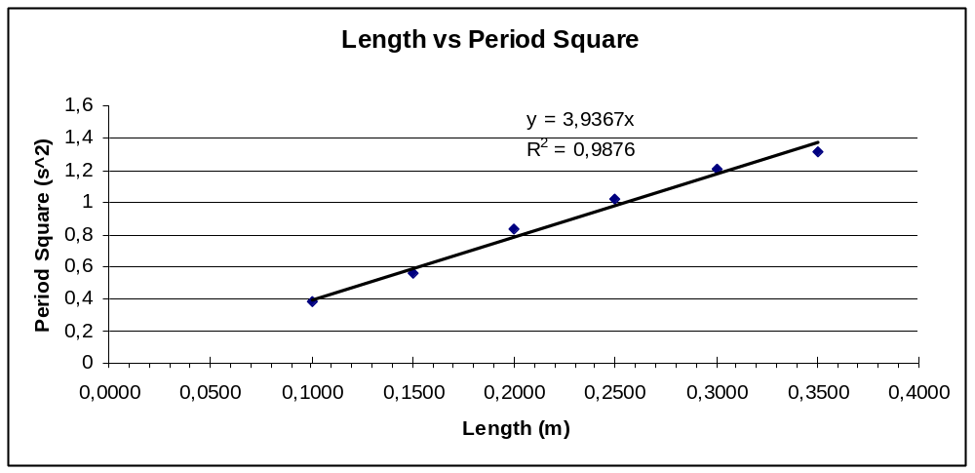
Slope of the best line: Δ T²/ Δ l = 3,94
g= 4 π² l/T² g= 10.02 ms⁻²
Gravitational acceleration was calculated from the graph.

- Conclusion and Evaluation:

The aim of the experiment was to determine the effects or contribution of the length of the string on the period for the simple pendulum and find out a mathematical relationship between the length and the period. According to the data taken during the experiment, although the mass of the object hanging from the string has no effect on the period of the pendulum, the period depends on the length of the string which the mass is hanged on. When the length of the string is increased, the value of the period also increases. As it is shown in Graph, the period of the pendulum square and the length of the string are directly proportional to each other.Gravitational acceleration was calculated from the slope of the graph 10.01 m s⁻² and if theoretical gravitational acceleration is taken 9.81 m s⁻², relative error was found from that formula

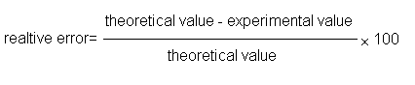
RE= % 2.03

There were some problems done during the experiment which, then, caused the relative error to increase. One of them was about the mass of the string. It had to be massless to have the most precise values of calculation. However, it is impossible to have a massless string. Although it was necessary to consider it as if it is massless, it caused our relative error to increase. Also there was friction force between the stand and string that cause losing of energy. According to the assumptions, the motion must occur in a two-dimensional plane. However, it was not possible to have an exactly two-dimensional plane because of the air friction in the room in which the experiment is done and wind which has occurred depend on our own movements during the experiment. In addition to that, the dimension of the movement changed depends on the person who let the movement to start. The ruler and mass scale that we had used could be the factors of uncertainties. We have used stopwatches that do not have uncertainty interval. Reaction time is also other error factor. Flexibility of the string is a problem, non-flexible string was chosen but a change in the length of the string might cause error.

There were not any other errors caused by the apparatus. It was stable enough for the experiment. Therefore, I would not need to change the apparatus if I would do this experiment again. However, I would use some other materials, such as the computer/multimedia system and a photogate timer, to measure the period of the pendulum. They would decrease the relative error. Making the experiment in air vacuumed place will decrease the air friction. If I had had more time, I would have taken more trails especially length vs time.

Reference:
- http://www.stkate.edu/physics/phys111/curric/image636.JPG
- http://www.kettering.edu/~drussell/Demos/Pendulum/Pendula.html
- http://www.search.com/reference/Pendulum
- http://en.wikipedia.org/wiki/Pendulum
- http://everywitchway.net/personal/pi.html
- http://en.wikipedia.org/wiki/Pendulum_%28mathematics%29

http://en.wikipedia.org/wiki/Pendulum_%28mathematics%29

