PSTAT 194 Final Project
Ayden Kelleher
2026-03-04
Table of Contents

Load and Prepare the Data

Load your chosen dataset into the course RStudio server and convert it to an ‘igraph’ object.
We loaded the data in Code Snippet 1

Consider what the vertices and edges represent in your network.
In our network, the vertices represent wikipedia articles, and edges represent mutual links between them. Since we are using the musae squirrel network, our articles are about topics related to squirrels, and the edges are mutual links between them.

Identify basic network elements: vertices, edges, weights, directionality, etc
Using code snippet 2, we can see that we have 5201 nodes, 217073 edges, that our graph is unweighted, and that our graph is undirected.

Generate Induced Subgraphs:

Create four induced subgraphs with 200 random nodes each from your dataset.
To create our induced subgraphs, we first attempted to sample 200 with 200 random nodes from our graph. However, we ran into the issue that much of our graph had degree zero, with 79 out of 200 nodes being unconnected to any other node, in contrast to our entire graph g have no points that are of degree zero. Thus any random sample would lose some structure.
To get around this, what we did instead was to draw a sample of 40 different nodes. Then we took a sample of 5 different neighbors of the nodes, or all of the neighbors if they had less than 5 total neighbors. Then we take 200 of those nodes, and put it in a subgraph. This subgraph is a biased subgraph, but it preserves some of the structure of the graph. We did this in each of the subgraphs, which can be seen in subgraph 1, subgraph 2, subgraph 3, and subgraph 4
Using the basic plotting, we plotted using the default layouts.

Visualize the Networks:

Use three different layouts from the igraph package to visualize each network.
For our visualizations, we chose 3 different layouts, the Fruchterman-Reingold layout, the Kamada-Kawai layout, and the layout nicely, where the plots can be found here.

Experiment with node and edge attributes to enhance visualizations.
To enhance out visualizations, we chose to do a few different things
- adjust the node size by the following function of degree 3 + 8 * (degree(simp_graph) / max(degree(simp_graph)))
- color in nodes based on louvain communities to make the groupings more obvious
- remove the node labels. Our nodes are labelled 0 to 5200. This gives us no information about the corresponding articles, so not showing the degree label doesn’t lose any information. Even if we had the article names, it would be very difficult to read.
- Make the lines between the nodes more see through so they take up less of the visual space.

Analyze Network Metrics:

Explore various network, node, and edge metrics. Interpret these metrics in the context of your network.

Degree
The degree of a node is the measure of amount of edges connecting to a node. For directed graphs, we can have in and out degree, but our graph is undirected, so we don’t need to worry about that. The first thing we will do is to look at the histogram of degree of the entire network. Here we can see that the distribution is heavily skewed to the right, with a giant peak at $\left[0,100\right]$.
When we look at the individual subgraphs, we can see a similar pattern. Each subgraph is skewed to the right. The most connected nodes have a bit less than 100 nodes, which is a little less than half the network. This tracks with the most connected nodes in the full network being connected to about half of the other nodes. One interesting pattern that was not expected is that for each of the subgraphs, there is a smaller peak at $\left[30,50\right]$. That is to say for each of the subgraphs degree distribution, there was a peak at zero, it decreased reaching a low at around $20$, then hit a second peak somewhere in $\left[30,50\right]$. We wonder if this is a result of a true pattern in the data, or if it is an artifact from the way we sampled. Recall we randomly sampled 40 nodes, then sampled neighbors of those nodes. Since nodes of a higher degree are connected to more nodes, they are more likely to appear when we sample neighbors of the nodes, so it is reasonable to infer this is a result of the way we sampled our data.

Closeness

Betweenness

Eigen Metric
The eigen centrality metric is a measure of centrality that, according to the documentation, states “eigenvector centrality scores correspond to the values of the principal eigenvector of the graph’s adjacency matrix; these scores may, in turn, be interpreted as arising from a reciprocal process in which the centrality of each actor is proportional to the sum of the centralities of those actors to whom he or she is connected. In general, vertices with high eigenvector centralities are those which are connected to many other vertices which are, in turn, connected to many others (and so on)” from here. The thing to keep in mind is that the score gets bigger when a node is connected to more nodes, and these nodes are connected to more nodes, and so on.
Looking at the plots of subgraphs here, we will start with the histograms. We can see that eigen centrality is distributed on $\left[0,1\right]$, where 1 is more connected. Looking at our subgraphs, we see the mode is at $\left[0,.1\right]$, with a second, much smaller, peak at about $\left[.4,.5\right]$. Comparing these to our degree distributions, we can see their shape is similar, with a main peak at 0, and a second smaller peak towards the middle of the data, which makes sense because both these node metrics are correlated. To show how this data looks when plotting the whole network, we cannot use the raw eigen metric because our nodes are too small, so we will use a transformation of the data. To give the reader an idea what this transformation does, we also plotted the histogram of the transformed data for the first subgraph.
Looking at the actual plots, we can see there there are a bunch of central nodes that are grouped together, and then there are some less connected peripheral nodes, that are very small. This is most prominent on subgraph 3. This shows eigen centrality is a good measure of centrality.

Community Detection:

Run community detection algorithms
We chose to run three different community detection algorithms, fast greedy, louvain, and walktrap.
The way fast greedy works is by first declaring each node its own community, then it combines nodes greedily, that is to say maximizing the increase in modularity for each step, and stops when it can no longer increase the modularity. One thing to look out for is when working with larger networks, it can fail to find smaller communities .
The way the louvain community detection works is by declaring each node its own community, then moves nodes into the community that increases the modularity the most, and then collapses the communities into super nodes. The way walktrap works is by starting a random walk in to run short random walks. The idea is that nodes in the same community will appear more on these short random walks.

Analyze and interpret the resulting communities
Comparing the results from the algorithms was interesting. Starting with the modularity of our subgraphs, none of the graphs had very large modularity. Below is the results
$$\begin{array} &\text{subgraph #}&\text{fast greedy}&\text{louvain}&\text{walktrap} \\
1& 0.1911257 &0.2461304 &0.15813260 \\
2& 0.3522581 &0.3608913 &0.29551518 \\
3& 0.1545764 &0.2025717 &0.10072104 \\
4& 0.2772735 &0.3141144 &0.08605815
\end{array}$$
In class, we learned that modularity over $.3$ suggests meaningful community structure. However, only subgraphs 2 and 4 had any communities with modularity at least this high. However, subgraphs 1 and 3 still had modularity $.246$ and $.202$ respectively most modular community structrues, which isn’t that much smaller than $.3$. This suggests that our network has a weak community structure.
Looking at the number of individual communities for each subgraph, we can see the following.
$$\begin{array}
& \text{subgraph #}& \text{fast greedy}& \text{louvain}& \text{walktrap} \\
1 &6 &5 &31 \\
2 &6 &6 &27 \\
3 &4 &7 &27 \\
4 &6 &5 &20
\end{array}$$
This gives us the biggest differences between the different community finding algorithms. We can see that both the fast greedy and the louvain algorithms ended up with a small amount of communities, around 6 for each subgraph. For the walktrap, each subgraph had many more communities, with 31, 27, 27, and 20 for each of the subgraphs respectively. Looking at the plots of the subgraphs with the community coloring, we can see that the walktrap has many isolated nodes that count as their own communities. This tells us if a node is relatively disconnected from the rest of the network, the walktrap will have a hard time placing it in a larger community.

Adjacency Matrix:

Examine the adjacency matrix of your network.
We felt it was important to show at the unordered adjacency matrix to show what an uncorrelated adjacency matrix looks like. Looking at the unordered adjacency matrix for subgraph 1 using the louvain method, we can see very little pattern. The most of a pattern one could make out is that there a few horizontal lines, representing the nodes that are most connected, and a few blocks, representing multiple nodes connected to similar nodes. This lack of pattern is expected since our nodes have not been ordered yet.

Reorder vertices to highlight patterns.
After reordering our nodes, we can see a clearer pattern. There are 5 squares, filled in by varying amounts, on the diagnol. This matches the number of communities subgraph 1 has according to the louvain method, which confirms our observation of 5 squares. Some observations we made were that
- The first square is much more filled in than any of the other squares.
- We can see many horizontal/vertical lines, especially the areas overlapping with the nodes of the first community. This shows that the first community has a higher average degree than the other communities.
- The other 4 communities have a much lower degree on average, and are much less connected among themselves, and have lots of empty space in their squares. This shows that our subgraph is quite sparse.
Our subgraph consisted on a single connected component. Thus we cannot reorder our network by connected components.
One thing we wonder is our sampling strategy effected this result. Recall we selected 40 random nodes, then for each node, selected either 5 neighbors, or if they didn’t have 5 neighbors, all of their neighbors. Then we selected 200 of those nodes. Thus, most of the nodes we chose were not quite randomly chosen, but conditioned on being neighbors with a random node, which biases the nodes we chose to those with a higher degree. Thus our network consists of nodes that are connected to more nodes than the typical node in our network. This could lead to less communities that are larger than expected in our subgraphs.

Summarize Findings:

Prepare a presentation and a short write-up summarizing your analysis and findings.

Appendix

Snippet 1
back to report
#install.packages('igraph')
library(igraph)
##
## Attaching package: 'igraph'
## The following objects are masked from 'package:stats':
##
## decompose, spectrum
## The following object is masked from 'package:base':
##
## union
#install.packages('tidygraph')
library(tidygraph)
##
## Attaching package: 'tidygraph'
## The following object is masked from 'package:igraph':
##
## groups
## The following object is masked from 'package:stats':
##
## filter
edges_matrix <- as.matrix(read.csv("musae_squirrel_edges.csv"))
edges_matrix[,1] <- factor(edges_matrix[,1]) # if we dont change this to factor, then there are too many id names idk. If you don't believe me comment this out :/
g <- graph_from_edgelist(edges_matrix, directed = FALSE)
length(V(g)) #this is exactly what the help page says
## [1] 5201
length(E(g)) #this is quite a few more edges than the help page says
## [1] 217073

Snippet 2
back to report
length(V(g))
## [1] 5201
length(E(g))
## [1] 217073
is_weighted(g)
## [1] FALSE
is_directed(g)
## [1] FALSE
summary(g)
## IGRAPH 0ac1c4c U--- 5201 217073 --

Creating Subgraphs

First Attempt at creating a subgraph
back to report
set.seed(30426)
subgraph_attempt <- induced_subgraph(g, sample(V(g), 200))
plot(subgraph_attempt,
vertex.size=10,
vertex.label.cex=.4,
edge.width=2)
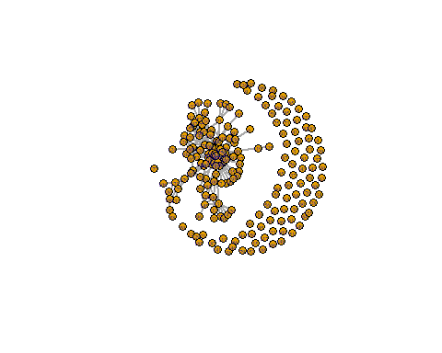
sum(degree(subgraph_attempt)==0)
## [1] 70
sum(degree(g)==0)
## [1] 0

Subgraph 1
back to report
set.seed(30326)
centers <- sample(V(g), 40)
sampled_vertices <- c()
for (v in centers) {
neigh <- neighbors(g, v)
if (length(neigh) > 5) {
neigh <- sample(neigh, 5)
}
sampled_vertices <- c(sampled_vertices, v, neigh)
}
subg1 <- induced_subgraph(g, unique(sampled_vertices)[1:200])

Plot 1
plot(subg1,
vertex.size=10,
vertex.label.cex=.4,
edge.width=2)
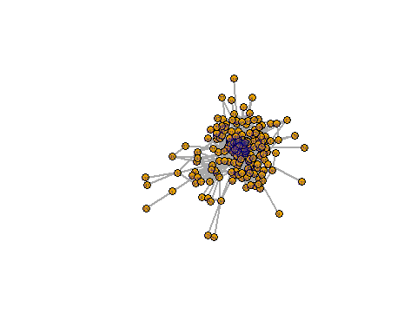

Subgraph 2
back to report
set.seed(30426)
centers <- sample(V(g), 40)
sampled_vertices <- c()
for (v in centers) {
neigh <- neighbors(g, v)
if (length(neigh) > 5) {
neigh <- sample(neigh, 5)
}
sampled_vertices <- c(sampled_vertices, v, neigh)
}
subg2 <- induced_subgraph(g, unique(sampled_vertices)[1:200])

Plot 2
plot(subg2,
vertex.size=10,
vertex.label.cex=.4,
edge.width=2)
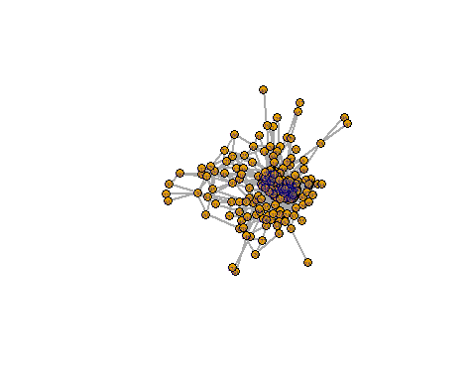

Subgraph 3
back to report
set.seed(30526)
centers <- sample(V(g), 41)
sampled_vertices <- c()
for (v in centers) {
neigh <- neighbors(g, v)
if (length(neigh) > 5) {
neigh <- sample(neigh, 5)
}
sampled_vertices <- c(sampled_vertices, v, neigh)
}
subg3 <- induced_subgraph(g, unique(sampled_vertices)[1:200])

Plot 3
plot(subg3,
vertex.size=10,
vertex.label.cex=.4,
edge.width=2)
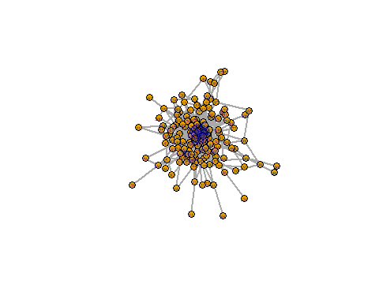

Subgraph 4
back to report
set.seed(30626)
centers <- sample(V(g), 41)
sampled_vertices <- c()
for (v in centers) {
neigh <- neighbors(g, v)
if (length(neigh) > 5) {
neigh <- sample(neigh, 5)
}
sampled_vertices <- c(sampled_vertices, v, neigh)
}
subg4 <- induced_subgraph(g, unique(sampled_vertices)[1:200])

Plot 4
plot(subg4,
vertex.size=10,
vertex.label.cex=.4,
edge.width=2)
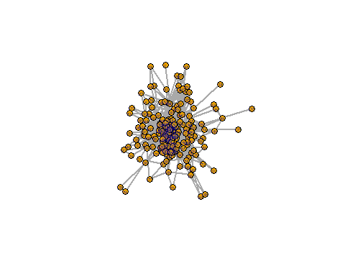

Three Different Visualizations
back to report
library(igraph)
set.seed(444)
graphs <- list(
subg1 = subg1,
subg2 = subg2,
subg3 = subg3,
subg4 = subg4
)
for (i in names(graphs)) {
#
simp_graph <- simplify(graphs[[i]])
#community detection for colors
cl <- cluster_louvain(as.undirected(simp_graph))
V(simp_graph)$color <- membership(cl)
#adjust size to match degree level
V(simp_graph)$size <- 3 + 8 * (degree(simp_graph) / max(degree(simp_graph)))
#remove labels
V(simp_graph)$label <- NA
#make lines between nodes cleaner
E(simp_graph)$color <- adjustcolor("gray50", alpha.f = 0.2)
plot(simp_graph, layout = layout_with_fr, main = paste(i, "FR"))
plot(simp_graph, layout = layout_with_kk, main = paste(i, "KK"))
plot(simp_graph, layout = layout_nicely, main = paste(i, "Nicely"))
}
## Warning: `as.undirected()` was deprecated in igraph 2.1.0.
## ℹ Please use `as_undirected()` instead.
## This warning is displayed once per session.
## Call `lifecycle::last_lifecycle_warnings()` to see where this warning was
## generated.
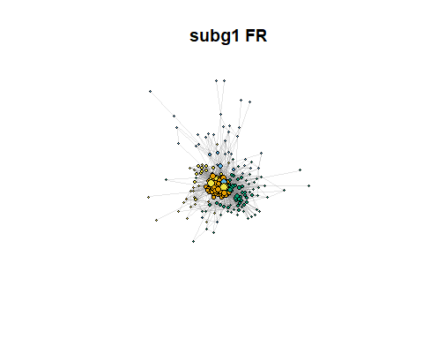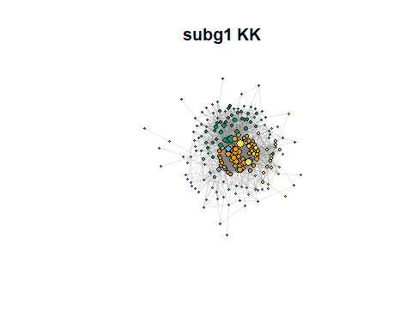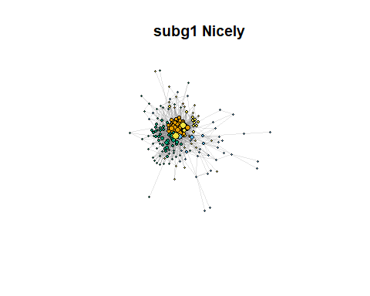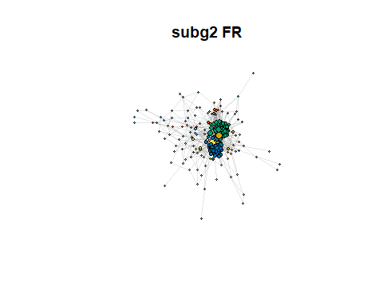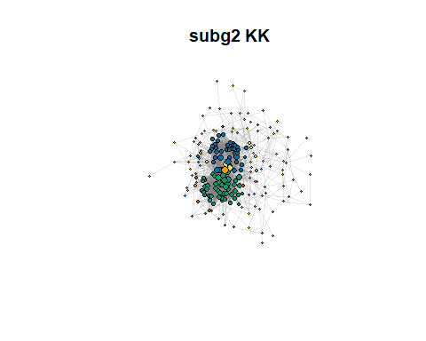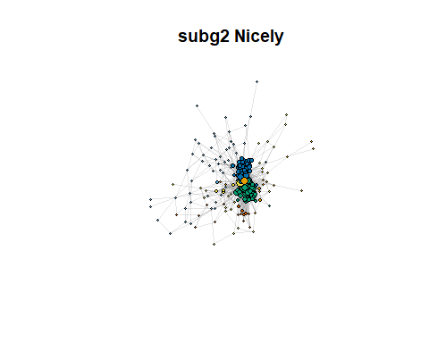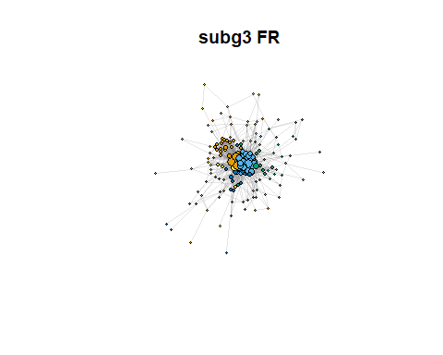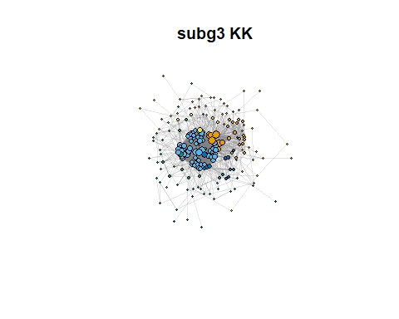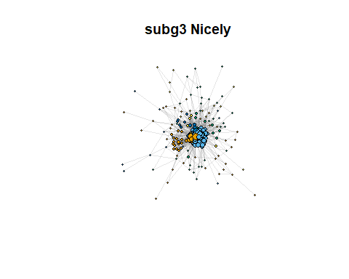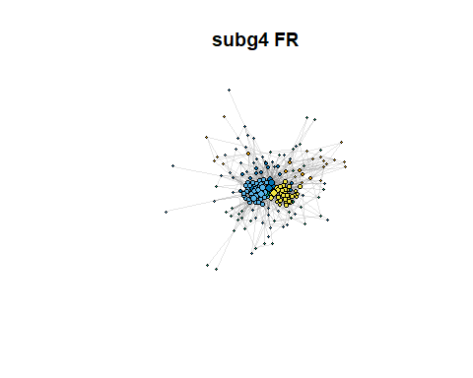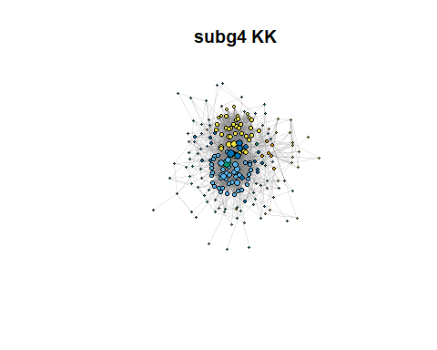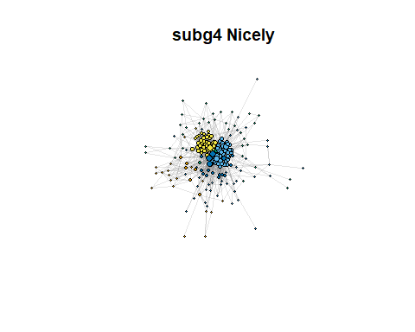

Community Detection
back to report
subg <- list(subg1 = subg1,
subg2 = subg2,
subg3 = subg3,
subg4 = subg4)
und_subg <- lapply(subg, as.undirected)

We choose Fast Greedy, Louvain, and Walktrap (top three methods on our lecture slide and covered in ica) to perform our community detection.
back to report
und_subg <- lapply(subg, function(x) simplify(as_undirected(x)))
com_fg <- lapply(und_subg, cluster_fast_greedy)
com_l <- lapply(und_subg, cluster_louvain)
com_w <- lapply(und_subg, cluster_walktrap)

And then we compare modularity
back to report
mod_fg <- sapply(com_fg, modularity)
mod_l <- sapply(com_l, modularity)
mod_w <- sapply(com_w, modularity)
data.frame(
subgraph = names(subg),
fast_greedy = mod_fg,
louvain = mod_l,
walktrap = mod_w
)
## subgraph fast_greedy louvain walktrap
## subg1 subg1 0.1911257 0.2461304 0.15813260
## subg2 subg2 0.3522581 0.3608913 0.29551518
## subg3 subg3 0.1545764 0.2025717 0.10072104
## subg4 subg4 0.2772735 0.3141144 0.08605815
ncom_fg <- sapply(com_fg, length)
ncom_l <- sapply(com_l, length)
ncom_w <- sapply(com_w, length)
data.frame(
subgraph = names(subg),
fast_greedy = ncom_fg,
louvain = ncom_l,
walktrap = ncom_w
)
## subgraph fast_greedy louvain walktrap
## subg1 subg1 6 5 31
## subg2 subg2 6 6 27
## subg3 subg3 4 7 27
## subg4 subg4 6 5 20

And as it was recommended in our lecture to report community size, we do so as well here.
back to report
sizes(com_l[[1]])
## Community sizes
## 1 2 3 4 5
## 51 32 51 37 29
sizes(com_l[[2]])
## Community sizes
## 1 2 3 4 5 6
## 21 47 50 30 43 9
sizes(com_l[[3]])
## Community sizes
## 1 2 3 4 5 6 7
## 54 63 31 16 13 18 5
sizes(com_l[[4]])
## Community sizes
## 1 2 3 4 5
## 12 27 52 40 69

And we visualize with community coloring, short eg
back to report
plot(com_l[[1]], und_subg[[1]], layout = layout_with_fr(und_subg[[1]]), vertex.label = NA, main = "Louvain community in subgraph 1")
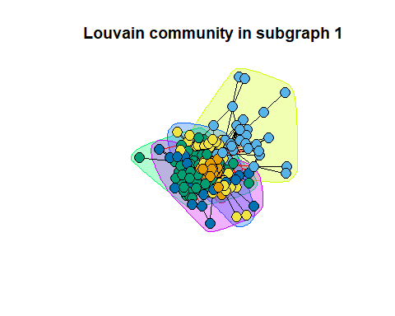
plot(com_l[[2]], und_subg[[2]], layout = layout_with_fr(und_subg[[2]]), vertex.label = NA, main = "Louvain community in subgraph 2")
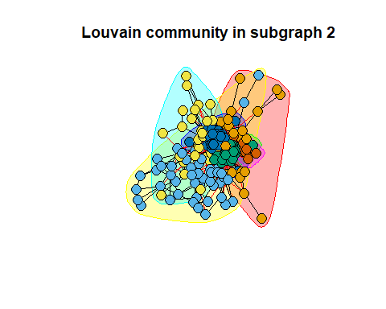
plot(com_l[[3]], und_subg[[3]], layout = layout_with_fr(und_subg[[3]]), vertex.label = NA, main = "Louvain community in subgraph 3")
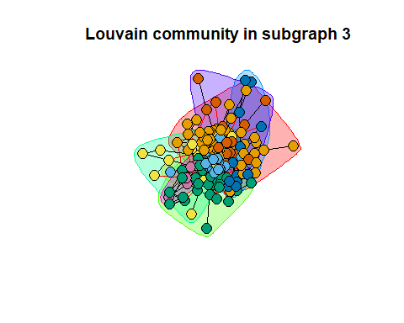
plot(com_fg[[1]], und_subg[[1]], layout = layout_with_fr(und_subg[[1]]), vertex.label = NA, main = "Fast Greedy community in subgraph 1")
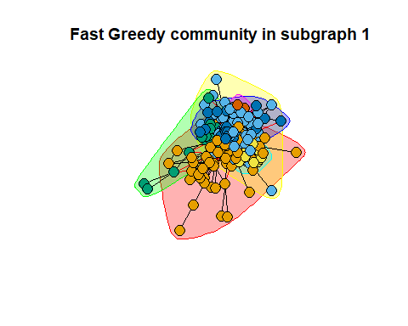
plot(com_fg[[1]], und_subg[[2]], layout = layout_with_fr(und_subg[[2]]), vertex.label = NA, main = "Fast Greedy community in subgraph 2")
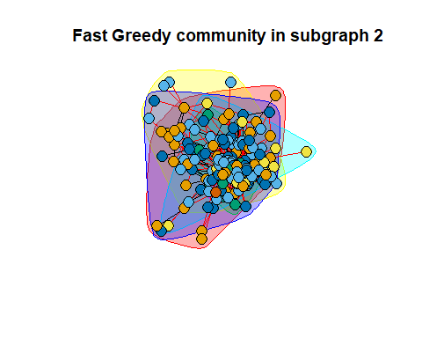
plot(com_fg[[1]], und_subg[[3]], layout = layout_with_fr(und_subg[[3]]), vertex.label = NA, main = "Fast Greedy community in subgraph 3")
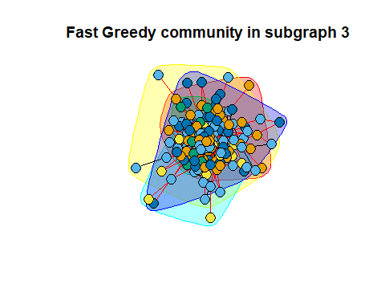
plot(com_w[[1]], und_subg[[1]], layout = layout_with_fr(und_subg[[1]]), vertex.label = NA, main = "Walktrap community in subgraph 1")
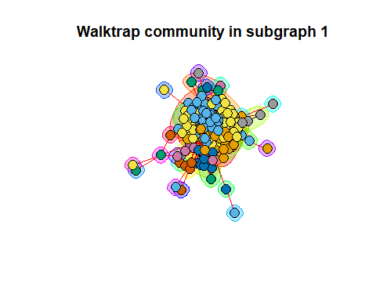
plot(com_w[[2]], und_subg[[2]], layout = layout_with_fr(und_subg[[2]]), vertex.label = NA, main = "Walktrap community in subgraph 2")
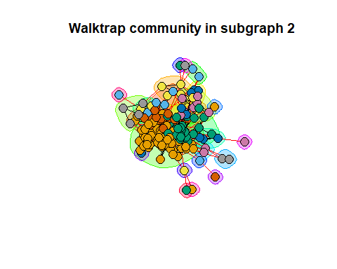
plot(com_w[[3]], und_subg[[3]], layout = layout_with_fr(und_subg[[3]]), vertex.label = NA, main = "Walktrap community in subgraph 3")
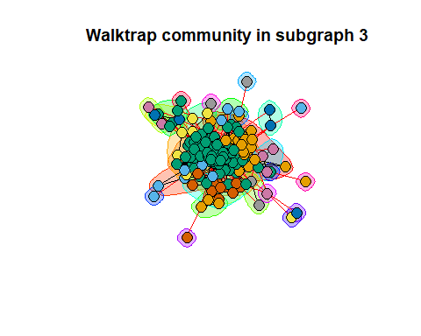

Adjacency Matrix
back to report

Unordered Adjacency Matrix
library(Matrix)
non_ord <- com_l[[1]]$membership
A <- as_adj(und_subg[[1]])
## Warning: `as_adj()` was deprecated in igraph 2.1.0.
## ℹ Please use `as_adjacency_matrix()` instead.
## This warning is displayed once per session.
## Call `lifecycle::last_lifecycle_warnings()` to see where this warning was
## generated.
image(Matrix(A))
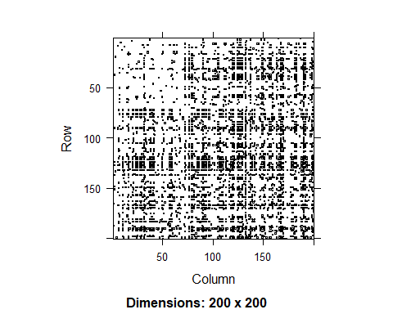

Ordered Adjacency Matrix
#library(Matrix)
ord <- order(com_l[[1]]$membership)
A <- as_adj(und_subg[[1]])
image(Matrix(A[ord, ord]))
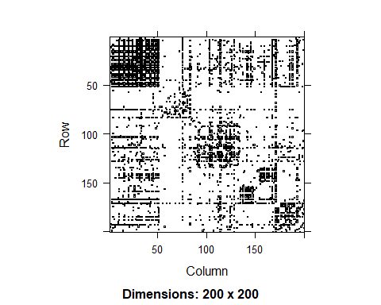
ord <- order(com_fg[[1]]$membership)
A <- as_adj(und_subg[[1]])
image(Matrix(A[ord, ord]), main="subg1 adj matrix, fast greedy communities")
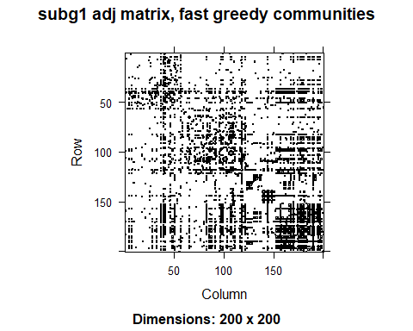
ord <- order(com_w[[1]]$membership)
A <- as_adj(und_subg[[1]])
image(Matrix(A[ord, ord]), main="subg1 adj matrix, walktrap communities")
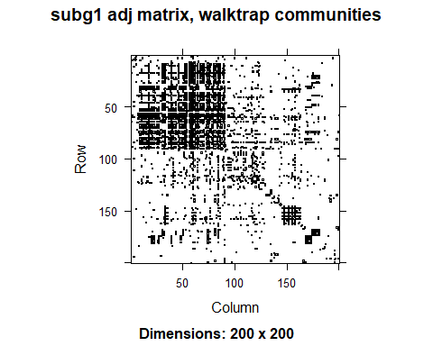

Analyzing Network Metrics (Degree)
back to report
hist(degree(g))
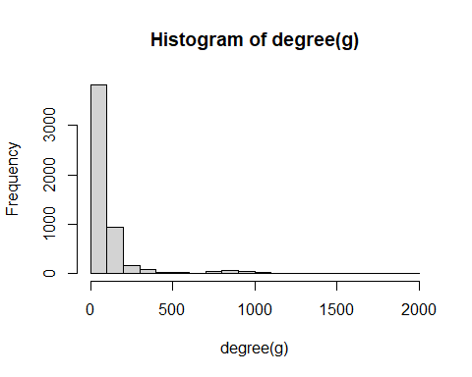
# Degree of Nodes in Subgraph 1
degree <- degree(subg1, mode="all")
# Degree Histogram
hist(degree,
breaks=50,
main="Degree histogram")
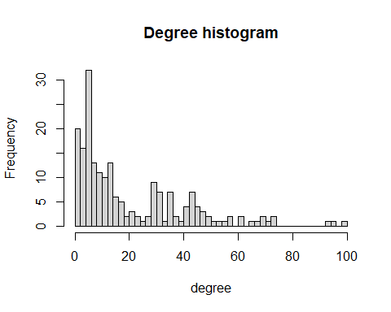
# Network Plot
sort(degree, decreasing = T, index.return = T)
## $x
## [1] 99 96 93 74 74 71 70 69 67 65 62 61 58 57 56 53 52 50 50 48 47 47 46 45 45
## [26] 45 44 44 44 44 43 43 43 42 42 41 41 40 38 38 36 36 35 35 35 35 35 34 32 32
## [51] 31 31 31 31 31 30 30 30 30 30 29 29 29 29 28 28 26 24 23 22 21 21 20 19 18
## [76] 17 17 17 17 16 16 16 15 15 15 14 14 14 14 14 14 14 14 14 14 13 13 13 12 12
## [101] 12 12 12 12 12 11 11 11 10 10 10 10 10 10 9 9 9 9 9 8 8 8 8 7 7
## [126] 7 7 7 7 7 7 7 6 6 6 6 6 6 6 6 6 6 6 6 6 6 5 5 5 5
## [151] 5 5 5 5 5 5 5 5 5 5 5 5 5 5 4 4 4 4 4 4 3 3 3 3 3
## [176] 3 3 3 3 3 2 2 2 2 2 2 2 2 2 2 1 1 1 1 1 1 1 1 1 1
##
## $ix
## [1] 190 167 132 125 129 120 31 79 137 90 149 76 127 192 183 198 124 159
## [19] 170 72 169 199 121 92 157 166 119 156 163 181 16 59 105 113 191 38
## [37] 96 41 107 118 29 57 91 93 139 178 188 151 10 23 37 49 89 106
## [55] 179 20 39 81 84 109 25 27 86 141 116 193 136 110 147 21 32 143
## [73] 150 64 154 7 83 152 197 6 35 88 50 61 100 30 33 51 66 67
## [91] 102 103 126 165 177 15 133 164 14 40 82 101 144 189 195 111 131 140
## [109] 145 161 174 175 187 196 42 58 114 158 171 5 60 95 146 2 22 36
## [127] 55 62 87 99 155 184 12 17 28 44 45 46 52 73 142 148 153 168
## [145] 186 200 1 13 18 24 34 63 65 68 70 85 94 97 104 134 138 162
## [163] 173 182 75 80 98 172 180 185 11 48 54 71 108 112 117 130 160 194
## [181] 3 8 26 47 53 56 69 77 122 176 4 9 19 43 74 78 115 123
## [199] 128 135
V(subg1)$color <- "white"
V(subg1)$label.color <- "black"
V(subg1)$frame.color <- "black"
V(subg1)$color[V(subg1)[c(29,37,77,62,52)]] <- "#F0DC16"
plot(subg1,
layout = layout_with_kk(subg1),
vertex.size = log(degree + 1) * 3,
vertex.label=NA,
edge.arrow.size = 0.1,
edge.color = "gray80",
edge.width = 0.5)
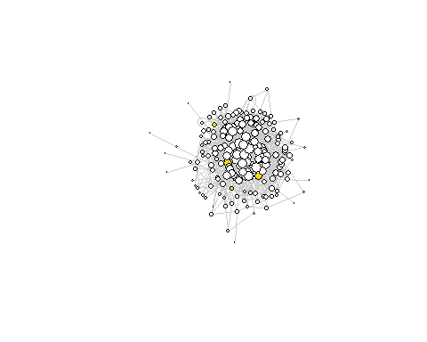
# Degree of Nodes in Subgraph 2
degree <- degree(subg2, mode="all")
# Degree Histogram
hist(degree,
breaks=50,
main="Degree histogram")
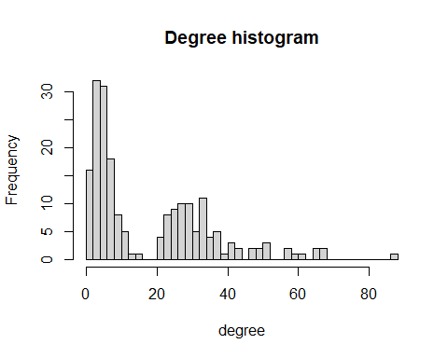
# Network Plot
sort(degree, decreasing = T, index.return = T)
## $x
## [1] 88 67 67 66 66 61 60 58 57 52 52 51 50 50 48 47 43 43 42 41 41 39 38 37 37
## [26] 37 37 36 35 35 35 34 34 34 34 34 34 34 34 33 33 33 32 32 31 31 31 30 30 30
## [51] 30 30 30 29 29 29 29 28 28 28 28 28 28 28 27 27 27 26 25 25 25 25 25 25 25
## [76] 25 24 24 24 24 24 24 24 23 22 22 22 22 16 13 12 12 11 11 11 10 10 10 9 9
## [101] 9 9 9 8 8 8 8 8 8 8 8 8 7 7 7 7 7 7 7 7 7 6 6 6 6
## [126] 6 6 6 6 6 6 6 6 6 6 5 5 5 5 5 5 5 5 5 5 5 5 5 5 5
## [151] 5 5 4 4 4 4 4 4 4 4 4 4 4 4 3 3 3 3 3 3 3 3 3 3 3
## [176] 3 3 3 3 3 3 3 3 3 2 2 2 2 2 2 2 1 1 1 1 1 1 1 1 1
##
## $ix
## [1] 140 196 198 107 182 141 30 143 175 77 106 160 39 70 13 92 114 135
## [19] 105 34 71 101 112 43 67 103 173 45 118 134 150 4 31 98 147 163
## [37] 165 188 195 3 38 88 158 172 53 153 157 66 75 99 151 154 155 51
## [55] 91 137 149 52 90 93 142 146 187 194 62 168 186 100 27 47 69 78
## [73] 85 152 185 200 7 9 16 87 108 115 145 126 17 76 109 159 136 57
## [91] 72 193 89 144 199 82 128 178 1 50 63 79 189 15 24 56 74 95
## [109] 97 130 156 170 11 35 37 80 120 131 133 139 191 8 20 26 29 44
## [127] 46 68 94 110 113 162 164 169 197 5 6 10 25 36 49 65 73 81
## [145] 102 111 116 148 167 176 179 180 12 14 21 28 42 59 86 119 122 127
## [163] 138 192 19 23 33 41 48 54 55 64 83 104 121 124 129 132 161 166
## [181] 171 177 184 190 2 58 84 117 123 125 181 18 22 32 40 60 61 96
## [199] 174 183
V(subg2)$color <- "white"
V(subg2)$label.color <- "black"
V(subg2)$frame.color <- "black"
V(subg2)$color[V(subg2)[c(29,37,77,62,52)]] <- "#F0DC16"
plot(subg2,
layout = layout_with_kk(subg2),
vertex.size = log(degree + 1) * 3,
vertex.label=NA,
edge.arrow.size = 0.1,
edge.color = "gray80",
edge.width = 0.5)
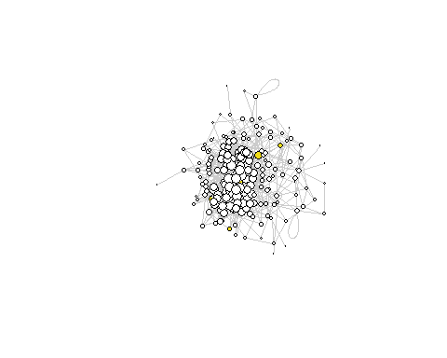
# Degree of Nodes in Subgraph 3
degree <- degree(subg3, mode="all")
# Degree Histogram
hist(degree,
breaks=50,
main="Degree histogram")
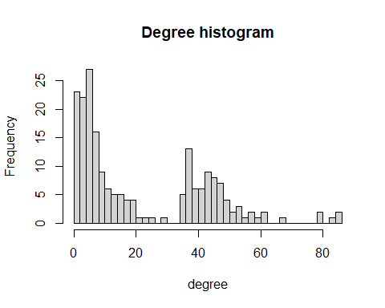
# Network Plot
sort(degree, decreasing = T, index.return = T)
## $x
## [1] 86 86 84 80 79 68 62 61 60 58 58 56 54 54 54 52 52 50 49 49 49 48 48 48 48
## [26] 47 47 47 46 46 46 46 45 45 45 45 44 44 44 43 43 43 43 43 43 42 42 42 42 42
## [51] 41 40 40 39 39 39 39 38 38 38 38 38 37 37 37 37 37 37 37 37 36 36 36 36 36
## [76] 29 26 23 22 20 19 19 19 18 18 17 17 16 16 15 15 15 14 13 13 13 13 12 12 12
## [101] 11 11 11 10 10 10 10 9 9 9 9 9 8 8 8 8 8 8 8 8 7 7 7 7 7
## [126] 7 7 7 6 6 6 6 6 6 6 6 6 6 6 5 5 5 5 5 5 5 5 5 5 5
## [151] 5 5 5 5 5 4 4 4 4 4 4 4 4 4 4 3 3 3 3 3 3 3 3 3 3
## [176] 3 3 2 2 2 2 2 2 2 2 2 2 2 2 2 2 1 1 1 1 1 1 1 1 1
##
## $ix
## [1] 146 187 78 194 191 147 156 82 143 142 176 193 122 174 190 93 178 105
## [19] 86 167 179 50 172 195 196 108 134 173 9 103 129 184 131 137 186 199
## [37] 51 104 180 20 30 45 90 102 139 48 58 62 158 177 4 37 89 3
## [55] 6 21 27 43 52 59 124 152 24 28 67 71 95 112 119 192 2 17
## [73] 29 128 148 10 171 144 198 168 33 79 160 14 94 54 150 118 154 116
## [91] 169 170 85 8 42 53 66 1 97 132 7 109 153 69 101 136 188 35
## [109] 91 100 113 130 22 39 40 41 64 135 140 175 74 75 84 107 123 157
## [127] 181 197 19 26 34 38 63 81 92 141 164 183 185 5 13 18 23 44
## [145] 46 65 83 99 114 117 133 145 155 162 166 12 25 32 55 73 87 98
## [163] 115 127 149 47 57 61 68 70 77 80 121 125 151 159 189 16 31 36
## [181] 56 72 76 96 110 111 120 161 165 182 200 11 15 49 60 88 106 126
## [199] 138 163
V(subg3)$color <- "white"
V(subg3)$label.color <- "black"
V(subg3)$frame.color <- "black"
V(subg3)$color[V(subg3)[c(29,37,77,62,52)]] <- "#F0DC16"
plot(subg3,
layout = layout_with_kk(subg3),
vertex.size = log(degree + 1) * 3,
vertex.label=NA,
edge.arrow.size = 0.1,
edge.color = "gray80",
edge.width = 0.5)
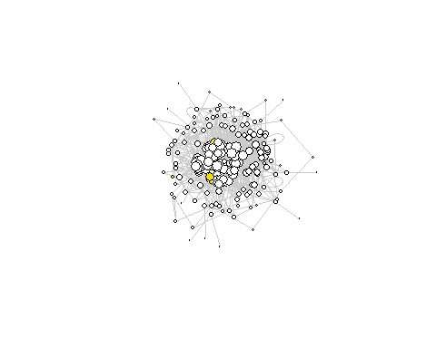
# Degree of Nodes in Subgraph 4
degree <- degree(subg4, mode="all")
# Degree Histogram
hist(degree,
breaks=50,
main="Degree histogram")
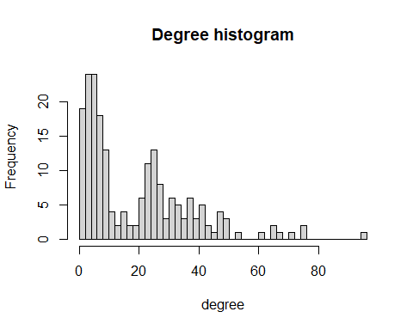
# Network Plot
sort(degree, decreasing = T, index.return = T)
## $x
## [1] 96 76 75 71 67 66 65 62 54 50 49 49 48 48 47 47 46 44 44 42 42 42 41 41 40
## [26] 40 39 38 38 38 38 37 37 36 36 35 34 33 33 33 33 32 31 31 31 31 31 30 30 29
## [51] 28 28 28 27 27 27 27 27 26 26 26 25 25 25 25 25 25 25 25 25 25 24 24 24 23
## [76] 23 23 23 23 23 23 23 22 22 22 22 21 21 19 19 17 17 16 15 15 15 13 13 12 12
## [101] 11 11 10 10 10 10 10 10 10 10 9 9 9 9 9 8 8 8 8 8 7 7 7 7 7
## [126] 7 7 7 7 7 7 7 7 6 6 6 6 6 6 6 6 6 6 6 6 6 6 5 5 5
## [151] 5 5 5 5 5 5 5 4 4 4 4 4 4 4 4 4 4 4 4 3 3 3 3 3 3
## [176] 3 3 3 3 3 3 2 2 2 2 2 2 2 2 2 2 2 2 2 1 1 1 1 1 1
##
## $ix
## [1] 145 176 147 149 163 124 186 151 141 178 183 200 63 139 26 105 88 70
## [19] 91 39 52 97 125 191 53 104 119 11 103 109 154 44 136 31 173 170
## [37] 114 95 108 117 156 121 6 10 96 102 199 168 175 59 25 110 133 43
## [55] 115 122 161 162 113 157 167 7 23 32 36 118 159 172 179 184 192 62
## [73] 142 152 3 9 17 35 66 68 155 181 37 55 89 120 61 80 49 182
## [91] 69 150 144 41 107 190 19 77 94 123 46 140 12 30 47 78 116 169
## [109] 180 196 5 65 93 174 198 64 98 130 194 197 2 13 27 82 99 101
## [127] 112 129 134 143 160 165 187 4 15 20 22 60 67 74 83 86 111 164
## [145] 166 171 188 16 18 58 73 81 87 106 131 132 193 8 28 54 75 90
## [163] 92 100 146 153 185 189 195 24 38 42 45 50 56 57 79 85 126 128
## [181] 177 14 21 29 33 40 48 51 71 72 84 137 148 158 1 34 76 127
## [199] 135 138
V(subg4)$color <- "white"
V(subg4)$label.color <- "black"
V(subg4)$frame.color <- "black"
V(subg4)$color[V(subg4)[c(29,37,77,62,52)]] <- "#F0DC16"
plot(subg4,
layout = layout_with_kk(subg4),
vertex.size = log(degree + 1) * 3,
vertex.label=NA,
edge.arrow.size = 0.1,
edge.color = "gray80",
edge.width = 0.5)
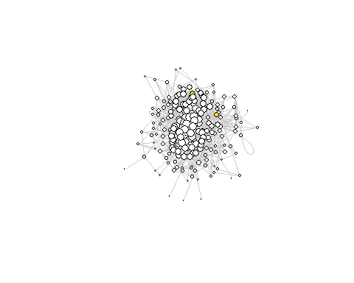

Analyzing Network Metrics (EigenCentrality)
back to report
print("Eigen Centrality SubGraph 1", quote=FALSE)
## [1] Eigen Centrality SubGraph 1
eig_subg1 <- eigen_centrality(subg1)$vector
hist(eig_subg1)
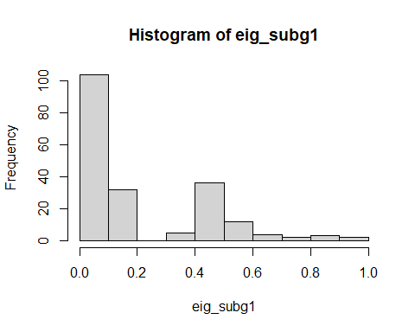
hist(15*sqrt(sqrt(eig_subg1)))
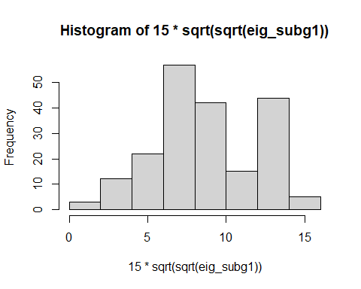
plot(subg1,
layout = layout_with_kk(subg1),
vertex.size = 15*sqrt(sqrt(eig_subg1)),
vertex.label=NA,
edge.arrow.size = 0.1,
edge.color = "gray80",
edge.width = 0.5)
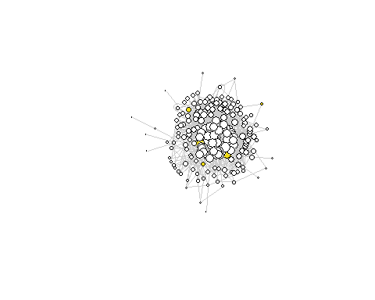
print("Eigen Centrality SubGraph 2", quote=FALSE)
## [1] Eigen Centrality SubGraph 2
eig_subg2 <- eigen_centrality(subg2)$vector
hist(eig_subg2)
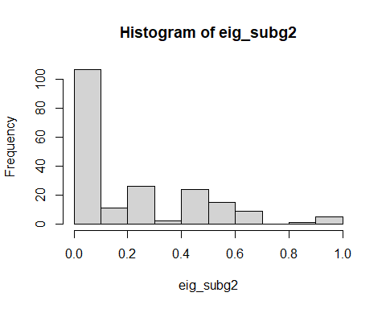
plot(subg2,
layout = layout_with_kk(subg2),
vertex.size = 15*sqrt(sqrt(eig_subg2)),
vertex.label=NA,
edge.arrow.size = 0.1,
edge.color = "gray80",
edge.width = 0.5)
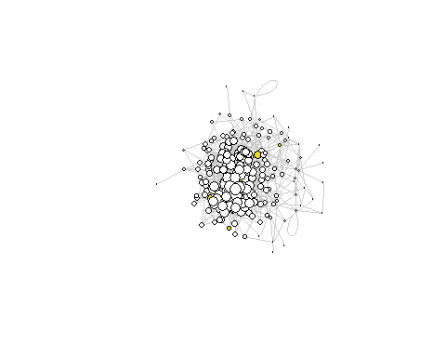
print("Eigen Centrality SubGraph 3", quote=FALSE)
## [1] Eigen Centrality SubGraph 3
eig_subg3 <- eigen_centrality(subg3)$vector
hist(eig_subg3)
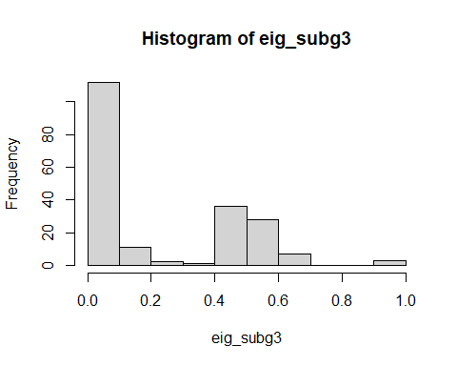
plot(subg3,
layout = layout_with_kk(subg3),
vertex.size = 15*sqrt(sqrt(eig_subg3)),
vertex.label=NA,
edge.arrow.size = 0.1,
edge.color = "gray80",
edge.width = 0.5)
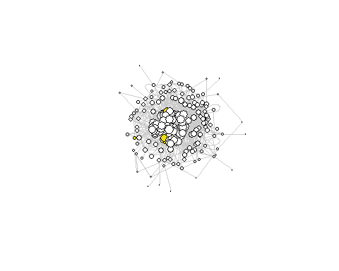
print("Eigen Centrality SubGraph 4", quote=FALSE)
## [1] Eigen Centrality SubGraph 4
eig_subg4 <- eigen_centrality(subg4)$vector
hist(eig_subg4)
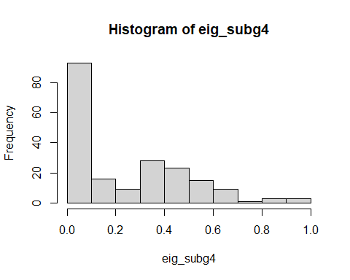
plot(subg4,
layout = layout_with_kk(subg4),
vertex.size = 15*sqrt(sqrt(eig_subg4)),
vertex.label=NA,
edge.arrow.size = 0.1,
edge.color = "gray80",
edge.width = 0.5)
