Introduction to Software Engineering (aka: OOP, OOD)
Ex1: Algorithm: Implementing a plane projection of 3D volume
Goal: Getting comfortable designing and implementing a not-so-well-defined algorithm in a robust and runtime-efficient manner.
Note: This assignment can be seen as an algorithmic challenge, yet here we are focusing on the design and the general quality of the code.
Problem statement: Given 3D raster data matrix (M), and a plane (p). Compute the 2D matrix (image) of the projection of p in V (note: this problem is NOT well-defined for implementation - a detailed design is needed).
Problem definition: Given a 3D matrix (M) of size sx*sy*sz byte values (the entry M[x][y][z] is an unsigned integer value of 8,16, 32 bits), where 1<=sx,sy,sz<2^10 and 0<=x<sx, 0<=y<sy, 0<=z<sz.
Implementation Requirements: Your implementation is secondary to the design; you can implement your code in any programming language over [Java, Python, C, C++]. Your code should be correct and stable. Given a matrix of size 500^3 bytes, a runtime of at least 100 fps is expected; +30 FPS is a must (a proper Java implementation leads to 300+ fps on an M2 Mac 2023).
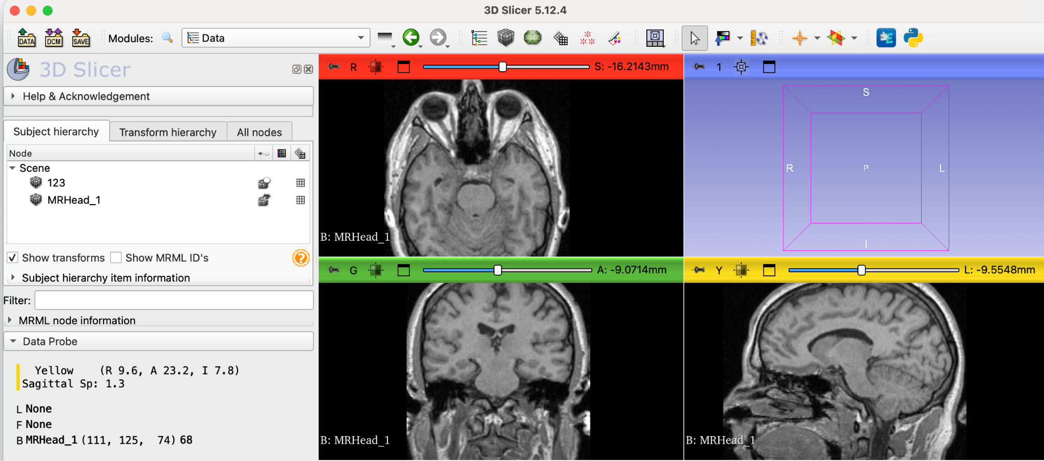
Data: In this assignment, we will use NRRD format and data from the 3D Slicer open-source project. In particular, we encourage you to start with this NRRD (MRI) file.
Figure 1: An example of a 3D NRRD file uploaded to the 3D Slicer software. The X, Y, Z Sections (Projections) are shown; your goal is to allow an efficient projection on any given plane.

The Projection algorithm:
Given a 3D matrix (M), and a plane (p) the goal is to project M onto p as a 2D image (matrix).
Given a plane defined by 3 (3D) points (a,b,c) - where dist(a,b)=dist(a,c) (a,b,c is an isosceles triangle). Any point (q) within the triangle a,b,c that lies within M should be projected to the output image (2D matrix) using the following method:
- Let Dab be the dist(a,b)=dist(a,c). Let Dbc be the dist(b,c).
- Let v(a,b) be the normalized vector: vector(a,b) / Dab, define v(a,c) accordingly.
- Define an output 2D Matrix E of size Dab*Dbc
- Let a1=a, a2=a
- For(int y=0; y<Dab; y++) # y runs from 0 (up) to Dab
  - a1=a1+v(ab) # a1 steps from a to b
  - a2=a2+v(ac) # a2 steps from a to c
  - p=a1; # p steps from a1 to a2
  - d12=dist(a1,a2) # d12 is the distance between a1 and a2
  - dp=vector(a1,a2)/d12 # dp is the normalized vector(a1,a2)
  - for(int x1=0;x1<=d12;x1++)
    - v=M[p] # if p is NOT in M, v=0
    - x=(Dbc/2)-(d12/2) + x1 # x
    - E[x][y] = v
    - p=p+dp
- Return E
Note: the same algorithm holds if instead of an isosceles triangle (a,b,c) the plane is presented by an isosceles trapezoid (two vectors on the same plane with the same length: a’→b and a’’→c.)

To Do:
- Create a repository, define the problem and the scope of the project (all in the README).
- Define an SRS document (Software Requirements Spec).
- Define the main algorithm (in detail).
- Define a data set of NRRD files.
- Define a testing strategy; make sure to address the demo (as in 7)
- Implement the project (Commit frequently).
- Create a demo “main” allowing you to run the script in the following format: python Ex0.py file.nrrd file.csv file.mp4.
  - The <file.nrrd> is a 3D volumetric data file in an NRRD format.
  - The <file.csv> is a csv file representing a list of 3 or 4 points coordinates.
  - The <file.mp4> is a video (output) file, including a frame for each corresponding plane coordinate as presented in the csv file (in the list order).
- Perform an experiment and write down a short description of the results, including the mp4 output file.
Q & A
- Can you elaborate on the definition of the plane (p)?
Ans: P can be represented using 3 or 4 points (on the same plane:
In case of 3 Points (a,b,c): |dist(a,b) - dist(a,c)| < EPS (EPS can be assumed to be 0.001).
In case of four Points (a1, a2, b, c)
- |dist(a1,b) - dist(a2,c)| < EPS
- dist(a1,a2) <= dist(b,c)
- A1→b and a2→c are on the same plane (p)

- Deadline: can we get additional time:
Ans: Sure the deadline was postponed to Nov 8th,

- "מה הציפיה מאיתנו אם הקלט לא תקין כלומר אם בקובץ הCSV יש מישור שאינו עומד בהגדרה של CSV שכתבת. האם אתה מצפה שנחזיר ERROR או שנתעלם מהפריים הבעייתי ונמשיך לרוץ על שאר הקובץ?"
Ans: Good question, yet it falls within the design strategy (& testing) you should decide on, here are some guidelines:
- If the set of the points (3 or 4) is not valid (assuming epsilon = 0.001) → an exception should be raised.
- In the Demo make sure you deal with such errors in a way that the output video will include an “Error frame” (e.g., a black frame with some marking regarding the wrong point set), yet the other (valid) planes should lead to the correct frames.

- "כשבאנו להשוואות בין חברים, גילינו שבחירות שנקטנו באלגוריתם משפיעות על בחירת הפיקסלים במצבים מסוימים מה שלא נותן זהות מלאה עבור כל הפיסקלים. סתם דוגמא יכולה להיות מה הפתרון עבור נקודה שהיא בין שני ווקסלים. אין זהות בין שני האלגוריתמים. אמנם במבחן העין לא רואים את ההבדלים כי ההבדל בין הגוונים הוא זניח אבל רצינו לדעת איך אתה מצפה מאיתנו להתייחס לבעיה זו.
Ans: good question: the closest voxel is the simplest (proper) way, there is no need for any “super resolution”, try to justify your decisions, and in any case if it is close enough it is O.K.
- Can you elaborate on the submission process?
Ans: sure: the main thing is the github repository, it should should contain all the needed docs + code + how to build and run + links to supplementary materials (benchmarks, videos, etc’).
Make sure you commit frequently, and that your repo is public.
As for the submission itself:
- Submit a text file with your ID(s) and a repo link to the moodle Ex1.
- Submit your Ex1 using the following form.

