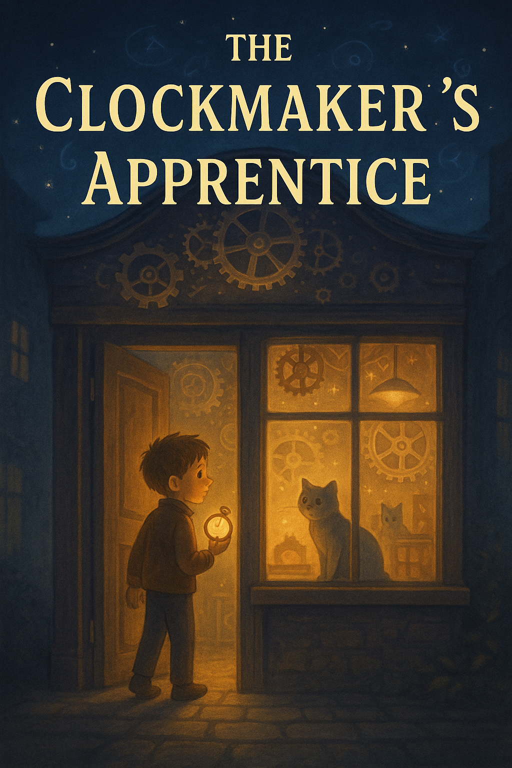

**Chapter 1: The Shop That Wasn't There Yesterday**

Eli Mother was late again. The last thing he wanted was another lecture from his mom. But when he took his usual shortcut through Maple Alley, he froze.

There, nestled between the flower shop and the abandoned tailor’s building, was a shop he’d never seen before.   
"Vinter & Tock: Clockmakers of the Unusual", the sign read.

Eli pressed his nose to the glass. Clocks of every shape ticked in soft harmony. One had backward numbers. Another had constellations instead of hands.

Curiosity won. He stepped inside.

**Chapter 2: Mr. Vinter and the Test**

A tall man with wild white hair and glasses that sparkled like stars appeared behind the counter.

"You're late," the man said.

"For what?" Eli asked.

"For your first day, of course."

The man, Mr. Vinter, explained he needed an apprentice. But not just anyone, someone who could feel time.

He handed Eli a tiny clock with no hands. “Make it tick,” he said.

Eli held the strange clock. A warmth spread through his fingers.   
The clock trembled... and ticked once. Mr. Vinter smiled. “You’ll do.”

**Chapter 3: A Tick Too Far**

Over the next few days, Eli learned to clean gears, set time by feel, and even whisper to old grandfather clocks.

But one evening, while winding a dusty wall clock, he heard a chime... and the room changed.

Suddenly, he was standing in the same shop, but it looked older.

Candle-lit. Dustier.

And outside the window, it was 1892.

He had just traveled through time.

**Chapter 4: Tock the Time Cat**

Back in the present, Mr. Vinter explained everything. "Time," he said, "is a fabric. Every tick matters. And some clocks are anchors. You've activated one." The silver cat meowed. "That’s Tock," Vinter said. "She helps guard the clocks that bend time. And she likes you.” Together, they began fixing unstable clocks, ones that linked to other eras. But soon, strange things began to happen. Time slips. Frozen moments. Vanishing seconds. “Someone is unraveling time,” Mr. Vinter warned.

**Chapter 5: The Missing Minutes**

Eli and Tock chased a trail of broken clocks and disappearing hours. Clues led them to an old apprentice of Vinter: **Cassian**, who wanted to control time, not guard it.

Cassian had stolen the Master Clock Key, a device that could rewind   
or fast-forward the entire world.

Eli had one chance to stop him - by entering the Clock Between Worlds, a suspended moment outside normal time.

**Chapter 6: Every Second Counts**

In the Clock Between Worlds, seconds stretched like string.   
Eli faced Cassian, who tried to turn time backward to erase Vinter’s memory of him. But Eli used the handless watch, the one that only ticked for him.

He placed it into the Master Clock, resetting it, locking it to now.

Time snapped back into place. Cassian disappeared into a forgotten moment. Peace returned to the shop.

**Chapter 7: The Apprentice of Time**

Back in the present, Eli’s watch now ticked constantly.

He was no longer just an apprentice, he was a Timekeeper.

Mr. Vinter handed him a notebook: “Unusual Clocks and Their Secrets.” “There will be more,” he said, “and you’ll be ready.”   
Tock purred and curled up beside Eli’s feet. And the clocks kept ticking.

***The End***