Library JS for Landing Pages

# Version Control

|  |  |  |  |
| --- | --- | --- | --- |
| Version | Date | Author | Comment |
| 0.1 | 2016, May 13th | F.Lacomère (IUD) | Initial version |
| 0.2 | 2016, May 18th | F.Lacomère (IUD) | Added : background image |
| 0.3 | 2016, May 26th | F.Lacomère (IUD) | update with new information |
|  |  |  |  |

# Introduction

# How to use the library

## Installation

<script src="/bower_components/jquery/dist/jquery.min.js "></script>  
<script src="/bower_components/com.threeds.landingpage/app.js"></script>  
<link rel="stylesheet" href="/bower_components/com.threeds.landingpage/style.css" />

## Setup

$(function () {

addEventListener('WebComponentsReady', function () {

var options = {

id: 'LDP6312',

type: 'download',

'background-image': 'http://image.url',

steps: {

0: {

title: '1',

content: 'To download the Case Study, please provide your email'

},

1: {

title: '2',

content: 'Please provide more informations to complete your Case Study download',

}

},

success: {

title: 'Thanks for your download',

content: 'Your download should start automatically, if not use the direct link',

},

action: {

url: 'http://www.3ds.com/en/file.pdf',

label: 'Download',

content: 'PDF - 3,84Mo',

},

accelerate: {

url: 'http://www.3ds.com/en/contact-us',

label: 'contact me',

content: 'You want to be contacted for a commercial purpose?',

},

form: {

nextLabel: 'Next',

prevLabel: 'Back',

api: {

url: 'http://dassault-test.neolane.net/dsx/lp_api.jssp',

},

callback: {

success: function(){

//...

}

},

},

error: {

title: 'Sorry !',

content: '<p>This service is temporarily unavailable. please try again later or contact the <a href="#" class="btn btn-primary">support</a></p> '

}

};

$('#ldp').threeds().landingPage(options);

});

});

## id

|  |  |  |
| --- | --- | --- |
| Contribution | Yes |  |
| Mandatory | Yes |
| Possible values | String |
| Default value | N/A |

## type

|  |  |  |
| --- | --- | --- |
| Contribution | Yes |  |
| Mandatory | Yes |
| Possible values | {'download', 'video', 'unlock'} |
| Default value | N/A |

**background-image**

|  |  |  |
| --- | --- | --- |
| Contribution | No | The image is the same provided for banner and card. |
| Mandatory | Yes |
| Possible values | url (absolute, with domain and protocol) |
| Default value | N/A |

## steps.0

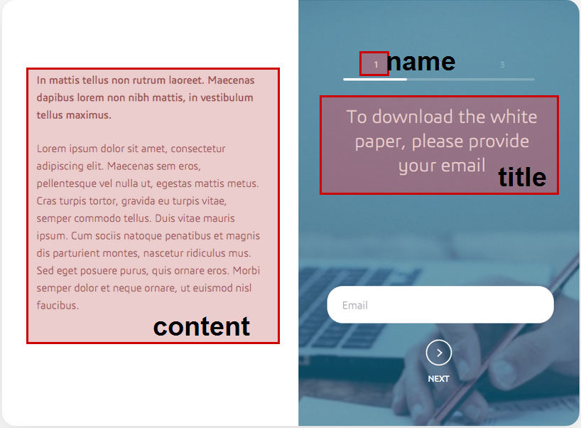

## steps.[X].name

|  |  |  |
| --- | --- | --- |
| Contribution | Optional | For the moment, ‘name’ is not contributed. Please add the index number of the step (1 for step #0, 2 for step #1, etc.) |
| Mandatory | Yes |
| Possible values | string |
| Default value | N/A |

## steps.[X].title

|  |  |  |
| --- | --- | --- |
| Contribution | Yes |  |
| Mandatory | Yes |
| Possible values | string |
| Default value | N/A |

## steps.[X].content

|  |  |  |
| --- | --- | --- |
| Contribution | Yes |  |
| Mandatory | No |
| Possible values | HTML (p, b, strong, i, em, span) |
| Default value | N/A |

## thankyou

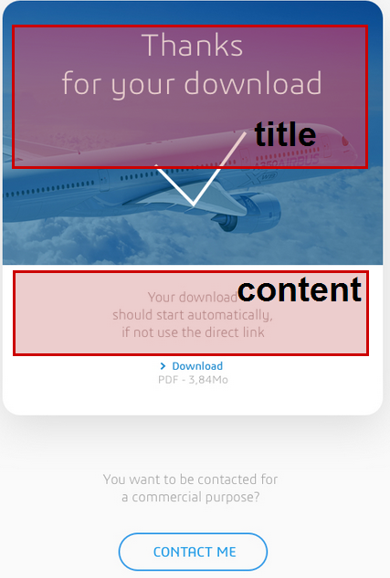 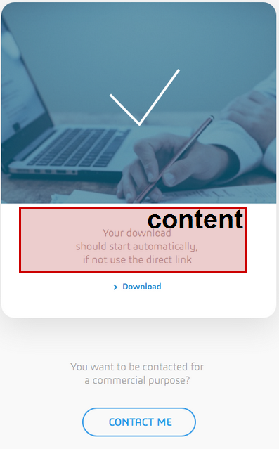

## thankyou.[X].title

|  |  |  |
| --- | --- | --- |
| Contribution | Yes |  |
| Mandatory | No |
| Possible values | string |
| Default value | N/A |

## thankyou.[X].content

|  |  |  |
| --- | --- | --- |
| Contribution | No | Please provide translation. |
| Mandatory | Yes |
| Possible values | string |
| Default value | N/A |

## action

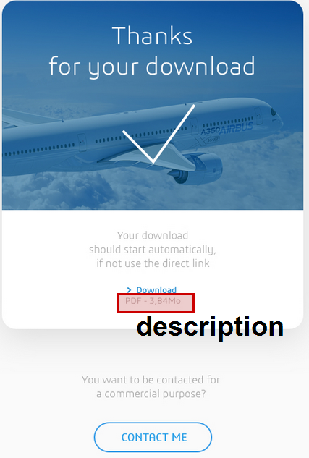 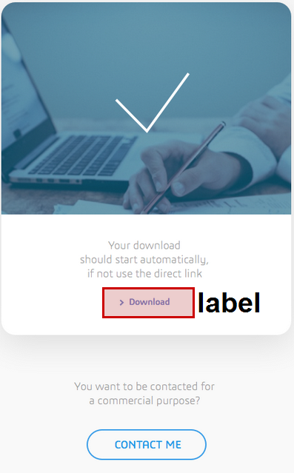 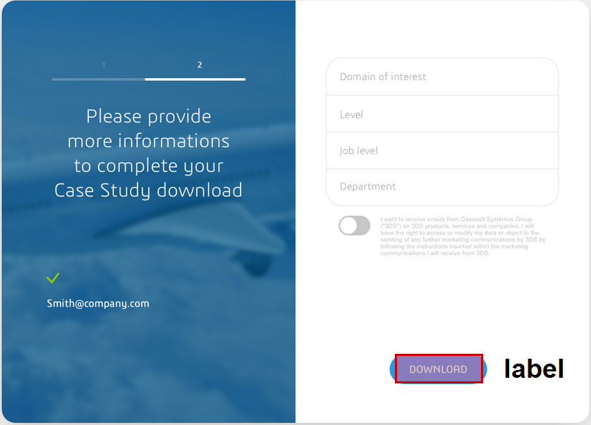

## action.[X].label

|  |  |  |
| --- | --- | --- |
| Contribution | TBD |  |
| Mandatory | Yes |
| Possible values | string |
| Default value | N/A |

## action.[X].url

|  |  |  |
| --- | --- | --- |
| Contribution | No | Please provide translation. |
| Mandatory | Yes |
| Possible values | string |
| Default value | N/A |

## action.[X].description

|  |  |  |
| --- | --- | --- |
| Contribution | TBD |  |
| Mandatory | No |
| Possible values | string |
| Default value | N/A |

## accelerate

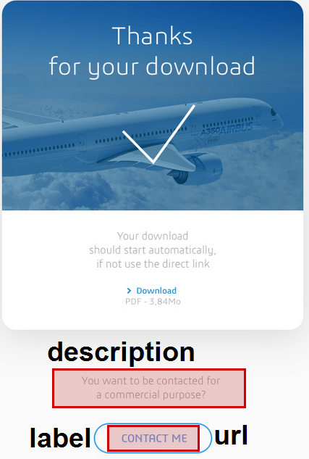

## accelerate.[X].label

|  |  |  |
| --- | --- | --- |
| Contribution | TBD |  |
| Mandatory | Yes |
| Possible values | string |
| Default value | N/A |

## accelerate.[X].url

|  |  |  |
| --- | --- | --- |
| Contribution | No | Please provide translation. |
| Mandatory | Yes |
| Possible values | string |
| Default value | N/A |

## accelerate.[X].description

|  |  |  |
| --- | --- | --- |
| Contribution | TBD |  |
| Mandatory | No |
| Possible values | string |
| Default value | N/A |

## api.url

|  |  |  |
| --- | --- | --- |
| Contribution | No | It’s always the same for the moment, according the server (prod, ppd, qal, etc…) |
| Mandatory | Yes |
| Possible values | url |
| Default value | N/A |

## callback.success

|  |  |  |
| --- | --- | --- |
| Contribution | No |  |
| Mandatory | Yes, if 'unlock' |
| Possible values | JS function to eval |
| Default value | N/A |

## form

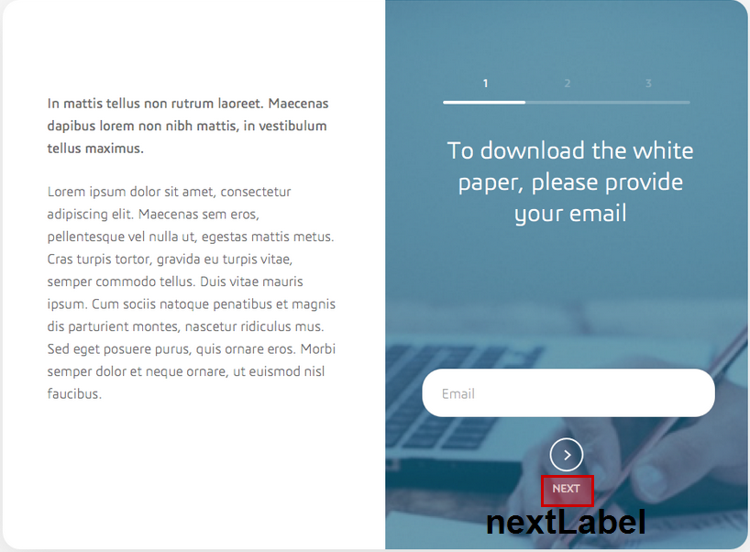

## form.nextLabel / form.nextLabel

|  |  |  |
| --- | --- | --- |
| Contribution | No | Please provide translation.  “prevLabel” is not used yet. |
| Mandatory | Yes |
| Possible values | string |
| Default value | N/A |