Question 1:

Question 2:
- Find a circle shape.
- Not effected.
- Shapes calculation:
Circle: Square: Hexagon:
Doesnt assist in distinguishing polygons.

Question 3:

Question 4:

If the image would move or rotate or change sizes, than the property would change and
therefore be irrelevant.

Question 5:
- If the square will shift +45 degrees then all the maximum points will move 45 degrees right on the Angle axis.
- If We will draw a line between 2 maximums points, this line will fit to a Filling of the two lines, in the original picture, starting from the crossing point and its width is up to its value.
Example:
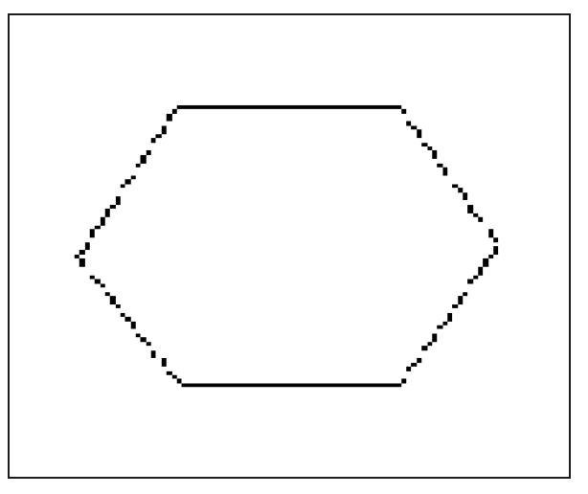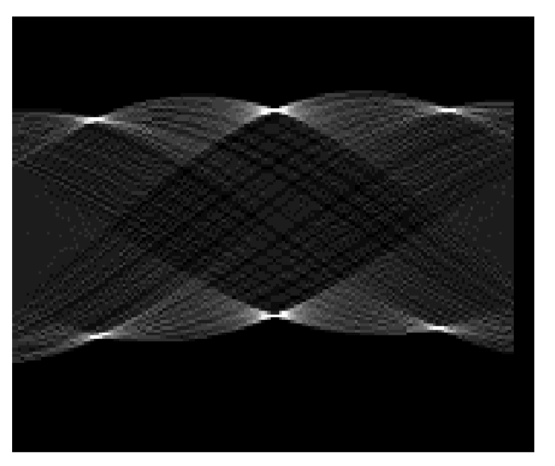

Question 6:
  - Yes, in fact for these 2 pictures we can only use M00. Because it’s a binary image we will get the Area of the two shapes which is clearly different.
  - For shapes with Symmetry to their center only M00 will be valid, the rest will be zeroed.
Therefore:
    - Same size shapes will have same moments.
    - Different size shapes will have different moments.
Question 7:
Calculations when ( x₀,y₀) = upper left:
- For 3:

- For 4:

