ODT Templating test:

Simple variable = {{ simple_variable }}

Array:

{% for element in array %}

{{ element }}

{% endfor %}

Litelar variables and conditions

{% if `literal variable` %}

Literal variables and conditions work

{% endif %}

{% img image_file_path %}

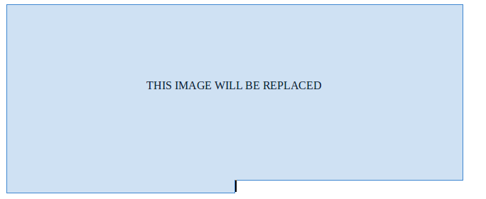{% endimg %}