CAREPOINT HOSPITAL MANAGEMENT SYSTEM
Comprehensive Project Report & System Architecture Specification
Department of Information Technology Academic Project Documentation

Table of Contents
- 1. Introduction
- 2. Literature Review
- 3. Summary on Literature Review
- 4. Problem Formulation / Identification
- 5. Objectives
- 6. Outline of the Project Work
- 7. Tentative Schedule
- 8. References

1. Introduction
Healthcare administration involves the coordination of multiple critical departments, ranging from outpatient consultations and diagnostic services to pharmaceutical dispensing and financial operations. In traditional clinical environments, many of these workflows remain fragmented, relying on manual logbooks, localized registers, or disjointed software tools. The CarePoint Hospital Management System (HMS) is conceived and engineered as an end-to-end, integrated enterprise solution designed to streamline healthcare delivery, eliminate operational bottlenecks, and enhance patient care.
CarePoint integrates medical practitioners, administrative staff, billing clerks, laboratory personnel, pharmacy inventory managers, and patients into a unified digital ecosystem. Built on modern web architecture (React.js frontend and Node.js/Express backend), the system delivers high responsiveness, data integrity, and strict role-based access control (RBAC). Key innovations include digital queue management with QR code-based reception check-ins, automated e-prescriptions with cryptographic digital signatures and printable summaries, real-time bed and appointment scheduling, and automated billing workflows.
The overarching purpose of CarePoint is to reduce waiting periods, eliminate manual documentation errors, safeguard protected health information (PHI), and provide institutional leadership with transparent, real-time analytics to drive operational decision-making.

2. Literature Review
The evolution of Health Information Systems (HIS) and Hospital Management Systems (HMS) has been widely documented over recent decades. Early healthcare software primarily addressed discrete billing needs and basic financial accounting. However, modern healthcare requires continuous interoperability across clinical and administrative domains.

2.1 Evolution of Hospital Information Systems
According to research by Haux (2006) and Shortliffe & Cimino (2014), the transition from departmental data silos to institution-wide Electronic Health Records (EHR) fundamentally transforms healthcare quality. Early implementations were hindered by rigid desktop architectures, lack of network interoperability, and high total cost of ownership. The proliferation of RESTful APIs, distributed databases, and responsive web technologies has enabled flexible, cost-effective deployments that adapt seamlessly across devices.

2.2 Outpatient Queue Management and QR Code Integration
Studies on outpatient waiting times (Ahmadi-Javid et al., 2017) emphasize that queue mismanagement is a leading contributor to patient dissatisfaction and operational strain in healthcare facilities. Conventional physical token systems fail to provide visibility into queue dynamics. Recent literature highlights QR-based self-service kiosks and mobile check-ins as highly effective mechanisms to optimize arrivals, reduce frontline administrative burden, and maintain real-time queue states.

2.3 Electronic Prescriptions and Patient Safety
Bates et al. (2001) and Kaushal et al. (2010) demonstrated that computerized physician order entry (CPOE) and electronic prescribing reduce medication errors by up to 81%. Illegible handwritten prescriptions, misread dosage units, and uncoordinated pharmacy fulfillment are recognized hazards in clinical practice. Standardized digital prescription generation with structured medication schedules, dosage instructions, and integrated pharmacy dispensing directly addresses these patient safety challenges.

2.4 Data Security and Role-Based Access Control in Healthcare
Medical data governance standards, such as HIPAA and ISO/IEC 27799, require rigorous confidentiality, data integrity, and auditability. Ferraiolo et al. (2001) established Role-Based Access Control (RBAC) as the industry standard for enterprise medical applications. By enforcing role boundaries (Admin, Doctor, Patient, Staff, Pharmacist, Lab Technician), systems ensure that users only access medical records and operational tools strictly pertinent to their clinical or administrative duties.

3. Summary on Literature Review
A comprehensive analysis of prevailing literature and clinical software studies reveals several pivotal findings:
- Integration is Essential: Stand-alone software for billing, pharmacy, and medical records causes severe synchronization lag and error propagation. A unified system architecture is required for real-time consistency.
- Frictionless Patient Intake: Long waiting queues at reception desks can be significantly minimized through automated registration, QR code check-in, and dynamic token queue scheduling.
- Clinical Accuracy via Digitization: Replacing handwritten prescriptions with structured electronic prescriptions with automated PDF generation mitigates adverse drug interactions and dispensing mistakes.
- Access Governance & Auditability: Enforcing granular role-based permissions combined with secure password hashing (e.g., bcrypt) and token-based authentication (JWT) is mandatory for safeguarding patient confidentiality.
- Lightweight & Scalable Technology: Modern web stacks utilizing React, Node.js, and JSON/NoSQL document storage provide higher agility, lower operational maintenance, and instant cross-device accessibility compared to legacy monolithic desktop suites.

4. Problem Formulation / Identification
Modern healthcare centers operating without unified computerized management encounter critical operational challenges across multiple dimensions:

4.1 Manual Paper-Based Record Keeping
Paper case sheets, manual appointment registers, and physical prescription slips are prone to physical deterioration, misplacement, and illegibility. Retrieving longitudinal medical histories of recurring patients is time-consuming and often incomplete during emergency consultations.

4.2 Protracted Outpatient Waiting Times
Patients frequently endure excessive delays in registration queues, consultation waiting rooms, diagnostic labs, and billing counters. Without real-time queue synchronization, receptionists cannot predict doctor availability, causing scheduling conflicts and overcrowding in waiting areas.

4.3 Prescription Discrepancies and Pharmacy Delays
Handwritten prescriptions present interpretation challenges for pharmacists, leading to potential medication dosage discrepancies or dispensing delays. Furthermore, pharmacy inventories are seldom synced in real time with doctor prescriptions, resulting in unexpected stock-outs of vital medicines.

4.4 Financial Inconsistencies and Billing Delays
Manual calculation of consultation fees, laboratory tests, room charges, and pharmaceutical items frequently leads to billing errors, unbilled services, and revenue leakages. Generating itemized discharge invoices manually is slow and susceptible to disputes.

4.5 Absence of Real-Time Administrative Oversight
Hospital management lacks unified visibility into daily patient footfalls, revenue metrics, bed occupancy, doctor schedules, and departmental workloads, severely constraining institutional planning and quality governance.

5. Objectives
The primary goal of the CarePoint Hospital Management System is to build and deploy an integrated, secure, and user-centric platform that resolves these systemic issues. The specific objectives are as follows:
- Unified Patient Record Management: Create a centralized digital repository for patient demographics, medical history, allergies, vitals, and previous visit logs.
- Doctor Scheduling & Online Appointments: Enable streamlined appointment booking with real-time doctor availability calendars, automated slot allocation, and cancellation management.
- QR-Code Automated Check-In & Queue Management: Implement a fast QR check-in module at reception/OPD to allow patients to instantly verify attendance and receive live queue tokens.
- Digital Prescription Generation & PDF Export: Equip physicians with an intuitive prescription interface featuring dosage guidelines, timing instructions, clinical notes, and instant downloadable PDF formats.
- Departmental Integration (Pharmacy & Laboratory): Connect outpatient prescriptions directly to pharmacy dispensing and clinical test requisitions to diagnostic laboratories for seamless tracking.
- Automated Invoicing & Revenue Transparency: Automate invoice computation across consultations, diagnostic tests, and medications with transparent discount handling and multi-method payment status tracking.
- Role-Based Access Control (RBAC): Enforce strict role separation for Administrators, Doctors, Receptionists, Lab Staff, Pharmacists, and Patients with cryptographically secured credentials.
- Executive Dashboard & Operational Analytics: Provide real-time analytics displaying patient volume, departmental revenue, appointment statuses, and doctor performance metrics.

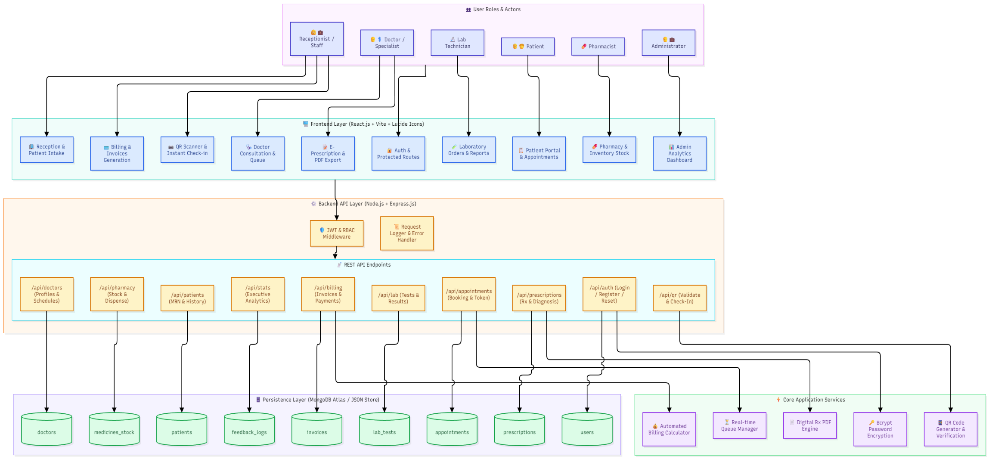

6. Outline of the Project Work
The CarePoint system is structured into cohesive modules designed to reflect the functional divisions of a modern multi-specialty healthcare facility. The architecture follows a Decoupled Single-Page Application (SPA) client communicating with a RESTful application backend.

6.1 Technology Architecture
- Client Layer: React.js 18 with Vite, modern CSS3 design system, Lucide icons, responsive layout supporting desktop, tablet, and mobile views.
- Server Layer: Node.js runtime with Express.js micro-framework providing modular routing, request validation, and error middleware.
- Persistence Layer: Structured JSON document data store with atomic asynchronous file writes and schema compliance (fully ready for seamless MongoDB Atlas migration).
- Security & Authentication: Bcrypt password hashing (10 salt rounds), secure session/token auth, CORS configuration, and strict endpoint authorization guards.

6.2 Key Modules Breakdown
- 1. Authentication & Role Governance: Centralized login supporting Admin, Doctor, Patient, and Staff roles with custom redirection, protected routing, and secure credential reset mechanisms.
- 2. Patient & Outpatient Management (OPD): Digital patient registration, unique medical record numbering (MRN), digital health profiles, and visit logs.
- 3. Doctor Consultation & Schedule Portal: Doctor profile management, daily consultation schedules, active patient queue review, and diagnostic note entry.
- 4. QR Scanner & Self Check-In: Integrated camera/scanner module for reading patient appointment QR tokens at clinic arrival, auto-updating appointment status to 'Checked-In'.
- 5. E-Prescription & Diagnostic Orders: Interactive prescription builder with medicine catalogs, dosage guidelines, duration, diagnostic test recommendations, and formatted print layouts.
- 6. Pharmacy Inventory & Dispensing: Drug catalog, batch tracking, stock level alerts, and prescription fulfillment synchronization.
- 7. Laboratory Investigation Module: Test requisition processing, sample status updates, lab result entry, and digital diagnostic report attachment.
- 8. Invoicing & Billing Engine: Automated calculation of consultation charges, pharmacy receipts, and lab fees with consolidated invoice generation and payment receipts.
- 9. Administrative Executive Dashboard: KPI monitors tracking total patients, active doctors, scheduled vs. completed appointments, revenue tallies, and system audit logs.

7. Tentative Schedule
The project was executed across five structured development phases spanning a 14-week timeline, following an Agile iterative delivery methodology:
Phase / Milestone | Key Activities & Deliverables | Duration | Status
Phase 1: Inception & Requirements | Stakeholder workflow study, SRS documentation, system architecture design, and database schema definition. | days 1 - 2 | Completed
Phase 2: Core System & Backend APIs | Node/Express server scaffold, RBAC authentication, user/doctor data models, and REST endpoints. | days 3 - 5 | Completed
Phase 3: Frontend Portals & UI Engine | React SPA layout, patient registration, appointment calendar, doctor consultation workspace, and admin dashboard. | days 6 - 9 | Completed
Phase 4: Advanced Modules & Hardware Integration | QR scanner check-in module, digital prescription PDF export, pharmacy & lab order workflows, and billing automation. | days 10 - 12 | Completed
Phase 5: Quality Assurance & Final Deployment | End-to-end integration testing, security audit, role validation, data store sanitation, and documentation. | days 13 - 14 | Completed

8. References
1. Ahmadi-Javid, A., Jalali, Z., & Klassen, K. J. (2017). Outpatient appointment systems in healthcare: A review of optimization studies. European Journal of Operational Research, 258(2), 395-434.
2. Bates, D. W., Leape, L. L., Cullen, D. J., Laird, N., Petersen, L. A., Teich, J. M., ... & Seger, D. L. (2001). Effect of computerized physician order entry and a team intervention on prevention of serious medication errors. JAMA, 280(15), 1311-1316.
3. Ferraiolo, D. F., Sandhu, R., Gavrila, S., Kuhn, D. R., & Chandramouli, R. (2001). Proposed NIST standard for role-based access control. ACM Transactions on Information and System Security (TISSEC), 4(3), 224-274.
4. Haux, R. (2006). Health information systems–past, present, future. International Journal of Medical Informatics, 75(3-4), 268-281.
5. Kaushal, R., Kern, L. M., Barrón, Y., Quaresimo, J., & Abramson, E. L. (2010). Electronic prescribing improves medication safety in community-based practices. Journal of General Internal Medicine, 25(6), 530-536.
6. Shortliffe, E. H., & Cimino, J. J. (Eds.). (2014). Biomedical Informatics: Computer Applications in Health Care and Biomedicine (4th ed.). Springer-Verlag London.

